**Phone Book Application using Doubly Circular Linked-List**

**Features:**

* New contact can be added.
* It can be deleted as well as updated.
* It provides restore and backup option.
* It having Search facility by using number as well as name.
* Linked list data structure used.

**Data Structure Design :-**

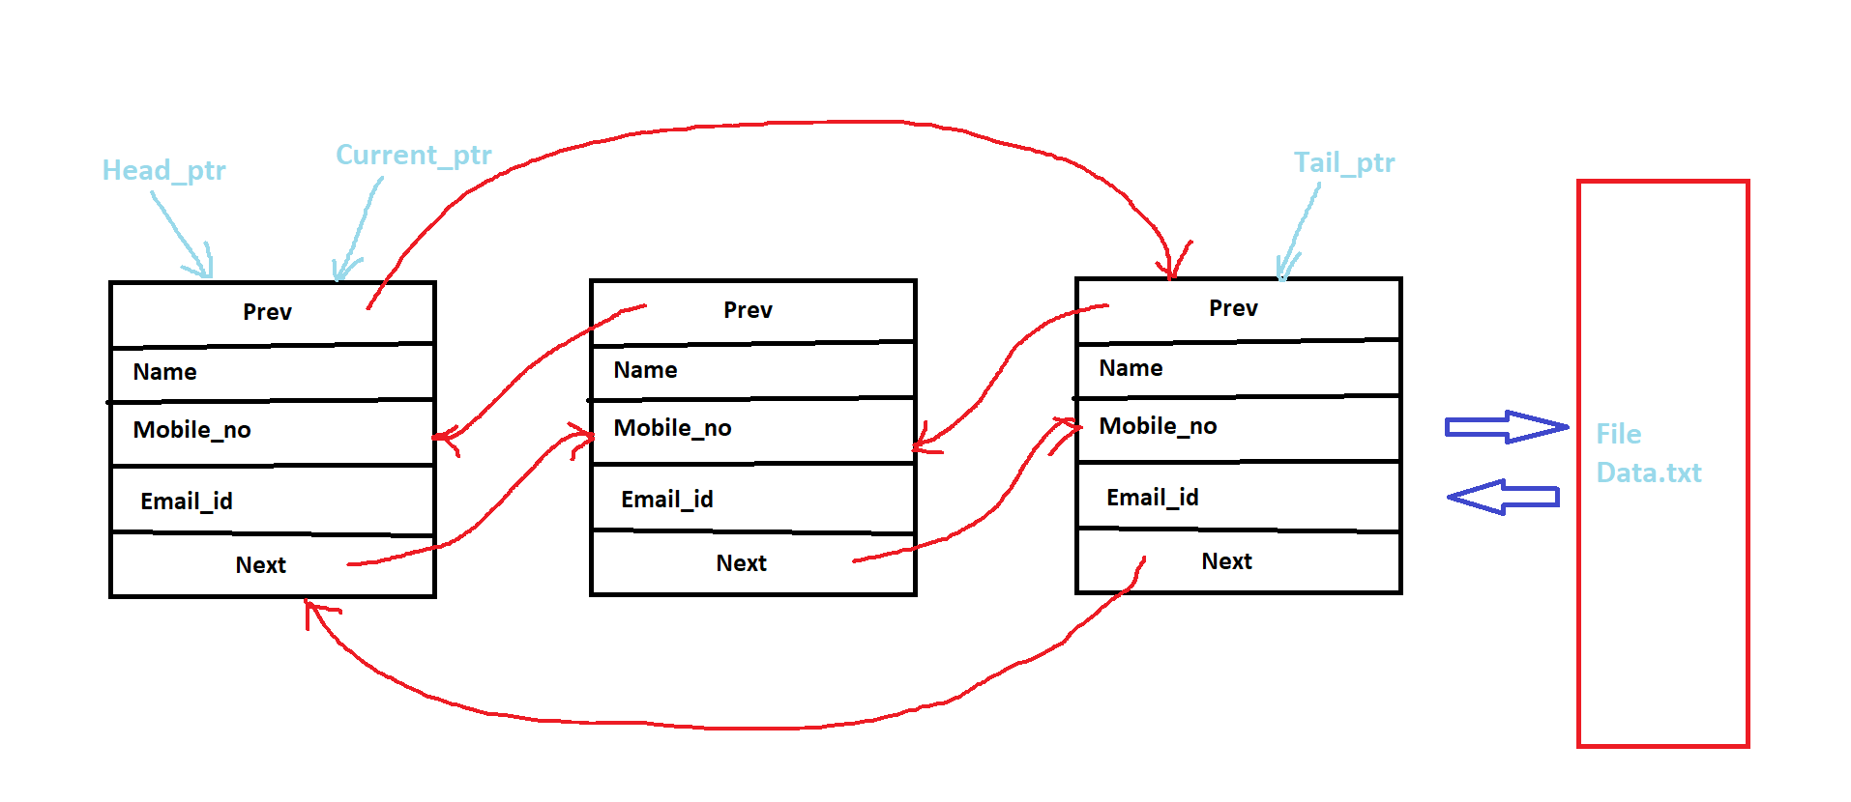

**Project Stucture – Data.txt, Backup.txt & main.cpp**

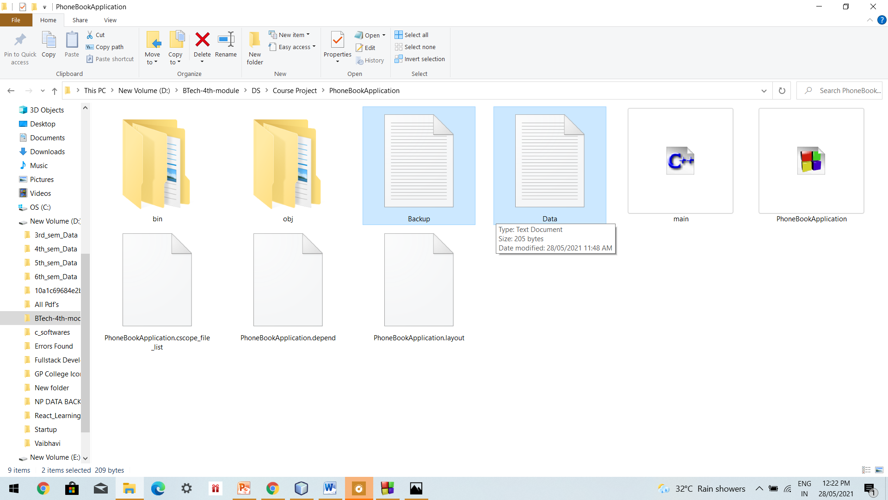

**Output Screenshots :-**

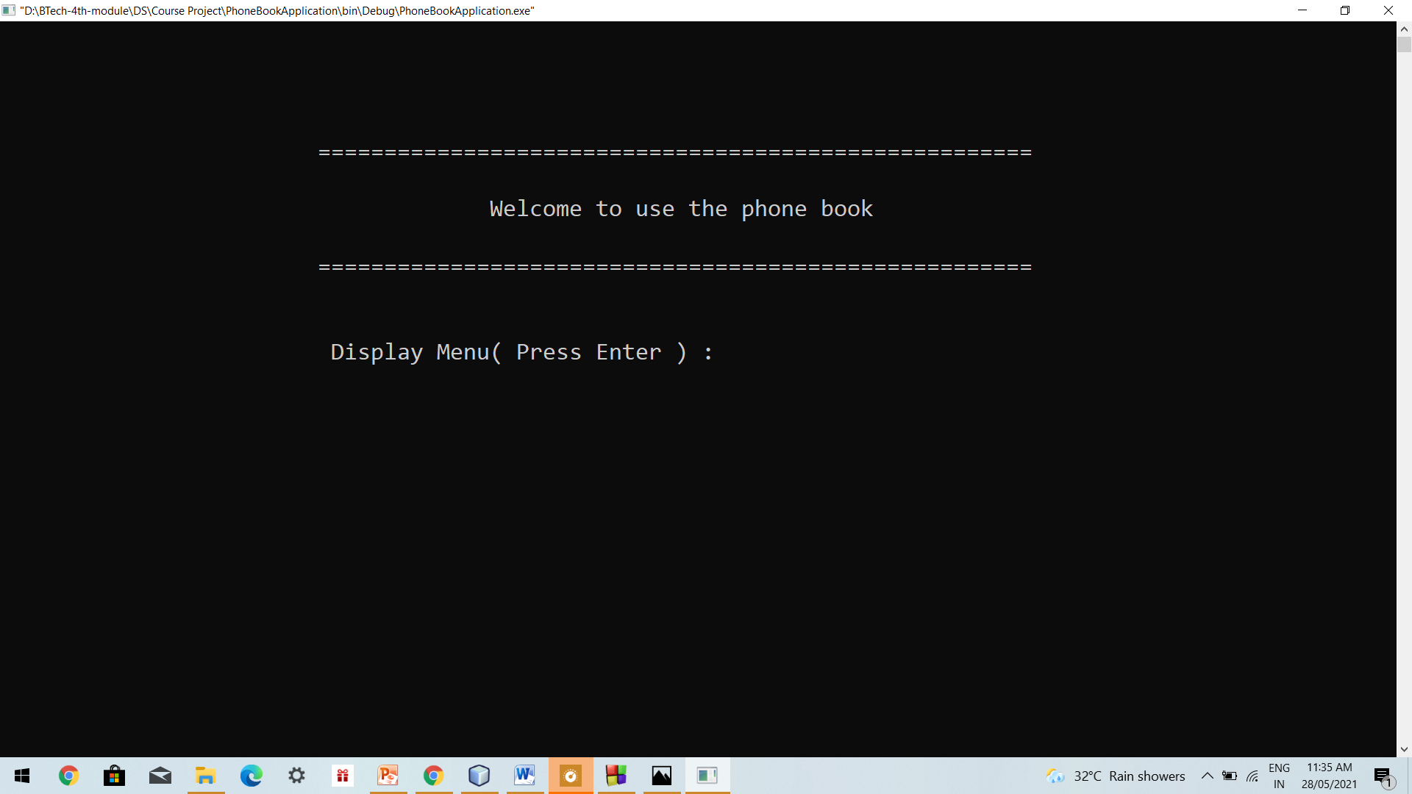

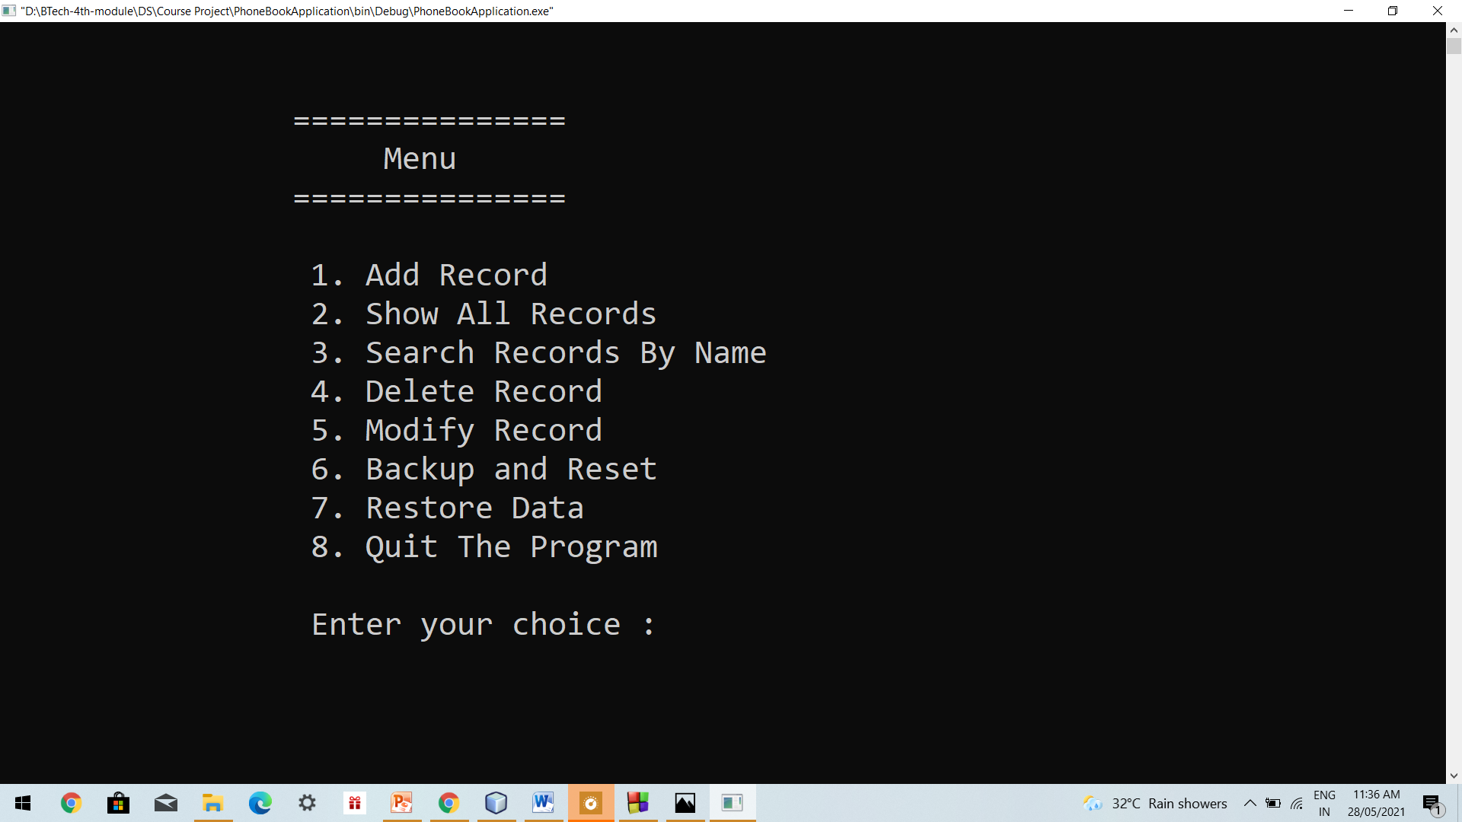

**Validations & Record Insertion –**

**Data.txt**

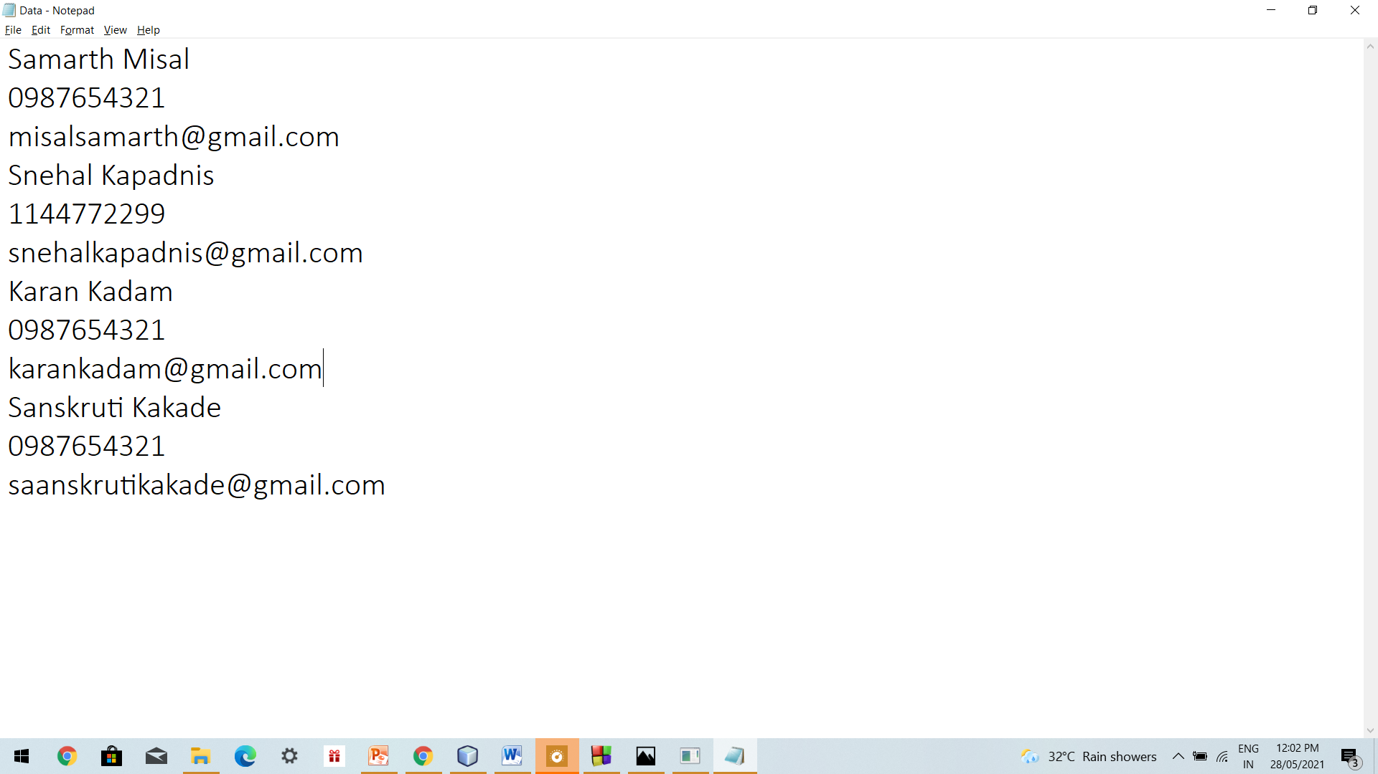

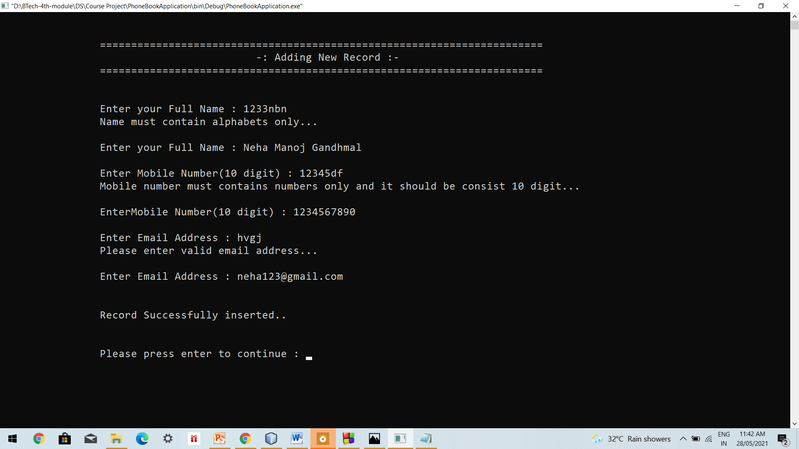

**Displaying Available Records –**

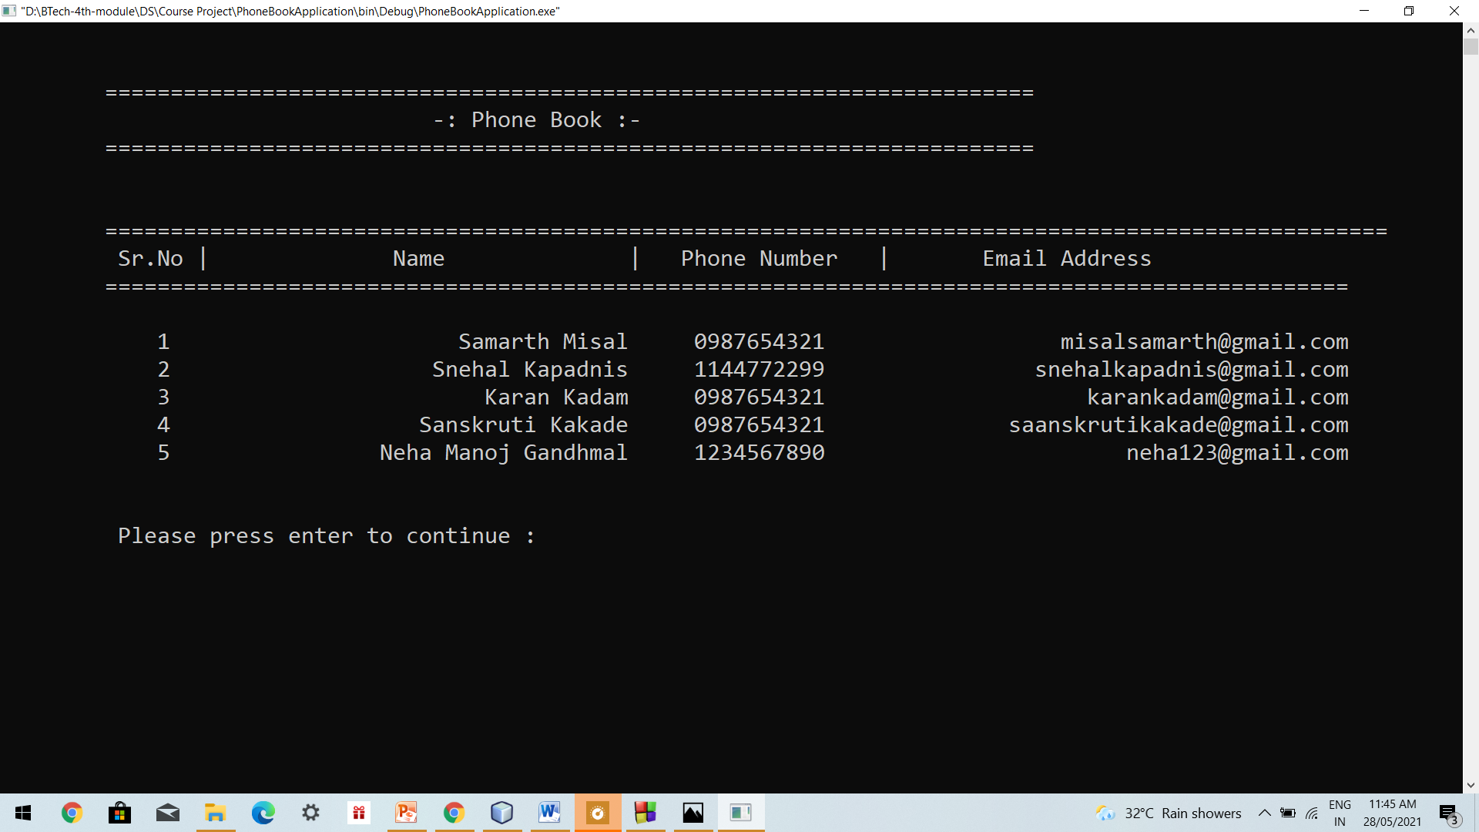

**Data.txt**

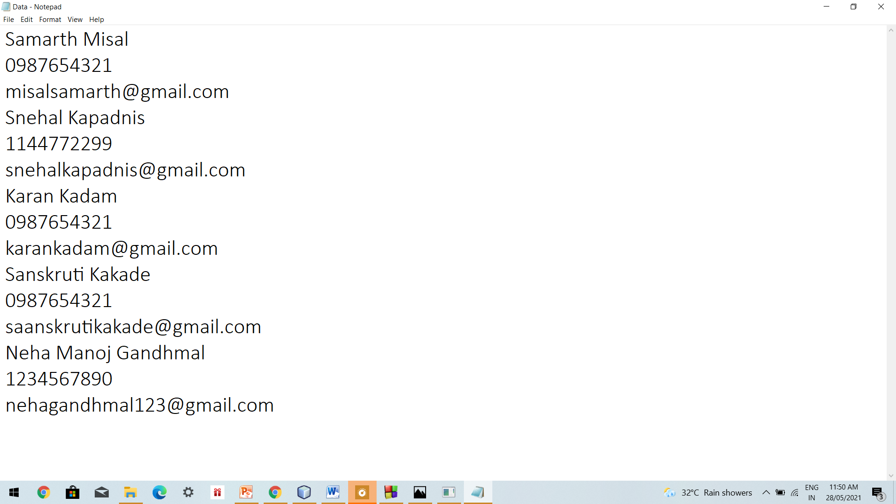

**Search Record –**

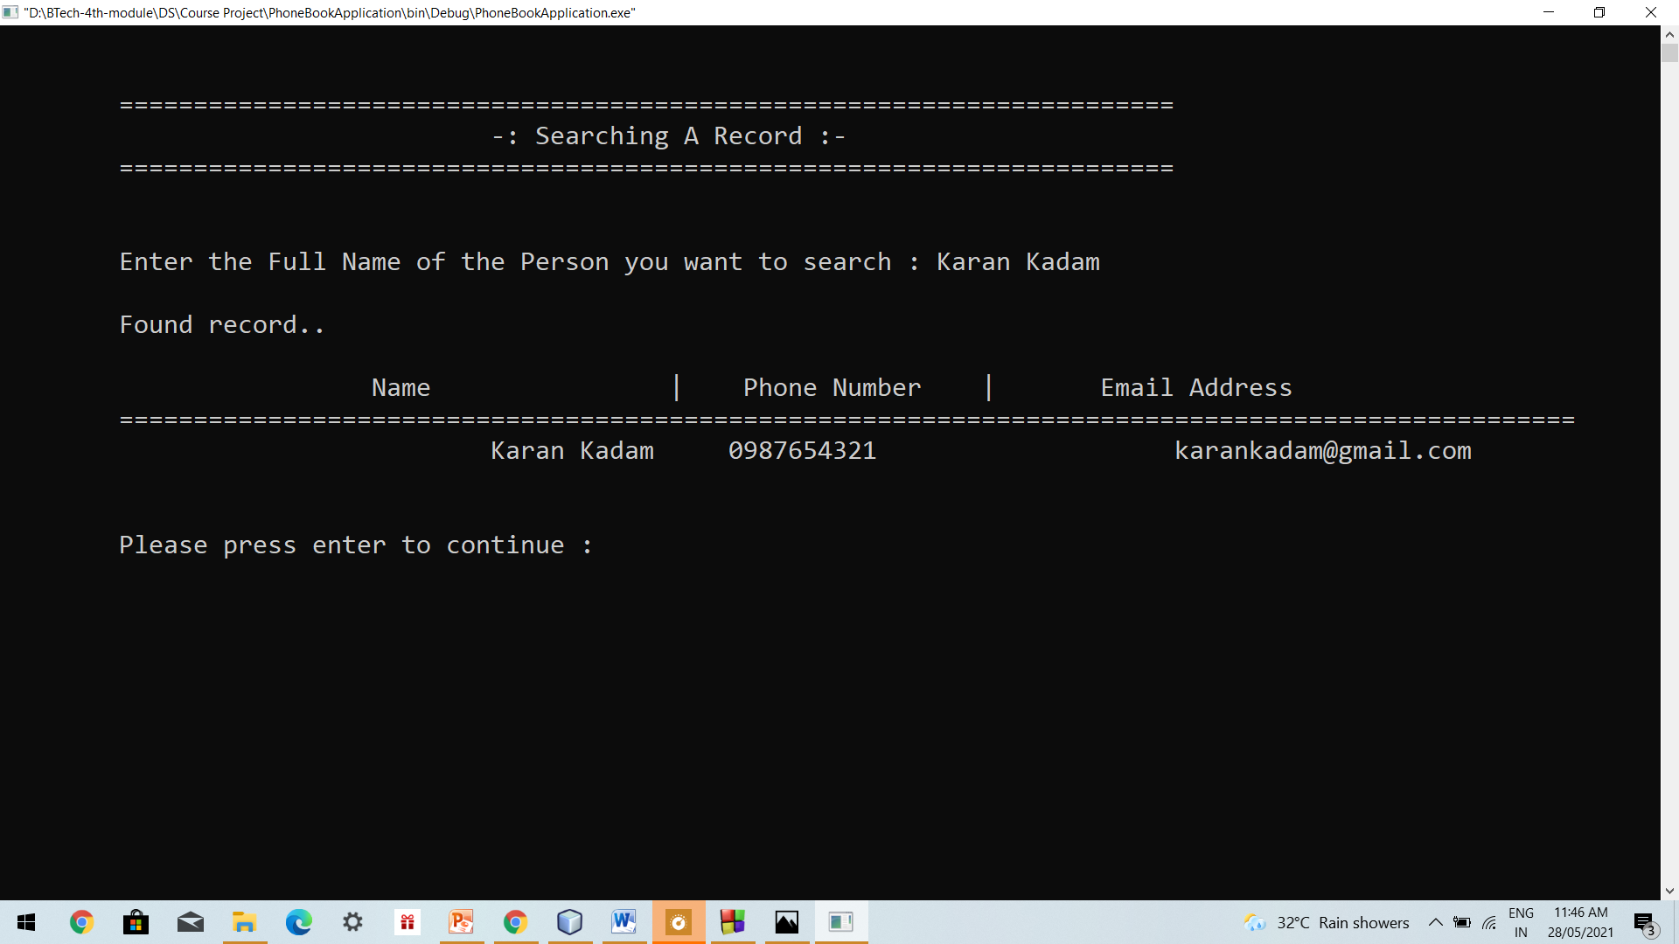

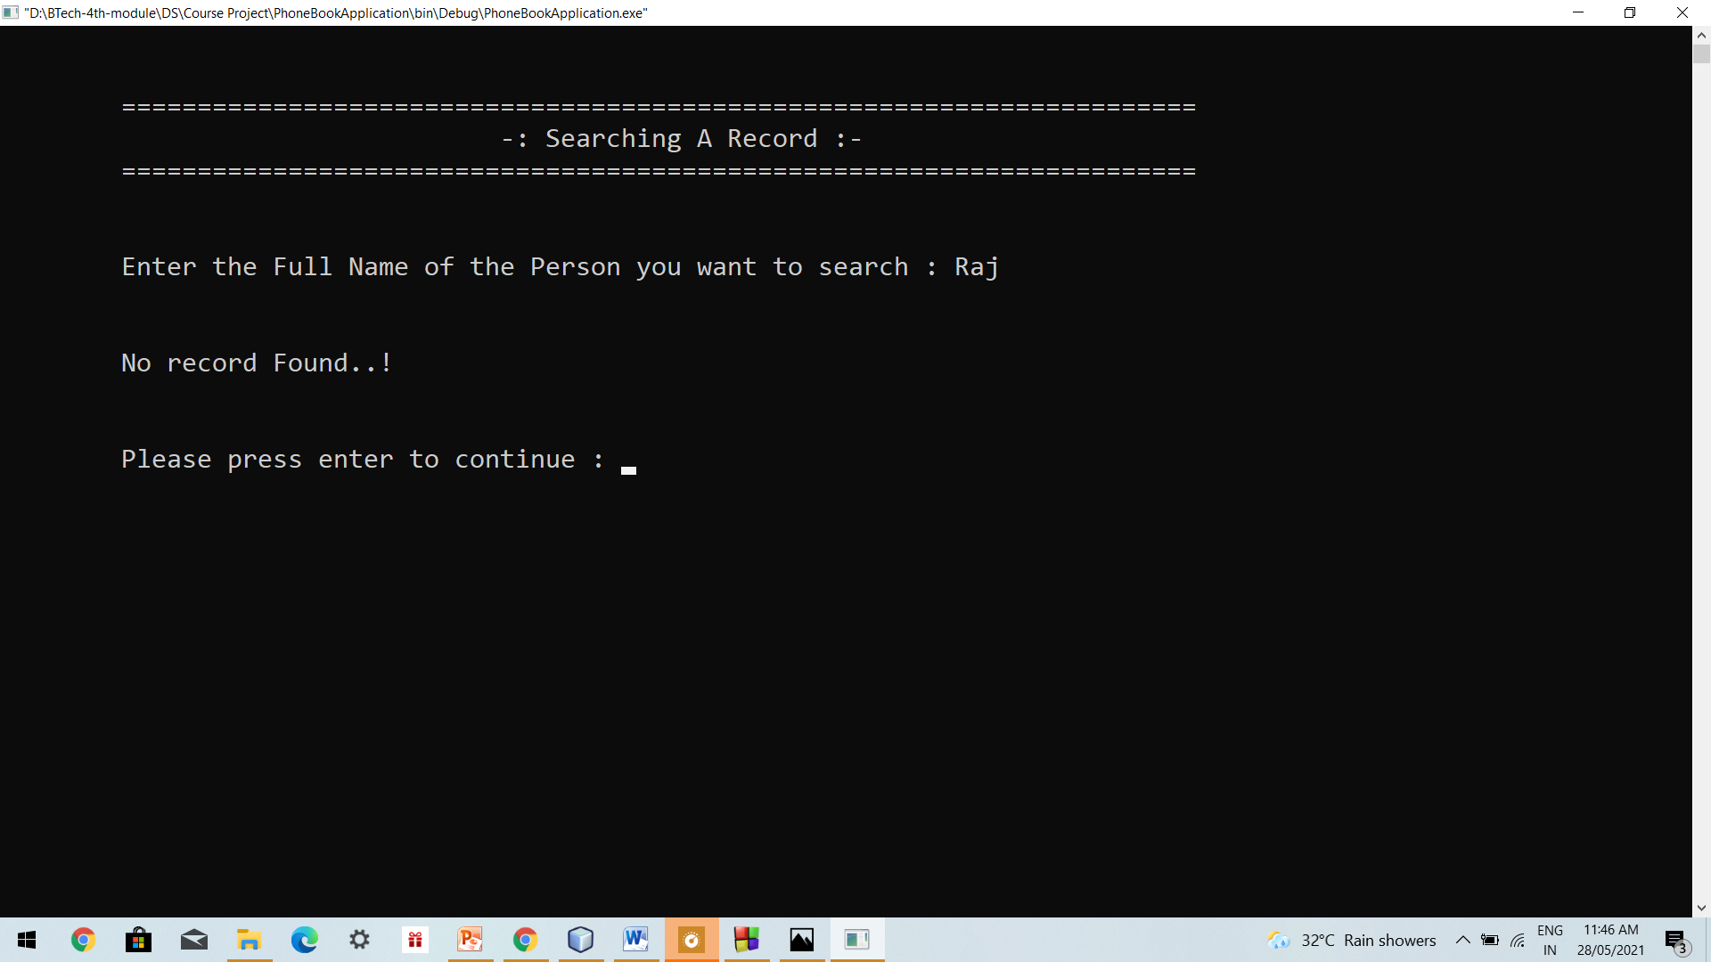

**Deleting Record –**

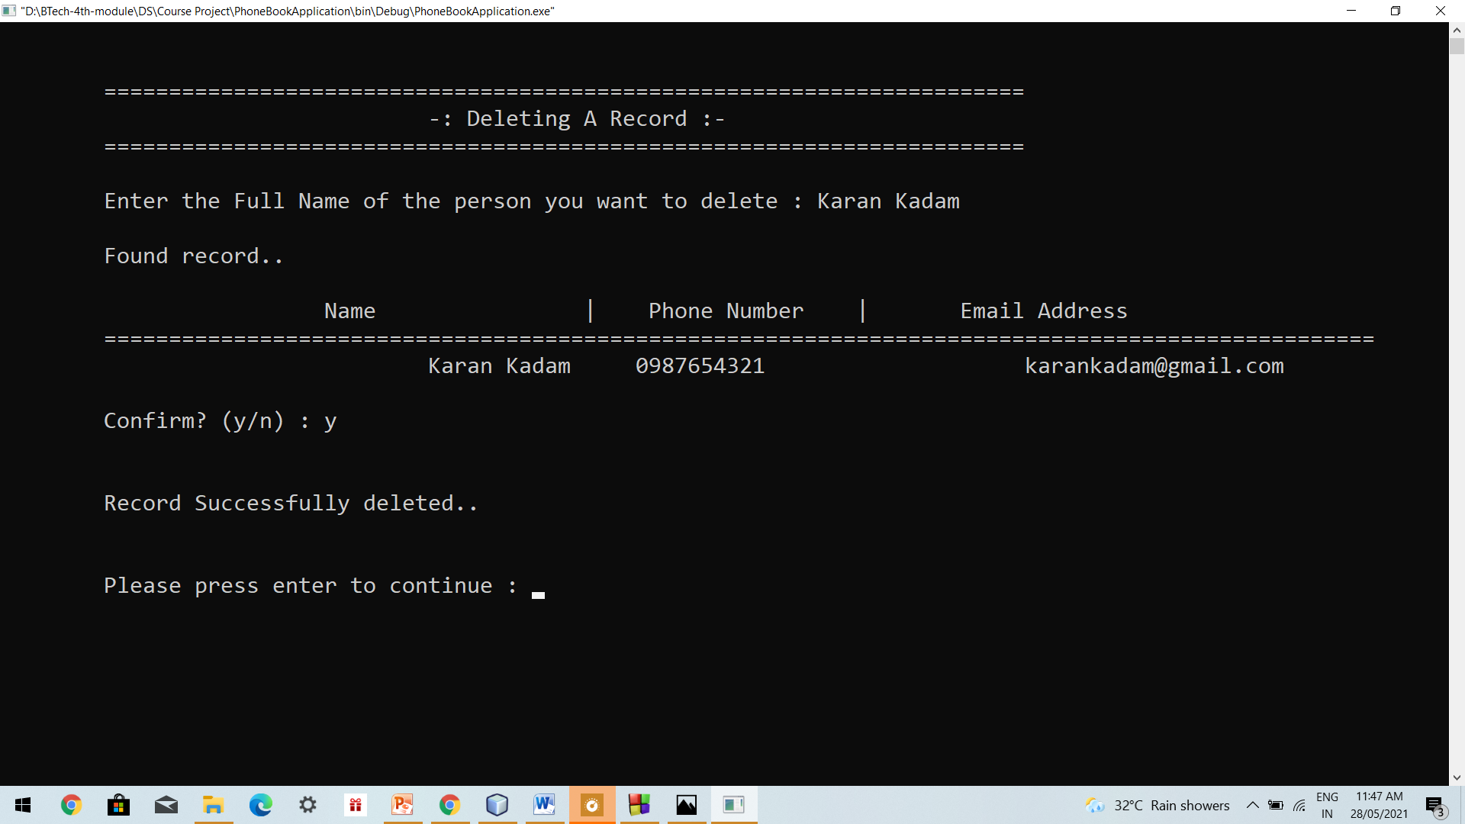

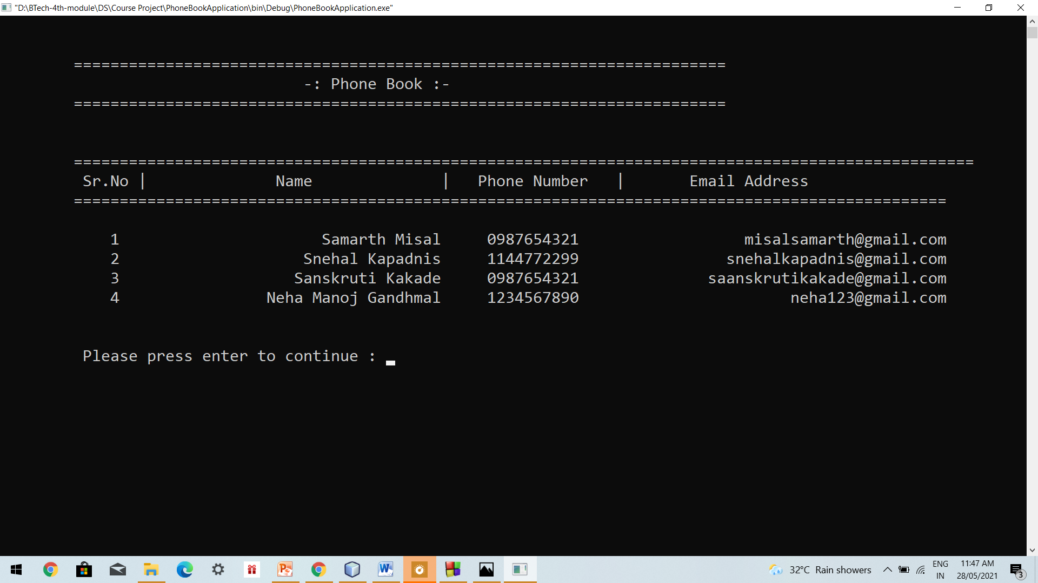

**Modifying Record –**

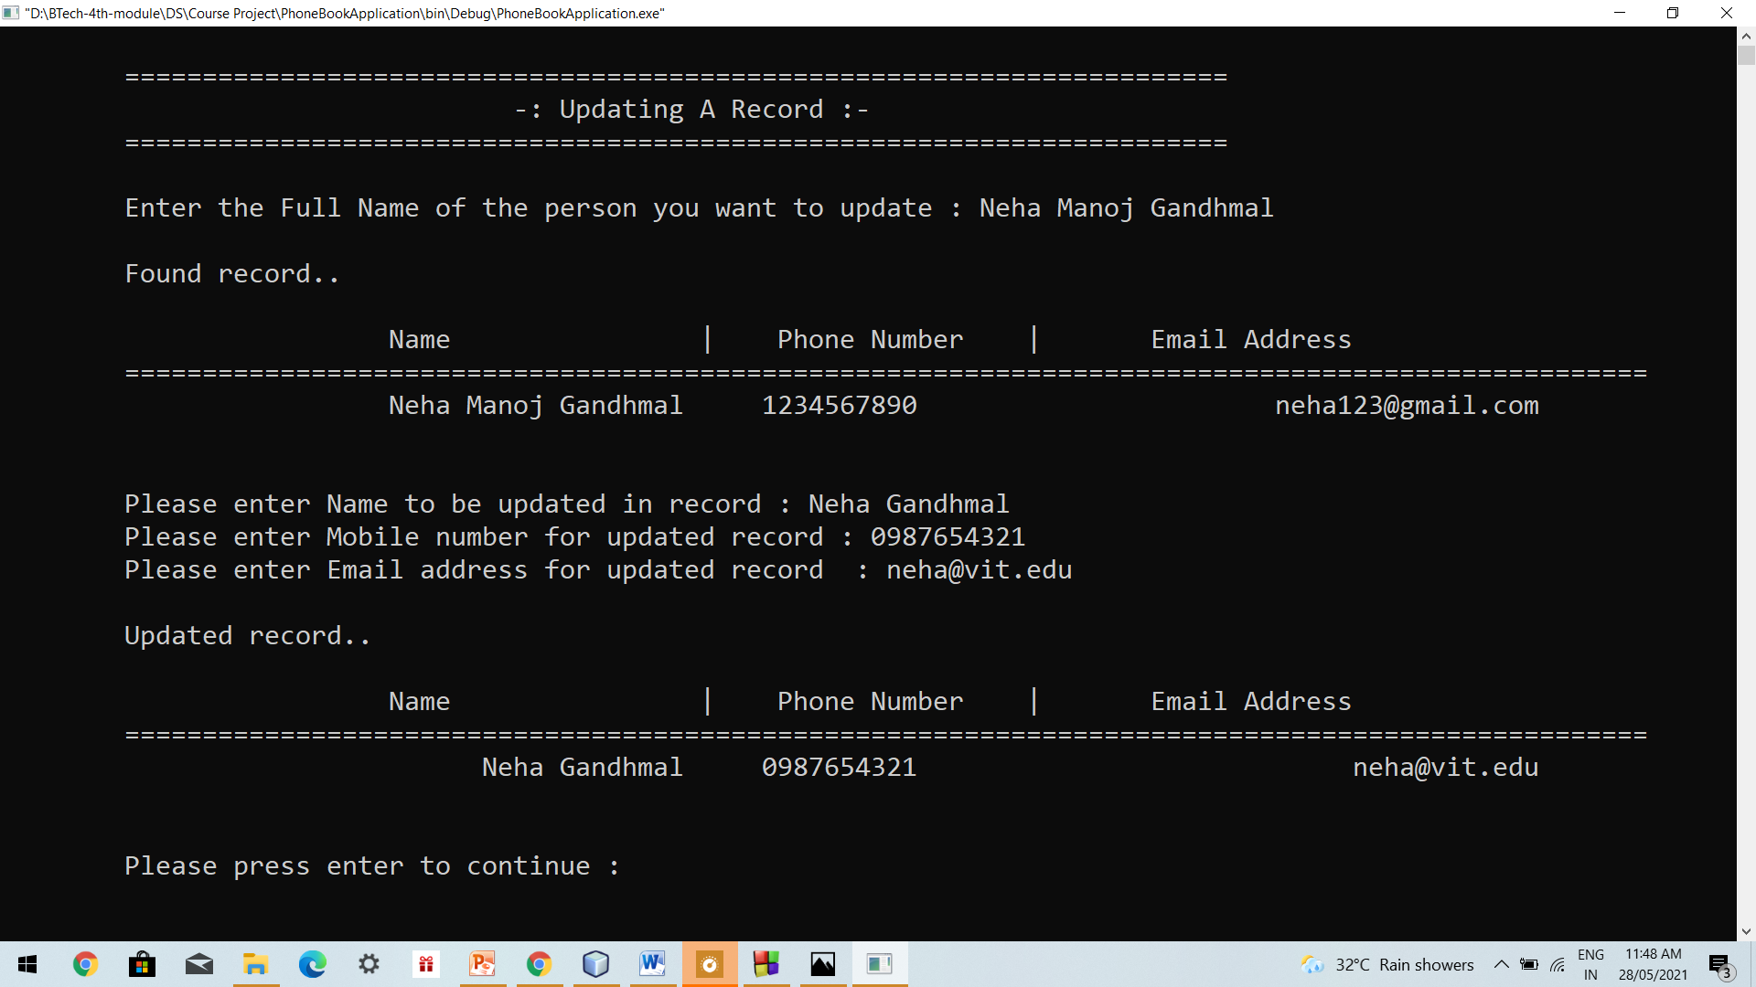

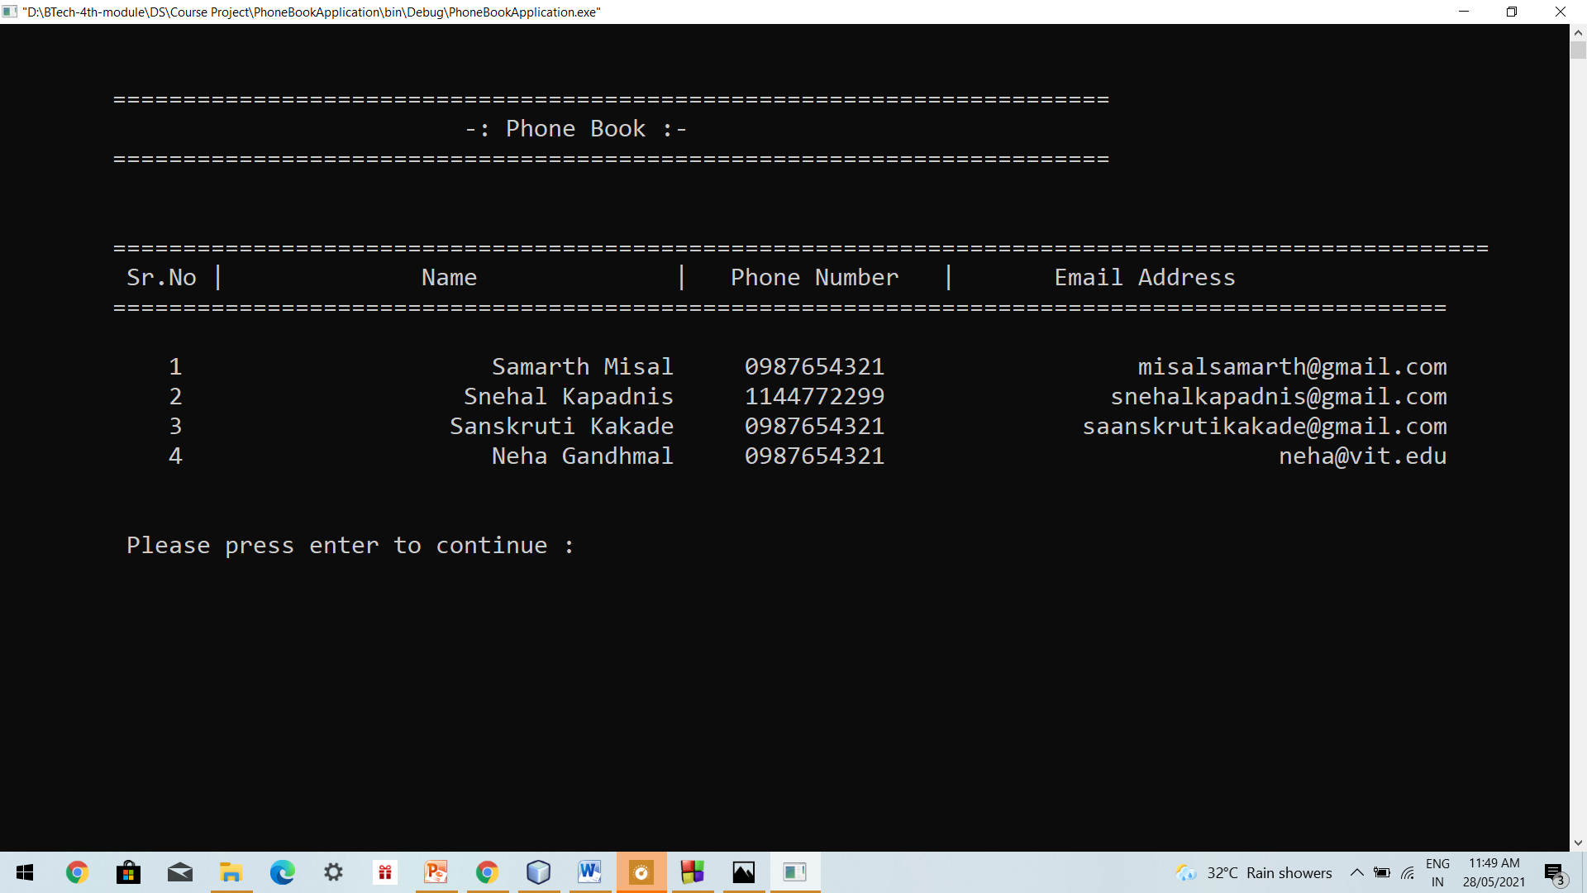

**Backup & Reset Data –**

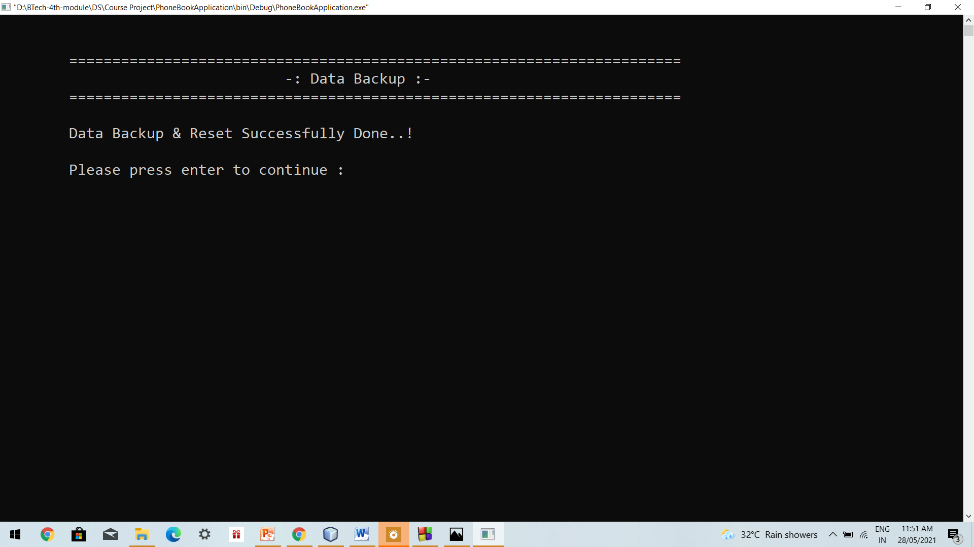

**Data.txt**

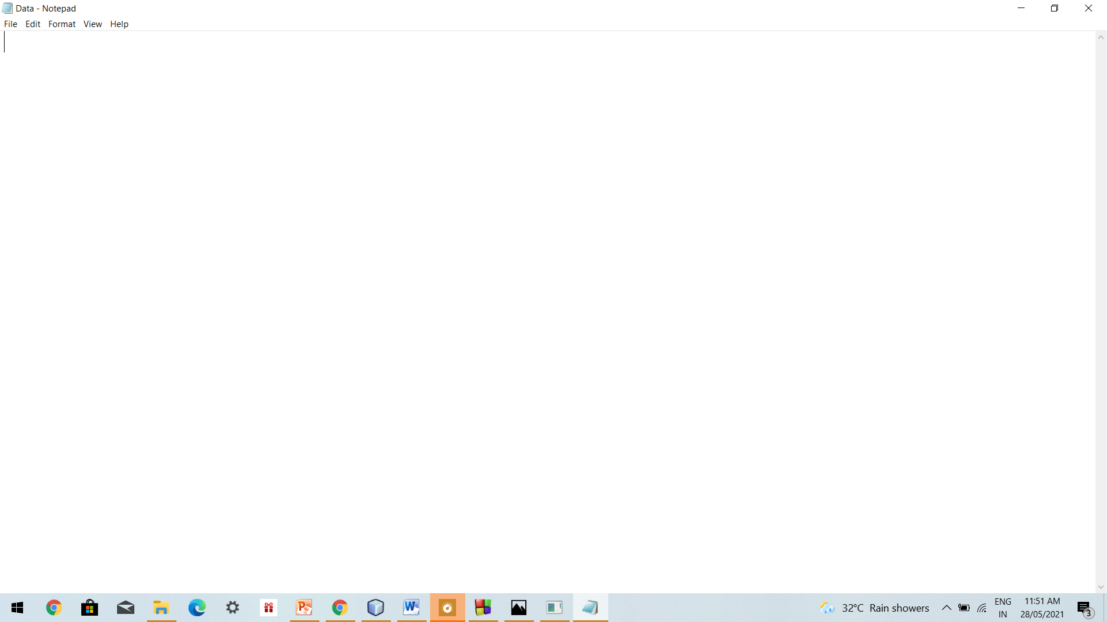

**Backup.txt**

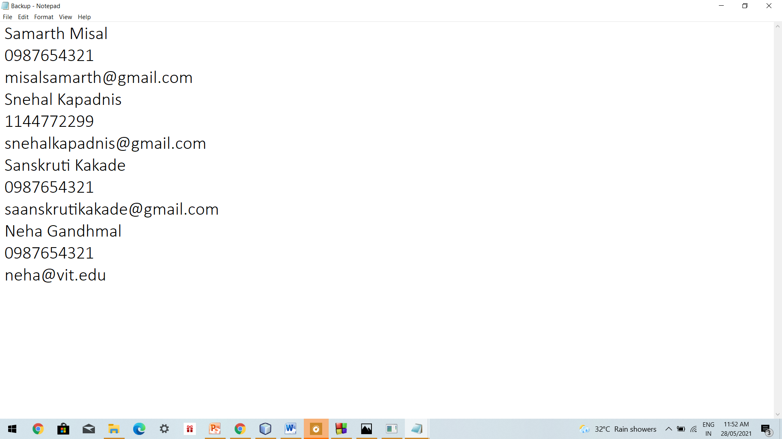

**Restore Data from Backup –**

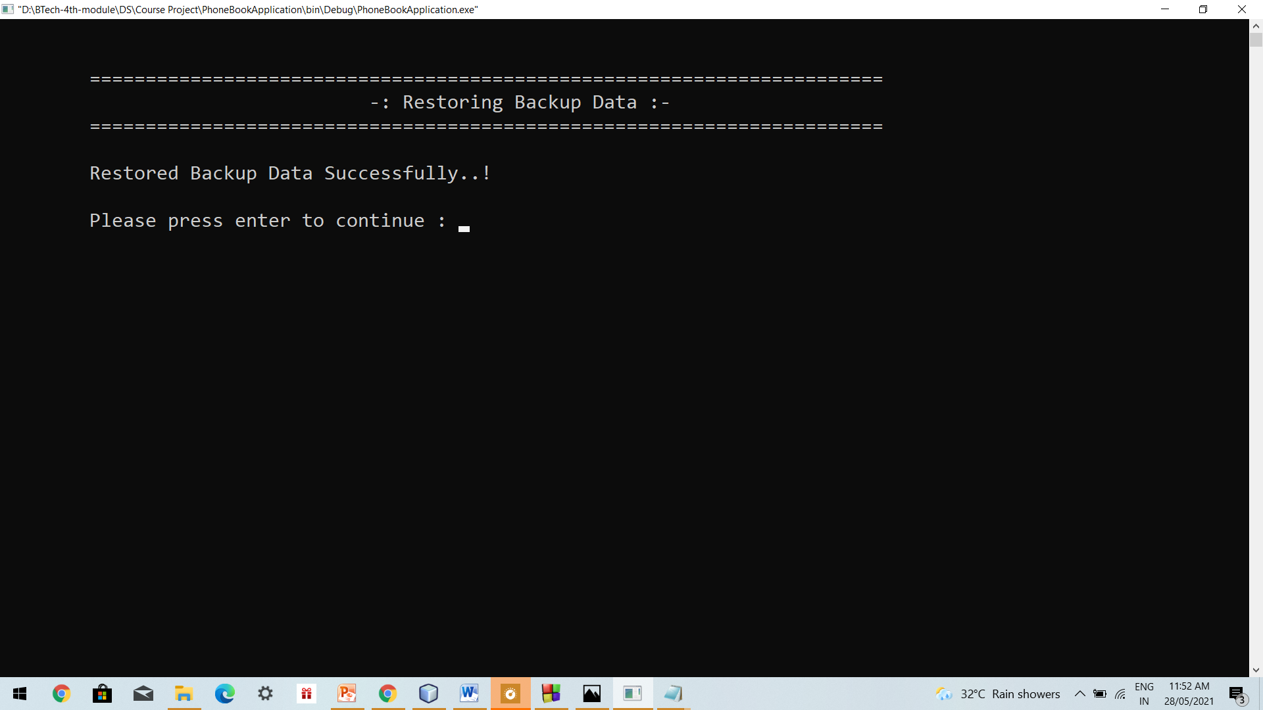

**Data.txt**

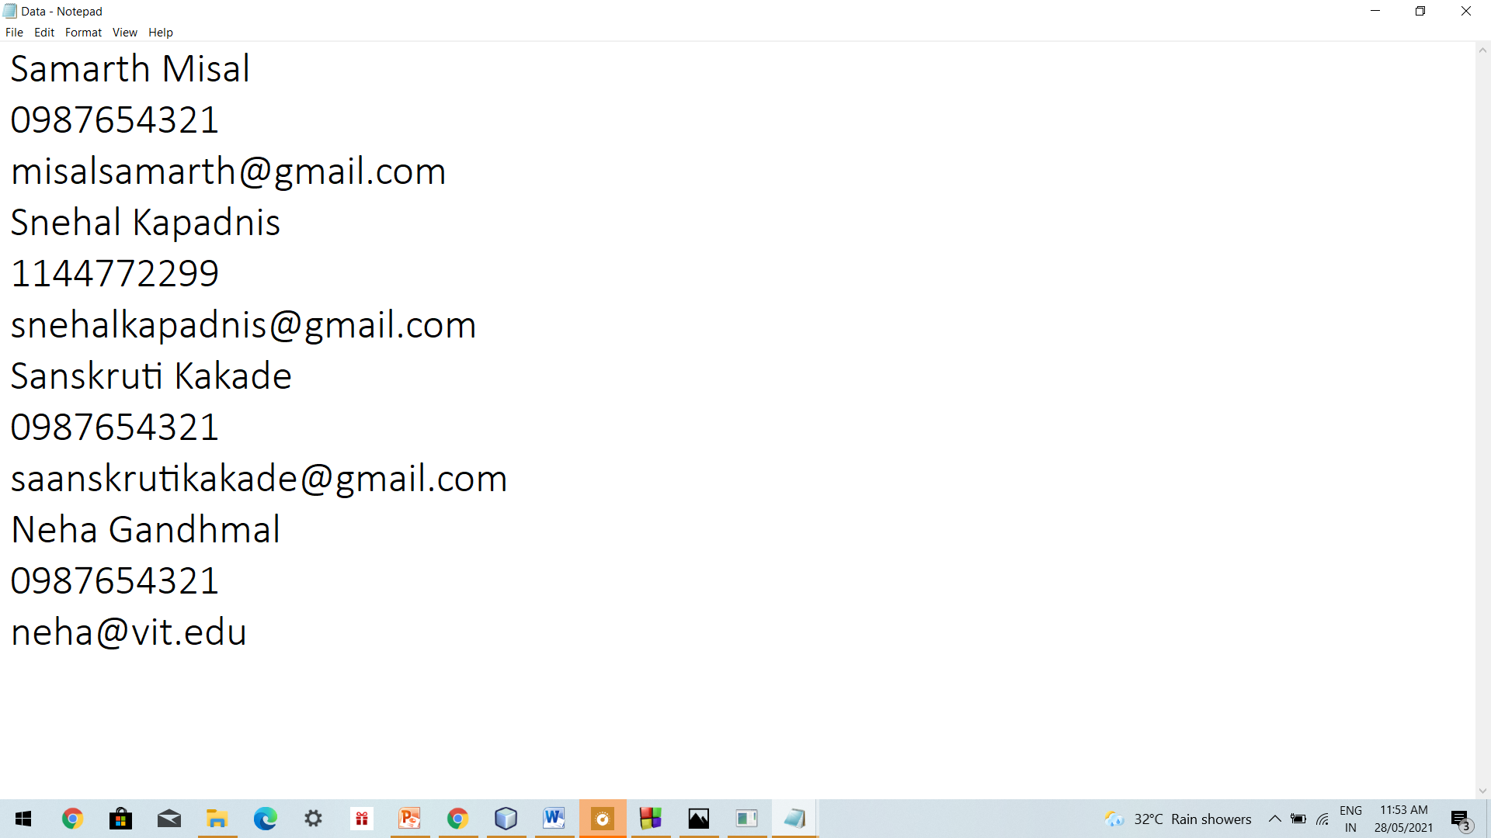

**Exit Application –**

