**DATA STRUCTURES LAB EXPERIMENTS**

SANSKRUTI SAMANT

USN: 2GI17EC113

DIV: B

**EXPERIMENT No:** 7

**Title:** Implementation of Bubble Sort

**Problem Statement:**

Write a C++ program to arrange the given set of numbers in ascending order using Bubble sort.

**Algorithm:**

1. Starting with the first element(index = 0), compare the current element with the next element of the array.
2. If the current element is greater than the next element of the array, swap them.
3. If the current element is less than the next element, move to the next element. Repeat Step 1.

**Program:**

#include<iostream>

using namespace std;

int main()

{

int array[50], n, i, j, k, temp;

cout<<"Enter the size of array: ";

cin>>n;

cout<<"Enter the array elements to be sorted:";

//To read the array

for(i=0;i<n;++i)

cin>>array[i];

cout<<"Array before sorting :";

for(i=0;i<n;++i)

cout<<" "<<array[i];

for(i=1;i<n;++i) // i keeps track of the no. of passes

{

{

for(j=0;j<(n-i);++j)

if(array[j]>array[j+1])

{

temp=array[j];

array[j]=array[j+1];

array[j+1]=temp;

}

}

//To print the array elements after every pass

cout<<"\n\n Array after Pass "<<i<<":" ;

for(k=0;k<n;++k)

cout<<" "<<array[k];

}

cout<<"\n\nArray after bubble sort:";

for(i=0;i<n;++i)

cout<<" "<<array[i];

return 0;

}

**Output:**

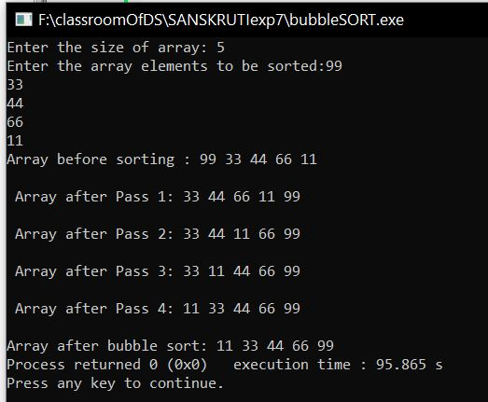

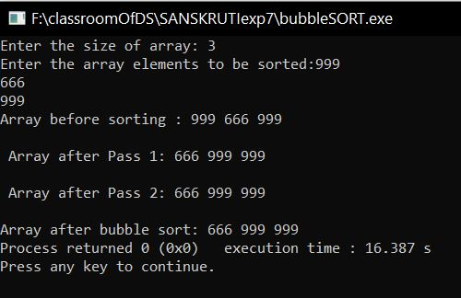

**Analysis:**

The main disadvantage of the bubble sort method is the time it requires. With a running time of O (n^2), it is highly inefficient for large data sets.