**DATA STRUCTURES LAB EXPERIMENTS**

Sanskruti Samant

USN: 2GI17EC113

DIV: B

**EXPERIMENT No**: 8

**Title:** IMPLEMENTATION OF QUICKSORT

**Problem statement:**

Write a C++ program to arrange the given set of numbers in ascending order using Quick sort.

**Algorithm:**

1. Pick the first element as pivot element.
2. Now all the elements smaller than pivot are placed at its left while elements bigger are placed at right.
3. Repeat the above two steps recursively for both halves.

**Program:**

#include <iostream>

using namespace std;

void quickSort(int[],int,int);

int partition(int[],int,int);

int main()

{

int a[50],n,i;

cout<<"How many elements to be sorted? :";

cin>>n;

cout<<"\nEnter the elements :";

for(i=0;i<n;i++) //To read the array elements

cin>>a[i];

quickSort(a,0,n-1);

cout<<"\nArray after sorting : ";

for(i=0;i<n;i++) //To print the sorted array

cout<<" "<<a[i]<<" ";

return 0;

}

void quickSort(int a[],int low,int up)

{

int j,i;

if(low<up)

{

j=partition(a,low,up);

// The following 3 blocks of code is to observe the partitioning

// and intermediate results

cout<<"\n";

for(i=low;i<=j-1;i++) //To print the array

cout<<" "<<a[i]<<" ";

cout<<"\n";

cout<<"\n";

for(i=j+1;i<=up;i++) //To print the array

cout<<" "<<a[i]<<" ";

cout<<"\n";

cout<<"\n";

for(i=0;i<=7;i++) //To print the array

cout<<" "<<a[i]<<" ";

cout<<"\n";

quickSort(a,low,j-1);

quickSort(a,j+1,up);

}

}

int partition(int a[],int low,int up)

{

int piv,i,j,temp;

piv=a[low]; //piv is the element whose final position is sought

i=low;

j=up+1;

cout<< "\n piv="<<piv<<"\n";

do

{

do

i++; // move up the array

while(a[i]< piv && i<=up);

do

j--; // move dpwn the array

while(piv<a[j]);

if(i<j)

{

temp=a[i];

a[i]=a[j];

a[j]=temp;

}

}while (i<j);

a[low]=a[j];

a[j]=piv;

return(j);

}

**Output:**

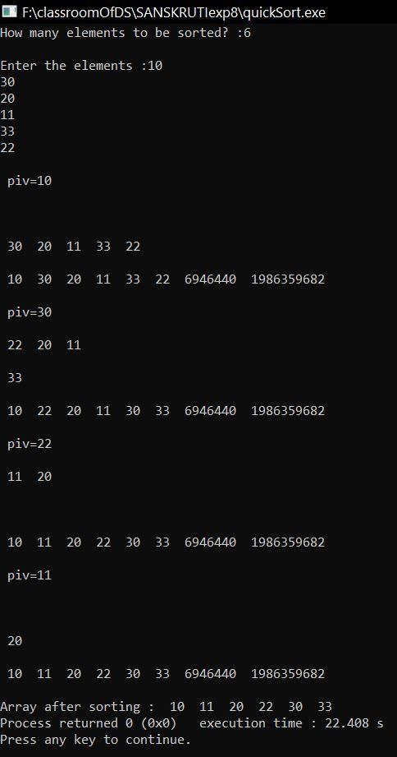

**Analysis:**

* Quick Sort is not adaptive.
* On sorted data, Quick Sort devolves to O(n^2) performance.
* It is not stable. It is less than ideal for highly repetitive data.
* It's not always fast or ideal, although for the AVERAGE case, it's acceptably efficient in time and memory.
* On sorted data for large N, it's 15–16 times SLOWER than Bubble Sort