**DATA STRUCTURES LAB EXPERIMENTS** **Experiment Number:** 9

Sanskruti Samant

USN: 2GI17EC113

DIV: B

**Title:** Implementation of Linear Search in C++.

**Problem Statement:**

Write a C++ program to search an element in an array using Linear search.

**Algorithm:**

1. Create the array of size specified by the user.
2. Read the value ‘X’ to be searched from the user.
3. Start from the leftmost element of array and one by one compare x with each element of array.
4. If x matches with an element, return the index+1.
5. If x doesn’t match with any of elements, return -1.

**Code:**

#include<iostream>

using namespace std;

int main()

{

int arr[20],n,x,i,flag=0;

cout<<"How many elements?";

cin>>n;

cout<<"\nEnter elements of the array\n";

for(i=0;i<n;++i)

cin>>arr[i];

cout<<"\nEnter element to search:";

cin>>x;

for(i=0;i<n;++i)

{ if(arr[i]==x)

{ flag=1;

break;

}

}

if(flag)

cout<<"\nElement is found at position "<<i+1;

else

cout<<"\nElement not found";

return 0;

}

**Sample Input/ Output:**

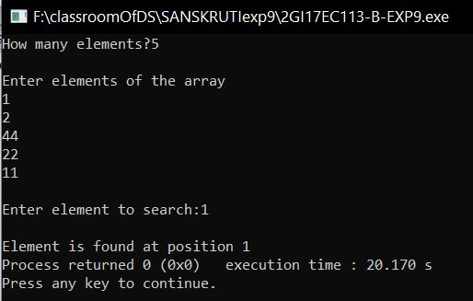

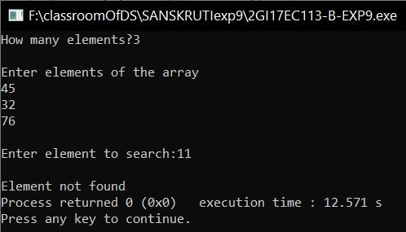

**Analysis:**

* Linear search is used to search an element in any array, the array may be sorted or unsorted.
* The sequential or linear search algorithm is very slow. This is because we need to compare the item with every element. But if the array is unsorted then Linear Search is the final option.