**Open ended 2**

**AIM**:To Implement Quiz E-Game on c and Execute it.

**INTRODUCTION**: The software is used on the basis of the Questions asked to the user . The Quiz goes like this, the user has to answer the question and if the user is right he or she gains 10 points and if question attempt goes wrong the Quiz will stop and next question appears.

**CODE**:

#include <stdio.h>

#include <stdlib.h>

char Q1;

char Q2;

char Q3;

char Q4;

char Q5;

char Q6;

char Q7;

char Q8;

char Q9;

char Q10;

int c,w;

main()

{

printf("WELCOME TO QUIZ-E-GAME\n\n\n\n\n");

system ("pause");

system ("cls");

printf ("1-What is 1 + 1?\nA=1\nB=2\nC=3\nD=4\n");

scanf ("%c", &Q1);

if ((Q1 == 'B')||(Q1 == 'b'))

{

c=c+1;

printf ("Correct Answer\n");

}

else

{

w=w+1;

printf ("Wrong Answer\n")

}

system ("pause");

system ("cls");

printf ("2-What is 2 + 2?\nA=4\nB=2\nC=6\nD=8\n");

scanf ("%s", &Q2);

{

if ((Q2 == 'A')||(Q2 == 'a'))

{

c=c+1;

printf ("Correct Answer\n");

}

else

{

w=w+1;

printf ("Wrong Answer\n");

}}

system ("pause");

system ("cls");

printf ("3-What is 4 + 4?\nA=2\nB=6\nC=8\nD=9\n");

scanf ("%s", &Q3);

{

if ((Q3 == 'C')||(Q3 == 'c'))

{c=c+1;

printf ("Correct Answer\n");

}

else

{

w=w+1;

printf ("Wrong Answer\n");

}

}

system ("pause");

system ("cls");

printf ("4-What is 4 + 7?\nA=2\nB=6\nC=2\nD=11\n");

scanf ("%s", &Q4);

if ((Q4 == 'D')||(Q4 == 'd'))

{c=c+1;

printf ("Correct Answer\n");

}

else

{

w=w+1;

printf ("Wrong Answer\n");

}

system ("pause");

system ("cls");

printf ("5-What is 1*3?\nA=2\nB=3\nC=4\nD=7\n");

scanf ("%s", &Q5);

if ((Q5 == 'B')||(Q5 == 'b'))

{c=c+1;

printf ("Correct Answer\n");

}

else

{

w=w+1;

printf ("Wrong Answer\n");

}

system ("pause");

system ("cls");

printf ("6-What is 6/1?\nA=7\nB=6\nC=5\nD=10\n");

scanf ("%s", &Q6);

if ((Q6 == 'B')||(Q6 == 'b'))

{ c=c+1;

printf ("Correct Answer\n");

}

else

{w=w+1;

printf ("Wrong Answer\n");

}

system ("pause");

system ("cls");

printf ("7-What is 3 + 9?\nA=8\nB=18\nC=17\nD=12\n");

scanf ("%s", &Q7);

if ((Q8 == 'D')||(Q8 == 'd'))

{c=c+1;

printf ("Correct Answer\n");

}

else

{

w=w+1;

printf ("Wrong Answer\n");

}

system ("pause");

system ("cls");

printf ("8-What is 3*9?\nA=8\nB=18\nC=17\nD=27\n");

scanf ("%s", &Q8);

if ((Q8 == 'D')||(Q8 == 'd'))

{ c=c+1;

printf ("Correct Answer\n");

}

else

{

w=w+1;

printf ("Wrong Answer\n");

}

system ("pause");

system ("cls");

printf ("9-What is 7*8?\nA=8\nB=18\nC=17\nD=56\n");

scanf ("%s", &Q9);

if ((Q9 == 'D')||Q9 == 'd'))

{c=c+1;

printf ("Correct Answer\n");

}

else

{

w=w+1;

printf ("Wrong Answer\n");

}

system ("pause");

system ("cls");

printf ("10-What is 3-9?\nA=8\nB=18\nC=17\nD=-6\n");

scanf ("%s",&Q10);

if ((Q10 == 'D')||(Q10 == 'd'))

{ c=c+1;

printf ("Correct Answer\n");

}

else

{

w=w+1;

printf ("Wrong Answer\n");}

printf("The Total scored is %d out of 7",c);

return 0;

}

EXPLANATION:

In this code, We Use very below function to execute the code:

#**include**<**stdio**.**h**>:is a statement which tells the compiler to insert the contents of **stdio** at that particular place. In C/C++ we use some functions like printf(), scanf(), cout, cin. These functions are not defined by the programmer. These functions are already defined inside the language library.

**#include<stdlib.h>:**is the header of the general purpose standard library of C programming language which includes functions involving memory allocation, process control, conversions and others.

**printf():** function is used to print the “character, string, float, integer, octal and hexadecimal values” onto the output screen.

**scanf()**:function is used to read character, string, numeric data from keyboard.

**If else condition:**If the test expression is evaluated to true (nonzero), statement(s) inside the body of if() is executed. If the test expression is evaluated to false (0), statement(s) inside the body of if() is skipped from execution.

**system(“pause”);** function because it has to pause the programs execution and make a system call and allocate unnecessary resources when you could be using something as simple as cin.get(). We use because we want the program to wait until user hit enter so they can see their output.

**System(“clr”);** In summary, it has to pause the programs execution and make a system call and allocate unnecessary resources when you could be using something as simple as cin.get(). People use System("PAUSE") because they want the program to wait until they hit enter to they can see their output

**OUTPUT:** 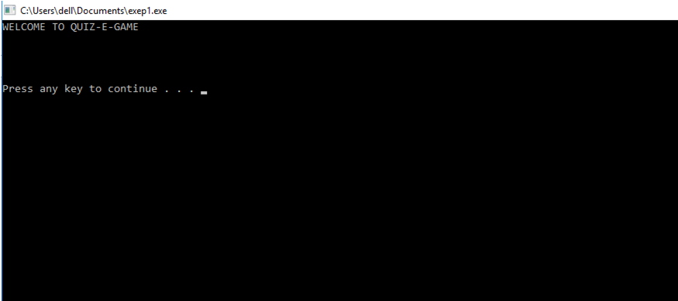

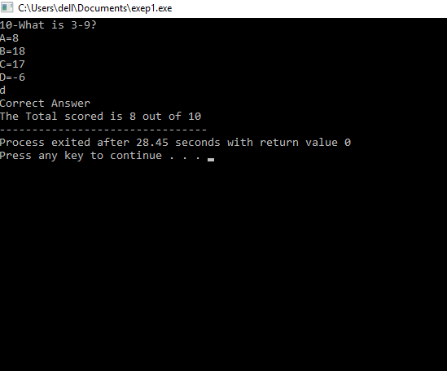

CONCLUSION**:**

Hence, We could execute a Quiz E-Game in c language using very simple functions.