Case Study No: 1
Experiment Title: Demonstration of basics of JavaScript program.

Case Study Title: Create a webpage for college department and link the student information page with it and write a Java Script Program to Display "Welcome to SIT Nagpur" in an alert Box.

Software/ Tools Required: VS Code (text editor), HTML, CSS, JavaScript.

Case Study Program Code:
Index.html –
<!DOCTYPE html>
<html>

<head>

<title>Symbiosis Institute of Technology</title>

<link rel="stylesheet" href="style.css">

<!-- Internal JavaScript -->
<script>

function welcome() {

document.getElementById("message").innerHTML =
"Welcome to Symbiosis Institute of Technology";

}

</script>

</head>

<body class="home" onload="welcome()">

<div class="overlay">

<h1>Symbiosis Institute of Technology</h1>

<h2>Student Portal</h2>

<p id="message"></p>

<p>"Empowering Minds • Inspiring Innovation"</p>

<br>

<a href="student.html">
<button>Get Started</button>
</a>
</div>
<footer>
Made by Sanskruti Asati | PRN - 24070521008
</footer>

</body>
</html>

Script.js –
function saveData(){

localStorage.setItem("name",
document.getElementById("name").value);

localStorage.setItem("prn",
document.getElementById("prn").value);

localStorage.setItem("age",
document.getElementById("age").value);

localStorage.setItem("email",
document.getElementById("email").value);

window.location.href="result.html";
}

document.getElementById("showName").innerHTML =
localStorage.getItem("name");

document.getElementById("showPrn").innerHTML =
localStorage.getItem("prn");

document.getElementById("showAge").innerHTML =
localStorage.getItem("age");

document.getElementById("showEmail").innerHTML =
localStorage.getItem("email");

}

function showData(){

document.getElementById("showName").innerHTML =
localStorage.getItem("name");

document.getElementById("showPrn").innerHTML =
localStorage.getItem("prn");

document.getElementById("showAge").innerHTML =
localStorage.getItem("age");

document.getElementById("showEmail").innerHTML =
localStorage.getItem("email");

}

function showData(){

document.getElementById("showName").innerHTML =
localStorage.getItem("name");

document.getElementById("showPrn").innerHTML =
localStorage.getItem("prn");

document.getElementById("showAge").innerHTML =
localStorage.getItem("age");

document.getElementById("showEmail").innerHTML =
localStorage.getItem("email");

}

Style.css
body{
margin:0;
font-family:Arial, sans-serif;
}

/* ---------------- Welcome Page ---------------- */
.home{
background-image: url("college.png");
background-size: cover;
background-position: center;
background-repeat: no-repeat;
height:100vh;
}
.overlay{
width:100%;
height:100vh;
background:rgba(0,0,0,0.5);

display:flex;
flex-direction:column;
justify-content:center;
align-items:center;

text-align:center;
color:white;
}
.overlay h1{
font-size:45px;
margin-bottom:10px;
}

.overlay p{
font-size:22px;
margin-bottom:15px;
}

.overlay h3{
font-size:30px;
margin-bottom:25px;
}

.overlay button{
width:180px;
padding:12px;
background:white;
color:darkblue;
border:none;
border-radius:5px;
font-size:18px;
cursor:pointer;
}
.overlay button:hover{
background:#e6e6e6;
}
/* ---------------- Student Form ---------------- */

.formpage{
background:#f2f2f2;
}

.resultpage{
background:#f2f2f2;
}

.container{
width:450px;
margin:50px auto;
background:white;
padding:25px;
border-radius:10px;
box-shadow:0px 0px 10px gray;
}

.container h2{
text-align:center;
color:darkblue;
}

label{
display:block;
margin-top:12px;
font-weight:bold;
}

input{
width:100%;
padding:10px;
margin-top:5px;
border:1px solid gray;
border-radius:5px;
box-sizing:border-box;
}

button{
width:100%;
padding:10px;
margin-top:20px;
background:darkblue;
color:white;
border:none;
border-radius:5px;
cursor:pointer;
font-size:16px;
}

button:hover{
background:#003399;
}

/* ---------------- Footer ---------------- */

footer{
position:fixed;
bottom:0;
width:100%;
background:rgba(0,0,0,0.7);
color:white;
text-align:center;
padding:10px;
font-size:14px;
}

Output



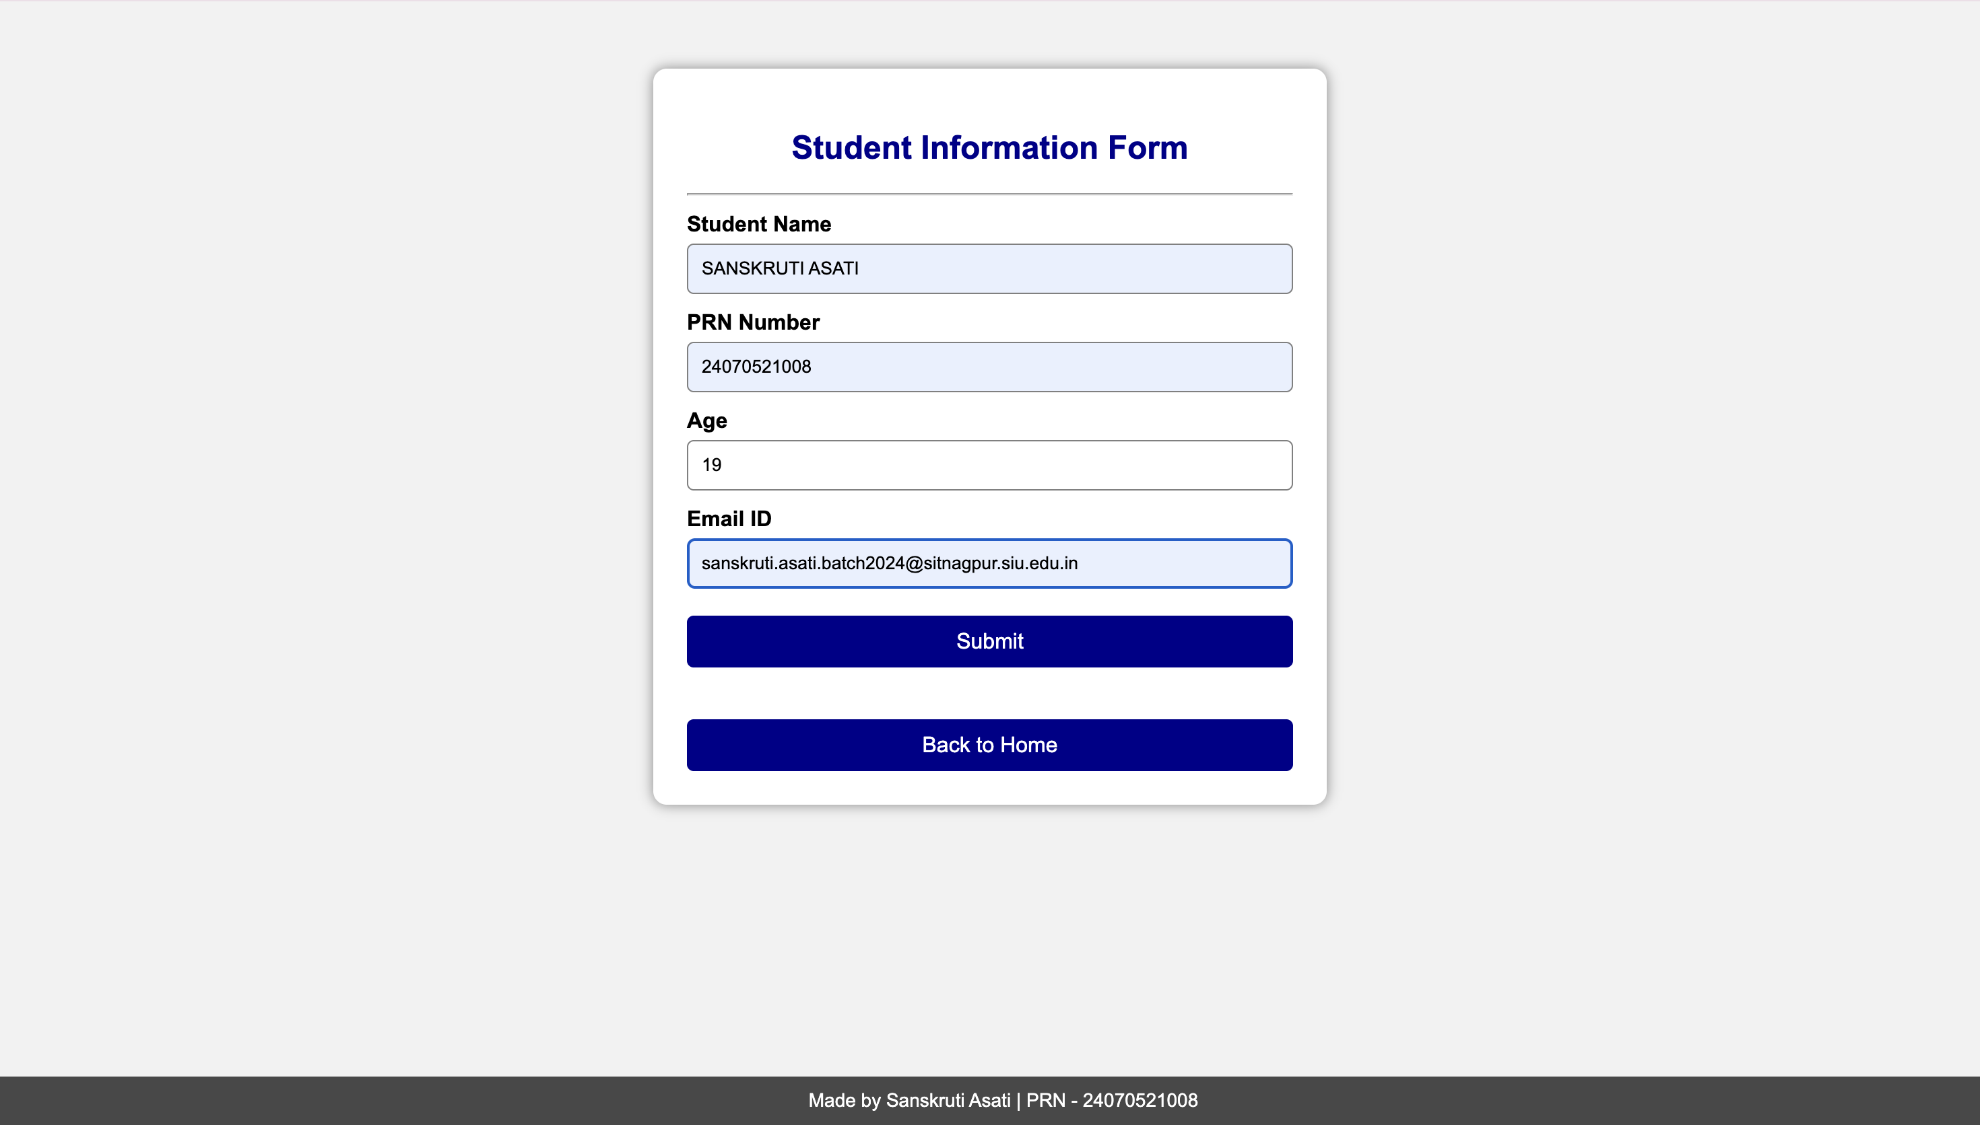

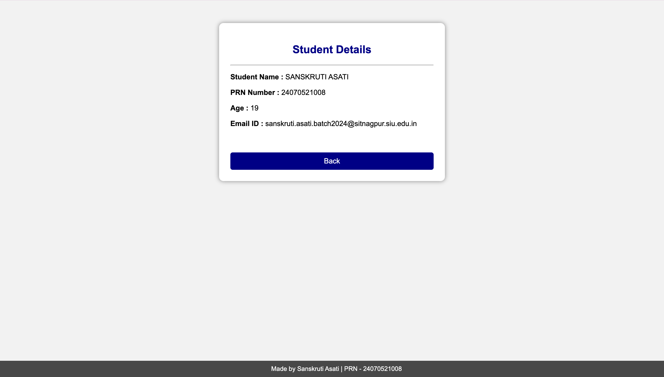
Result/ Conclusion: Thus a working website has been created using HTML, JS and its UI was styled using CSS.

