Case Study No: 2
Experiment Title: Demonstration of basics of JavaScript program.

Case Study Title: Develop the webpage for an online shopping website with using
HTML,CSS and HTML5 tags . And calculate the bill.

Software/ Tools Required: VS Code (text editor), HTML, CSS, JavaScript.

Case Study Program Code:
Index.html
<!DOCTYPE html>
<html lang="en">
<head>
<meta charset="UTF-8">
<meta name="viewport" content="width=device-width, initial-scale=1.0">
<title>My Shopping Store</title>
<link rel="stylesheet" href="style.css">
</head>
<body>
<!-- Header -->
<header>
<h1>🛒 My Shopping Store</h1>
<p>Quality Products At Best Price</p>
</header>
<!-- Customer Details -->
<div class="customer">
<h2>Customer Details</h2>
<input type="text" id="name" placeholder="Enter Customer Name">
<input type="text" id="phone" placeholder="Enter Phone Number">
<input type="text" id="coupon" placeholder="Coupon Code (SAVE10)">
</div>
<!-- Products -->
<div class="products">
<!-- Shoes -->
<div class="card">
<img src="images/shoes.jpg">
<h3>Sports Shoes</h3>
<h2>₹1500</h2>
Qty
<input type="number" id="shoeQty" value="0" min="0">
</div>
<!-- Watch -->
<div class="card">
<img src="images/watch.jpg">
<h3>Smart Watch</h3>
<h2>₹2500</h2>
Qty
<input type="number" id="watchQty" value="0" min="0">
</div>
<!-- Headphones -->
<div class="card">
<img src="images/headphones.jpg">
<h3>Headphones</h3>
<h2>₹1200</h2>
Qty
<input type="number" id="headphoneQty" value="0" min="0">
</div>
<!-- Tshirt -->
<div class="card">
<img src="images/tshirt.jpg">
<h3>T-Shirt</h3>
<h2>₹800</h2>
Qty
<input type="number" id="shirtQty" value="0" min="0">
</div>
<!-- Handbag -->
<div class="card">
<img src="images/handbag.jpg">
<h3>Hand Bag</h3>
<h2>₹2200</h2>
Qty
<input type="number" id="bagQty" value="0" min="0">
</div>
<!-- Sunglasses -->
<div class="card">
<img src="images/sunglasses.jpg">
<h3>Sunglasses</h3>
<h2>₹900</h2>
Qty
<input type="number" id="glassQty" value="0" min="0">
</div>
</div>
<div class="button">
<button onclick="generateBill()">Generate Bill</button>
</div>
<!-- Bill -->
<div id="bill"></div>
<footer>
Made By Sanskruti Asati | PRN - 24070521008
</footer>
<script src="script.js"></script>
</body>
</html>
Style.css-
*{
margin:0;
padding:0;
box-sizing:border-box;
font-family:Arial, sans-serif;
}
body{
background:#f4f6f9;
}
/* Header */
header{
background:#2c3e50;
color:white;
text-align:center;
padding:20px;
}
header p{
margin-top:8px;
}
/* Customer Section */
.customer{
width:80%;
margin:20px auto;
background:white;
padding:20px;
border-radius:10px;
box-shadow:0 0 10px lightgray;
}
.customer h2{
color:#2c3e50;
margin-bottom:15px;
}
.customer input{
width:100%;
padding:10px;
margin-top:10px;
border:1px solid gray;
border-radius:5px;
}
/* Product Cards */
.products{
width:90%;
margin:20px auto;
display:grid;
grid-template-columns:repeat(3,1fr);
gap:20px;
}
.card{
background:white;
padding:15px;
border-radius:10px;
text-align:center;
box-shadow:0 0 10px lightgray;
}
.card:hover{
transform:scale(1.03);
}
.card img{
width:150px;
height:150px;
object-fit:cover;
border-radius:8px;
}
.card h3{
margin-top:10px;
}

.card h2{
color:green;
margin:10px 0;
}
.card input{
width:70px;
padding:6px;
text-align:center;
}
/* Button */
.button{
text-align:center;
margin:30px;
}
.button button{
background:#2c3e50;
color:white;
padding:12px 35px;
border:none;
border-radius:5px;
font-size:18px;
cursor:pointer;
}
.button button:hover{
background:#1b2838;
}
/* Bill */
#bill{
width:80%;
margin:20px auto;
background:white;
padding:20px;
border-radius:10px;
box-shadow:0 0 10px lightgray;
}
/* Footer */
footer{
margin-top:30px;
background:#2c3e50;
color:white;
text-align:center;
padding:15px;
}
Script-
// var
var discount = 0;
// let
let total = 0;
// const
const gst = 0.18;
// Arrow Function
const generateBill = () => {
// Customer Details
let customerName = document.getElementById("name").value;
let phone = document.getElementById("phone").value;
let coupon = document.getElementById("coupon").value;
// Product Prices
const shoes = 1500;
const watch = 2500;
const headphones = 1200;
const tshirt = 800;
const handbag = 2200;
const sunglasses = 900;
// Quantities
let shoeQty = Number(document.getElementById("shoeQty").value);
let watchQty = Number(document.getElementById("watchQty").value);
let headphoneQty = Number(document.getElementById("headphoneQty").value);
let shirtQty = Number(document.getElementById("shirtQty").value);
let bagQty = Number(document.getElementById("bagQty").value);
let glassQty = Number(document.getElementById("glassQty").value);
// Total Amount
total =
(shoeQty * shoes) +
(watchQty * watch) +
(headphoneQty * headphones) +
(shirtQty * tshirt) +
(bagQty * handbag) +
(glassQty * sunglasses);
// Coupon
if (coupon == "SAVE10") {
discount = total * 0.10;
}
else {
discount = 0;
}
let gstAmount = (total - discount) * gst;
let grandTotal = total - discount + gstAmount;
// Object
const customer = {
customerName,
phone
};
// Destructuring
const { customerName: name, phone: mobile } = customer;
// Template Literal
document.getElementById("bill").innerHTML = `
<h2 align="center">Shopping Bill</h2>
<hr>
<p><b>Customer Name :</b> ${name}</p>
<p><b>Phone Number :</b> ${mobile}</p>
<hr>
<table border="1" width="100%" cellpadding="8">
<tr>
<th>Product</th>
<th>Quantity</th>
<th>Price</th>
</tr>
<tr>
<td>Sports Shoes</td>
<td>${shoeQty}</td>
<td>₹${shoeQty * shoes}</td>
</tr>
<tr>
<td>Smart Watch</td>
<td>${watchQty}</td>
<td>₹${watchQty * watch}</td>
</tr>
<tr>
<td>Headphones</td>
<td>${headphoneQty}</td>
<td>₹${headphoneQty * headphones}</td>
</tr>
<tr>
<td>T-Shirt</td>
<td>${shirtQty}</td>
<td>₹${shirtQty * tshirt}</td>
</tr>

<tr>
<td>Hand Bag</td>
<td>${bagQty}</td>
<td>₹${bagQty * handbag}</td>
</tr>
<tr>
<td>Sunglasses</td>
<td>${glassQty}</td>
<td>₹${glassQty * sunglasses}</td>
</tr>
</table>
<br>
<h3>Subtotal : ₹${total}</h3>
<h3>Discount : ₹${discount}</h3>
<h3>GST (18%) : ₹${gstAmount.toFixed(2)}</h3>
<h2>Grand Total : ₹${grandTotal.toFixed(2)}</h2>
<hr>
<h3 align="center">Thank You For Shopping ❤️</h3>
}

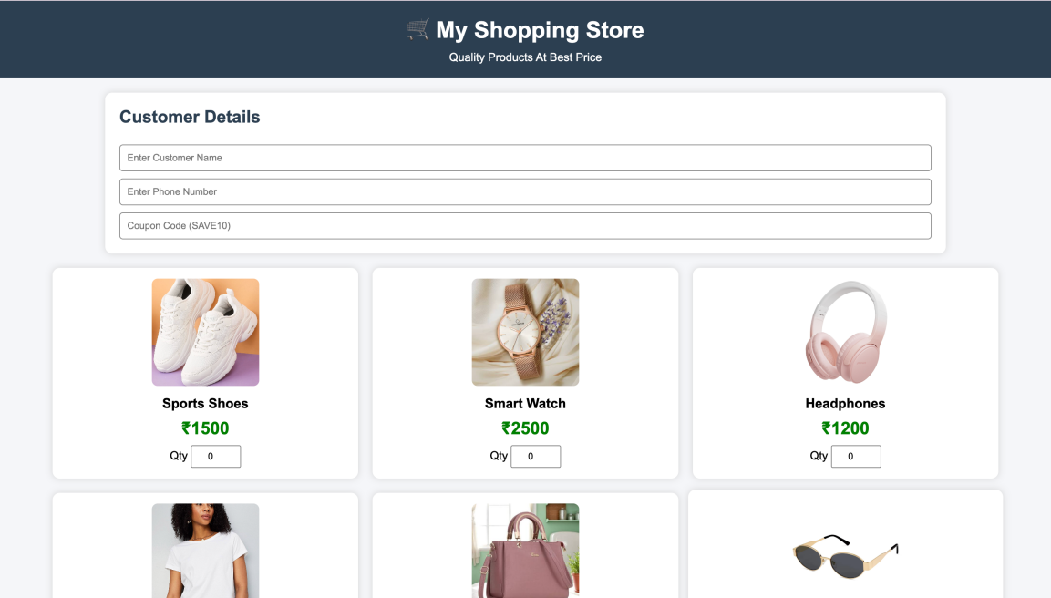

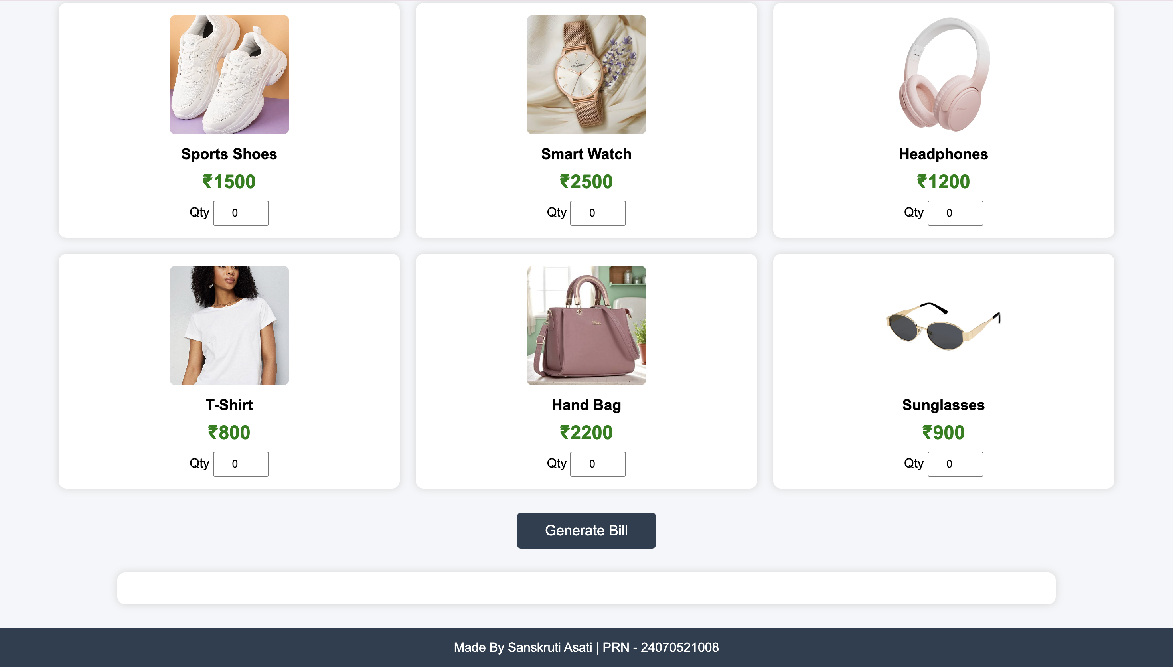
Result/ Conclusion: Thus a working website has been created using HTML, HTML5
tags, and its UI was styled using CSS.

