**Master’s Degree in Computer Science**

**Academic year 2023/2024**

**RoomFinder**

A report for the Mobile Programming and

Multimedia Project

|  |  |
| --- | --- |
| Authors | Student ID |
| Michael Amista’ | 2122865 |
| Sebastiano Sanson | 2130917 |

**Index of contents**

1 The project 4

1.1 Mobile app 4

1.2 Users segment 4

2 Mobile Design 5

2.1 Mockups 5

2.1.1 Nonregistered user 5

2.1.2 Registered user (Student) 10

2.1.3 Registered user (Host) 13

**Disclaimer**

*Note on Gender Language*

This document uses the masculine pronoun ("he") to refer to people of all genders. This is done for readability purposes only, and to avoid the constant use of "he/she" or other gender-neutral constructions. Please be assured that the content applies equally to all genders.

# **1 The project**

This project has been developed for the Mobile Programming and Multimedia course and it consists in the development of a mobile application using a cross-platform development approach to optimize the writing of the code for both Android and iOS platforms.

This section presents the idea of the mobile app, considering the contribute it can bring through people, and the kind of users who can retain the developed app a useful and effective tool for their daily life.

## **1.1 Mobile app**

Students who want to move to another city for study reasons should have the possibility to examine in a simple way all the rental proposals of the city without making a lot of calls or passing through a lot of rental agencies. This represents something that is missing in the largest Italian cities and that is the reason behind the idea of the chosen application.

The original idea of **RoomFinder** was to develop an app that allows the Italian student community, composed by both national and international students, to easily review all the rental proposals of the various accommodations scattered around the city of studies. The user can examine the various proposals by comparing prices, location and using all the other metrics offered by the app and useful for a particular facility of interest. A further important aspect is the possibility of being able to consult the possible roommates already present through a short description which will inform the user, who is carrying out the search, about the kind of persons he will meet choosing that facility. It is also possible to engage in a chat with the host of the facility of interest with the aim of exchanging useful information for both parties.

## **1.2 Users segment**

The application represents a useful tool for multiple kinds of users. In fact, RoomFinder is not only a useful tool for students who are looking for an accommodation but even for private hosts who want to make available their spaces. RoomFinder represents also an effective solution for international students who can encounter difficulties in interacting with people who only talk Italian. In fact, the application is available in both Italian and English version to increase RoomFinder’s users segment.

In RoomFinder there are three types of users:

1. **Nonregistered users**: visitors that are not subscribed to RoomFinder. This kind of user can view all the rental proposals present in the system but to access to further features the subscription is necessary.
2. **Registered users**: registered students who are looking for an available and affordable facility. This kind of user can view all the rental proposals present in the system and he can access to further features that can power up his/her user experience. Some of these features are the possibility to save ads, chat with a host to request more information and view the roommates’ details for a facility of interest.
3. **Registered Hosts**: registered owners of facilities present in the system. This kind of user can add new ads in the system and/or manages ads already added. Hosts can also respond to requests of information from students via a chat system.

# **2 Mobile Design**

The main RoomFinder pages have been designed using Figma tool. That tool allowed us to easily design pages, considering the mobile design principles seen during lessons, rather than directly code the pages.

The mockups and all the mobile design choices are discussed in this section.

## **2.1 Mockups**

Before starting to design the mockups we had to decide the color palette for the application. Considering that colour theory is a complex theme that interacts also with emotional design and cultures, we decided to make deeper research before choosing the main color and its variations for the palette. What we have found is that **color** **blue** conveys trust, calmness, professionalism, and inclusivity, all of which are crucial for an app aimed at helping students find reliable accommodations in a new city. The emotional comfort and broad appeal of blue can significantly enhance user experience, making the app a trusted and preferred tool for our users segment. This guided us to the choice of a blue palette for the entire application.

After that we produced different mockups for the main pages of RoomFinder, dividing them based on the type of user who is using the app. All the pages respect the just-in-time principle, showing only the elements that are necessary for that page. Furthermore, all the pages try to reduce the number of user interactions without having crowded layouts and respecting the “content always on top” principle.

### **2.1.1 Nonregistered user**

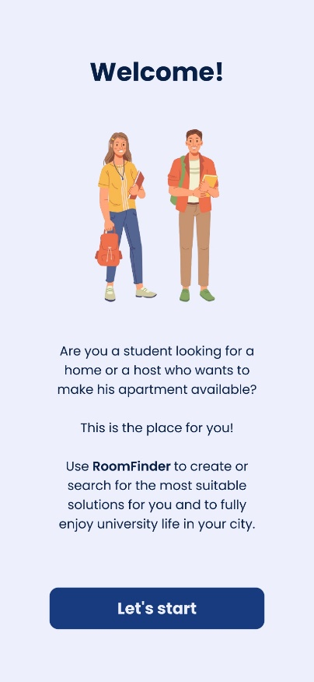**FIRST VISIT**

This page is the first one every user will see the first time he runs RoomFinder. The idea is to transmit a message to capture the user curiosity through the **humanization**, involving the user through a humanized figure that represents happiness, calmness and trust of students like him that found their stability using RoomFinder.

Furthermore, there is a written message that encourages students and hosts to use and be part of the RoomFinder network.

At the end the user, if he is convinced, is ready to start the experience through a tap on “*Let’s start*” button which redirects the user to the rental proposals search page, the homepage of RoomFinder, where, ideally, a short tutorial on how to use the app is shown.

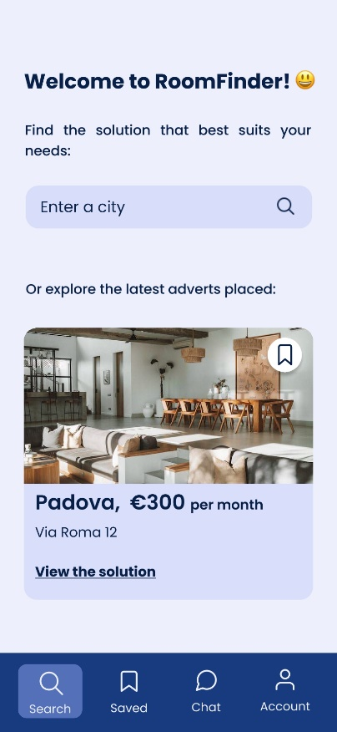**RENTAL PROPOSALS SEARCH**

After watching the short tutorial on how to use the app, the user lands on the rental proposals page, the homepage of RoomFinder, where he can search offers for a particular city of interests or explore some of the latest inserted adverts. The layout of the page is simple and gives to the user all the information and instructions it needs to begin the experience in RoomFinder. The above part of the page allows users to search for facilities located in the digited city and the rest of the page is dedicated to show to users some of the latest ads. Users can view more details for a single insertion by tapping anywhere inside the facility box or more intuitively by tapping on “*View the solution*”. Furthermore, it is even possible to save insertions of interest by tapping on the top right corner button of each insertion box. This functionality is reserved to only registered users, but the idea is to show to the user all he can do in the application and then, when he tries to use a functionality that requires a RoomFinder account, redirect him to the login page (discussed later in the document) explaining him why.

The content of the page is easily reachable reducing the user effort. The bottom bar provides the access to all other main pages of the application, even if some of them (as saved ads, chat or account) are available only for registered users. Anyway, when the user tries to use some of these functionalities is automatically redirected to the login page that explains why the user is landed there.

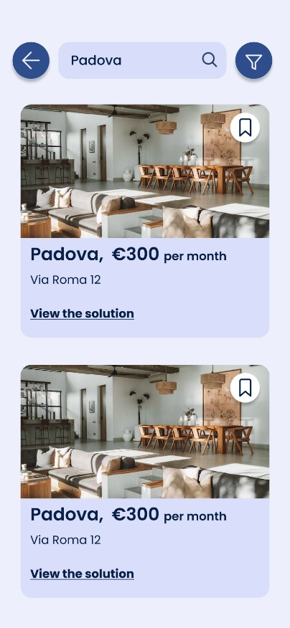**SEARCH RESULTS**

This page contains the results, so all the rental proposals, for the city searched by the user through the search functionality present in the previous page (rental proposals search). The results are presented as a list of items of the same form seen for the previous page and so with the same already discussed modalities to open or save them.

To decrease the number of user interactions the search bar has been placed even in this page for further user searches. In this way, if the user wants to search the proposals of another city, he can simply enter the new city in the search bar placed in the top area of the page to avoid wrong taps.

It is also possible to close the page, returning so to the rental proposals search page, by using the back button placed on the left corner, again to avoid wrong taps by users.

Therefore, since the results for the searched city can be a lot, the user can filter them using a filter menu that appears through a tap on the top right icon.

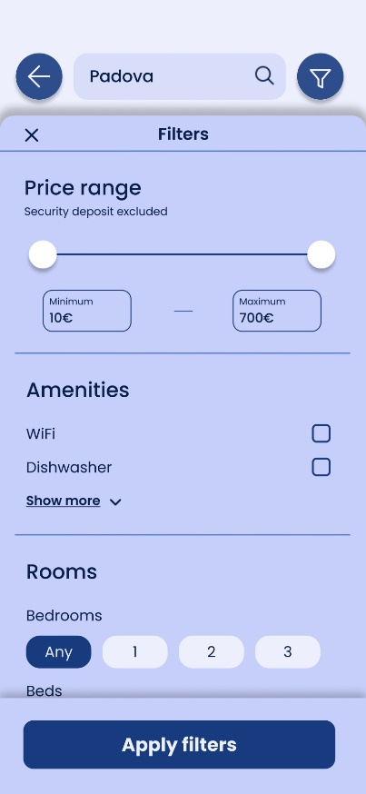**SEARCH RESULTS – FILTER MENU**

As mentioned before, the filter menu allows users to filter the search results to match their preferences for the different proposals in the system.

This menu contains several voices that can be used to search the rental proposals that match what user is looking for. At the end of the panel there is a confirmation floating trigger button to search for the customized results.

The panel can be closed in three ways, by tapping on the top left “*X*”, tapping outside the panel itself or using a flick gesture with a movement that starts from the top area (approximately from the “*Filters*” voice) to the bottom of the screen. This gesture will be taught when the user tries to use the panel for the first time.

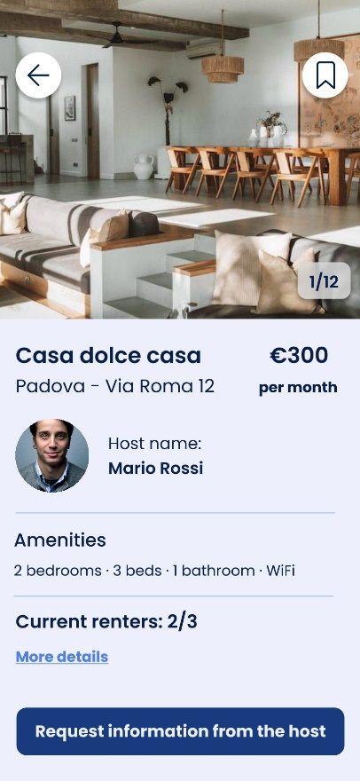**DETAILED PAGE FOR A FACILITY**

This page represents a detailed page for a facility present in the system and on which user tapped during its navigation. The page contains all the information needed to better understand what the facility offers.

In the top area we have a slider which shows some photos of the room. In general, it is true that sliders should be avoided if possible because they cause the loss of the user’s overall vision. In this case the user has full control over the slider, without the problem of annoying timers that update continuously the slide. Furthermore, the user can expect what comes next since it a simple slider of the facility photo. Users can move on and back the slides with a simple natural gesture from the left or right depending on the movement they want to do. This gesture is taught with a tutorial. Furthermore, in every moment user knows at which point of the slider he is thanks to the numbered label on the right side. In the top area there are also two other buttons, a back button on the left and another button on the right to save the insertion.

In the page there is even the possibility to open a detailed page about the current renters already present in the facility, but this is a functionality available only for registered users, so when a user taps on “*More details*”, as before, will be redirected to the login page. At the end it is possible to request further information, regarding the facility, directly sending a message to the host through the floating trigger button “*Request information from the host*” placed in the bottom part of the screen.

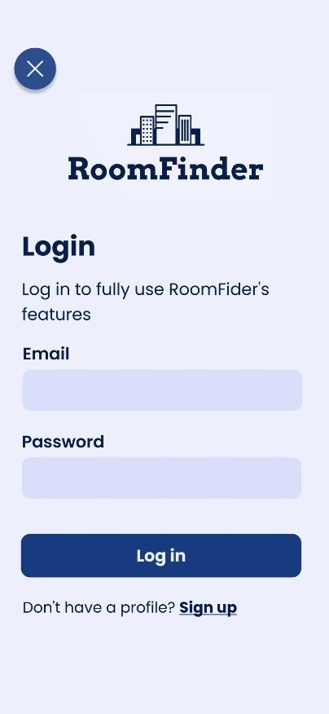**LOGIN**

This page offers the possibility to access to the RoomFinder account. Users can be also redirected to this page when they try to use a functionality not available for non-authenticated users. In this case, since the user is automatically redirected here, the page provides an explanation about the necessity to have an account to use all the functionalities that RoomFinder offers.

The page is simple, and it provides a standard form to authenticate users by an email and a password. The labels for both inputs have been placed above the input to avoid that users hide them unintentionally during digiting the input.

If the user has not a profile it is possible to access to the registration page tapping on “*Sign up*” voice.

To avoid mistake by the user in the comfort zone, the “*cancel*” button, useful to close the login page and to return where the user was, has been placed in the top left corner.

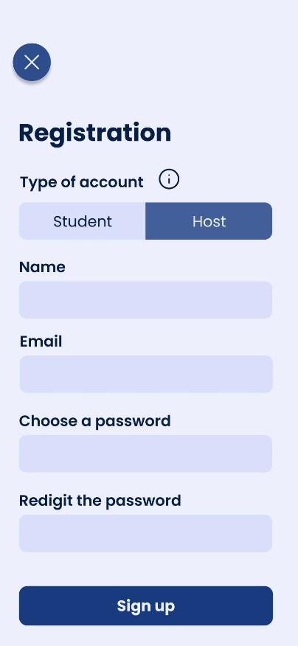**REGISTRATION**

To create a new account every user can pass through the registration page. The layout of this page is pretty much the same of the login one, so all the considerations discussed for the login page are still valid here.

The only thing that changes is the form field “*Type of account*” which is related to the purpose for which the user is creating a new account, so to be a student who is searching for a house or a host who want to publish ads. The user has to select one of the two kinds of account by tapping on the label “*Student*” or “*Host*”. To make everything clear an info button, placed near that field, allows to obtain more information about the different types of account, ideally opening a pop-up that can be closed after everything is clear.

Talking again about the “*Type of account*” button, there is a preselected option which is highlighted with a darker color, different from all the other uncomplete form fields in the page, to indicate the chosen option. This is quite intuitive because the difference of color compared to the other fields in the page can suggest which is the current chosen option. This implementation choice is even explained tapping on the info button, previously discussed.

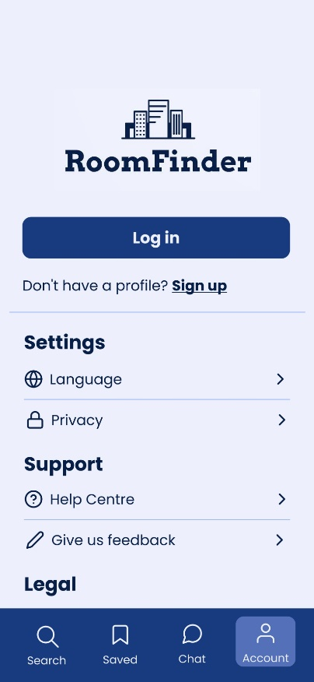**ACCOUNT**

The page contains both account and app settings. It is possible to login to RoomFinder or manages the app preferences such as the language.

The layout of the page is simple, intuitive and it tries to contain the basic elements for account and system settings present in every real application. In particular the language setting is fundamental since the users segment are both Italian and international students.

All the above pages are available for both registered and nonregistered users so, if those pages do not present layout or content changes depending on the type of user who is using the app, they will not be discussed anymore to avoid redundant explanations.

### **2.1.2 Registered user (Student)**

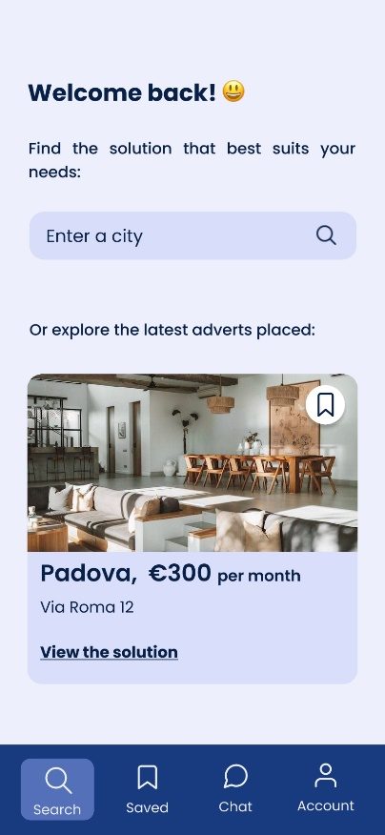**RENTAL PROPOSALS SEARCH**

The rental proposals search page is identical to the counterpart available for nonregistered users, so all the considerations made for that page are still valid for this version. The only element that changes in the content is the “*Welcome back!*” message and no more “*Welcome to RoomFinder*” that was used only as a nice message for new users.

Even the bottom menu bar is the same with the only difference that now, since the user logged in, all the RoomFinder pages and functionalities are available.

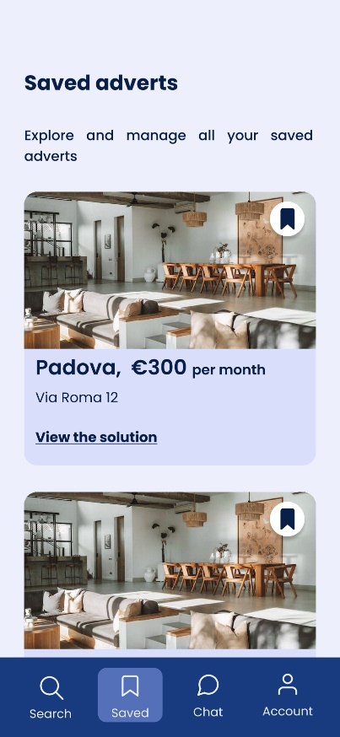**SAVED ADVERTS**

This page contains all the rental proposals saved by the user during its navigation. As mentioned before, the proposals can be saved by tapping on the save icon present on the specific proposal result or in its detailed page. Users can also remove the saved proposals by tapping on the same icon used to initially save them. The icon changes its look depending on if it can be saved or it has been already saved by replacing a void bookmark icon with a filled bookmark icon respectively. For us this approach is natural and effective, thinking also on what happens in social media apps, like Instagram, when the user put or remove a like on a post.

Since the appearance of the results list is the standard one used among all RoomFinder pages, the single saved proposal can be opened, with same modalities already discussed, to view the detailed page, again by tapping on the whole box of a single proposal or, more intuitively, tapping on the “*View the solution*” voice.

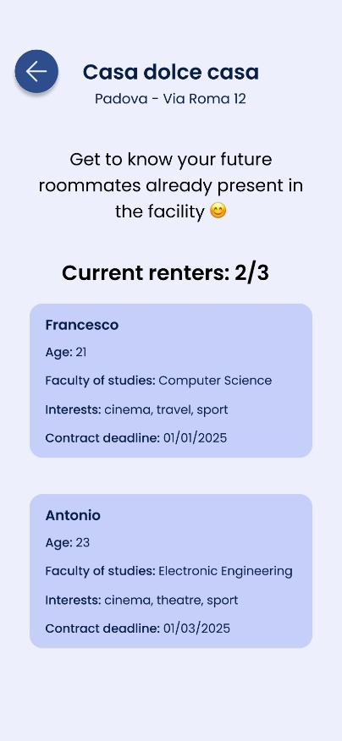**CURRENT RENTERS**

In the detailed page for a facility, it is possible to get more information about the current renters. Only registered users are allowed to open this page.

The content is simple, and it provides a way to know better the future roommates with the user will live if he chooses that facility. Every roommate is represented by a box containing some general information about him.

It is possible to go back to detailed page of the relative facility by tapping on the left button, near which a general summary of the facility has been placed to remember user where it was before landing on this page.

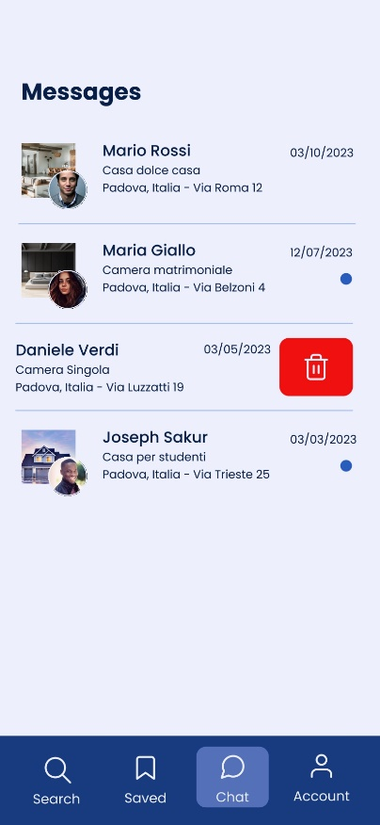**CHAT**

This page allows to manage all the messages to hosts. Messages are grouped in different chats, each one representing the request made for a specific rental proposal. New messages are highlighted by a blue circle on the right area of each chat.

It is even possible to delete old chats with a flick gesture on the specific element, starting the movement from the right to the left area of the chat itself. This gesture does not require high precision and we think that after a while it can become a sort of reflex for the user, decreasing so the required effort. This is due also to the fact that similar gestures are already used in other common application (for instance Gmail) to delete messages, so this implementation is really similar to something that users could have already seen or experimented in other scenarios. As discussed before for other gestures, this one is taught the first time the user lands on the chat page.

Then, tapping on one chat, more precisely on the whole horizontal area occupied by each element, it is possible to view every message sent to request information about a specific rental proposal.

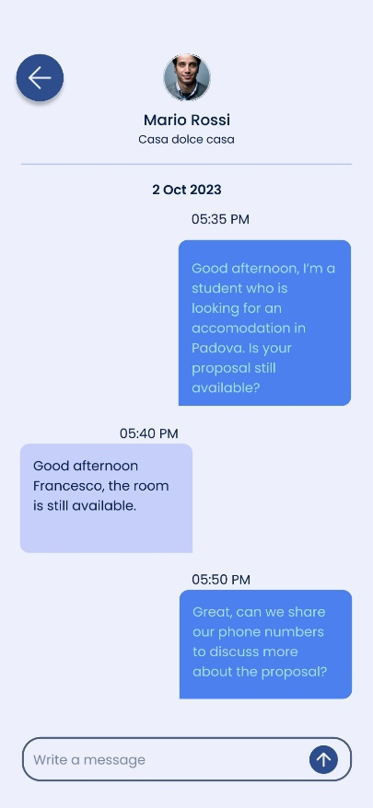**DETAILED PAGE FOR A CHAT**

The page represents the whole history of messages sent to a host regarding a facility of interest. The layout of the page is really similar to every chat application present in the market. On the right it is possible to find the student messages and on the left the host ones. It is possible to write and send a new message using the input text field on the bottom of the page.

In the top part of the page there is a short summary of the rental proposal for which the student is writing.

It is possible to go back to the chat page using the top left button.

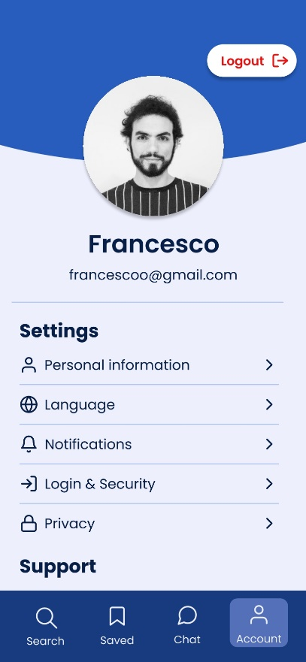**ACCOUNT**

This page allows users to view and manage their profile information. It is also possible to customize the app experience by some general settings, as discussed before for the counterpart available for nonregistered users. It is also possible to logout using the top right button which has been placed outside the comfort zone to avoid mistakes by user even if a confirmation dialog to complete the operation is however shown.

### **2.1.3 Registered user (Host)**

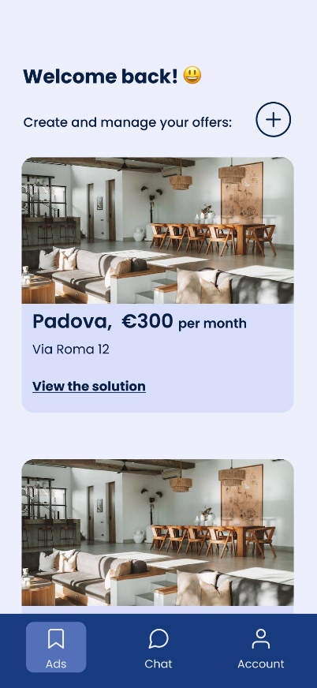**RENTAL PROPOSALS MANAGEMENT**

This page represents the first page that a registered host sees when he starts RoomFinder. This page allows to create and manage rental proposals that can be viewed by students who want to search for an accommodation.

The overall layout is really similar to other pages previously discussed. The host can view the whole list of his/her proposals and can add new ones by tapping on the “+” button placed on the top right area. The user can also view in detail each proposal that appears in the list tapping on the whole item box or, more intuitively, tapping on the label “*View the solution*”.

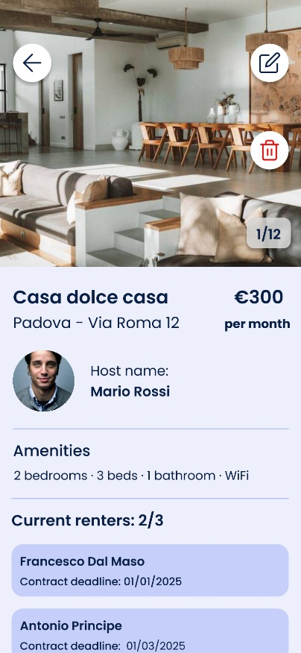**DETAILED PAGE FOR A FACILITY**

The detailed page is pretty identical to the counterpart available for other kinds of user with just a few differences. The host has two more features represented by the two buttons placed in the top right area which allow respectively to edit the proposal or to delete the proposal. Since both buttons allow to modify the page content, they have been placed outside the comfort zone to avoid wrong taps by user. Anyway, even in this case, the delete option opens a confirmation dialog that requires the user confirmation before proceeding with the elimination.

Since the chat and the account pages are the identical to the counterparts available for a registered student, they are not discussed again to avoid redundant explanations.

**PAGES FOR ADD/EDIT RENTAL PROPOSALS**

These standardized screens, employed throughout the rental proposal creation/modification process, feature consistent navigational elements:

* **Back Button**: Allows the user to return to the previous step in the workflow, it is positioned in the top-left corner of the screens, outside the comfort-zone;
* **Next Button**: Enables progression to the subsequent stage;
* **Progress Indicator**: Visually communicates the user's current position within the multi-step process, mitigating potential disorientation.

These persistent components enhance usability by providing a clear, intuitive path through the creation/modification journey.

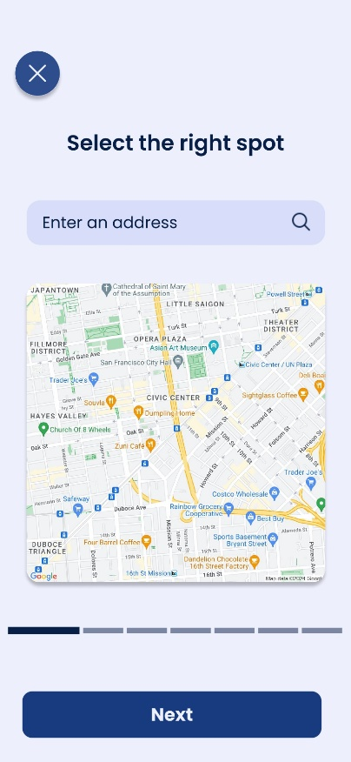**ADD/EDIT RENTAL PROPOSAL – PAGE 1**

This initial screen in the rental proposal creation/modification workflow allows users to pinpoint the accommodation's address. This can be achieved by either:

* **Direct Input**: Manually typing the address into the search bar.
* **Map Interaction**: Navigating and selecting the location on the embedded map.

The initial screen in the process deviates slightly, incorporating a "Cancel" button that allows the user to terminate the wizard workflow entirely. This provides an emergency exit, ensuring users are not locked into the process if they wish to abandon their changes.

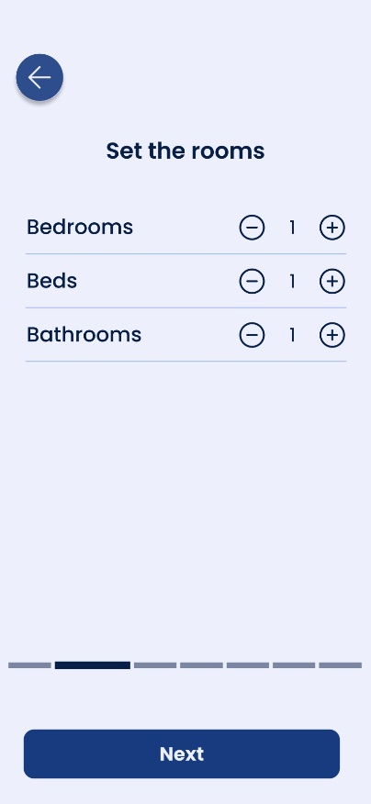**ADD/EDIT RENTAL PROPOSAL – PAGE 2**

The "Set the Rooms" screen, appearing as the second step in the workflow, streamlines the process of defining the accommodation's capacity. Users can easily indicate the quantity of bedrooms, beds, and bathrooms using intuitive plus/minus buttons, which increment or decrement the values for each category.

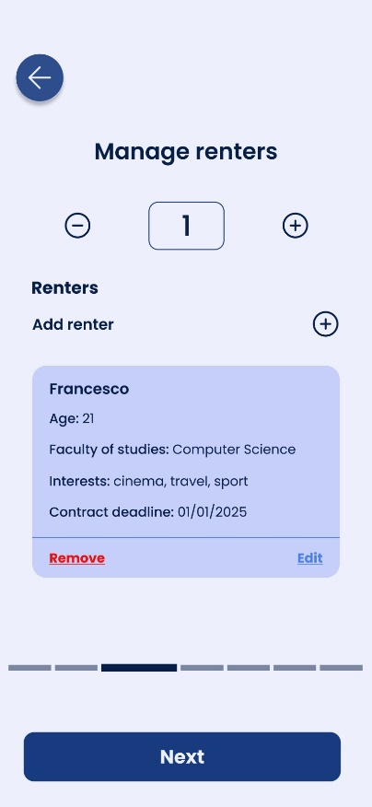**ADD/EDIT RENTAL PROPOSAL – PAGE 3**

The "Manage Renters" screen serves multiple purposes:

* **Maximum Guests**: A field allows users to specify the total number of guests allowed for the accommodation.
* **Add Renter**:Strategically positioned above the renter list, a "+" button provides a convenient way to add new renters to the proposal. This placement eliminates the need for users to scroll down the list to add entries. Basic renter information is collected at this stage, with more comprehensive details captured on the subsequent screen.
* **Edit/Remove Renter**:Each renter entry in the list includes options to either edit the associated information or remove the renter entirely. This inline functionality streamlines the modification process and eliminates the need for users to restart the wizard to make adjustments.

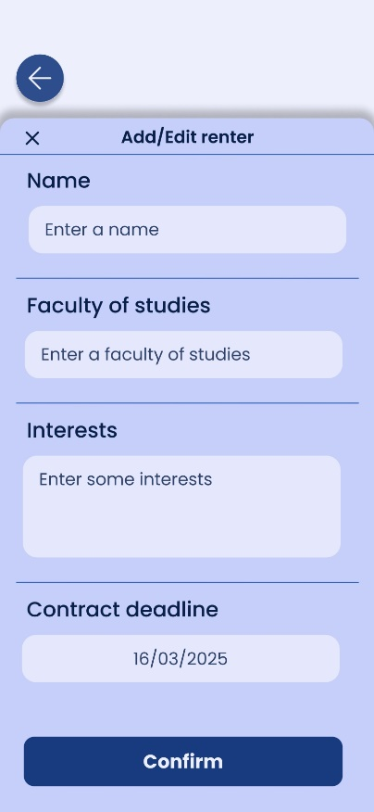**ADD/EDIT RENTAL PROPOSAL – PAGE 3 (ADDING/EDIT RENTERS PANEL)**

The "Add/Edit Renter" popup, triggered by the corresponding buttons on the "Manage Renters" screen, emerges from the button's location to ensure optimal interaction. This popup facilitates the input of detailed renter information, comprising:

* **Name**: The renter's full name.
* **Faculty of studies**: The renter's faculty of studies.
* **Interests**: The renter's interests.
* **Contract deadline**: The renter's contract deadline.

By originating from the button itself, the popup minimizes the need for users to shift their attention or make extensive movements on the screen. This strategic design fosters a seamless and efficient workflow when adding or modifying renter details.

Furthermore, the "Contract Deadline" field, providing flexibility in date entry:

* **Manual Input**: Users can directly type the contract deadline date into the field.
* **Calendar Widget**: Clicking on the field opens a calendar widget, allowing users to visually select the desired date.

This dual approach caters to different user preferences, accommodating both those who prefer manual entry and those who find a visual calendar more intuitive.

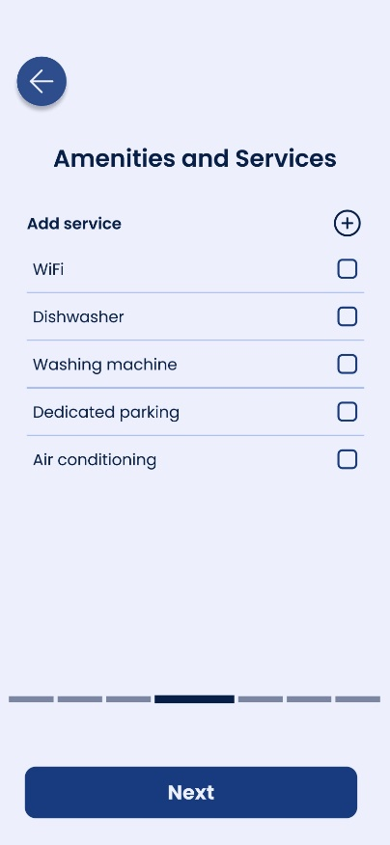**ADD/EDIT RENTAL PROPOSAL – PAGE 4**

The "Amenities and Services" screen empowers users to curate the accommodation's offerings:

* **Amenity Selection**: Users can choose from a predefined list of amenities to indicate those available at the property.
* **Add Service**: Conveniently located above the amenities list, the "Add Service" button facilitates the creation of custom services not included in the standard options. This strategic placement eliminates unnecessary scrolling for users.

By combining pre-populated choices with the option to add personalized services, this screen ensures a comprehensive representation of the accommodation's features and offerings.

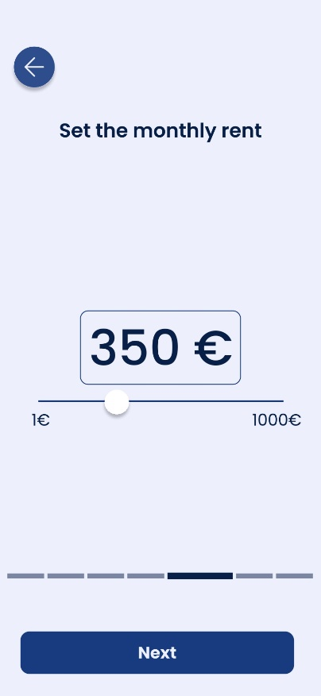**ADD/EDIT RENTAL PROPOSAL – PAGE 5**

The "Set the monthly rent" screen simplifies the process of defining the accommodation's rental cost. A slider component provides an intuitive mechanism for users to select the desired monthly rent amount. The slider's range and incremental values allow for precise adjustments, ensuring accurate representation of the rental price.

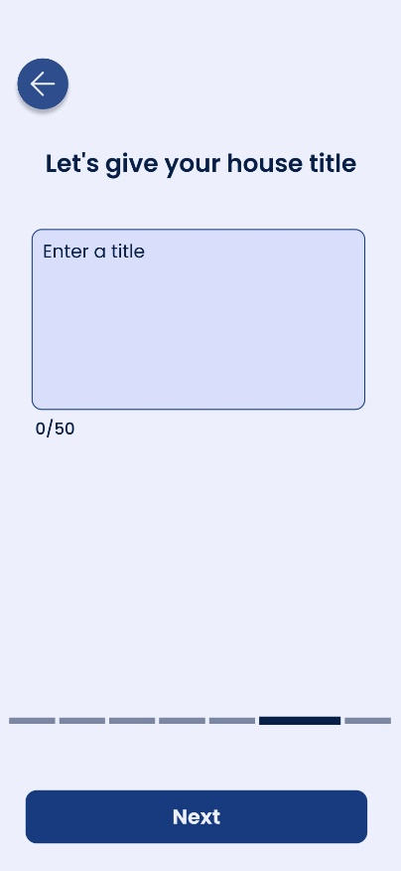**ADD/EDIT RENTAL PROPOSAL – PAGE 6**

The "Let’s give your house title" screen presents a text field where users can input a descriptive and engaging title for their rental listing. This title plays a crucial role in attracting potential renters and summarizing the key features of the accommodation.

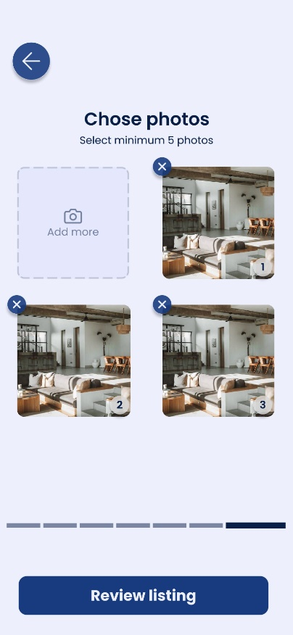**ADD/EDIT RENTAL PROPOSAL – PAGE 7**

The "Chose Photos" screen facilitates the selection and management of accommodation visuals:

* **Add Photo Button:** Strategically positioned above the photo grid, this button enables users to easily add new images to the listing without needing to scroll.
* **Photo Grid:** Uploaded photos are displayed in a grid format, each marked with a number indicating their display order.
* **Remove Photo:** A dedicated button on the top-left corner of each photo allows for individual photo removal,offering flexibility in image curation.
* **Review Listing:** Unlike previous screens, this screen features a "Review Listing" button at the bottom, providing direct access to the final review stage for a comprehensive overview before submission.

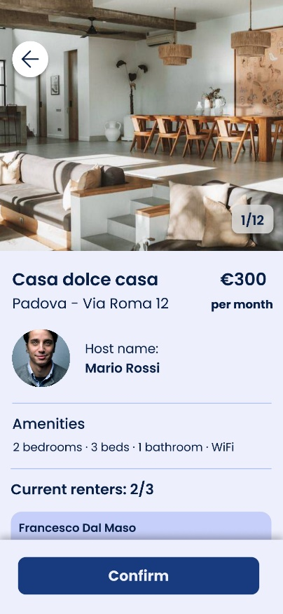**ADD/EDIT RENTAL PROPOSAL – PAGE 8**

The final screen provides a comprehensive overview of the accommodation details entered throughout the wizard process. This step allows users to verify the accuracy of the information, including the address, room configuration, guest capacity, amenities, monthly rent, listing title, and uploaded photos. This final check ensures that the listing is complete and ready for publication, minimizing the risk of errors or omissions.