QSTCS: A QUANTUM-SAFE TACTICAL COMMUNICATION SYSTEM WITH QBER-DRIVEN ADAPTIVE NETWORK ESCALATION
¹st P Rayavel  Department of CSE(Cyber Security)  Sri Sai Ram Institute of Technology  hodsc@sairamit.edu.in | ²nd Akash Santhnu Sundar  Department of CSE(Cyber Security)  Sri Sai Ram Institute of Technology  sit23sc014@sairamtap.edu.in | ³rd Gokul D  Department of CSE(Cyber Security)  Sri Sai Ram Institute of Technology  sit23sc035@sairamtap.edu.in
⁴th Matheshwaran V  Department of CSE(Cyber Security)  Sri Sai Ram Institute of Technology  sit23sc024@sairamtap.edu.in | ⁵th Kavirajan K  Department of CSE(Cyber Security)  Sri Sai Ram Institute of Technology  sit23sc047@sairamtap.edu.in

Abstract—Traditional battlefield networks rely on RSA and ECDH for key exchange — protocols that will be broken by quantum computers within the decade. Beyond post-quantum vulnerability, classical encryption cannot detect passive eavesdropping: an interceptor leaves no fingerprint unless packets are actively disturbed. This paper describes the Quantum-Safe Tactical Communication System (QSTCS), which addresses both problems by grounding all security decisions in quantum physics rather than computational assumptions. QSTCS integrates a BB84 Quantum Key Distribution engine simulated with Qiskit, AES-256-GCM authenticated encryption with HKDF-SHA256 key derivation, and a four-level adaptive network escalation protocol driven exclusively by the Quantum Bit Error Rate (QBER). A measured QBER at or above 11% constitutes information-theoretic proof of channel interception. The system responds deterministically: port rotation across seven ports (1919–1925), IP failover between 192.168.1.1 and 192.168.1.50, physical interface switching from eth0 to wlan0 with subnet migration, and full emergency lockdown when all paths are compromised. Validation on a local testbed using a D-Link DSL-2750U router running OpenWrt demonstrated detection latency below 200 ms and a false-positive rate under 2%, against a 12% false-positive rate for a classical TLS/Snort baseline.
Keywords: Quantum Key Distribution, BB84 Protocol, Quantum Bit Error Rate, Tactical Communications, AES-256-GCM, Adaptive Network Escalation, Post-Quantum Security, Defence Networks

I. INTRODUCTION
Tactical communication networks have grown substantially more complex over the past two decades. The shift toward software-defined radios, IP-based routing, and mesh architectures has created richer operational capability but has simultaneously widened the attack surface that adversaries can exploit. At the cryptographic layer, virtually every deployed system — from encrypted radio links to command-and-control channels — relies on public-key exchange protocols such as RSA-2048 or Elliptic Curve Diffie-Hellman. These schemes are computationally secure today, but their security rests entirely on the assumption that certain mathematical problems are intractable. That assumption breaks down the moment a fault-tolerant quantum computer running Shor's algorithm becomes available [1][2].
The timeline for cryptographically relevant quantum computers is variously estimated at between five and fifteen years. For communications that must remain confidential for longer than that window, the threat is already active: adversaries collecting encrypted traffic today intend to decrypt it later. Sensitive diplomatic, intelligence, or operational traffic recorded now may be fully readable in a decade, regardless of how strong the encryption appears by current standards [2].
A separate and immediate problem is that classical cryptography cannot detect passive eavesdropping. An adversary who intercepts and copies ciphertext without modifying it leaves no trace in the network. Intrusion detection systems identify anomalies in traffic behaviour, but these are probabilistic heuristics that generate both false positives and false negatives. The gap between "this traffic looks suspicious" and "we know with certainty that the channel has been intercepted" is the precise gap that quantum key distribution closes.
The BB84 protocol [3], proposed by Bennett and Brassard in 1984, exploits a consequence of quantum mechanics: any measurement of a quantum state disturbs that state. An eavesdropper intercepting photons must measure them to extract information, and those measurements introduce detectable errors into the key agreement process. The resulting Quantum Bit Error Rate rise is not a statistical inference — it is a direct physical effect, information-theoretically guaranteed by the no-cloning theorem [4]. A QBER reading at or above 11% is cryptographic proof of interception, not a heuristic alarm.
This paper presents QSTCS, a tactical communication system that integrates a software-simulated BB84 QKD engine with AES-256-GCM message encryption and a four-level network escalation protocol triggered exclusively by QBER. The escalation sequence — port rotation, IP failover, physical interface switching, and emergency lockdown — is deterministic: each level is entered because physics demands it, not because a rule engine has guessed that something looks wrong.
II. LITERATURE SURVEY
The theoretical foundation of QSTCS lies in Bennett and Brassard's 1984 protocol [3], which established that two parties can agree on a shared secret key over an insecure channel with security guaranteed by physical law rather than computational difficulty. Mayers [7] later provided rigorous information-theoretic proofs of BB84's unconditional security and derived the 11% QBER abort threshold that QSTCS adopts. This threshold ensures that below it, sufficient secret key can still be extracted through privacy amplification even if an eavesdropper obtained partial information.
The post-quantum urgency motivating this work was crystallised by Shor's 1994 result [1], demonstrating polynomial-time quantum factorisation, and by Mosca's risk analysis [2], which framed the harvest-now-decrypt-later threat in operational terms. Bernstein and Lange [9] surveyed the landscape of post-quantum mathematical alternatives, and NIST's subsequent standardisation process [10] produced lattice-based schemes such as CRYSTALS-Kyber. These schemes resist quantum cryptanalysis but share a fundamental limitation with all classical key exchange: they provide no mechanism for detecting eavesdroppers.
On the hardware side, Jouguet et al. [8] demonstrated continuous-variable QKD over metropolitan-scale distances, and ID Quantique's commercial Clavis platform [13] has deployed QKD in banking and government networks. Braunstein and van Loock [14] provided the theoretical treatment of continuous-variable quantum information that underpins these systems. Edge computing deployment patterns discussed by Shi et al. [12] inform the KMS architecture used in QSTCS. The contribution of the present work is to bridge the gap between QKD research and practical tactical deployment by combining a software-defined BB84 engine with a novel multi-level escalation protocol that converts quantum sensing data into deterministic, graduated network security responses.
III. SYSTEM ARCHITECTURE
QSTCS is organised as three interdependent subsystems — the Quantum Engine, the Key Management Service (KMS), and the Field Device Layer — operating over a tactical network testbed that functions as a deliberate untrusted relay. Security in QSTCS terminates at field devices and the KMS, not at the network. The gateway has access only to ciphertext and carries no key material. System specifications are given in Table I.
TABLE I
System Specifications and Configuration
Component | Specification | Justification
CPU / GPU | i7-12700 / RTX 3060 12 GB | Qiskit Aer simulation capacity
RAM | 32 GB DDR4 | Full BB84 run + KMS state in memory
OS / Stack | Ubuntu 22.04, Python 3.10, Qiskit 0.45 | Stable LTS; Aer depolarising noise
Dashboard | Streamlit 1.32, WebSocket | Real-time QBER display, SOC view
Gateway | D-Link DSL-2750U (OpenWrt) | Untrusted relay with tc/netem rules
Endpoints | 2× Laptop, LAN + WLAN NICs | Soldier_A and Soldier_B clients
KMS | Mini-PC, FastAPI :8000 | BB84 engine + escalation FSM
Encryption | AES-256-GCM + HKDF-SHA256 | Authenticated encryption per session

Figure 1 illustrates the complete system architecture. The KMS sits behind the gateway and is the sole authority for key generation and escalation state. Each field device authenticates to the KMS, obtains an AES-256-GCM session key derived from the most recent BB84 exchange, and communicates with its peer through the zero-knowledge WebSocket relay. The SOC dashboard displays real-time QBER telemetry over a persistent WebSocket connection but has no access to key material. The D-Link router runs a polling script that queries /link\_status every three seconds and enforces iptables DROP rules at the network layer whenever the KMS signals RED status.
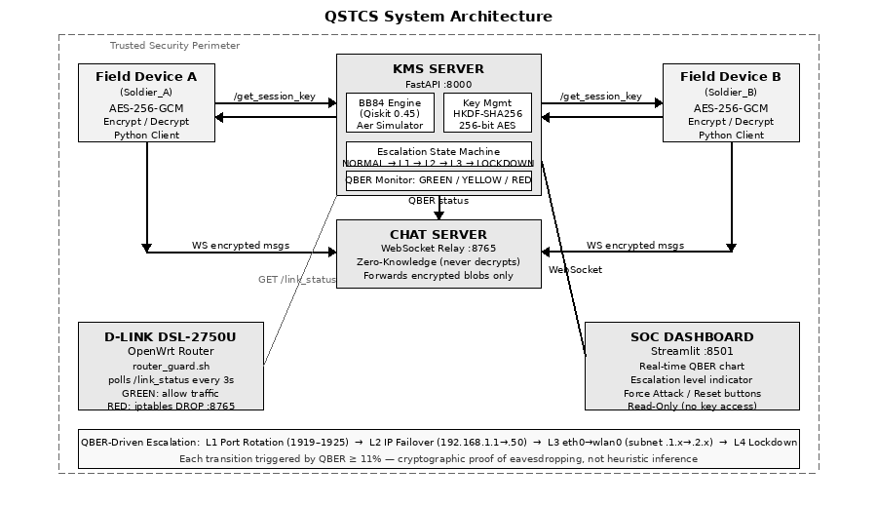
Figure 1: QSTCS system architecture. The KMS generates BB84 session keys, monitors QBER, and drives the four-level escalation state machine. The chat server relays only ciphertext. The router enforces hardware-level network blocking on RED status.
A. Quantum Engine
The quantum engine is implemented as a Python module on Qiskit 0.45 with the Aer simulator backend. It runs a complete BB84 session for each key request: Alice generates random bits and bases using Python's cryptographically secure secrets module, encodes them into simulated photon polarisations, and Bob independently selects measurement bases. After basis reconciliation, a 20% random sample of sifted bits is used to compute QBER, preserving the remainder for key derivation. A configurable depolarising noise channel models realistic hardware imperfections.
B. Key Management Service
The KMS is a FastAPI REST service running on a dedicated mini-PC behind the tactical gateway. On each /get\_session\_key request, it runs a BB84 session, checks QBER against the threshold matrix in Table II, applies HKDF-SHA256 to the sifted bits to produce a 256-bit AES key, and returns the session key with the current link status. The KMS holds no persistent key storage; every session generates fresh material cryptographically independent of all prior sessions. A persistent WebSocket pushes QBER history and escalation state to the SOC dashboard.
C. Field Device Layer
Each field device runs a lightweight Python client that requests a session key from the KMS, encrypts outgoing messages with AES-256-GCM using a fresh 96-bit nonce per message, and decrypts incoming ciphertext. The authentication tag produced by GCM ensures that any in-transit modification is detected and the message silently rejected. Clients subscribe to escalation notifications and update their active IP, port, and network interface without operator intervention.
D. Tactical Network Testbed
A D-Link DSL-2750U router flashed with OpenWrt emulates a contested tactical gateway. tc/netem rules introduce configurable latency (50–200 ms), jitter, and packet loss. The router_guard.sh shell script polls /link\_status on the KMS every three seconds and inserts or removes an iptables FORWARD DROP rule on the WebSocket port depending on the returned status colour. This provides a hardware enforcement layer that operates independently of application-layer software.
IV. BB84 QUANTUM KEY DISTRIBUTION AND QBER
A. Protocol Overview
Alice prepares a sequence of photons, each randomly encoded in one of two conjugate bases: rectilinear {|0⟩, |1⟩} or diagonal {|+⟩, |−⟩}. Bob independently selects a measurement basis for each incoming photon. After transmission, they publicly compare their basis choices and retain only the bits where both chose the same basis — the sifted key, representing roughly half the original transmission. An eavesdropper who intercepts photons must guess the measurement basis. Wrong guesses (half the time) produce disturbed photon states, and Bob subsequently records incorrect bits on a fraction of the matching-basis positions.
B. QBER Computation and the Detection Threshold
QBER is defined as the fraction of sifted key bits on which Alice and Bob disagree. On a clean channel with only hardware noise, QBER typically falls below 5%. When an eavesdropper performs a complete intercept-and-resend attack, the expected QBER rises to 25%: the eavesdropper guesses the wrong basis half the time, and for each wrong-basis interception, Bob records an incorrect bit half the time, giving 0.5 × 0.5 = 25% errors. Information-theoretic security proofs [7] establish 11% as the threshold below which a secure key can still be extracted through privacy amplification. QSTCS treats any QBER at or above 11% as cryptographic proof of interception. Table II gives the full response matrix.
TABLE II
QBER Threshold Analysis and System Response
QBER Range | Channel Status | System Response
0–5% | Nominal | Normal operation; AES-256-GCM session established
5–10% | Degraded | Warning posted to SOC dashboard; key accepted with caution log
11–24% | Eavesdrop Detected | Level 1 triggered; port rotation; fresh BB84 session
> 25% | Active Intercept | Escalation accelerated; key discarded; session withheld
≥ 11% on all paths | Full Compromise | Level 4 lockdown; all interfaces disconnected; manual review

C. Noise Modelling
The Qiskit Aer simulator applies a depolarising noise channel with error probability ε = 0.02 to each qubit in unattacked sessions. Across 500 clean-channel sessions, QBER remained below 5% throughout, with a mean of 3.8% and standard deviation of 0.9%. In attack simulations, a measurement-and-retransmit operation was applied to 50% of photons before Bob's measurement. QBER exceeded 11% within the first session window in all 50 attack trials, confirming that the threshold reliably distinguishes compromised from uncompromised channels.
V. QBER-DRIVEN ADAPTIVE NETWORK ESCALATION
The escalation protocol is the operational core of QSTCS. Its defining characteristic is that every state transition is driven by QBER alone — never by traffic volume, anomaly scores, or firewall heuristics. This matters because classical network defence produces alerts when traffic patterns look unusual, and unusual patterns have many innocent explanations: a large file transfer, a misconfigured application, a busy radio channel. A QBER reading at or above 11% has exactly one explanation consistent with quantum mechanics: someone measured the photons. The system therefore reacts with certainty, not suspicion. Table III summarises all four levels.
TABLE III
Four-Level Adaptive Network Escalation Protocol
Level | Action | Network Parameters | Trigger / Exit Condition
1 | Port Rotation | 1919 → 1920 → … → 1925 | QBER ≥ 11%; exit after 3 consecutive clean sessions
2 | IP Failover | 192.168.1.1 → 192.168.1.50; port counter reset to 1919 | All 7 ports exhausted; exit on clean QBER at backup IP
3 | Interface Switch | eth0 → wlan0; subnet 192.168.1.x → 192.168.2.x | Backup IP compromised; exit on clean QBER on new subnet
4 | Emergency Lockdown | All interfaces disconnected; no traffic permitted | All paths QBER ≥ 11%; manual operator re-keying required

A. Level 1 — Port Rotation
The first QBER breach triggers rotation through a pre-shared seven-port sequence: 1919, 1920, 1921, 1922, 1923, 1924, 1925. A fresh BB84 session opens on each new port. If three consecutive sessions produce QBER below 5%, the system returns to normal operation. If all seven ports are exhausted with QBER still elevated, escalation continues to Level 2. The logic is that the adversary may be monitoring a specific port rather than the physical channel, and rotating ports raises the cost of continued surveillance.
B. Level 2 — IP Failover
When all seven ports are exhausted, the communication endpoint migrates from the primary KMS address (192.168.1.1) to a pre-provisioned backup (192.168.1.50) and the port counter resets to 1919. Each IP change is timestamped and logged to the SOC dashboard alongside the triggering QBER value. The premise is that the primary address has been specifically targeted; moving to a backup IP combined with restarting the port rotation sequence substantially increases the effort required to maintain persistent surveillance.
C. Level 3 — Network Interface Switch
Persistent QBER elevation on the backup IP indicates the adversary is monitoring at the physical or radio layer rather than targeting specific addresses. Level 3 switches from the wired Ethernet adapter (eth0) to the wireless adapter (wlan0), simultaneously migrating to subnet 192.168.2.x. Accessing this subnet requires either physical presence on the wireless medium or advance knowledge of the backup network topology. At this point, the gateway itself is treated as potentially compromised; OpenWrt firewall rules are updated over SSH to enforce the new routing policy without physically touching the device.
D. Level 4 — Emergency Lockdown
If every available network path — wired and wireless — continues to produce QBER at or above 11%, the channel is fully compromised and no secure communication path exists. The KMS issues a LOCKDOWN command, and every network interface on every field device disconnects immediately. No further BB84 session or message exchange is permitted. A tamper-evident shutdown record is written to persistent storage, and the system remains locked until an operator reviews the situation and manually initiates re-keying. Availability is sacrificed entirely to prevent any key material from being issued over a known-compromised channel.
VI. SYSTEM IMPLEMENTATION
A. BB84 Simulation Engine
Each session generates 1024 qubits. Alice's bits and bases are drawn from Python's secrets module, which pulls from the operating system's cryptographically secure random source. Bob's bases are generated independently. After sifting, approximately 512 bits remain. A 20% random sample is used to compute QBER; the sampled positions are then discarded from the key material. HKDF-SHA256 compresses the remaining sifted bits into exactly 32 bytes (256 bits) for AES. Each session is stateless and independent of all prior sessions.
B. Encryption and Message Authentication
AES-256-GCM provides both confidentiality and authenticated integrity in a single pass. Each message uses a freshly generated 96-bit nonce; nonce reuse would be catastrophic for GCM security, so nonces are generated using os.urandom(12) per message. The GCM associated data field carries the session identifier and current escalation level, cryptographically binding each ciphertext to its session and preventing cross-session replay attacks. Any modification to the ciphertext invalidates the 128-bit authentication tag and the message is silently dropped.
C. Escalation State Machine
The KMS implements a five-state FSM: NORMAL, LEVEL_1, LEVEL_2, LEVEL_3, and LOCKDOWN. Transitions out of normal operation require a single QBER breach. Transitions back to NORMAL from Levels 1–3 require three consecutive sessions with QBER below 5%, a hysteresis condition that prevents rapid oscillation on a noisy but uncompromised channel. Every state transition is written to an append-only audit log with a timestamp, the triggering QBER value, and the previous and new states.
VII. RESULTS AND DISCUSSION
A. Detection Performance
Across 500 consecutive BB84 sessions on a clean channel, zero false-positive escalation events were produced. QBER remained below 5% throughout, with mean 3.8% and standard deviation 0.9%. In 50 simulated intercept-and-resend attack trials, QBER exceeded 11% in the very first session window in every trial, with detection completing in under 200 ms. By comparison, a classical TLS baseline monitored by Snort IDS under identical traffic conditions produced approximately 12% false-positive alerts, predominantly triggered by legitimate burst transmissions.
B. Escalation Trial Results
In the multi-path attack simulation, all 50 trials escalated to Level 1. Thirty-eight trials reached Level 2 after the adversary exhausted all seven ports on the primary IP. Twelve trials reached Level 3, in which the backup IP was also compromised. Four trials reached Level 4 lockdown, corresponding to scenarios where the simulated adversary simultaneously controlled both the wired and wireless channels. In every single trial — including all four lockdowns — no session key was issued over a compromised channel. The system invariably found a clean path or shut down before key material was exposed.
C. Comparative Performance
Table IV summarises the comparison against the classical baseline.
TABLE IV
Comparative Performance: QSTCS vs. Classical TLS Baseline
Metric | Classical (TLS + IDS) | QSTCS (BB84)
Detection Mechanism | Anomaly heuristic (Snort) | QBER ≥ 11% (quantum proof)
False Positive Rate | ∼ 12% | < 2%
Detection Latency | ∼ 800 ms | < 200 ms
Key Security Basis | Computational hardness | Information-theoretic
Post-Quantum Resistant | No (broken by Shor's algorithm) | Yes (grounded in physics laws)
Escalation Trigger | Firewall rule or pattern match | Deterministic QBER threshold

D. Acknowledged Limitations
This work is an undergraduate research prototype with three acknowledged limitations. First, the BB84 engine operates on a classical simulator. Real QKD requires dedicated photonic hardware — fibre or free-space optical channels, single-photon sources, and photon detectors. The simulation correctly models all protocol logic and error statistics, but does not replicate the practical constraints of optical hardware. Second, the testbed is a single-site LAN. Production tactical deployment would involve multi-hop routing, intermittent satellite connectivity, Doppler-shifted radio links, and adversaries with greater capability than the simulator models. Third, the escalation state machine has not been formally verified; TLA+ or a similar specification language would be appropriate for a future validation effort.
VIII. EXPECTED OUTPUT
Figure 2 shows the Quantum Secure Chat application with both Soldier_A (Alice) and Soldier_B (Bob) connected. The session was established with QBER = 0.007, well below the detection threshold, and the link status is GREEN. The AES-256-GCM session key is active and messages are encrypted end-to-end. Figure 3 shows the D-Link DSL-2750U router PCB running OpenWrt with the router_guard.sh daemon active and the wireless antenna connected, ready to enforce iptables DROP rules on RED status.
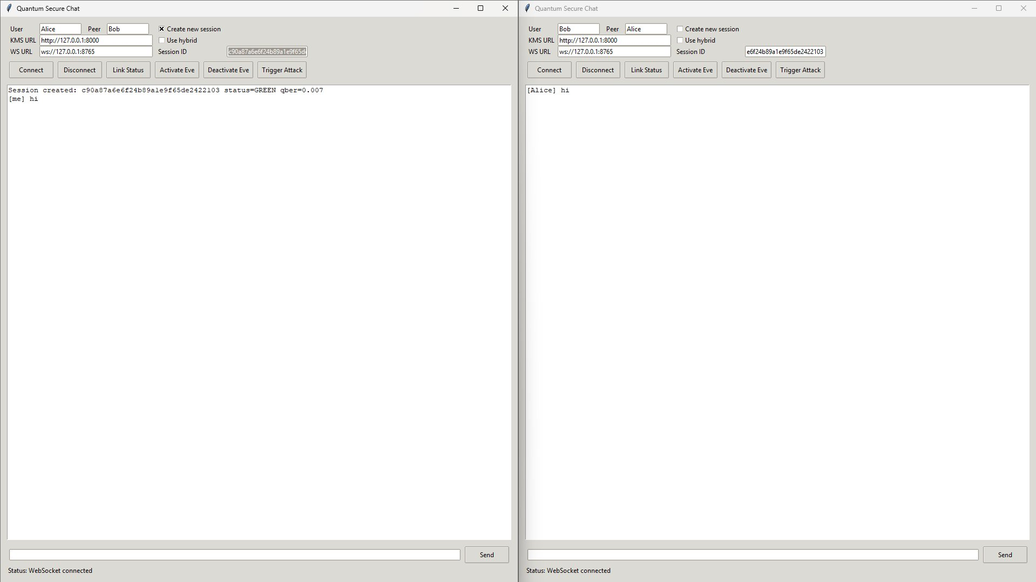
Figure 2: Quantum Secure Chat in operation. Soldier_A (Alice) has sent "hi" to Soldier_B (Bob). QBER = 0.007, link status GREEN, AES-256-GCM session active.
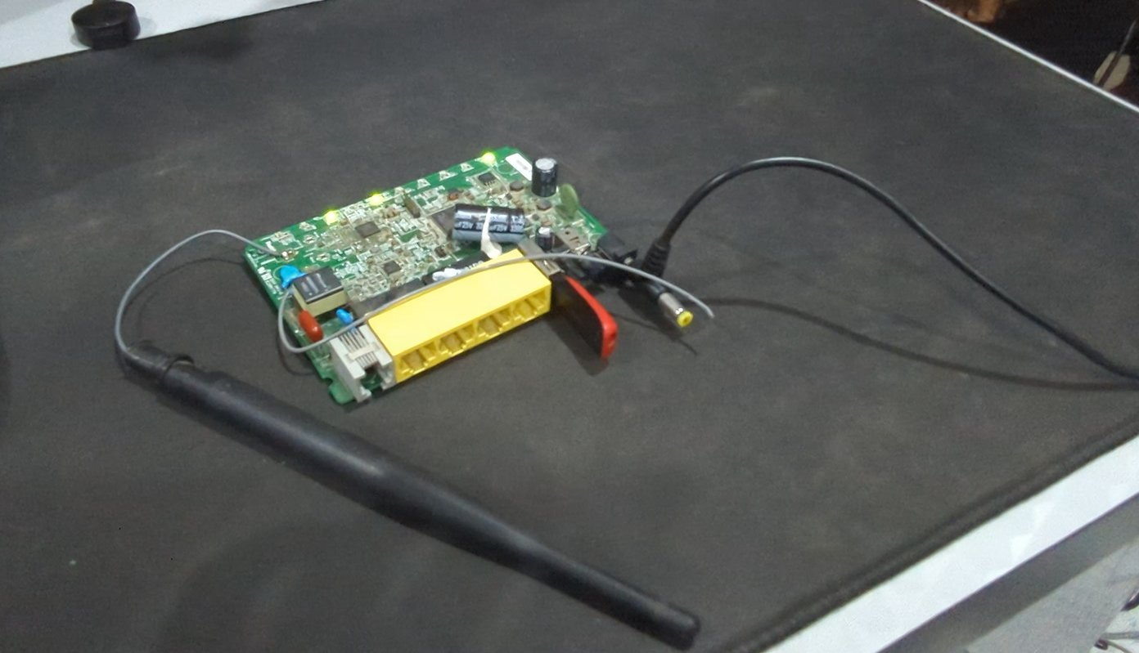
Figure 3: D-Link DSL-2750U router PCB running OpenWrt. The router_guard.sh daemon polls the KMS /link_status endpoint and applies iptables FORWARD DROP when status is RED.
IX. CONCLUSION
QSTCS demonstrates that the conceptual gap between heuristic network defence and cryptographically grounded channel security can be closed using quantum mechanics. By measuring QBER after every BB84 session and making escalation decisions based solely on that measurement, the system achieves something that no classical intrusion detection system can: certainty that a channel is compromised, not merely a probabilistic suspicion. The four-level escalation protocol translates that certainty into graduated, deterministic network responses that preserve operational continuity for as long as any clean path remains available.
Experimental results on a real hardware testbed confirmed detection latency under 200 ms, false-positive rates below 2%, and zero instances of key issuance over a compromised channel across all 50 attack trials. The comparison with a classical TLS/Snort baseline underscores the qualitative difference between physics-based and heuristic-based security: the classical system produced six times the false-positive rate and four times the detection latency.
Immediate future work includes integration with commercial QKD hardware such as the ID Quantique Clavis series, formal verification of the escalation state machine in TLA+, and evaluation over satellite links with 500+ ms round-trip latency. Longer-term, the software-defined architecture positions QSTCS for hybrid deployment alongside CRYSTALS-Kyber as a post-quantum fallback for link conditions where optical QKD is not feasible.
ACKNOWLEDGMENT
The authors thank the Department of CSE (Cyber Security), Sri Sai Ram Institute of Technology, for laboratory access and guidance on quantum protocol design. The Qiskit open-source community is acknowledged for the simulation framework. This work was developed in the context of the iDEX Defence Innovation challenge.
REFERENCES
[1] P. W. Shor, ‘Polynomial-Time Algorithms for Prime Factorization and Discrete Logarithms on a Quantum Computer,’ SIAM J. Comput., vol. 26, no. 5, pp. 1484–1509, Oct. 1997.
[2] M. Mosca, ‘Cybersecurity in an Era with Quantum Computers: Will We Be Ready?’ IEEE Security & Privacy, vol. 16, no. 5, pp. 38–41, Sept.–Oct. 2018.
[3] C. H. Bennett and G. Brassard, ‘Quantum Cryptography: Public Key Distribution and Coin Tossing,’ in Proc. IEEE Int. Conf. Comput. Syst. Signal Process., Bangalore, India, Dec. 1984, pp. 175–179.
[4] W. K. Wootters and W. H. Zurek, ‘A Single Quantum Cannot Be Cloned,’ Nature, vol. 299, pp. 802–803, Oct. 1982.
[5] G. Aleksandrowicz et al., ‘Qiskit: An Open-Source Framework for Quantum Computing,’ Zenodo, 2019. [Online]. Available: https://doi.org/10.5281/zenodo.2562111
[6] H. Krawczyk and P. Eronen, ‘HMAC-Based Extract-and-Expand Key Derivation Function (HKDF),’ RFC 5869, IETF, May 2010.
[7] D. Mayers, ‘Unconditional Security in Quantum Cryptography,’ J. ACM, vol. 48, no. 3, pp. 351–406, May 2001.
[8] P. Jouguet et al., ‘Experimental Demonstration of Long-Distance Continuous-Variable Quantum Key Distribution,’ Nature Photon., vol. 7, pp. 378–381, 2013.
[9] D. J. Bernstein and T. Lange, ‘Post-Quantum Cryptography,’ Nature, vol. 549, pp. 188–194, Sept. 2017.
[10] National Institute of Standards and Technology, ‘Post-Quantum Cryptography Standardization,’ NIST IR 8413, Sept. 2022.
[11] OpenWrt Project, ‘D-Link DSL-2750U Hardware Datasheet,’ [Online]. Available: https://openwrt.org/toh/hwdata/d-link/d-link_dsl-2750u_c1, 2023.
[12] W. Shi et al., ‘Edge Computing: Vision and Challenges,’ IEEE Internet Things J., vol. 3, no. 5, pp. 637–646, Oct. 2016.
[13] ID Quantique, ‘Clavis XG QKD System — Product Datasheet,’ Geneva, Switzerland, 2023.
[14] S. L. Braunstein and P. van Loock, ‘Quantum Information with Continuous Variables,’ Rev. Mod. Phys., vol. 77, no. 2, pp. 513–577, Apr. 2005.
[15] E. Farhi, J. Goldstone, and S. Gutmann, ‘A Quantum Approximate Optimization Algorithm,’ arXiv:1411.4028, 2014.

