[Opportunity Dashboard - CRM Analytics_SantoshJul2025 - Power BI](https://app.powerbi.com/groups/me/reports/2ab6d7a2-387f-4a7f-891c-0d1394657ce9/6999e5dd92ea522fb467?experience=power-bi)

POWERBI - CRM Opportunity Dashboard

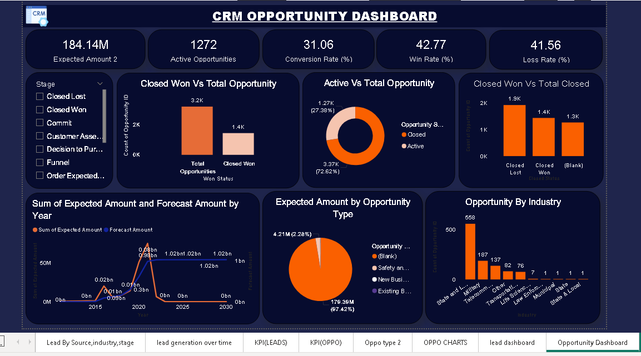

---------------------------------------------------------------------------------------------------------------------------------------------------

[lead dashboard - CRM Analytics_SantoshJul2025 - Power BI](https://app.powerbi.com/groups/me/reports/2ab6d7a2-387f-4a7f-891c-0d1394657ce9/2065a27592f2de34bc73?experience=power-bi)

POWERBI - CRM Lead Dashboard

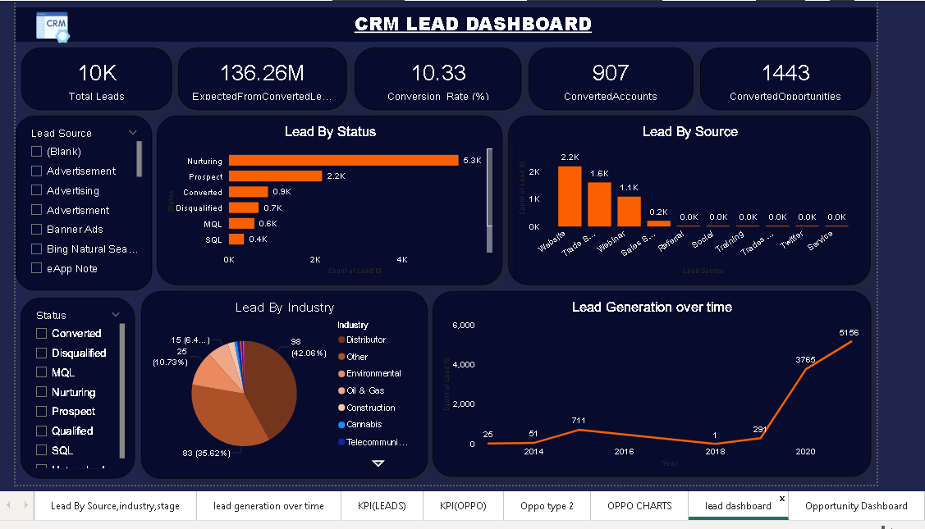

---------------------------------------------------------------------------------------------------------------------------------------------------

TABLEAU - CRM Opportunity Dashboard

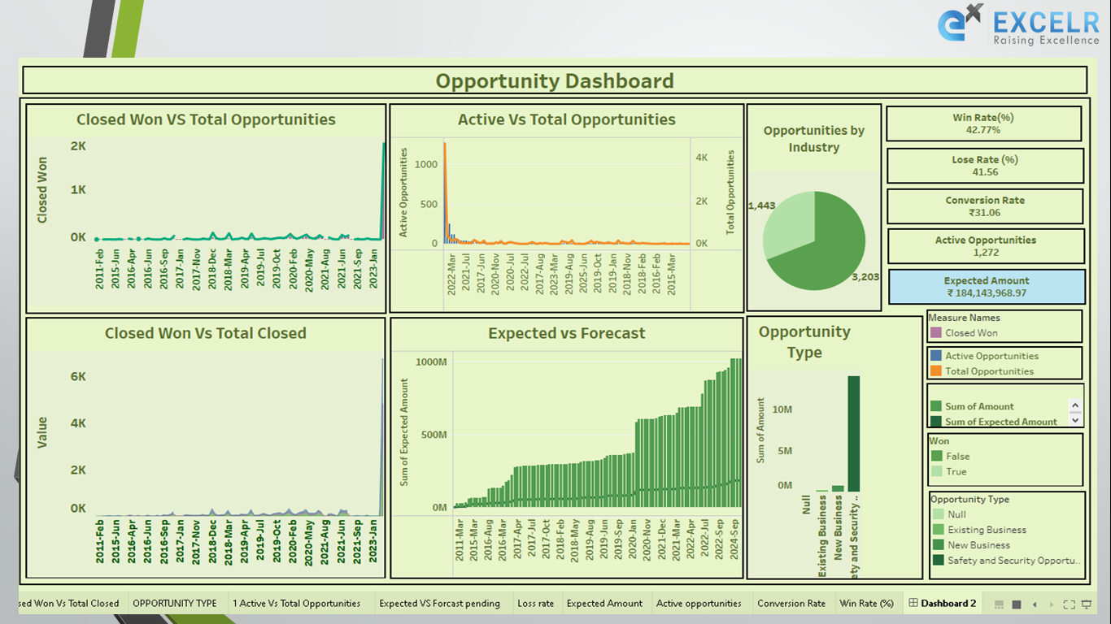

---------------------------------------------------------------------------------------------------------------------------------------------------

TABLEAU - CRM Lead Dashboard

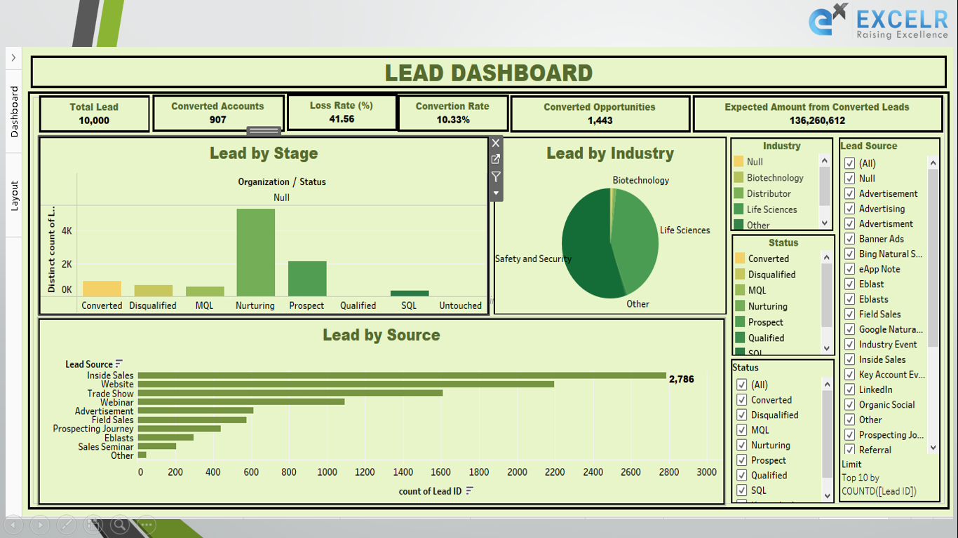

---------------------------------------------------------------------------------------------------------------------------------------------------

EXCEL - CRM Opportunity Dashboard

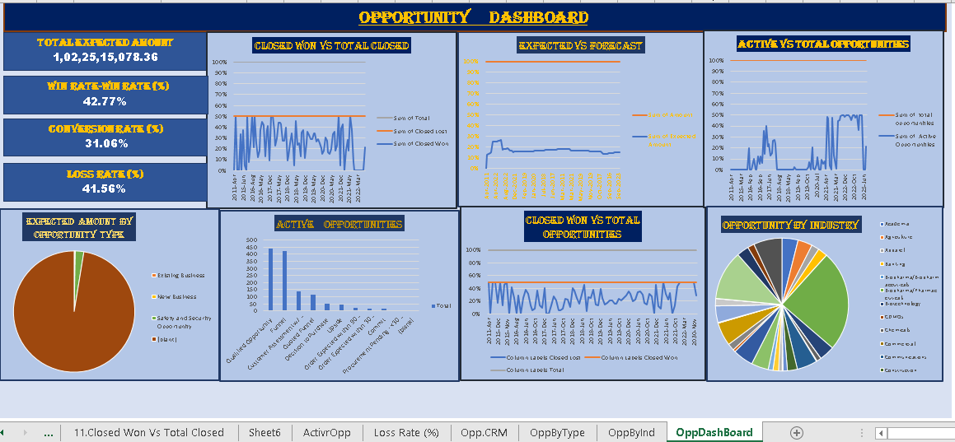

---------------------------------------------------------------------------------------------------------------------------------------------------

EXCEL - CRM Lead Dashboard

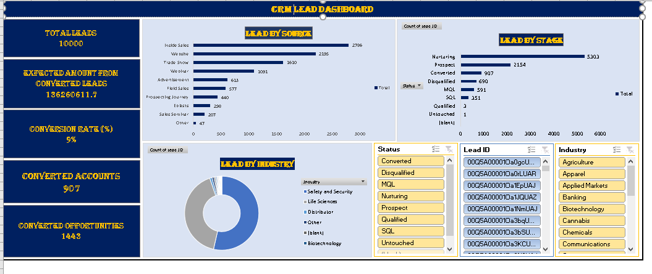

---------------------------------------------------------------------------------------------------------------------------------------------------

PowerBI - Insurance Dashboard

<https://app.powerbi.com/groups/me/reports/6fa47014-ccd8-4940-83b0-aa3d92e0be29/4b5a3acb10f37ced2548?experience=power-bi>

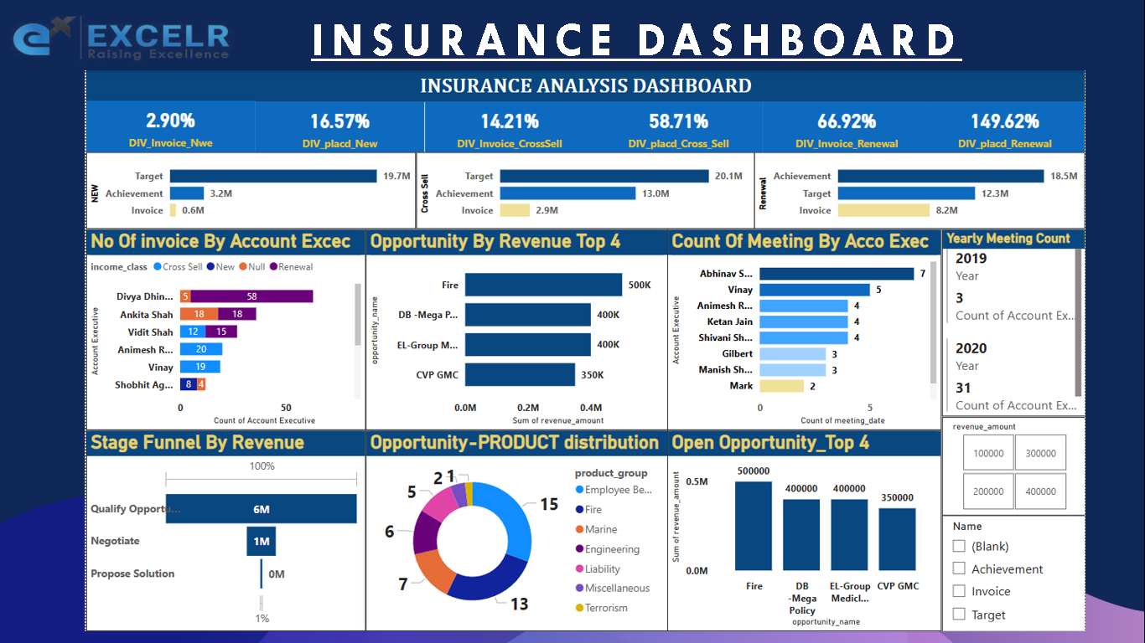

---------------------------------------------------------------------------------------------------------------------------------------------------

TableAU - Insurance Dashboard

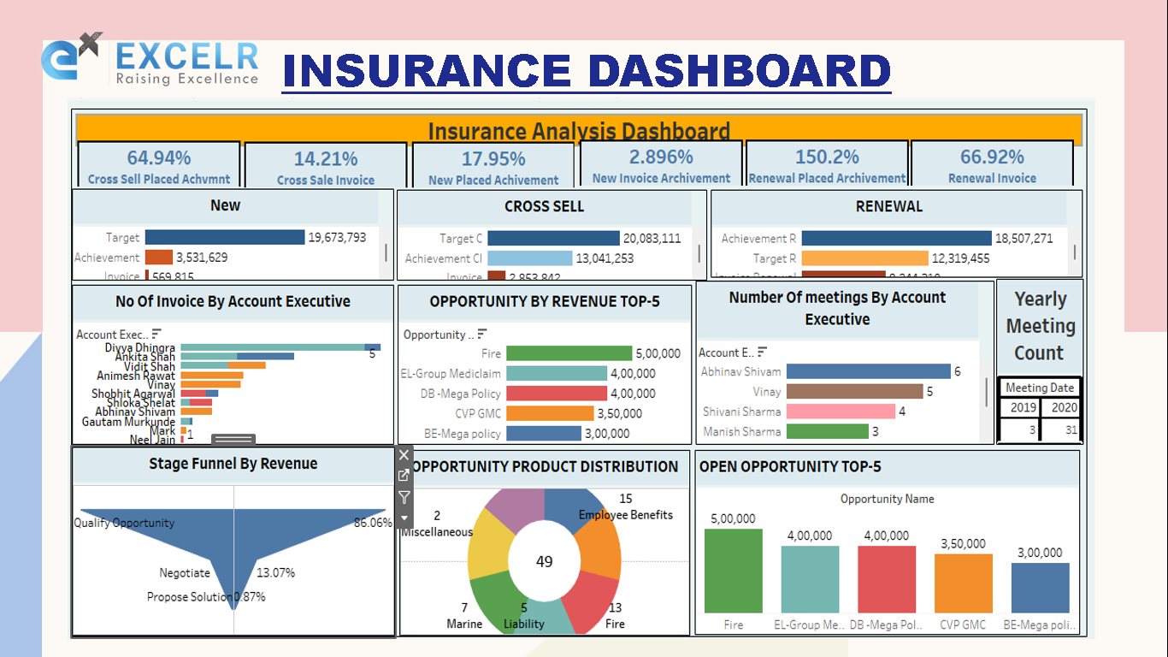

---------------------------------------------------------------------------------------------------------------------------------------------------

EXCEL - Insurance Dashboard

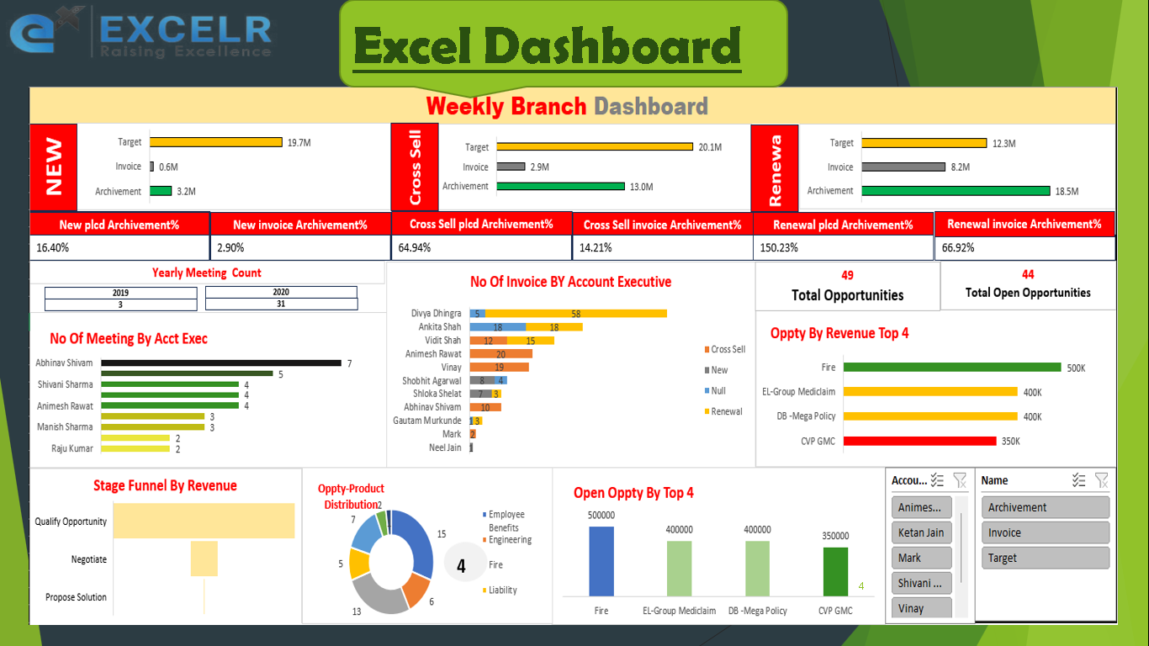

---------------------------------------------------------------------------------------------------------------------------------------------------

PowerBI – S N Corporation Dashboard

<https://app.powerbi.com/view?r=eyJrIjoiNTU0ZjgwMGYtYTMzMS00NjExLWFjNTItODVjNWQ0Y2I5MjcwIiwidCI6IjQ5MGEwNjk0LTEzMjUtNDdlNy1hYTU4LWIzZjY4YjdmOTkyYSJ9>

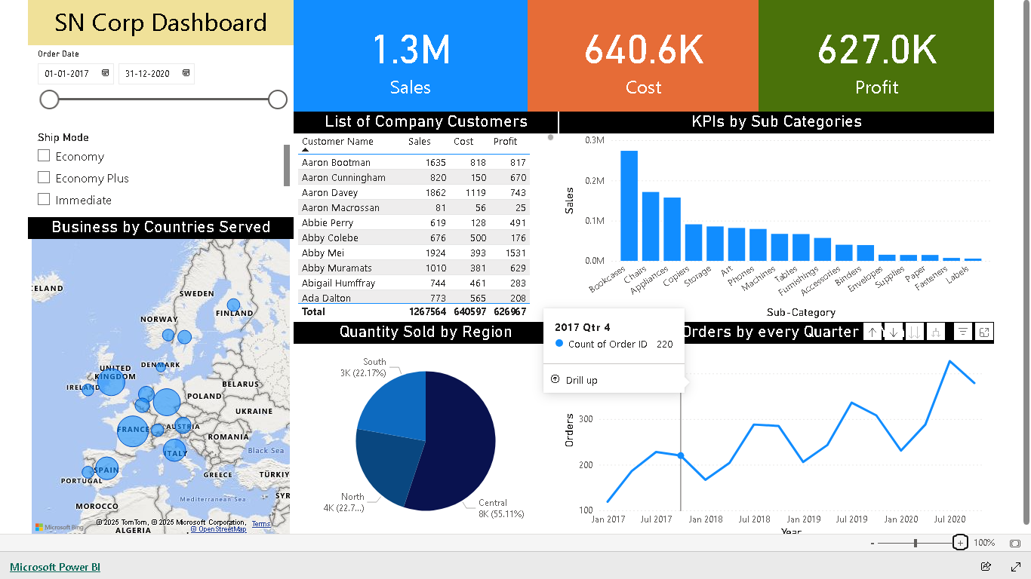

PowerBI – Amazon Sales Analytics

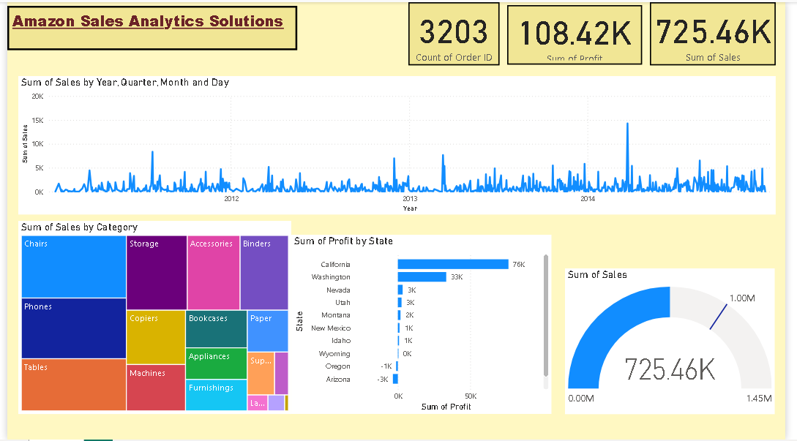

TableAU – Electric Vehicles Dashboard

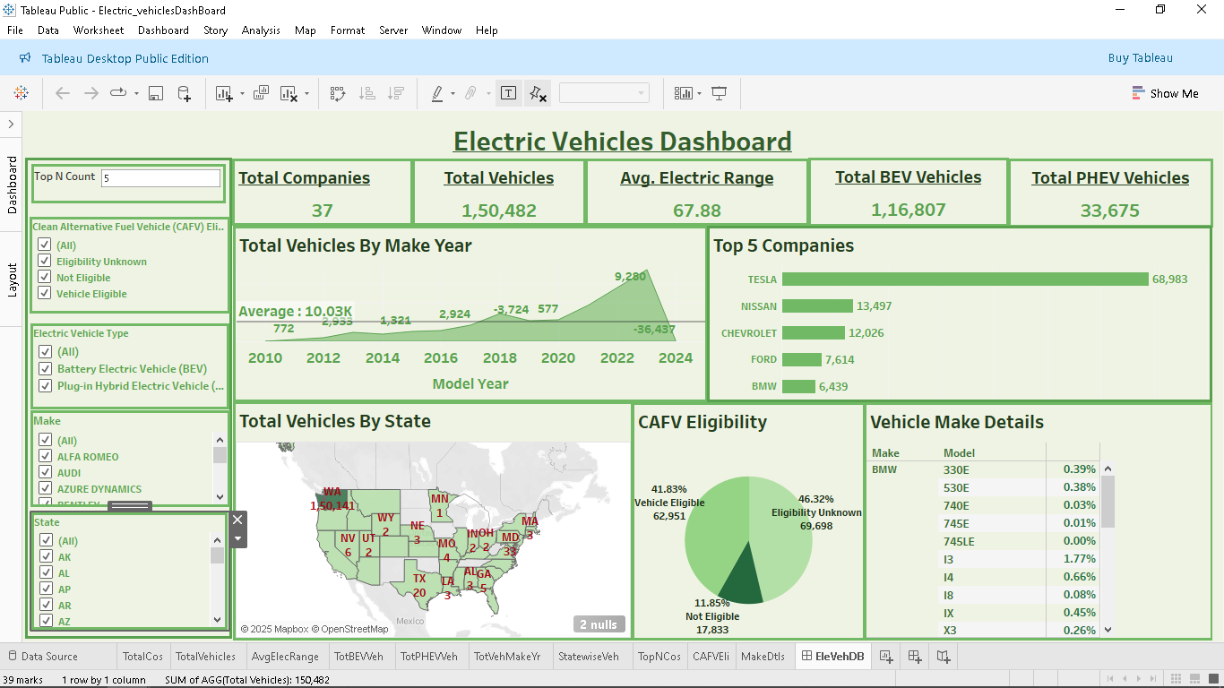

TableAU – NetFlix Show Dashboard

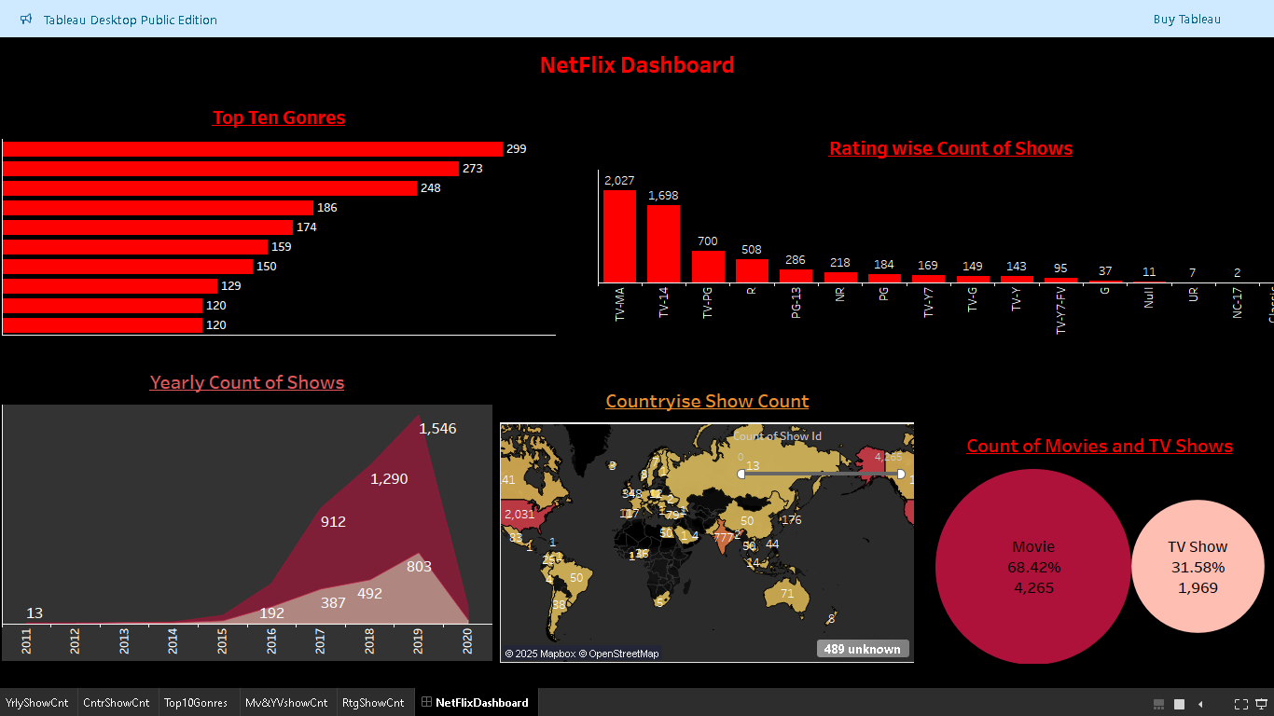

TableAU – Sample Sales Dashboard

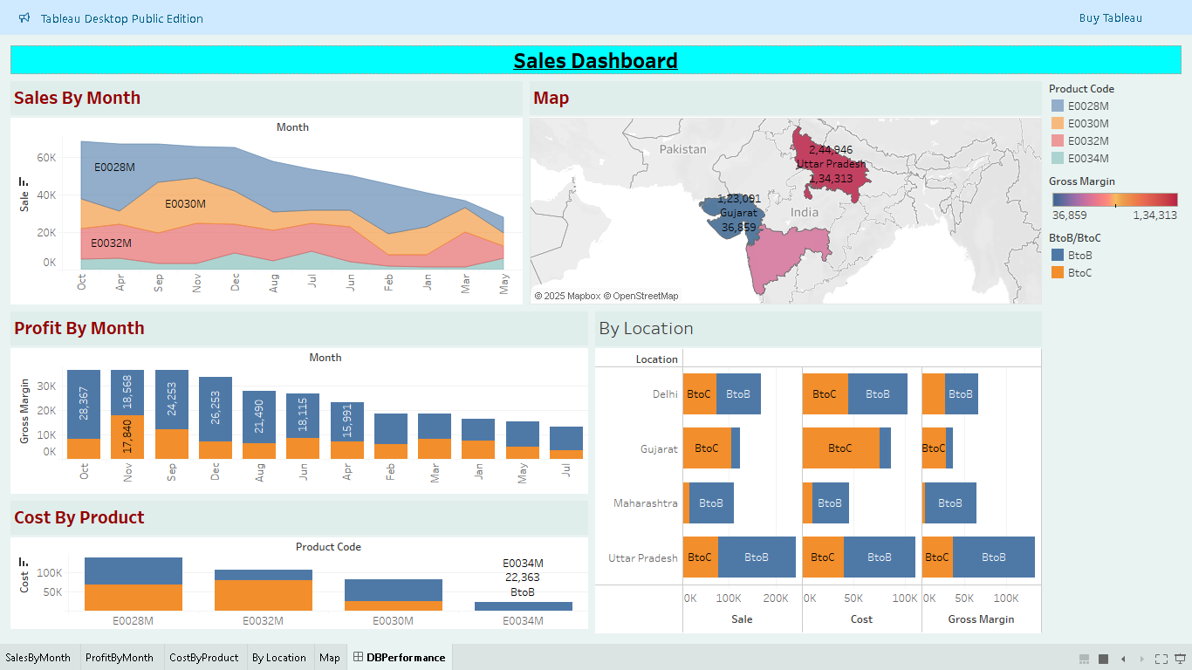

TableAU –Sample Superstore Dashboard

