Ex. No. 10 | Shared Memory
Date of Exercise | 28-03-2017 | Date of Upload | 04-04-2017

Aim : To write a shell script to do understand shared memory in unix.
Video : https://youtu.be/R97cata7zc0
Algorithm:
Write :
Step 1: Use shmget() system call to get a new shared memory location.
Step 2: Attach the shared memory to the executing process and get an address.
Step 3: Convert the address to character pointer
Step 4: Ask user for the data to be written.
Step 5: Write to the shared memory using a for loop and increment the character pointer.
Step 6: End
Read :
Step 1: Use shmget() and the id to get the used shared memory location.
Step 2: Use shmat() to attach the shared memory address.
Step 3: Convert the address to character pointer
Step 4: Read from the location and output the text
Step 5: Do the operation needed of the read text.
Step 6: Convert to lower case using a for loop.
Step 7: Output the text on which operation is been executed.
Step 8: End

Program:
Write :
#include <sys/ipc.h>
#include <sys/shm.h>
#include <stdio.h>
#include <fcntl.h>
#include <string.h>
int main ( ) {
void *virAddr;
char str[100];
int i = 0;
char *a;

int shmid = shmget(10,50,IPC_CREAT|0666 );
if (shmid == -1) {
printf ( "\nUnable to create shared memory!\n" );
return -1;
}
if (( virAddr = shmat(shmid, 0, 0 )) == (void *)-1 ) {
printf ( "\nUnable to attach shared memory.\n" );
return -1;
}
a = (char *)virAddr;

printf ( "\nEnter a string: " );
scanf("%s",str);

printf ( "\nWriting to shared memory...\n" );
for ( i = 0; i < strlen(str); i++ ) {
*a = str[i];
a++;
}
*a = '\0';
printf ( "Writing complete.\n\n" );

return 0;
}

Read :
#include <sys/ipc.h>
#include <sys/shm.h>
#include <fcntl.h>
#include <stdio.h>

int main ( ) {
void *virAddr;
char *a;

int shmid = shmget ( 10, 50, IPC_CREAT );
if ( shmid == -1 ) {
printf ( "Unable to retrieve the shared memory.\n" );
return -1;
}
if ((virAddr = shmat ( shmid, 0, 0 )) == (void * )-1 ) {
printf ( "Unable to attach shared memory.\n" );
return -1;
}
a = (char *)virAddr;
printf ( "\nReading from shared memory...\n" );
printf ( "%s", a );
printf ( "Reading complete.\n" );

printf ( "\nConverting to lower case...\n" );
char c = *a;
while ( c != '\0' ) {
c = tolower ( c );
printf ( "%c", c );
c = *++a;
}
printf ( "Conversion complete.\n\n" );
return 0;
}
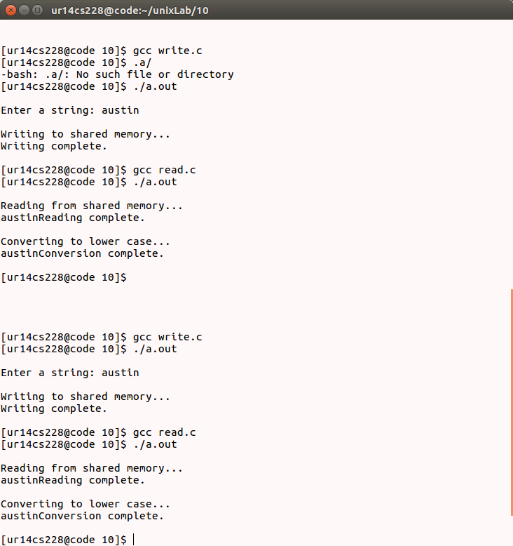
Output:

Result: .
The programs to understand the usage of shared memory has been successfully completed.

