Ex. No. 2 | CONDITIONAL STATEMENTS USING SHELL SCRIPTING
Date of Exercise | 10-12-2016 | Date of Upload | 17-01-2017
Aim :
To write a shell program for :
1. Greatest of three numbers
2. Student grade calculation
3. Electricity bill calculator
4. Finding the alphabet is a vowel or consonant
5. Given umber is palindrome or not
Video : https://youtu.be/rIh2Ady3Axs
Description:
Theses shell programs are scripted using the different looping and conditional statements available in shell language. The conditional statements includes the if else statements. The looping structures include the for loop, while loop and switch case structure.
Program:
1. Greatest of three numbers
#!/usr/bin/sh
echo Enter the three numbers
read a b c
l=$a
if [ $l -lt $b ]
then
l=$b
fi
if [ $l -lt $c ]
then
l=$c
fi
echo "The greatest number is $l"

2. Student grade calculation
#!/usr/bin/sh
#read a b c
echo ENter the marks
read a b c
t=`echo $a+$b+$c | bc `
avg=`echo $t/3|bc`
g=3
if [ $avg -lt 40 ]
then
g=0
elif [ $avg -lt 80 ]
then
g=1
else
g=3
fi
case $g in
0)
echo "The student has failed"
;;
1)
echo "The student have passed satisfactorily"
;;
3)
echo "The student has passd with distinction"
;;
esac

3. Electricity bill calculator
#!/usr/bin/sh
echo Enter the units of electricity
read a
c=100
if [ $a -lt 100 ]
then
c=100
elif [ $a -lt 200 ]
then
c=200
elif [ $a -gt 200 ]
then
c=400
fi
cost=`echo $a*$c |bc`
echo $cost

4. Finding the alphabet is a vowel or consonant
#!/usr/bin/sh
echo "Enter the alphabet"
read a
v=('a' 'e' 'i' 'o' 'u')
for i in "${v[@]}"
do
if [ $i == $a ]
then
echo "The alphabet is a vowel"
exit 0
fi
done
echo "The alphabet is a consonant"

5. Given number is palindrome or not
#!/usr/bin/sh
echo "Enter the number to be checked"
read a
t=$a
n=0
while [ $a -gt 0 ]
do
r=`echo $a%10 |bc`
n=`echo $n*10 |bc `
n=`echo $n+$r |bc `
a=`echo $a/10 |bc `
done
if [ $n == $t ]
then
echo "The number is palindrome"
exit 0
fi
echo "The number is not plaindrome"

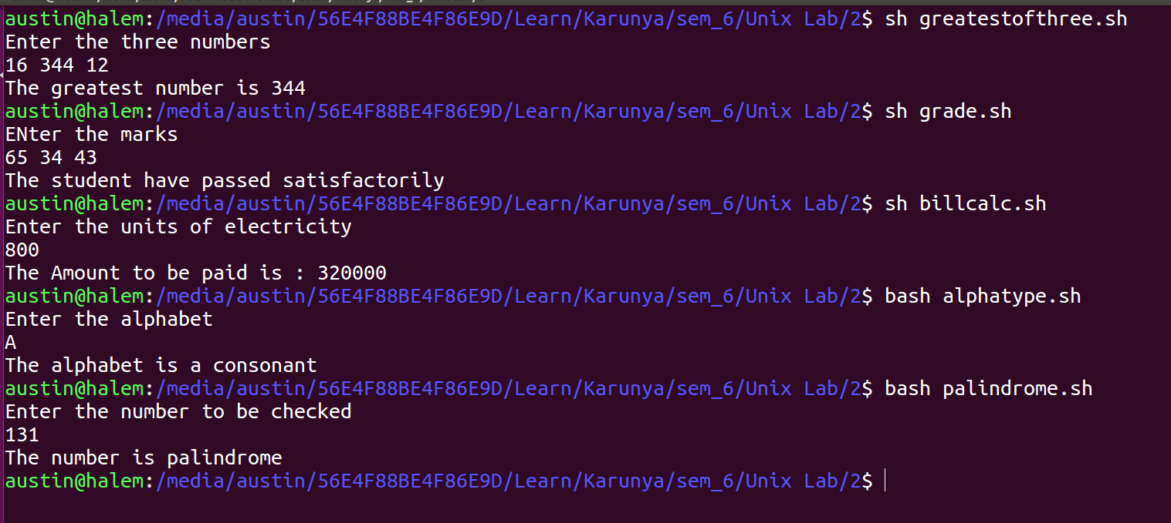
Output:

Result:
The unix commands are executed successfully.

