Ex. No. 3 | LOOPING STATEMENTS USING SHELL SCRIPTING
Date of Exercise | 10-01-2017 | Date of Upload | 17-01-2017

Aim :
To write shell program for :
1. Factorial of number
2. Sum of given series
3. Fibonacci series
4. Multiplication Table
5. Scientific calculator
Video : https://youtu.be/ZliCJpbuTlg
Description:
The given programs are created using the looping statements of shell scripting. The looping statement include the for loop, while loop, and switch case statements. The arithmetic operations are performed using the basic calculator and the expr operator. The advanced scientific calculations are done using the bc -l operation.
Peogram :
1. Factorial of number
#!/bin/sh
echo "Enter the Number"
read a
sum=1
for ((j=1;j<=a;j++))
do
sum=`echo $sum*$j | bc`
done

echo "Factorial " $sum

2. Sum of given series
echo ENter the number
read a
n=`echo $a+1 |bc`
n=`echo $n*$a | bc`
n=`echo $n/2 | bc`
echo $n

3. Fibonacci series
echo "Fibonacci"
echo " Enter the limit : "
read n
f1=0
f2=1
f3=1
echo -n " fibonacci series : $f1 $f2 "
for ((i=2;i<$n;i++))
do
f3=`expr $f1 + $f2`
f1=$f2
f2=$f3

echo -n " $f3"
done

4. Multiplication Table
echo "multiplication table"
echo "enter number"
read num
echo "values of limit:"
read lim
echo "multiplication table of $num is :"
for((i=1;i<=lim;i++))
do
sum=`expr $num \* $i`
echo " $num x $i= $sum"
done

5. Scientific calculator
while true
do
echo"SCIENTIFIC CALCULATOR"
echo "-------------------------------------"
echo "1.ADD 2.SUBTRACT 3. MULTIPLY 4.DIVIDE"
echo "5.SINE 6.COSINE 7.SQRT 8.LOG 9.POWER 10.EXPONENTS"
read ch
case $ch in

1) echo "Enter a"
read a
echo "Enter b"
read b
sum=`expr $a + $b`
echo "Sum is: $sum";;
;;
2) echo "Enter a"
read a
echo "Enter b"
read b
sum=`expr $a - $b`
echo "Difference is: $sum";;
;;
3) echo "Enter a"
read a
echo "Enter b"
read b
sum=`expr $a \* $b`
echo "Product is: $sum";;
;;
4) echo "Enter a"
read a
echo "Enter b"
read b
sum=`expr $a / $b`
echo "quotient is: $sum";;
;;
5) echo "Enter degree value"
read d
a=0.01745
temp=`echo $a \* $d|bc`
result=`echo "scale=2;s($temp)"|bc -l`
echo "Answer: $result";;
;;
6) echo "Enter degree value"
read d
a=0.01745
temp=`echo $a \* $d|bc`
result=`echo "scale=2;c($temp)"|bc -l`
echo "Answer: $result";;
;;
7) echo "Enter value"
read d
result=`echo "scale=2;sqrt($d)"|bc -l`
echo "Answer: $result";;
;;

8) echo "Enter degree value"
read d
a=0.01745
temp=`echo $a \* $d|bc`
result=`echo "scale=2;l($temp)"|bc -l`
echo "Answer: $result";;
;;
9) echo "Enter value"
read d
echo "Enter power"
read p
var=`echo $d^$p | bc`
echo "Answer: $var";;
;;
10) echo "Enter value"
read d
var=`echo "scale=2;e($d)"|bc -l`
echo "Answer: $var";;
;;
esac
done

Output:
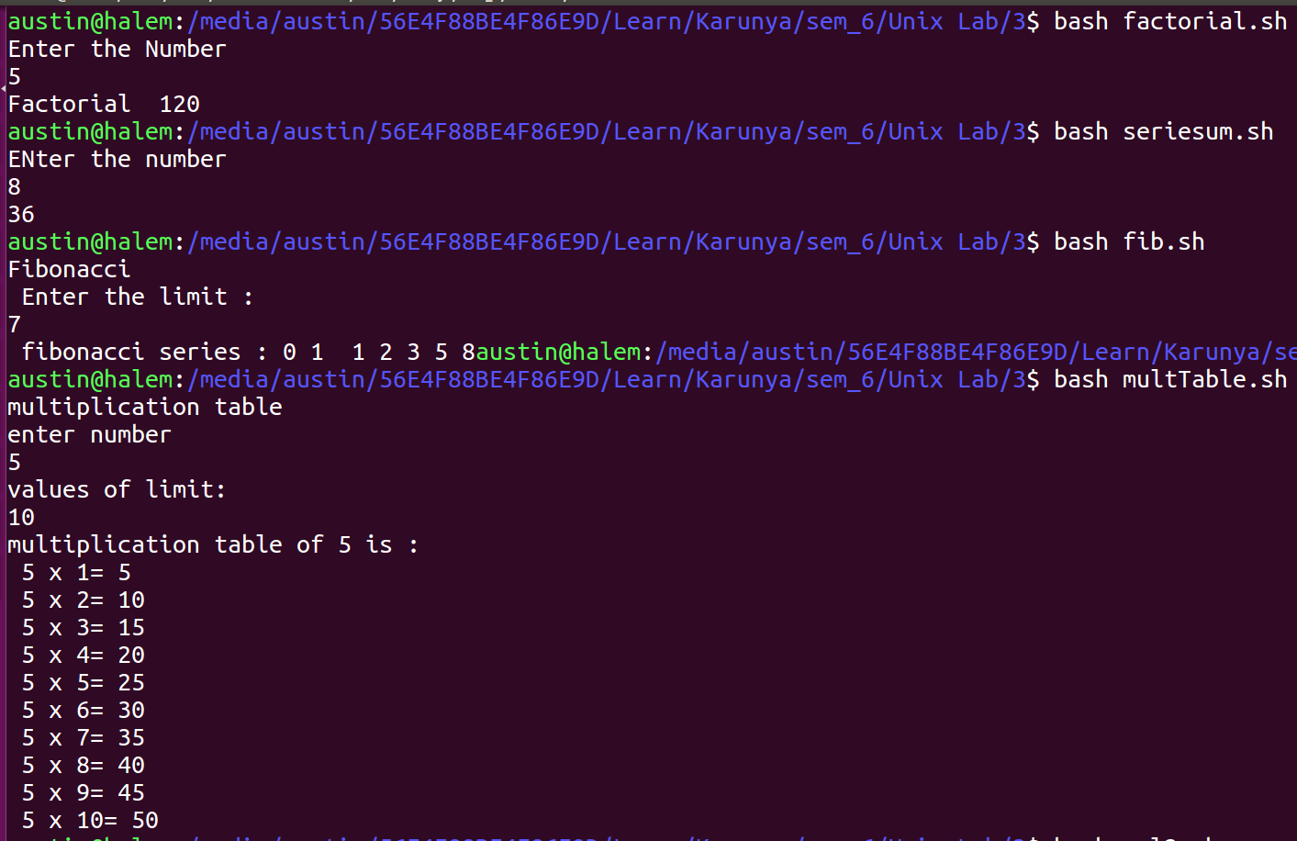

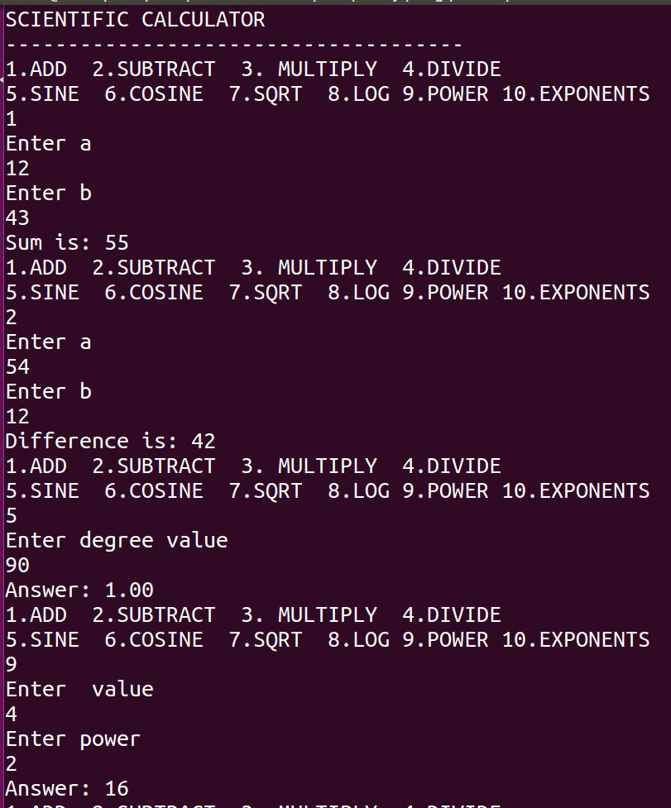

Result:
The given programs are completed the programs successfully and verified.

