Ex. No. 5 | File Operations
Date of Exercise | 15-02-2017 | Date of Upload | 01-03-2017

Aim :
To write shell program for the given file operation questions.
Video : https://youtu.be/w5220oixd-I
Description:
The user has to give input for the files to be checked. The program uses file operation tools like stat etc to get info about the file. The file information is also taken using the parameters for the if loop which include the -s, -w, -f etc which check the permissions of the file.
Program :
- Write a shell script to find the frequency of occurrences of any alphabet and a word in the content of the given file name (use grep, wc)

echo "enter the word"
read a
echo "Enter file name "
read f
echo `grep $a $f|wc -w`

- Write a shell script to and replace a word in a file. (use sed)
echo "Enter the word to find"
read a
echo "Enter the word to be replaced"
read b
sed 's/'$a'/'$b'/g' test.txt

- Write a shell script that given a person's uid, tells you how many times that person is logged on. (use last, grep, wc)
echo "Enter the user name "
read a
last | grep $a |wc -l

- Write a shell script that takes filename as an argument and print the file information such as inode number, permission, links, owner ID, group ID, etc.
echo "Enter the file name "
read a
ls -il $a

- Write a shell script that takes a uid as an argument and prints out that person's name, home directory, shell and group number. Print out the name of the group corresponding to the group number, and other groups that person may belong to (details are available in /etc/passwd and /etc/group files)
echo "Enter the UID : "
read a
echo -e "\nName : "
cat /etc/passwd| grep $a | cut -f 1 -d ':'
echo -e "\nShell and Group Number : "
cat /etc/passwd| grep $a | cut -f 3 -d ':'
echo -e "\nHome dir :"
cat /etc/passwd| grep $a | cut -f 6 -d ':'
echo -e "\nGroup name :"
cat /etc/passwd| grep $a | cut -f 3 -d ':' | id -g -n
echo -e "\nOther groups :"
cat /etc/passwd| grep $a | cut -f 1 -d ':' |groups

- Write a shell script to test various properties associated with a file.
Checks if file exists
Checks if file is readable
Checks if file is writable
Checks if file is executable
Checks if file is an ordinary file
Checks if file is a directory
Checks if file has size greater than 0

echo "Enter file name : "
read f

if [ -e $f ]
then
echo "File Exists"
if [ -r $f ]
then
echo "File readable"
else
echo "File not readable"
fi

if [ -w $f ]
then
echo "File writable"
else
echo "File not writable"
fi

if [ -x $f ]
then
echo "File executable"
else
echo "File not executable"
fi

if [ -f $f ]
then
echo "File is a regular file"
else
echo "File not regular file"
fi

if [ -d $f ]
then
echo "File is a directory"
else
echo "File not directory"
fi

if [ -s $f ]
then
echo "File size is non zero"
else
echo "File size is zero"
fi

else
echo "File do not Exist"
fi

Output:
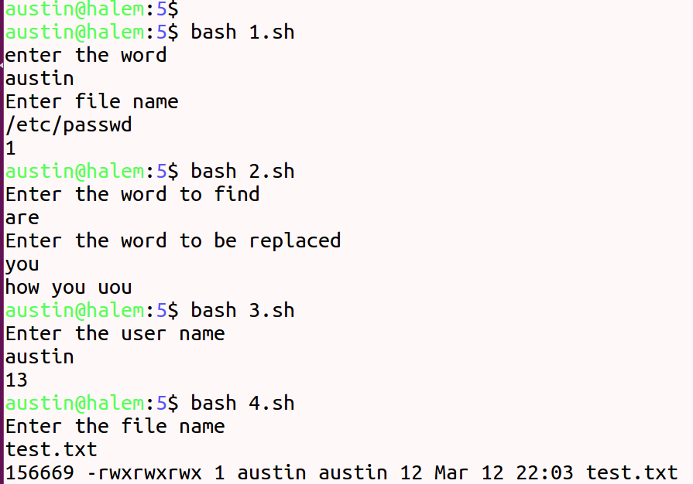

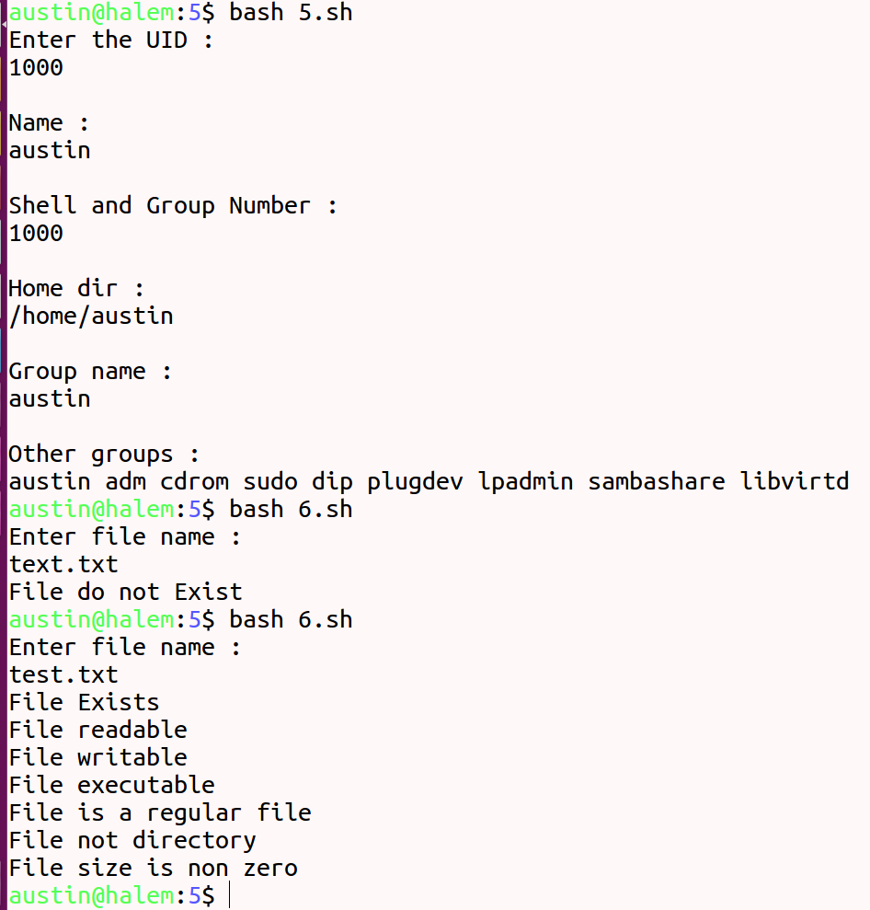

Result:
The given programs are completed the programs successfully and verified.

