Ex. No. 6 | User Defined Function
Date of Exercise | 21-02-2017 | Date of Upload | 14-03-2017

Aim : To write a shell script to understand the usage of user defined functions
Video : https://youtu.be/TP5c0uHaH_E
Algorithm:
Step 1: Ask for user input
Step 2: invoke getdetails() function
Step 3: get the details of the user
Step 4: invoke calculate() function
Step 5: allowance[$i]=`echo ${basic[$i]}*0.54|bc`
total[$i]=`echo ${allowance[$i]}+${basic[$i]}|bc`
Step 6: invoke getdetails()
Step 7: print the details and total salary of the user
Step 8: End

Program:
Add()
{
echo "Enter Book $i Name : "
read name[$i]
echo "Enter Book Number"
read bookno[$i]
echo "Enter author Book$i"
read author[$i]
echo "Enter price for Book$i"
read price[$i]
echo " Number of Copies"
read copies[$i]
}

display()
{
echo -e "${name[$i]} \t ${bookno[$i]} \t ${author[$i]} \t\t ${price[$i]} \t ${copies[$i]}"
}

edit()
{
echo "Enter the book number which is issued"
read j
copies[$j]=`echo "${copies[$j]}-1"|bc`
}

y=1
while [ $y -eq 1 ]
do
echo "1.Add Book"
echo "2.Display Book"
echo "3.Enter Issued/Not issued"
echo "4. Exit"

echo "Enter your choice"
read c

case $c in
1)
echo "Enter the number of Books:"
read n
for i in `seq 1 $n`
do
Add
done;;
2) echo -e "Name \t BookNo \t Author \t price \t Issued "
for i in `seq 1 $n`
do
display
done;;
3) edit
;;
4) exit;;
esac
done

Output:
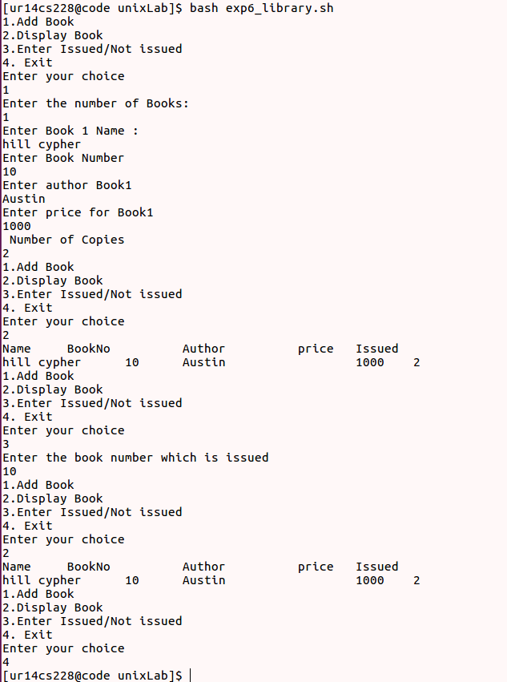

2.BANKING APPLICATION
withdraw(){
if (($with > $currt))
then
echo insufficient balance
else
currt=`expr $currt - $with`
echo current balance :$currt
fi
}

deposit() {
currt=`expr $depo + $currt`
echo current balance in your account is :$currt
}

balance() {
echo your current balance is $currt
}

echo Welcome
flag=1
currt=1000
while((flag==1))
do
echo 1.DEPOSIT 2.WITHDRAW 3.BALANCE
read op
case $op in
1)
echo Enter amount you want to deposit into account
read depo
deposit $depo
echo Do you want to continue? 0 or 1
read flag
;;
2)
echo Enter amount you want to withdraw from your account.
read with
withdraw $with
echo Do you want to continue? 0 or 1
read flag
;;
3)
balance
;;
esac
done

Output:
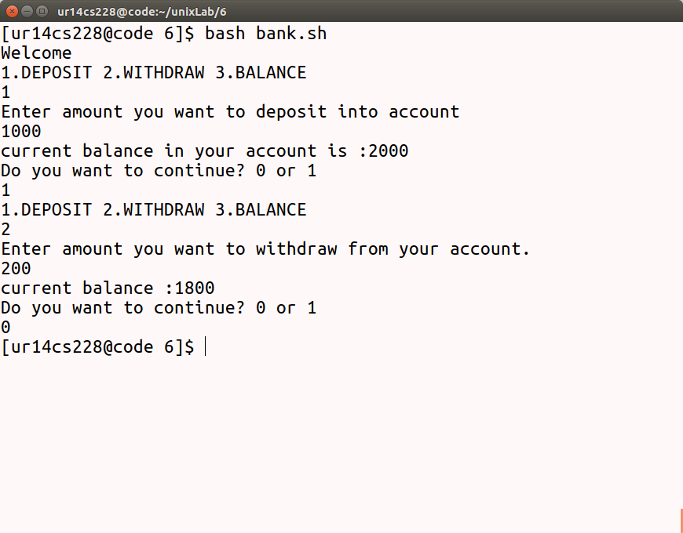
Result: .
The programs for library management system and Banking application is completed.

