Ex. No. 7 | System Calls
Date of Exercise | 28-02-2017 | Date of Upload | 14-03-2017

Aim : To write a shell script to understand the usage of System Calls
Video : https://youtu.be/yXs8HFYCIwA
Algorithm:
Step 1: Ask user to enter the text to be written to the file.
Step 2: Create the file to which the data is to written using creat system call
Step 3: Open the text file using the open system call and O_RDWR attribute
Step 4: Write into the file using the write system call
Step 5: Read from the file using the read system call
Step 6: Output the read text into user terminal
Step 7: Make sure user looks happy
Step 8: End

Program:
#include <stdio.h>
#include <sys/types.h>
#include <stdlib.h>
#include <sys/stat.h>
#include <fcntl.h>
#include <string.h>
int main()
{
int fd,newfd,choice,byte,bytes;
char buf[100];
while(1){
printf("choose\n1.create\n2.open\n3.write\n4.read\n5.close\n");
scanf("%d",&choice);
switch(choice){
case 1:
fd=creat("process.txt",0755);
printf("File created with fd: %d \n",fd);
break;
case 2:
fd=open("process.txt",O_RDWR);
printf("File opened with fd: %d\n",fd);
break;
case 3:
printf("enter data: ");
scanf("%s",buf);
byte = write(fd,buf,strlen(buf));
printf("bytes written: %d \n",byte);
lseek(fd,0,0);
break;
case 4:
newfd=dup(fd);
printf("The file descriptor table is deleted %d. And duplicate is created. %d \n",fd,newfd);
close(fd);
bytes = read(newfd,buf,sizeof(buf));
printf("%s \n",buf);
break;
case 5:
close(newfd);
printf("File closed with new fd: %d \n",newfd);
exit(1);
}
}
}

Output:
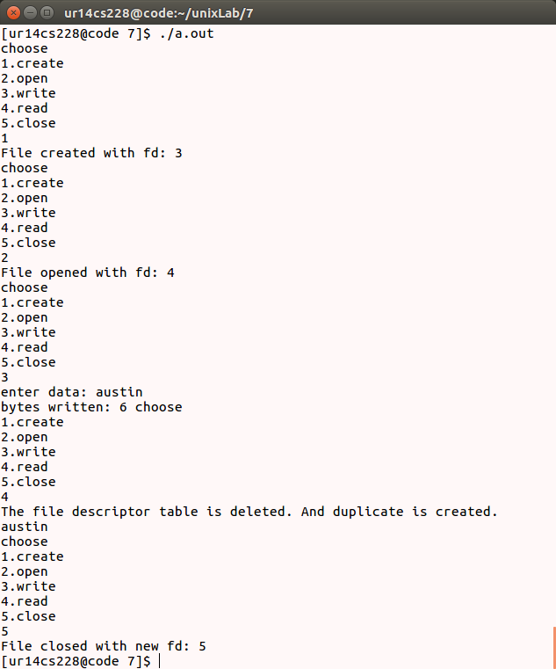

Result: .
The programs for usage of System Calls is completed.

