Ex. No. 8 | Process Creation
Date of Exercise | 04-03-2017 | Date of Upload | 14-03-2017

Aim :
To write a shell script to understand the usage of Process Creation
Video : https://youtu.be/lyumaFf3WDQ
Algorithm:
Step 1: Create a new process using fork system call
Step 2: create a variable of type pid_t to store the PID returned by the fork system call
Step 3: if PID is -1, output the process creation was unsucessful
Step 4: else if PID is 0 or a positive value a new child process it created
Step 5: Use else if structure to demonstrate the execution of both child and parent process.
Step 6: Output the PID of both parent and child process
Step 7: Exit the program.
Step 8: End
Program:
#include <fcntl.h>
#include <stdio.h>
int main(){
int id1,id2,id3,id4;
id1= fork();
printf("id value : %d\n",id1);
if(id1==0) {
printf("Child : Hello I am the B process\n");
printf("Child : Child.s PID: %d\n", getpid());
printf("Child : Parent.s PID: %d\n", getppid());
}
else{
printf("Parent : Hello I am the A process\n" ) ;
printf("Parent : Parent.s PID: %d\n", getpid());
printf("Parent : Child.s PID: %d\n", id1);
id2= fork();
printf("id value : %d\n",id2);
if(id2==0){
id3=fork();
printf("id value : %d\n",id3);
if(id3==0){
printf("Child : Hello I am the C process\n");
printf("Child : Child.s PID: %d\n", getpid());
printf("Child : Parent.s PID: %d\n", getppid());
}
else {
id4=fork();
printf("id value : %d\n",id4);
if (id4==0){
printf("Child : Hello I am the D process\n");
printf("Child : Child.s PID: %d\n", getpid());
printf("Child : Parent.s PID: %d\n", getppid());
}
else {
printf("Parent : Hello I am the E process\n" ) ;
printf("Parent : Parent.s PID: %d\n", getpid());
printf("Parent : Child.s PID: %d\n", id4);
}
}
}
else {
printf("Parent : Hello I am the C process\n" ) ;
printf("Parent : Parent.s PID: %d\n", getpid());
printf("Parent : Child.s PID: %d\n", id2);
}
}
return 0;
}
Output:
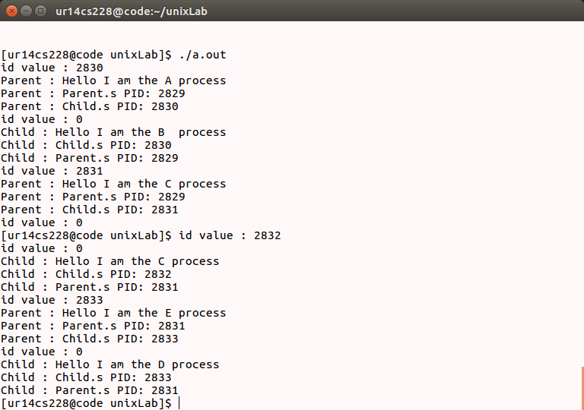
Result: .
The process creation is simulated.

