Ex. No. 9 | Interprocess Communication using Pipes
Date of Exercise | 27-03-2017 | Date of Upload | 03-04-2017

Aim :
To write a shell script to understand the usage of Interprocess Communication using Pipes
Video : https://youtu.be/PgVmZ7Vssvo
Algorithm:
1 – Named pipes
Step 1: check if file already exists
Step 2: Create a node using mknod
Step 3: Open the file created
Step 4: Ask user for input
Step 5: Write the buffer into the file
Step 6: Open the file using read permission
Step 7: Ouput the read data from file
Step 8: End
2 – Unamed pipes
Step 1: Create pipe using pipe system call
Step 2: Ask user for input
Step 3: Write into the file descriptor pointer
Step 4: Create a new process to read from the pipe
Step 5: Use fork() system call to create new process
Step 6: Read using the file descriptor pointer
Step 7: Ouput the read data
Step 8: End
Program:
1 – Named pipes
writeNamedPipe.c
#include<fcntl.h>
#include<stdio.h>
#include<sys/types.h>
void main() {
int id=mknod("pipe",0666,S_IFIFO);
if(id==0){
printf("Pipe Created \n ");
}
else {
printf("Pipe not created\n");
}
int fd=open("pipe",O_RDWR);
char buf[200];
printf("Enter String to be written : ");
scanf("%s",&buf);
write(fd,buf,sizeof(buf));
}
readNamedPipe.c
#include<fcntl.h>
#include<stdio.h>
#include<sys/types.h>
#include<string.h>
void main() {
int fd=open("pipe",O_RDWR);
char buf[100],buf2[100];
int fd2=read(fd,buf,10);
printf("String read from pipe:%s \n ",buf);
}
2 – Unamed pipes
#include<fcntl.h>
#include<stdio.h>
#include<sys/types.h>
void main(){
int fdptr[2];
int id=pipe(fdptr);
if(id==0){
printf("Pipe Created \n");
}
else{
printf("Pipe not Created \n");

}
char buf[100],buf2[100];
printf("Enter the String to be written : ");
scanf("%s",&buf);
write(fdptr[1],buf,sizeof(buf));
int pid=fork();
if(pid==0)
{
read(fdptr[0],buf2,10);
printf("String Read: %s \n",buf2);
}
}
Output:
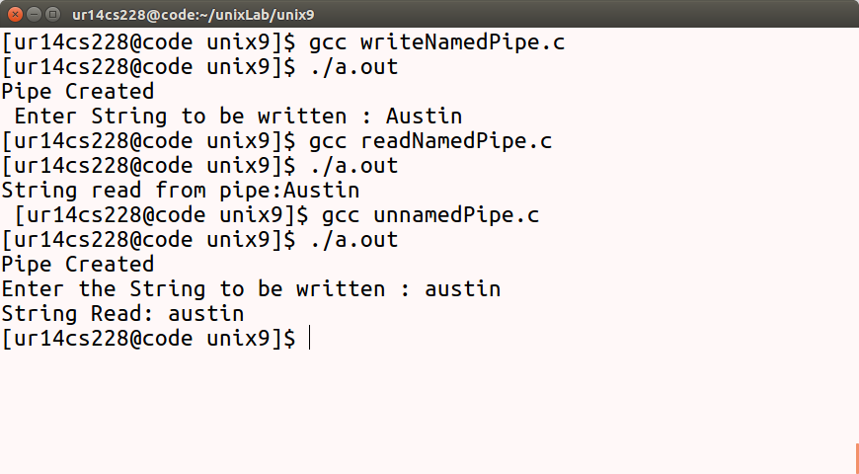
Result: .
The programs for library management system and Banking application is completed.

