Ex. No. 6 | JavaScript – Timer Functions and Objects
Date of Exercise | 22-08-2016 | Date of Upload | 28-10-2016

Aim
Build a Website using JavaScript – Timer Functions and Objects.
Program
HTML:
<!DOCTYPE html>
<html lang="en">
<head>
<title>Website</title>
<meta charset="utf-8">
<meta name="viewport" content="width=device-width, initial-scale=1.0">
<link rel="stylesheet" href="lab5.css">
<script src="new.js"></script>
<link rel="stylesheet" href="bootstrap.min.css">
<link rel="stylesheet" href="new.css">
</head>
<body>
<div class="nav">
<center><ul>
<li><a href="page1.html" style="text-decoration: none">Quest1</a></li>
<li><a href="page2.html" style="text-decoration: none">Quest2</a></li>
<li><a href="page3.html" style="text-decoration: none">Quest3</a></li>
<li><a href="page4.html" style="text-decoration: none">Quest4</a></li>
<li><a href="page5.html" style="text-decoration: none">Quest5</a></li>
</ul></center>
</div>
<div class="container">
<center><h1>Digital Clock</h1><br><br><br><br><br><br><br>
<span id="time" style="font-size:50px;"></span></center>
</div>
<script>
function display(){
var d = new Date();
document.getElementById('time').innerHTML = d.getHours()+":"+d.getMinutes()+""+":"+d.getSeconds();
}
setInterval("display()", 1000);
</script>

<div class="container">
<center><h1>Dynamic Background</h1></center>
<script>
//define function setBackgroundColor
function setBackgroundColor(){
var red = Math.floor(Math.random()*255);
var blue = Math.floor(Math.random()*255);
var green = Math.floor(Math.random()*255);
var color= "rgb("+red+","+green+","+blue+")";
document.getElementsByTagName("body")[0].style="background-color:"+color;
}
//call the setBackgroundColor function for every two seconds
setInterval("setBackgroundColor()", 300);
</script>
</div>

<div class="container">
<center><h1>Change font size</h1>
<p id="para1" onmouseover="incSize()" onmouseout="decSize()">
move cursor over me to zoom in...
</p></center>
<script>
//define function incSize
var ori = document.getElementById('para1').style.fontSize;
function incSize(){
document.getElementById('para1').style.fontSize = "50px";
}
function decSize(){
document.getElementById('para1').style.fontSize = ori;
}
//define function decSize
</script>
</div>

<div class="container">
<img src="car.png" id="myImage">
<br><br>
<input type="button" onclick="moveRight()" value="Start">
<input type="button" onclick="stop()" value="Stop">
<script>
var imgObj = null;
var animate;
imgObj = document.getElementById('myImage');
imgObj.style.position = 'relative';
imgObj.style.left = '0px';
function moveRight() {
imgObj.style.left = parseInt(imgObj.style.left) + 10 + 'px';
animate = setTimeout(moveRight, 200);
//call moveRight in 20msec
}
function stop()
{
clearTimeout(animate);
imgObj.style.left = '0px';
}
</script>
</div>

<div class="container">
<span id="boook"></span><br><br>
<span>Before 1980s: </span>
<span id="b"></span><br><br>
<span>After 1980s: </span>
<span id="a"></span>
<script>
var books = [
{ title: 'Book A',
author:'Author A',
Year:'2007'
},
{ title: 'Book B',
author:'Author B',
Year:'1940'
},
{ title: 'Book C',
author:'Author C',
Year:'1981'
},
{ title: 'Book D',
author:'Author D',
Year:'1990'
},
{ title: 'Book E',
author:'Author E',
Year:'1910'
}];
//Iterate through an array
var i=0;
while(i<books.length){
document.getElementById('boook').innerHTML += books[i].title+" by "+books[i].author+"<br />";
i++;
}
var i=0;
while(i<books.length){
if(parseInt(books[i].Year)<=1980){
console.log(parseInt(books[i].Year));
document.getElementById("b").innerHTML+=books[i].title;
document.getElementById("b").innerHTML+=' ';
}
else {
document.getElementById("a").innerHTML+=books[i].title;
document.getElementById("a").innerHTML+=' ';
}
i++;
}
</script>
</div>

</body>
</html>

Output
[Output snapshot here – all web pages]
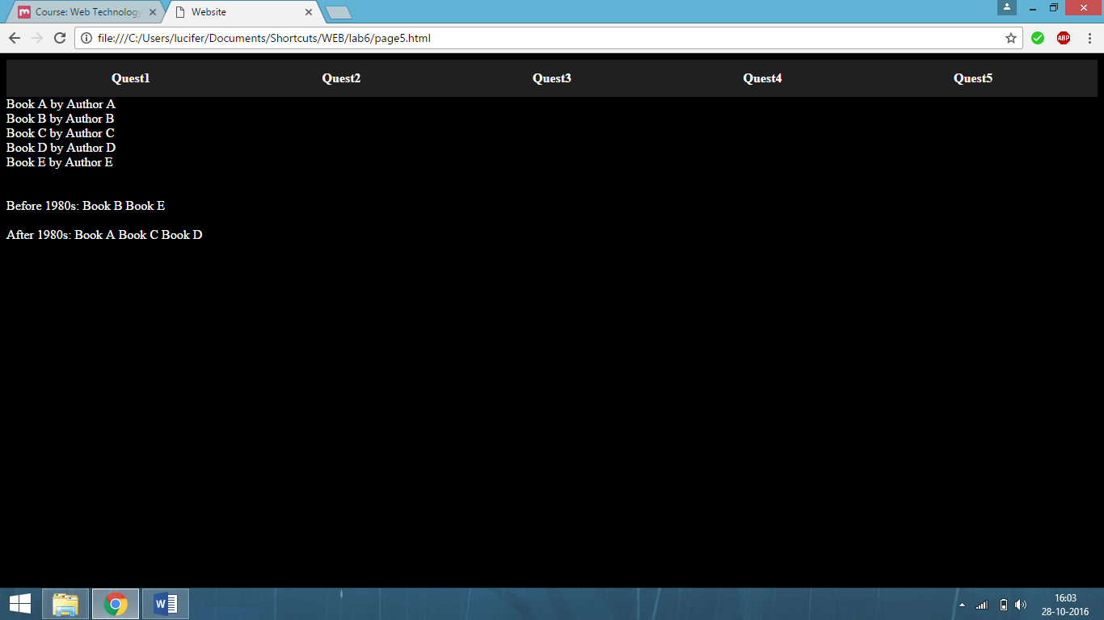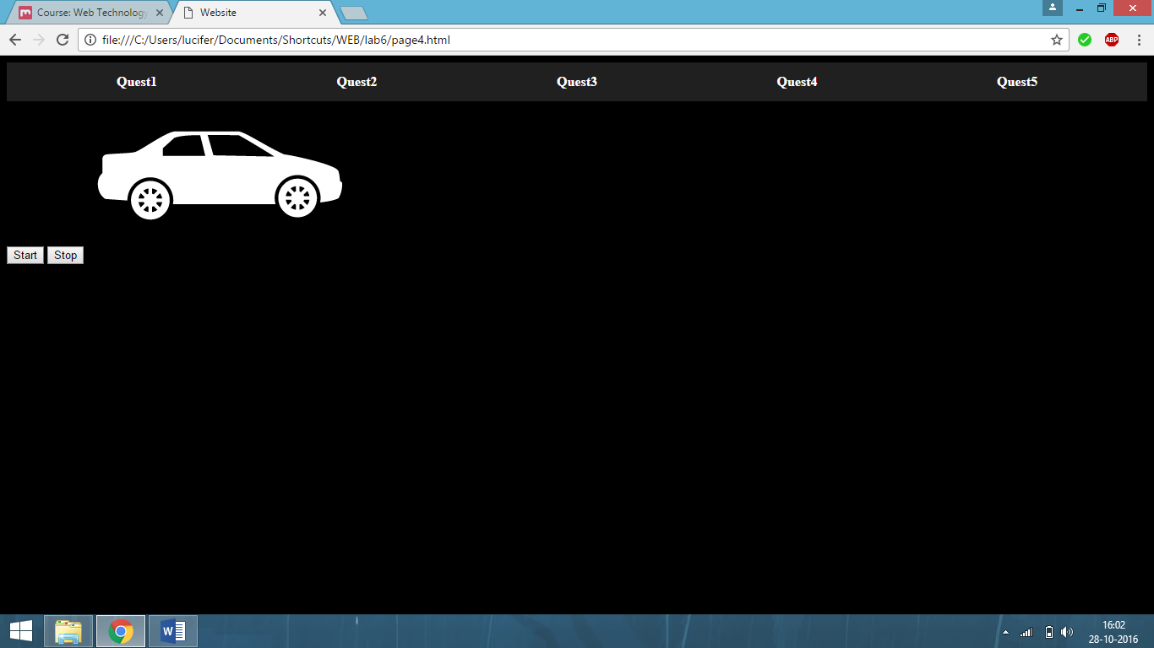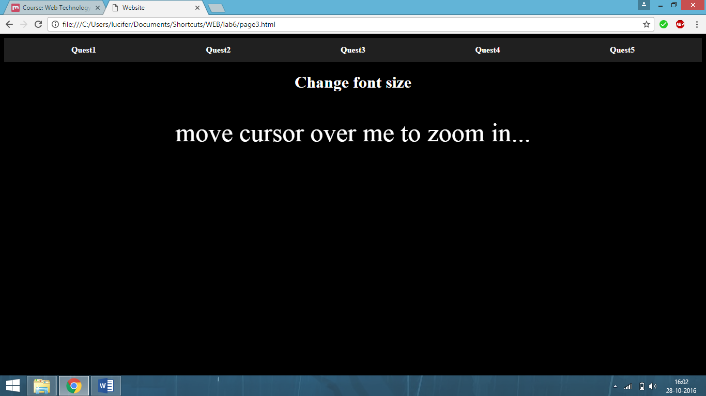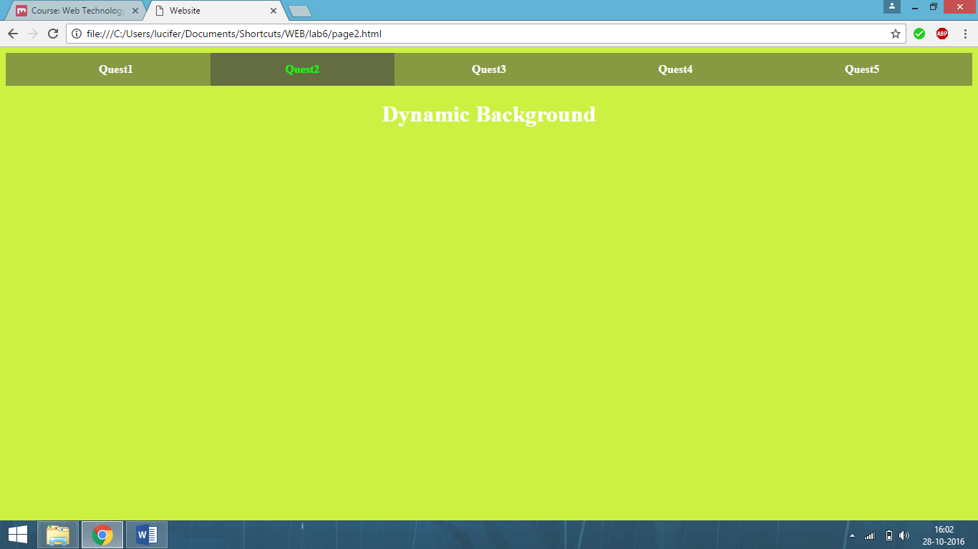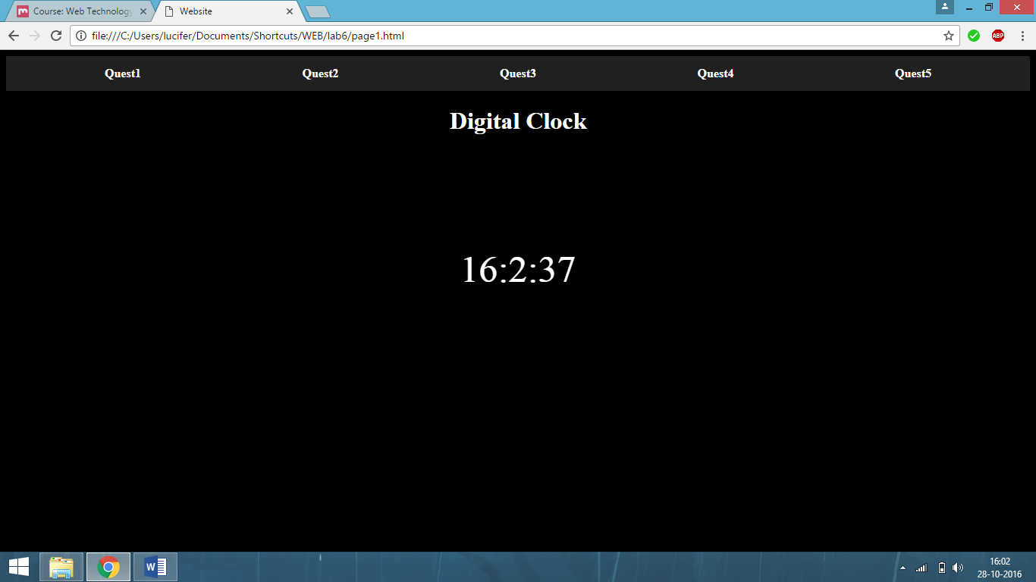

Result
The Lab experiment to Create a document that conforms javascript timer function has been done and verified.

[ lab-in charge:- Anitha Christy Angeline P.]

