Ex. No. 1 | Simple web design using HTML
Date of Exercise | 04-07-2016 | Date of Upload

Aim
Create a document that conforms to HTML5 standards and has the following elements.
Program
Youtube link : https://youtu.be/p0tYmUX6XzM
<!DOCTYPE html>
<html>
<head>
<title>maybe</title>
</head>
<body>
<h1>Heading 1</h1>
<div id="sb1">
<h2>Sub Heading 1</h2>
<p>Lorem ipsum dolor sit amet, consectetur adipisicing elit, sed do eiusmod
tempor incididunt ut labore et dolore magna aliqua. Ut enim ad minim veniam,
quis nostrud exercitation ullamco laboris nisi ut aliquip ex ea commodo
consequat. Duis aute irure dolor in reprehenderit in voluptate velit esse
cillum dolore eu fugiat nulla pariatur. Excepteur sint occaecat cupidatat non
proident, sunt in culpa qui officia deserunt mollit anim id est laborum.</p>
<p>External link-link to <a href="http://karunya.edu/cse/inde.php">http://www.karunya.edu/cse/inde.php</a></p>
<p>Internal link <a href="nextpage.html">nextpage.html</a></p>
<p>Email to : <a href="mailto:admin@myweb.com">send your feedbacks</a></p>
<p>Phone link : <a href="tel:293492349223">293492349223</a></p>
<p>Clickable image <a href="http://karunya.edu"><img src="images.png" width="10%"></a></p>
</div>

<!-- section 2 -->
<div id="sb2">
<h2>Sub Heading 2</h2>
<p>Lorem ipsum dolor sit amet, consectetur adipisicing elit, sed do eiusmod
tempor incididunt ut labore et dolore magna aliqua. Ut enim ad minim veniam,
quis nostrud exercitation ullamco laboris nisi ut aliquip ex ea commodo
consequat. Duis aute irure dolor in reprehenderit in voluptate velit esse
cillum dolore eu fugiat nulla pariatur. Excepteur sint occaecat cupidatat non
proident, sunt in culpa qui officia deserunt mollit anim id est laborum.</p>
<dl>
<dt>Php</dt>
<dd>Server side scripting language</dd>
<dt>Javascript</dt>
<dd>Client side scripting language</dd>
</dl>
<p>Complicated mixed list</p>
<ul>
<li>First item</li>
<ol>
<li>First utem of the nested list</li>
<li>second item</li>
<ul>
<li>even futher nested</li>
<li>one more</li>
<ol type="A">
<li>alpha numbered list</li>
<li>2nd alpha numbered list</li>
</ol>
</ul>
</ol>
</ul>
</div>

<!-- section 3 -->
<div id="sb3">
<h2>Sub Heading 3</h2>
<p>Lorem ipsum dolor sit amet, consectetur adipisicing elit, sed do eiusmod
tempor incididunt ut labore et dolore magna aliqua. Ut enim ad minim veniam,
quis nostrud exercitation ullamco laboris nisi ut aliquip ex ea commodo
consequat. Duis aute irure dolor in reprehenderit in voluptate velit esse
cillum dolore eu fugiat nulla pariatur. Excepteur sint occaecat cupidatat non
proident, sunt in culpa qui officia deserunt mollit anim id est laborum.</p>
<table border="1" bgcolor="BBE4F2">
<tr align="center">
<td>Row 1-Col 1</td>
<td>Row 1-Col 2</td>
<td>Row 1- Col 3</td>
<td rowspan="4">Row 1,2,3,4- Col 4</td> </tr>
<tr align="center">
<td>Row 2-Col 1</td>
<td colspan=2 rowspan="3">Row 2,3 & 4- Col2 & 3 </td>
</tr>
<tr> <td>Row 3-Col 1</td> </tr>
<tr> <td>Row 4-Col 1</td> </tr>
<tr align="center">
<td colspan="2">Row 5-Col 1 & 2</td>
<td colspan="2">Row 5- Col 3 & 4</td>
</tr>
<tr align="center">
<td colspan="4">Row 6-Col 1,2,3 & 4</td> </tr>
</table>
</div>
<hr>
<div>
<a href="#sb1">Sub heading 1</a>
<a href="#sb2">Sub heading 2</a>
<a href="#sb3">Sub heading 3</a>
</div>

</body>
</html>
Output
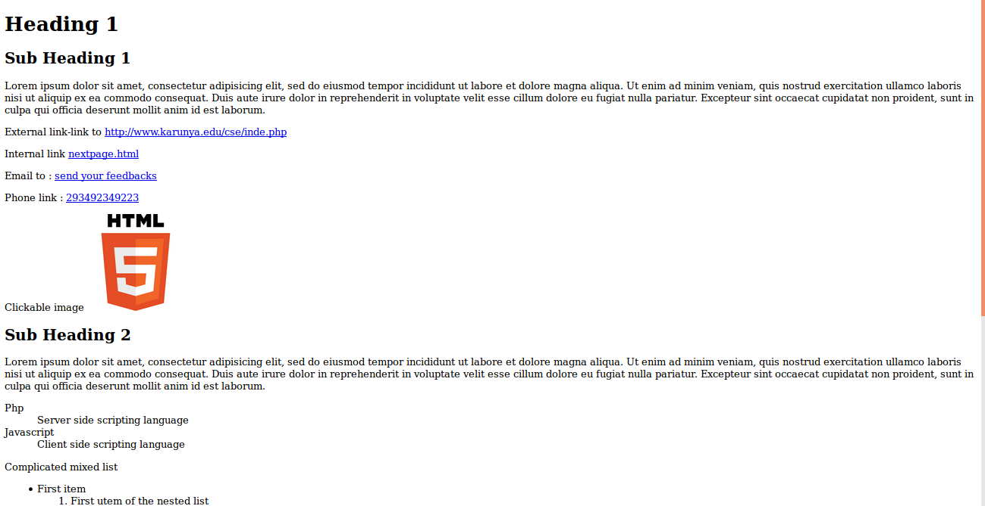
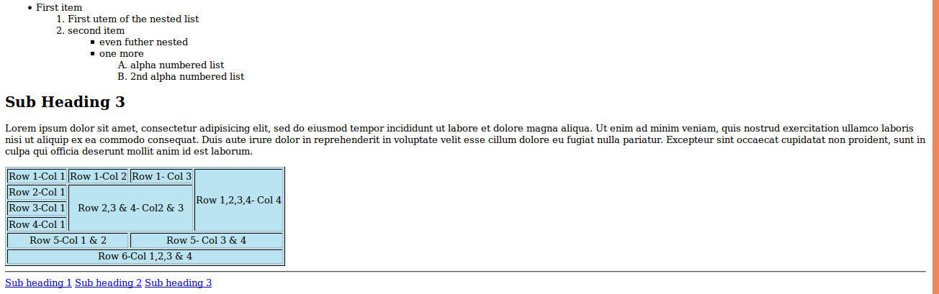
Result
[Result here]

[]
Result
The experiment has been successfully completed.

Staff : Mrs. Anitha Christy

