Ex. No. 3 | Design a webpage using HTML5 and CSS3
Date of Exercise | 22-08-2016 | Date of Upload | 03-09-2016

Aim
Create a webpage using proper HTML5 and CSS3. Page should have semantic tags header, section and footer.
Video URL : https://youtu.be/qvJpRJQD3tw
Program
<!DOCTYPE html>
<html>
<head>
<title>UR14CS228_ex3</title>
<meta charset="UTF-8">
<meta name="viewport" content="width=device-width, initial-scale=1.0">
<link rel="stylesheet" type="text/css" href="root.css">
</head>
<body>
<header><h1>Gru Labs</h1></header>

<nav>
<ul>
<li><a href="#">Home</a></li>
<li><a href="#">About Us</a></li>
<li><a href="#">Resource</a></li>
<li><a href="#">Download</a></li>
<li><a href="#">Contact</a></li>
</ul>
</nav>

<div id="content">

<div id="banner">
<img src="banner.jpg" alt="Banner image">
<h3></h3>
</div>

<div id="blocks-3">
<div class="imgs">
<a href="#">
<img alt="about image" src="about.jpg">
<h1> </h1>
<h3><a href="#">About Us</a></h3>
</a>
</div>

<div class="imgs">
<img alt="resoure image" src="1.jpg">
<h3><a href="#">Resource</a></h3>
</div>
<div class="imgs">
<img alt="Contact image" src="2.jpg">
<h3><a href="#">Contact Us</a></h3>
</div>
</div>

<divs>
<section>
<h3>Sub Heading-1</h3>
<p>Lorem ipsum dolor sit amet, consectetur adipiscing elit, sed do eiusmod tempor incididunt ut labore et dolore magna aliqua. Ut enim ad minim veniam, quis nostrud exercitation ullamco laboris nisi ut aliquip ex ea commodo consequat. Duis aute irure dolor in reprehenderit in voluptate velit esse cillum dolore eu fugiat nulla pariatur. Excepteur sint occaecat cupidatat non proident, sunt in culpa qui officia deserunt mollit anim id est laborum.Lorem ipsum dolor sit amet, consectetur adipiscing elit, sed do eiusmod tempor incididunt ut labore et dolore magna aliqua. Ut enim ad minim veniam, quis nostrud exercitation ullamco laboris nisi ut aliquip ex ea commodo consequat. Duis aute irure dolor in reprehenderit in voluptate velit esse cillum dolore eu fugiat nulla pariatur. Excepteur sint occaecat cupidatat non proident, sunt in culpa qui officia deserunt mollit anim id est laborum.</p>
</section>
<section>
<h3>Sub Heading-2</h3>
<p>Lorem ipsum dolor sit amet, consectetur adipiscing elit, sed do eiusmod tempor incididunt ut labore et dolore magna aliqua. Ut enim ad minim veniam, quis nostrud exercitation ullamco laboris nisi ut aliquip ex ea commodo consequat. Duis aute irure dolor in reprehenderit in voluptate velit esse cillum dolore eu fugiat nulla pariatur. Excepteur sint occaecat cupidatat non proident, sunt in culpa qui officia deserunt mollit anim id est laborum.Lorem ipsum dolor sit amet, consectetur adipiscing elit, sed do eiusmod tempor incididunt ut labore et dolore magna aliqua. Ut enim ad minim veniam, quis nostrud exercitation ullamco laboris nisi ut aliquip ex ea commodo consequat. Duis aute irure dolor in reprehenderit in voluptate velit esse cillum dolore eu fugiat nulla pariatur. Excepteur sint occaecat cupidatat non proident, sunt in culpa qui officia deserunt mollit anim id est laborum.</p>
</section>
</div>

</div>

<footer id="footer">
<h2>Address</h2><br>
<h4>Door No., Street Name, City, State-Pincode</h4>
</footer>

</body>
</html>
CSS STYLESHEET
*{
margin: 0;
padding: 0;
font-family: arial !important;
border: 0;
}

header{
padding: 30px;
text-align: center;
background-color: #30505C;
color: #fff;
}

nav{
text-align: center;
background-color: #555;
padding: 20px;
}

nav ul li{
display: inline-block;
}

nav ul li a{
padding: 20px 50px;
color: #ccc;
text-decoration: none;
}

nav ul li a:hover{
background-color: #333;
color: #fff;
}

img{
width: 100%;
height: 380px;
}

.imgs{
width: 29.333%;
margin: 2%;
float: left;
position: relative;
}

.imgs:hover{
opacity: 0.8;
background-color: #0C80A8;
}

.imgs h3{
background-color: #000;
opacity: 0.5;
padding: 20px 0 20px 0;
position: absolute;
width: 100%;
bottom: 0;
margin: 0;
text-align: center;
}
.imgs h3 a{
text-decoration: none;
color: #fff;
}

section{
width: 44%;
margin: 2%;
background-color: #13616A;
float: left;
padding:1%;
color: #fff;
}
section h3{
margin: 10px;
text-align: right;
font-size: 200%;
}
section p{
text-align: justify;
}

#footer{
padding: 2%;
text-align: center;
color: #fff;
background-color: #063140;
bottom: 0px;
}
#footer h2{
border-bottom: 2px solid #fff;
}
Output :
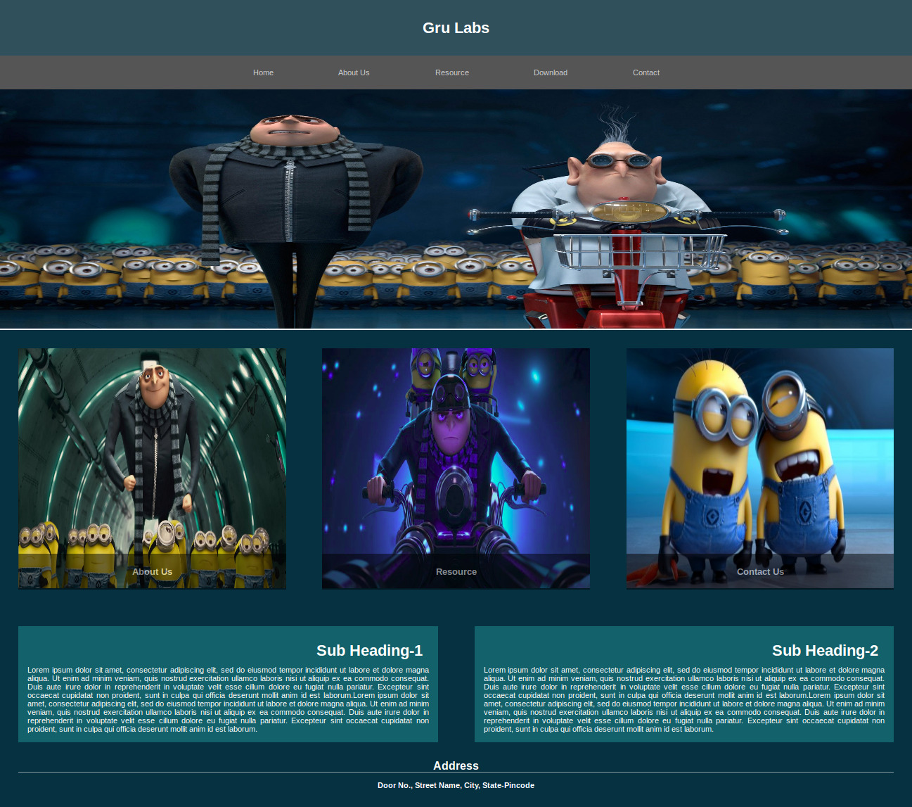
Result
The experiment has been successfully completed.

Staff : Mrs. Anitha Christy

