Ex. No. 4 | JavaScript – DOM Elements and Events
Date of Exercise | 10-10-2016 | Date of Upload | 28-10-2016

Aim
Create a webpage using proper HTML5 and CSS.
Video URL : https://youtu.be/BRQb_w6MSfI
Program
<!DOCTYPE html>
<html>
<head>
<title>Experiment 4</title>
<meta name="description" content="Web Technology Lab - Experiment 4">
<META HTTP-EQUIV="Content-Type" CONTENT="text/html; charset=utf-8">
<meta name="viewport" content="width=device-width, initial-scale=1.0">
<link rel="stylesheet" type="text/css" href="exp4.css">
</head>

<body>
<div class="banner">
<ul>
<li>
<a href="">Home</a>
</li>
<li>
<a href="">My Profile</a>
</li>
<li>
<a href="">Menu Item3</a>
</li>
<li>
<a href="">Menu Item4</a>
</li>
<li>
<a href="">Contact Us</a>
</li>
</ul>
<div class="percentage">
<img src="per.jpg">
</div>
<div class="myprofile">
Profile of <span>Austin</span>
</div>
<div class="lnr">
Learner
</div>
</div>
<section class="sec">
<section class="family">
<div class="heading">
My Family Members
</div>
<div class="col">
<div class="image dad">
<img src="cover.png" width="100%" height="100%" class="coverImg">
</div>
<div class="caption">
<h2>Father</h2>
<p>A really cool guy with great views about life. He tought me to have a goal and to enjoy working hard to achieve it. </p>
</div>
</div>
<div class="col">
<div class="image mom">
<img src="cover.png" width="100%" height="100%" class="coverImg">
</div>
<div class="caption">
<h2>Mother</h2>
<p>She showed me what love is and tought me to take care of family. </p>
</div>
</div>
<div class="col">
<div class="image bro">
<img src="cover.png" width="100%" height="100%" class="coverImg">
</div>
<div class="caption">
<h2>Brother</h2>
<p>A crazy guy who is in mad persuit of his dreams.</p>
</div>
</div>
</section>
<section class="fav">
<div class="heading">
My Favorites
</div>
<div>
<table>
<th>
My Favorite Food
</th>
<tr>
<td class="itemName">
Puttu
</td>
<td class="itemImg">
<img src="x .jpg" alt="Image comes here" width="100%" height="100%">
</td>
</tr>
<tr>
<td class="itemName">
Mango
</td>
<td class="itemImg">
<img src="mango.jpg" alt="Image comes here" width="100%" height="100%">
</td>
</tr>
<tr>
<td class="itemName">
French toast
</td>
<td class="itemImg">
<img src="toast.jpg" alt="Image comes here" width="100%" height="100%">
</td>
</tr>
<tr>
<td class="itemName">
Biriyani
</td>
<td class="itemImg">
<img src="biriyani.jpg" alt="Image comes here" width="100%" height="100%">
</td>
</tr>
<tr>
<td class="itemName">
Fruit salad
</td>
<td class="itemImg">
<img src="fruitsalad.jpg" alt="Image comes here" width="100%" height="100%">
</td>
</tr>
</table>
</div>
</section>
</section>
</body>
</html

CSS STYLESHEET
*
{
margin: 0;
padding: 0;
border: 0;
}

.banner
{
width: 100%;
height: 500px;
background-image: url('1.jpg');
background-repeat: no-repeat;
background-size: 100%;
}
ul
{
position: fixed;
z-index: 1;
width: 100%;
opacity: .8;
background-color: black;
}
li
{
font-family: Helvetica;
font-size: 25px;
font-weight: bold;
float: left;
width: 20%;
padding: 10px 0;
list-style-type: none;
text-align: center;
color: grey;
background-color: white;
}
li:hover
{
cursor: pointer;
color: rgba(255,255,255,.5);
border-bottom: 2px solid grey;
background-color: #f88;
}
.banner a
{
text-decoration: none;
color: grey;
}
.percentage
{
position: relative;
top: 55px;
float: right;
width: 30%;
}
.percentage img
{
width: 100%;
height: 250px;
opacity: .8;
border-left: 2px dashed black;
}
.myprofile
{
font-size: 25px;
position: relative;
top: 55px;
float: left;
width: 70%;
height: 50px;
padding: 15px 0 10px 0;
text-align: center;
opacity: .8;
border-right: 2px dashed black;
background-color: white;
}
.myprofile span
{
font-size: 35px;
margin-left: 10px;
text-transform: uppercase;
text-shadow: 2px 2px 2px black;
}
.lrn
{
font-size: 30px;
font-style: bolder;
position: relative;
top: 50px;

float: right;
width: 30%;
height: 18%;
padding-top: 35px;
text-align: center;
text-transform: uppercase;
opacity: .8;
color: GREY;
border-left: 2px dashed black;
background-color: white;
text-shadow: 2px 2px 2px black;
}
.lrn:first-letter
{
font-size: 60px;
}
.col
{
float: left;
width: 33%;
}
.sec
{
height: auto;
background-image: url(family.jpg);
background-size: 100%;
}
.family .heading
{
font-size: 30px;
padding: 30px;
opacity: .8;
color: white;
border-top: 5px solid white;
border-bottom: 5px solid white;
background-color: black;
}
.fav .heading
{
font-size: 30px;
position: relative;
margin-top: 400px;
padding: 30px;
opacity: .8;
color: white;
border-top: 5px solid white;
border-bottom: 5px solid white;
background-color: black;
}
.image
{
z-index: 1;
width: 150px;
height: 150px;
margin-top: 50px;
margin-left: 150px;
text-align: center;
border: 3px solid black;
border-radius: 50%;
background-color: white;
box-shadow: 5px 8px 5px black;
}
.coverImg{
opacity: 0.5;
z-index: 1;
border-radius: 50%;
}
.coverImg:hover{
opacity: 0;
}
.mom
{
background-image: url(mom.png);
background-repeat: no-repeat;
background-position: center;
background-size: 60%;
}
.dad
{
background-image: url(dad.jpg);
background-repeat: no-repeat;
background-position: center;
background-size: 70%;
}
.bro
{
background-image: url(bro.jpg);
background-repeat: no-repeat;
background-position: center;
background-size: 90%;
}
.caption
{
padding: 15px 100px 0 100px;
text-align: center;
}
.caption h2
{
color: turquoise;
text-shadow: 2px 2px 2px black;
}
table
{
width: 50%;
margin-top: 50px;
margin-left: 400px;
color: #022;
border: 3px solid black;
border-radius: 20px;
background-color: white;
box-shadow: 3px 3px black;
}
th{
text-align: center;
padding-left: 150px;
}
tr:nth-child(odd)
{
height: 60px;
background-color: white;
}
tr:nth-child(even)
{
height: 60px;
background-color: grey;
}
tr:first-child
{
font-size: 30px;
height: 80px;
}
td:first-child{
padding-left: 60px;
font-size: 25px;
width: 80%;
}
td{
height: 80px;
}
.itemImg{
opacity :0.2;
}
.itemName:hover,.itemName:hover+.itemImg, .itemImg:hover{
opacity: 1;
font-weight: bolder;

}
Output :
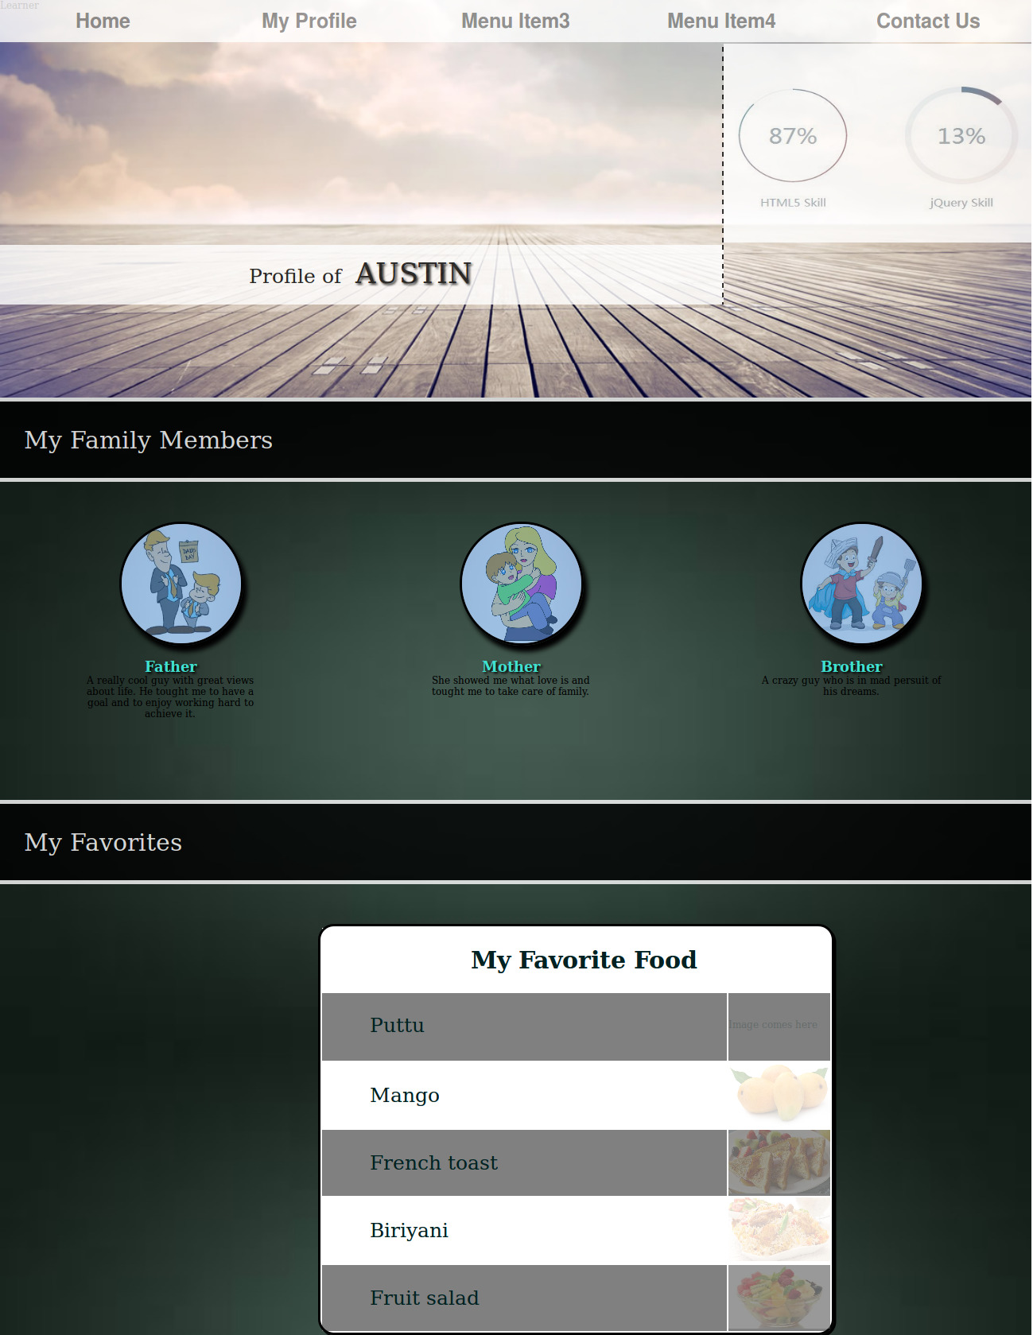

Result
The experiment has been successfully completed.

Staff : Mrs. Anitha Christy

