Ex. No. 5 | JavaScript – DOM Elements and Events
Date of Exercise | 10-10-2016 | Date of Upload | 28-10-2016

Aim
Create javascript functions to perform the following tasks.
Video URL : https://youtu.be/88pwzkPOSuA
Program
- Write a function that accepts a string as a parameter and find the shortest and longest word within the string.
<!DOCTYPE html>
<meta charset="utf-8">
<html>
<head>
<title>
Javascript
</title>
</head>
<body>
<p>Enter the string </p>
<input type="text" id="entry">
<input type="submit" value="submit" onclick="forward()">
<p>Longest: <span id="large"> </span> <br> Shortest: <span id="small"></span> </p>

<script type="text/javascript">
var forward = function (){
var data= document.getElementById("entry").value;
lenFinder(data);
}
var lenFinder = function(data){
var ar = data.split(" ");
var small=ar[0];
var large=ar[0];
for(var a=0;a<ar.length;a++){
if(ar[a].length>large.length){
large=ar[a]
}
if(ar[a].length<small.length){
small=ar[a]
}
}
document.getElementById("large").innerHTML=large;
document.getElementById("small").innerHTML=small;
}
</script>

</body>
</html>

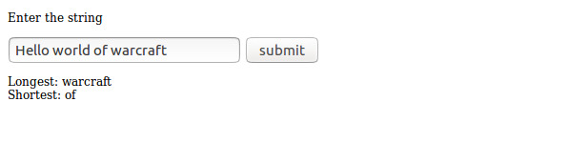
2. Write thecalculate() function that takes the weight and height in the text boxes and displays the BMI in the span with the id of “score.”

<!DOCTYPE html>
<meta charset="utf-8">
<html>
<head>
<title>

</title>
</head>
<body>

<h1>Calculate your Body Mass Index (BMI)!</h1>
<fieldset>
Weight (in kilograms): <input type="text" id="weight" /><br />
Height (in meters): <input type="text" id="height" /><br />
<button onclick="calculate();">Get BMI!</button>
</fieldset>
<p>
Your BMI is <span id="score"></span>. <br />
Your body type is <span id="type"></span>.
</p>

<script type="text/javascript">var calculate= function(){
var w=document.getElementById("weight").value;
var l=document.getElementById("height").value;

var bmi=w/(l*l);

document.getElementById('score').innerHTML=bmi;

var type="";
if(bmi<18)
type='Underweight';
else if(bmi>18 && bmi<25)
type='Normal';
else if(bmi>25 && bmi<30)
type='Overweight'
else
type='Obese';
document.getElementById('type').innerHTML=type;
}
</script>

</body>
</html>

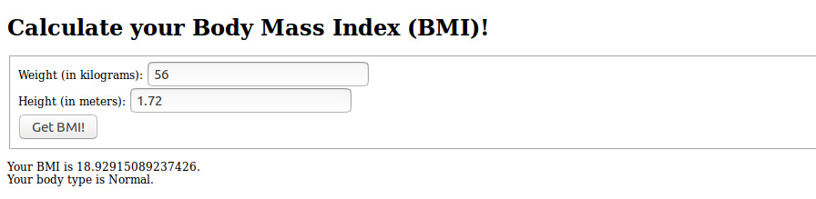
3. When you click the “Plant Garden” button, the page should generate a rectangular grid of fruit images in the div with the id of “garden.”

<!DOCTYPE html>
<meta charset="utf-8">
<html>
<head>
<title>

</title>
</head>
<body>

<h1>Fruit Farm</h1>
<div>
Rows: <input type="text" id ="rows" value="2" />
Columns: <input type="text" id ="columns" value="2" /> <br />
<button onclick="grow();">Plant Garden</button>
</div>
<div id="garden"></div>

<script type="text/javascript">
var grow = function(){
document.getElementById("garden").innerHTML="";

var rows= document.getElementById("rows").value;
var col= document.getElementById("columns").value;

var ac=0,oc=0;
var slots= rows*col;

for(var i=0;i<rows;i++){
for(var j=0;j<col;j++){
var choice= Math.round(Math.random()+1)

if(choice==1 && ac<(slots/2)){
document.getElementById("garden").innerHTML += "<img src= Apple.jpg width =100px height= 100px>"
ac++;
}
else if(choice==2 && oc<(slots/2)){
document.getElementById("garden").innerHTML += "<img src= orange.jpg width =100px height= 100px>"
oc++;
}
else if(choice==2 && ac<=(slots/2)){
document.getElementById("garden").innerHTML += "<img src= Apple.jpg width =100px height= 100px>"
ac++
}
else {
document.getElementById("garden").innerHTML += "<img src= orange.jpg width =100px height= 100px>"
oc++;
}
}

document.getElementById("garden").innerHTML += "<br/>"
}
}

</script>

</body>
</html>
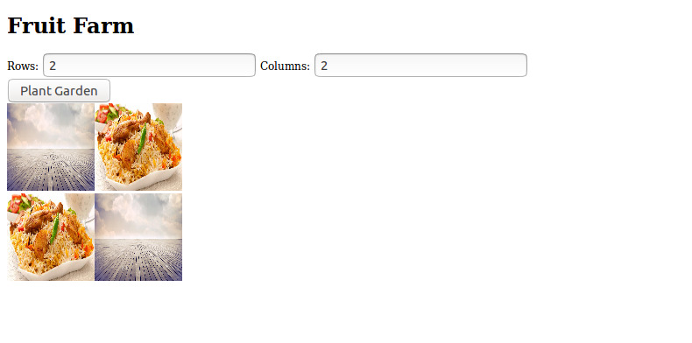
4. Write the convert() function that takes the value in the text input and converts it from the unit selected in the left dropdown box to the unit selected on the right. The unit should be displayed in the empty span with the id of “answer.”

<!DOCTYPE html>
<meta charset="utf-8">
<html>
<head>
<title>

</title>
</head>
<body>

<fieldset> Convert <input type="text" id="data" />
<select id="from">
<option>Indian Rupee</option>
<option>US Dollar</option>
</select>
to
<select id ="to">
<option> US Dollar </option>
<option> Indian Rupee </option>
</select>
<button onclick="convert();">Calculate</button> <br><br> <p>Answer : <span id="answer"></span> </p>
</fieldset>

<script type="text/javascript">
var convert=function(){
var f=document.getElementById("from").selectedIndex;
var t=document.getElementById("to").selectedIndex;

var amnt=document.getElementById("data").value;

if(f==0&&t==0){
console.log("Inidan to US")
amnt=amnt/60;
}

if(f==1&&t==1){
console.log("us to India")
amnt=amnt*60;
}

document.getElementById("answer").innerHTML=amnt;

}
</script>

</body>
</html>
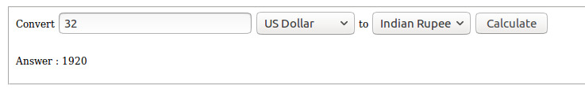

5. The image should change to the heads or tails picture with equal probability. Keep track of how many flips have resulted in heads and tails and report the results beneath the button in two spans with ids "num_heads" and "num_tails" respectively.

<!DOCTYPE html>
<meta charset="utf-8">
<html>
<head>
<title>

</title>
</head>
<body>
<p>Enter the string </p>
<h1>Heads or Tails?</h1>
<div>
<img src="head.jpg" width="100px" id="coin" /> <br />
<button id="flip" onclick="flip()">Flip!</button>
</div>
<p>
Heads Total: <span id="num_heads">0</span><br />
Tails Total: <span id="num_tails">0</span>
</p>

<script type="text/javascript">
var hn=0,tn=0;
var flip=function(){
if(document.getElementById('coin').src=="file:///home/austin/Documents/Learn/karunya/webLab/Ex5/head.jpg"){
document.getElementById('coin').src="tail.jpg";
tn++;
}
else{
document.getElementById('coin').src="head.jpg";
console.log(document.getElementById('coin').src)
hn++;

}
document.getElementById("num_tails").innerHTML=tn;
document.getElementById("num_heads").innerHTML=hn;
}
</script>

</body>
</html>

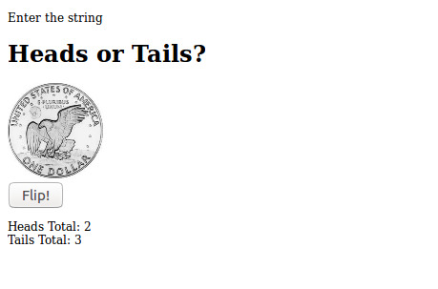

6. A 1/2kg cake is Rs.100, a 1kg cake is Rs.200 and a 2kg cake is Rs.400. Tax is an additional 9% to the order. The user must also pay a tip from 10-20% of the total cost of the order after tax. Write the JavaScript code necessary to calculate and display the total cost of the order in the span with the id of “price” when the user clicks the “Calculate Order” button.

<!DOCTYPE html>
<meta charset="utf-8">
<html>
<head>
<title>

</title>
</head>
<body>

<h1>Pizza Order Form</h1>
<fieldset>
# of 1/2kg Cakes <input type="text" id="small" /><br />
# of 1kg Cakes <input type="text" id="medium" /><br />
# of 2kg Cakes <input type="text" id="large" /><br />
Tip:
<label><input type="radio" value="10" name="tip" /> 10%</label>
<label><input type="radio" value="15" name="tip" checked="checked" /> 15% </label>
<label><input type="radio" value="20" name="tip" /> 20%</label> <br />
<button id="submit" onclick="cal()">Calculate Order</button>
</fieldset>
<p>
Cost of order: <span id="price"></span>
<p>

<script type="text/javascript">

var cal=function(){
var cost=(document.getElementById("small").value*100)+(document.getElementById("medium").value*200)+(document.getElementById("large").value*400);
cost=cost*1;
cost=cost+(cost*0.09);
cost= cost+(cost*(document.querySelector('input[name="tip"]:checked').value/100));
document.getElementById("price").innerHTML=cost;
}
</script>

</body>
</html>
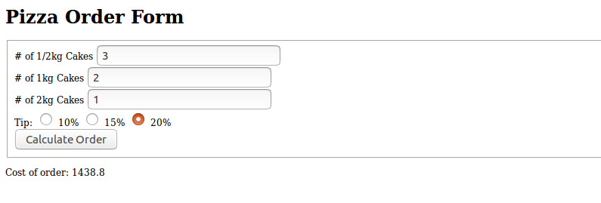

Result
The experiment has been successfully completed.

Staff : Mrs. Anitha Christy

