Ex. No. 2 | Working with HTML5 Form and Media Elements
Date of Exercise | 18-07-2016 | Date of Upload | 22-08-2016

Aim
Build a site that conforms to HTML5 standards and has the following elements:
doctype, html, meta (in the revised html5 format), title, body, head, div, p, headings, image, anchor, table ,audio, video, iframe, form, input, select, progress, fieldset, label, html comment..
Video URL : https://youtu.be/YMmIi5xZemU
Program
<!DOCTYPE html>
<html>
<head>
<meta charset="UTF-8">
<meta name="viewport" content="width=device-width, initial-scale=1.0">
<title>maybe</title>
</head>
<body>
<header>
<table>
<tr align="center" wi>
<td width="40%"></td>
<td width="10%"><img src="images.png" width="100%" alt="logo"></td>
<td width="10%"><h1>welcome</h1></td>
<td width="40%"></td>
</tr>
</table>
</header>
<hr>
<table>
<tr>
<td width="25%" align="center"><a href="">Link 1</a></td>
<td width="25%" align="center"><a href="">Link 2</a></td>
<td width="25%" align="center"><a href="">Link 3</a></td>
<td width="25%" align="center">|</td>
<td width="25%" align="right"><input type="search" name="searchbox" placeholder="Search"/></td>
</tr>
</table>
<hr>
<table cellpadding="10%">
<tr>
<td width="50%">
<video width="100%" height="70%" controls>
<source src="vi.mp4" type="video/mp4">
Your browser does not support the video tag
</video>
</td>
<td width="50%">
<p>Lorem ipsum dolor sit amet, consectetur adipiscing elit, sed do eiusmod tempor incididunt ut labore et dolore magna aliqua. Ut enim ad minim veniam, quis nostrud exercitation ullamco laboris nisi ut aliquip ex ea commodo consequat. Duis aute irure dolor in reprehenderit in voluptate velit esse cillum dolore eu fugiat nulla pariatur. Excepteur sint occaecat cupidatat non proident, sunt in culpa qui officia deserunt mollit anim id est laborum. Lorem ipsum dolor sit amet, consectetur adipisicing elit, sed do eiusmod tempor incididunt ut labore et dolore magna aliqua. Ut enim ad minim veniam,quis nostrud exercitation ullamco laboris nisi ut aliquip ex ea commodo consequat. Duis aute irure dolor in reprehenderit in voluptate velit essecillum dolore eu fugiat nulla pariatur. Excepteur sint occaecat cupidatat non proident, sunt in culpa qui officia deserunt mollit anim id est laborum.</p>
<audio controls loop="loop">
<source src="audio.mp3" type="audio/mpeg"> </audio>
</td>
</tr>
</table>
<hr>
<table cellpadding="10">
<tr>
<td width="35%">
<form action="exp2_2.htm" method="GET">
<fieldset>
<LEGEND>Sign up</LEGEND>
<label>Username : <input type="text" placeholder="username"></label><br><br>
<label>Password : <input type="text" placeholder="password"></label><br><br>
<input type="submit" value="Submit">
</fieldset>
</form>
</td>
<td width="10%"></td>
<td width="30%">
<h3>Contact us</h3>
<p>Address line 1:</p>
<p>Address line 2:</p>
<p>Address line 3:</p>
<p>Mail id: <a href="mailto:aaa@linux.org">aaa@linux.org</a></p>
<p>Phone no: <a href="tel:+91999999999">(+91) (99999 99999)</a></p>
</td>
<td width="25%">
<div>
<iframe src="https://www.google.com/maps/embed?pb=!1m14!1m8!1m3!1d15669.439531477268!2d76.744061!3d10.936164!3m2!1i1024!2i768!4f13.1!3m3!1m2!1s0x0%3A0xc650b8a75e7b51f0!2sKarunya+University!5e0!3m2!1sen!2sin!4v1472366870720" width="400" height="300" frameborder="0" style="border:0" allowfullscreen></iframe>
</div>
</td>
</tr>
</table>
</body>
</html>
2nd page
<!DOCTYPE html>
<html>
<head>
<meta charset="UTF-8">
<meta name="viewport" content="width=device-width, initial-scale=1.0">
<title>Experiment 2_2</title>
</head>
<body>

<form method="post" action="#">
<h1>Submit Your Resume</h1>
<fieldset>
<legend>Personal Details</legend>
<table>
<tr>
<td> <label>*First Name: </label> </td>
<td> <input type="text" placeholder="Enter your first name" required> </td>
</tr>
<tr>
<td> <label>*Middle Name: </label> </td>
<td> <input type="text" placeholder="Enter your middlename" required> </td>
</tr>
<tr>
<td> <label>*Last Name: </label> </td>
<td> <input type="text" placeholder="Enter your last name" required></td>
</tr>
<tr>
<td> <label>Date of Birth: </label></td>
<td> <input type="date" name="bday"> </td>
</tr>
<tr>
<td> <label>Age in Years: </label> </td>
<td><input type="number" min="18" max="30" placeholder="<30 & >18"></td>
</tr>
<tr>
<td> <label>Gender: </label> </td>
<td><input type="radio" name="gender" value="male" checked>Male <input type="radio" name="gender" value="female">Female
</td>
</tr>
</table>
</fieldset>

<br>
<progress value="20" max="100" style="width:500px; height:20px;"></progress>
<br>
<br>

<fieldset>
<legend>Address Details</legend>
<table>
<tr>
<td> <label>Address: </label></td>
<td><textarea rows="4" cols="50"></textarea></td>
</tr>
<tr>
<td> <label>City/Town: </label> </td>
<td> <input type="text"></td>
</tr>
<tr>
<td><label>State: </label></td>
<td><input type="text"> </td>
</tr>
<tr>
<td>
<label>Zip Code: </label>
</td>
<td>
<input type="number" pattern="[0-9]{6}" placeholder="Only 6 numbers">
</td>
</tr>
</table>
</fieldset>

<br><br>
<progress value="40" max="100" style="width:500px; height:20px;"></progress>
<br><br>

<fieldset>
<legend>Contact Information</legend>
<table>
<tr>
<td>
<label>Telephone: </label>
</td>
<td>
<input type="number" pattern="[)][0-9][)][0-9]{3}[-][0-9]{4}" placeholder="(044)999-9999">
</td>
</tr>
<tr>
<td>
<label>*Mobile: </label>
</td>
<td>
<input type="number" pattern="[(][+][0-9]{2}[)][0-9]{5}[-][0-9]{5}" placeholder="(+91)99999-99999" required>
</td>
</tr>
<tr>
<td>
<label>*Email: </label>
</td>
<td>
<input type="email" placeholder="valid email">
</td>
</tr>
<tr>
<td>
<label>Website: </label>
</td>
<td><input type="url" placeholder="valid url">
</td>
</tr>
</table>
</fieldset>

<br><br>
<progress value="40" max="100" style="width:500px; height:20px;"></progress>
<br><br>

<fieldset>
<legend>Education Details</legend>
<table border="1">
<tr>
<td>Qualification</td>
<td>Board/Univeresity</td>
<td>Country</td>
<td>Starting Year</td>
<td>Ending Year</td>
<td>Percentage</td>
</tr>
<tr>
<td>
<input type="checkbox" name="option1" value="10th" checked="checked">10th
</td>
<td>
<input type="text" placeholder="Board/University">
</td>
<td>
<select>
<option value="Choose">Choose</option>
<option value="India">India</option>
<option value="USA">USA</option>
<option value="UK">UK</option>
<option value="Paris">Paris</option>
<option value="Canada">Canada</option>
</select>
</td>
<td>
<input type="date" name="startingyear">
</td>
<td>
<input type="date" name="endingyear">
</td>
<td>
<input type="number" min="0" max="100" placeholder="70">
</td>
</tr>
<tr>
<td>
<input type="checkbox" name="option2" value="11th" checked="checked">11th
</td>
<td>
<input type="text" placeholder="Board/University">
</td>
<td>
<select>
<option value="Choose">Choose</option>
<option value="India">India</option>
<option value="USA">USA</option>
<option value="UK">UK</option>
<option value="Paris">Paris</option>
<option value="Canada">Canada</option>
</select>
</td>
<td>
<input type="date" name="startingyear">
</td>
<td>
<input type="date" name="endingyear">
</td>
<td>
<input type="number" min="0" max="100" placeholder="70">
</td>
</tr>
<tr>
<td>
<input type="checkbox" name="option3" value="B.Tech">B.Tech
</td>
<td>
<input type="text" placeholder="Board/University">
</td>
<td>
<select>
<option value="Choose">Choose</option>
<option value="India">India</option>
<option value="USA">USA</option>
<option value="UK">UK</option>
<option value="Paris">Paris</option>
<option value="Canada">Canada</option>
</select>
</td>
<td>
<input type="date" name="startingyear">
</td>
<td> <input type="date" name="endingyear"></td>
<td><input type="number" min="0" max="100" placeholder="70"></td>
</tr>
<tr>
<td><input type="checkbox" name="option4" value="M.Tech">M.Tech </td>
<td><input type="text" placeholder="Board/University"></td>
<td>
<select>
<option value="Choose">Choose</option>
<option value="India">India</option>
<option value="USA">USA</option>
<option value="UK">UK</option>
<option value="Paris">Paris</option>
<option value="Canada">Canada</option>
</select>
</td>
<td>
<input type="date" name="startingyear">
</td>
<td>
<input type="date" name="endingyear">
</td>
<td>
<input type="number" min="0" max="100" placeholder="70">
</td>
</tr>
</table>
</fieldset>

<br><br>
<progress value="80" max="100" style="width:500px; height:20px;"></progress>
<br>
<br><br>

<fieldset>
Attach your resume in .doc or .pdf format: <input type="file" name="resume" accept=".doc | .pdf"><br>
<input type="checkbox" name="details" value="filled" required>I filled all the details<br>
</fieldset>

<br><br>
<progress value="100" max="100" style="width:500px; height:20px;"></progress>
<br>
<br><br>
<table align="center">
<tr>
<td>
<input type="submit" name="" value="Submit">
</td>
</tr>
</table>
</form>
</body>
</html>
Output
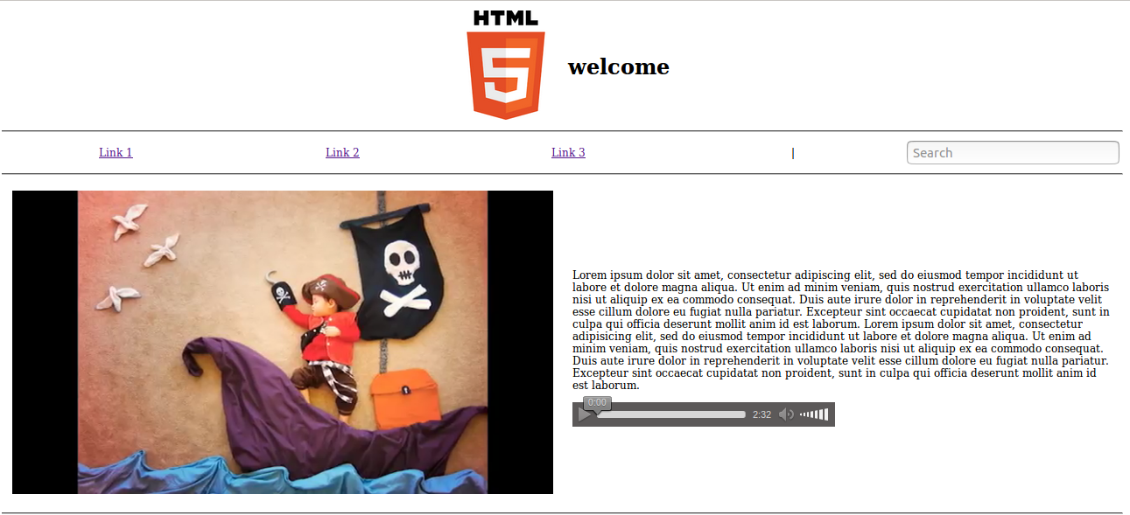
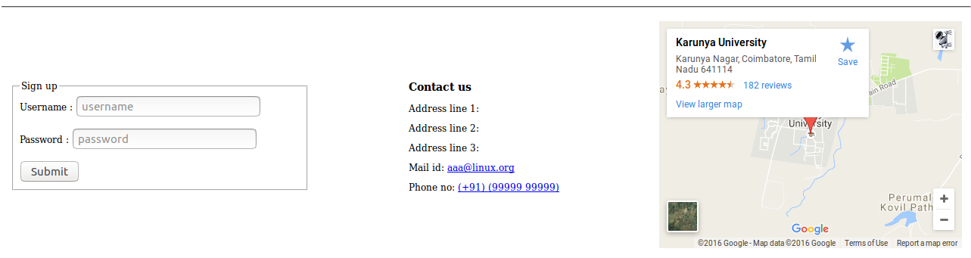
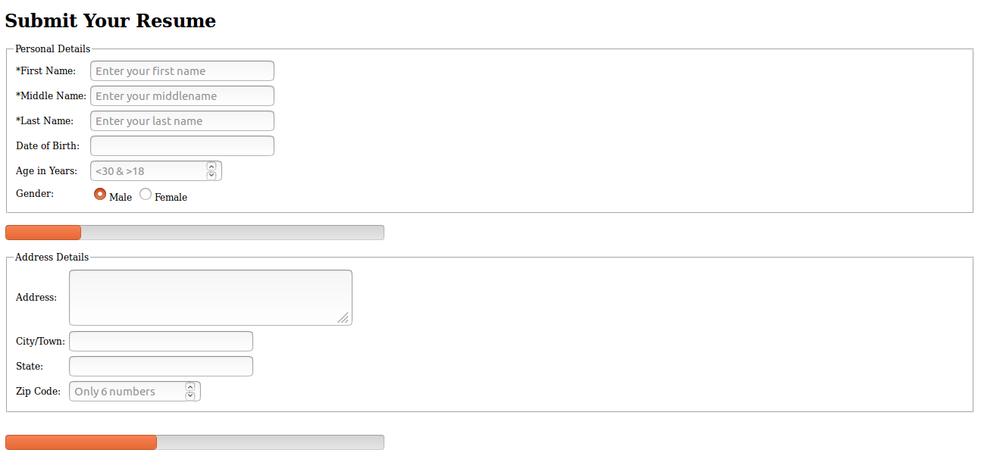

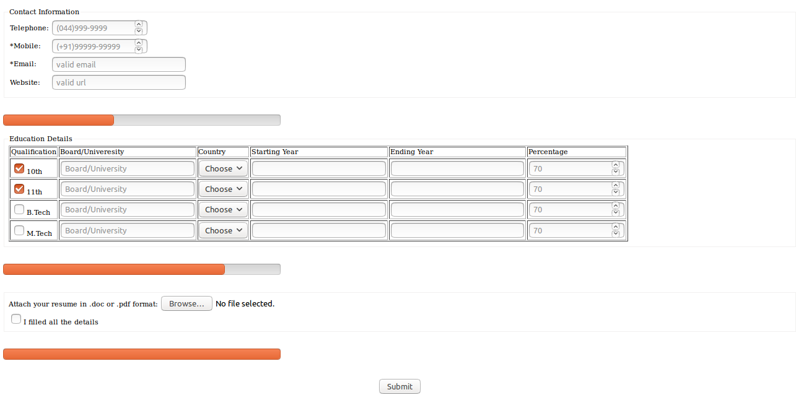
Result
The experiment has been successfully completed.

Staff : Mrs. Anitha Christy

