Practical assignments

Algorithms

**Assignment No.1 (10min)**

The algorithm is the list with actions that are needed to get the goal.

For example, to bake a cake

* Buy all ingredients;
* Mix together all ingredients in the bowl;
* Preheat the oven to 175°C.
* Put mixed ingredients in the oven for 40min.
* Eat a cake!

Or use this recipe for advance example:

<https://www.bbcgoodfood.com/recipes/angel-cake-meringue-icing-strawberry-ganache>

1. collect all ingredients;
2. heat the oven;
3. mix egg whites and sugar in stand mixer;
4. when finished mixing after 2 minutes add lemon juice, vanilla, pinch of salt;
5. after adding mentioned above mix again till shiny;
6. fold flour with spatula until no lumps;
7. scrape the mixture into a 25cm angel cake tin;
8. bake 40-45 mins, till cake puffed and lightly browned;
9. Turn the tin upside down – if it doesn’t have its own legs, then invert it onto four water glasses or tins of food exactly the same size. Leave to cool completely.;
10. Run a palette knife around the tin to loosen the cake and gently let it drop out;
11. then set aside on a board or cake stand;
12. make the meringue icing:
13. put the egg whites, sugar, vanilla, pinch of cream of tartar and 100ml water in a large heatproof bowl;
14. set over a pan of simmering water and beat it on high speed with an electric whisk for 15 mins or until thick and shiny and standing up in stiff peaks;
15. Ice the cake straight away as the icing will stiffen as it sets;
16. Spread over using a palette knife or use a piping bag to pipe on swirls;
17. Put the iced cake in the fridge while you make the strawberry ganache.
18. Put the white chocolate in a small heatproof bowl and set aside.
19. Put the cream and strawberries in a saucepan over a medium heat and cook, stirring all the time, until the strawberries have broken down and the cream starts to simmer;
20. Quickly pour the hot cream mixture over the white chocolate and leave it, without stirring, for 1 min, then add the food coloring and mix until smooth;
21. Push through a sieve into a jug (to get rid of the strawberry seeds);
22. then, while it’s still runny, pour it over the top of the cake and let it drizzle down the sides;
23. Put the cake back in the fridge for 10-20 mins to set;
24. Just before serving (particularly if it’s a hot day), top with the strawberries and your choice of decorations.

**Assignment No.2 (20min)**

Create an algorithm - what to do today!

An information:

Mary woke up at 7 AM. She asked herself - is this day a holiday? She can’t remember. If this day is a working day - need to go to work. If this day is a holiday - need to take a look at the weather forecast. If the forecasts show the possibility of rain - need to go to the Shopping center, if not - need to go to the beach.

* How many options Mary has? **A: 3 options.**
* Please take a look here:

<https://www.lucidchart.com/pages/templates/flowchart/sample-flowchart-template>

* Create a flowchart of all options of Mary activities.

Another example:

<https://www.lucidchart.com/pages/templates/flowchart/decision-flowchart-template>

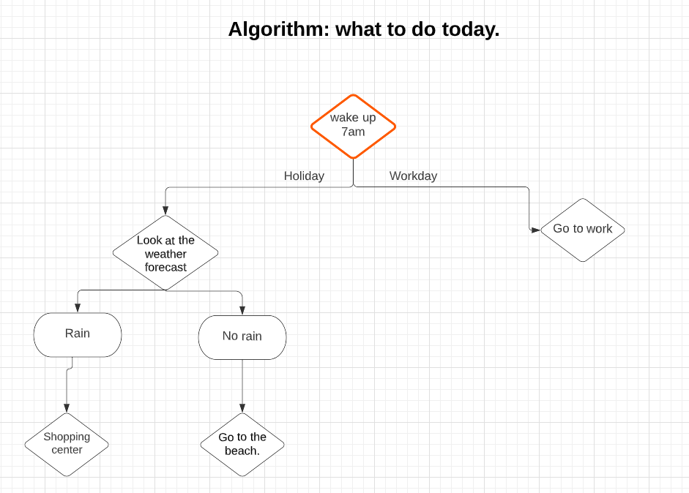

**Assignment No.3 (40min)**

Algorithms are used in programming as well. If we need to create a program with the specific goal, the list of the actions should be described.

Please take a look here:

<https://www.lucidchart.com/pages/templates/flowchart/algorithm-flowchart-template>

* Create and algorithm how to find out which is larger $2^{3}$ or $3^{2}$

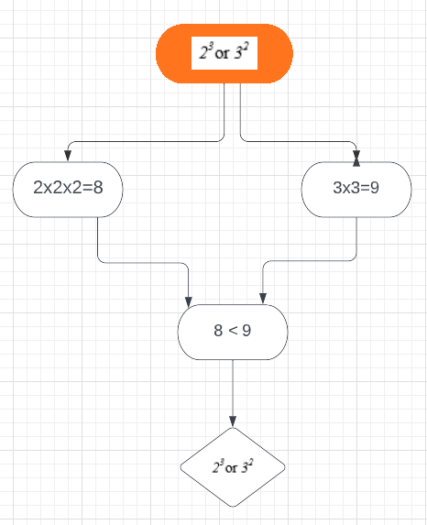

* Create and algorithm how to solve this equation:



2x = 16

X = 16 / 2

X = 8

8+Y= 10

Y = 10 – 8

Y = 2

X = 8;

Y = 2;