# Firewall Configuration and Rule- based Filtering

**Aim:** To configure and test firewall rules to control network traffic, filter packets based on specified criteria, and protect network resources from unauthorized access.

#### Theory:

Firewalls are network security devices or software applications designed to monitor, filter, and control incoming and outgoing network traffic based on a set of predetermined security rules. The primary purpose of a firewall is to act as a barrier between a trusted internal network (such as a company's internal network) and untrusted external networks (like the internet), in order to prevent unauthorized access, data breaches, and other potential cyber threats.

Firewalls operate by inspecting network packets (small units of data) as they pass through the firewall and making decisions about whether to allow or block the traffic based on a set of predefined rules. These rules can be configured to specify which types of traffic are permitted and which are denied. Firewalls can be implemented in various locations within a network, including at the network perimeter, on individual devices, or even within cloud environments.

There are several types of firewalls, including:

* 1. Packet Filtering Firewalls: These examine network packets and decide whether to allow or block them based on criteria like source and destination IP addresses, port numbers, and protocols. While they are relatively simple, they lack the ability to inspect the actual content of the data packets.
  2. Stateful Inspection Firewalls: Also known as dynamic packet filtering firewalls, these maintain a state table to keep track of active connections and only allow incoming traffic that matches an existing, legitimate connection. This approach is more secure than basic packet filtering.
  3. Proxy Firewalls: Proxy firewalls act as intermediaries between the internal network and the external network. They receive requests from internal users, then initiate and manage connections to external resources on behalf of those users. This can provide an additional layer of security by hiding internal network details.
  4. Application Layer Firewalls: These operate at the application layer of the OSI model and can understand the context of the traffic, such as the specific application or service being accessed. They are capable of making more fine-grained decisions based on the actual content of the traffic.
  5. Next-Generation Firewalls (NGFW): NGFWs combine traditional firewall functionality with advanced features such as intrusion prevention, deep packet inspection, and application-aware filtering. They are designed to provide more comprehensive protection against modern threats.

Firewalls play a crucial role in network security by helping organizations establish a strong defence against unauthorized access, malware, and various cyber attacks. However, it's important to note that while firewalls are an essential component of a comprehensive cyber- security strategy, they are not a standalone solution. They should be used in conjunction with other security measures such as antivirus software, intrusion detection systems, regular software updates, and user training to ensure a robust defence against evolving threats.

Using a firewall to block unauthorized access is an important aspect of securing your network and systems. Firewalls act as barriers between your network and potential threats from the internet or other external sources. Here's a step-by-step guide on how to use a firewall to block unauthorized access:

1. Choose the Right Firewall:

There are hardware firewalls (devices that are placed between your network and the internet) and software firewalls (installed on individual computers or servers). Choose the type that best suits your needs.

1. Install and Configure the Firewall:

For software firewalls, install the firewall software on the computers or servers you want to protect. For hardware firewalls, follow the manufacturer's instructions to set it up between your network and the internet.

1. Define Security Policies:

Determine which types of traffic are allowed and which are denied. This can involve specifying rules that allow or block traffic based on criteria such as IP addresses, ports, and protocols.

1. Block Unauthorized Access:

Create rules to block access from unauthorized IP addresses or ranges. For example, you might block IP addresses known for malicious activities or any IP address that doesn't have a legitimate reason to access your network.

1. Allow Necessary Traffic:

Configure rules to allow access to the services and applications that are essential for your business operations. For instance, if you have a web server, you'll need to allow incoming traffic on port 80 or 443.

1. Regularly Update Rules:

Keep your firewall rules up to date. New threats can emerge, and you might need to adjust your rules accordingly.

1. Use Application Layer Filtering:

Modern firewalls can inspect traffic at the application layer, allowing you to block specific applications or services. This can help prevent unauthorized access to potentially risky services.

1. Intrusion Detection and Prevention Systems (IDPS):

Consider integrating an IDPS with your firewall. These systems can detect and prevent intrusion attempts by analyzing network traffic and patterns.

1. Logging and Monitoring:

Enable logging on your firewall to keep track of connection attempts and blocked traffic. Regularly review the logs to identify potential security issues.

1. Testing and Adjusting:

Regularly test your firewall's effectiveness by attempting to access your network from different scenarios. This can help you identify any gaps in your security and adjust your rules accordingly.

1. Keep Firewall Software Updated:

If you're using software firewalls, make sure to keep the firewall software up to date with the latest security patches.

1. Educate Users:

Even with a firewall in place, user awareness is essential. Educate your users about safe online practices, such as not clicking on suspicious links or downloading unknown files.

Remember that while firewalls are a valuable part of network security, they are not a complete solution. It's important to adopt a multi-layered security approach that includes regular updates, patches, antivirus software, intrusion detection, and employee training.

We would use firewall to block

* 1. A Port
  2. A Program
  3. A Website

**Part 1: Blocking the HTTP and HTTPS (Port 80 and Port 443) using the Firewall**

Before starting with the blocking port process, we note that the applications running at the server- end are identified with the well-known Port numbers, some of the commonly used are as follows

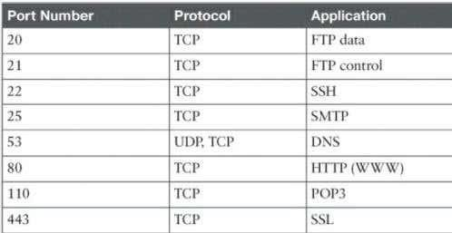

We perform the blocking Port operation as follows:

Step 1: We access any website through the browser and confirm that the HTTP/HTTPS protocols are working.

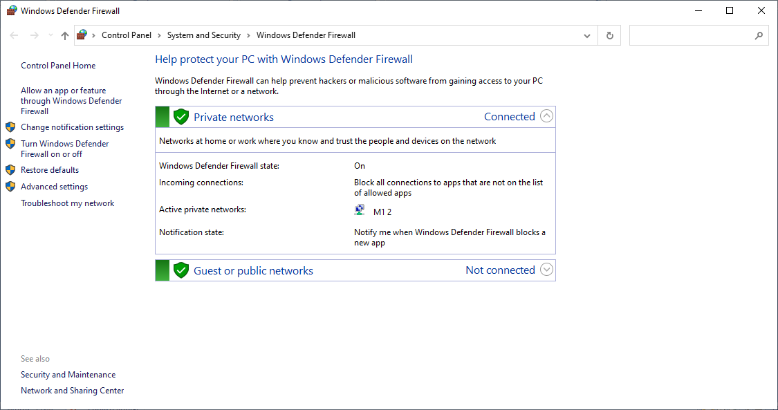Step 2: We open ‘Windows Defender Firewall’

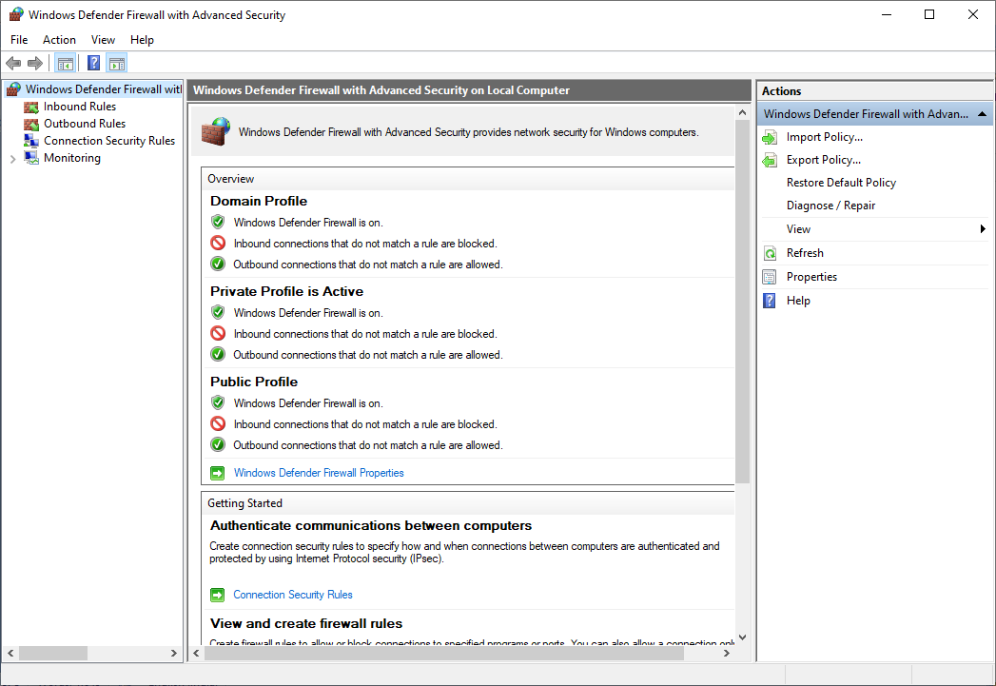Next we click on ‘Advanced settings’

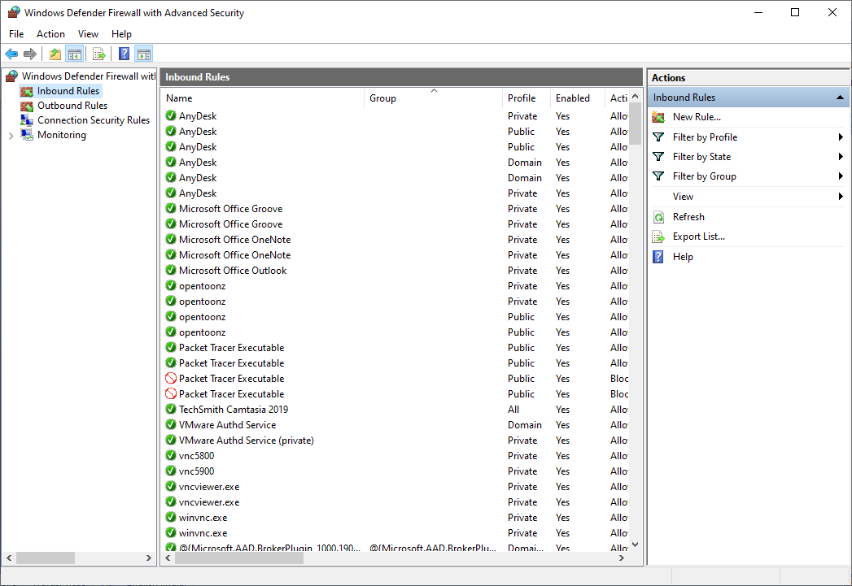Next we click on ‘Inbound Rules’

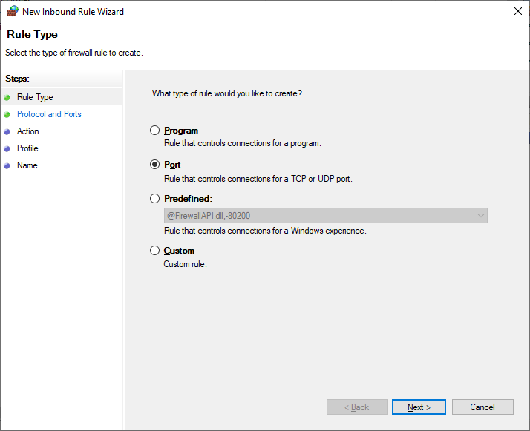Then click on ‘New Rule’

Select the radio button ‘Port’ and click ‘Next’ and enter the following

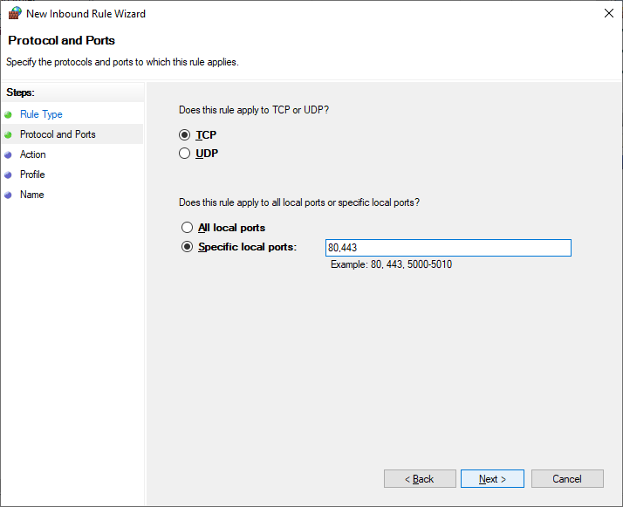

After next, we need to finalise the rule

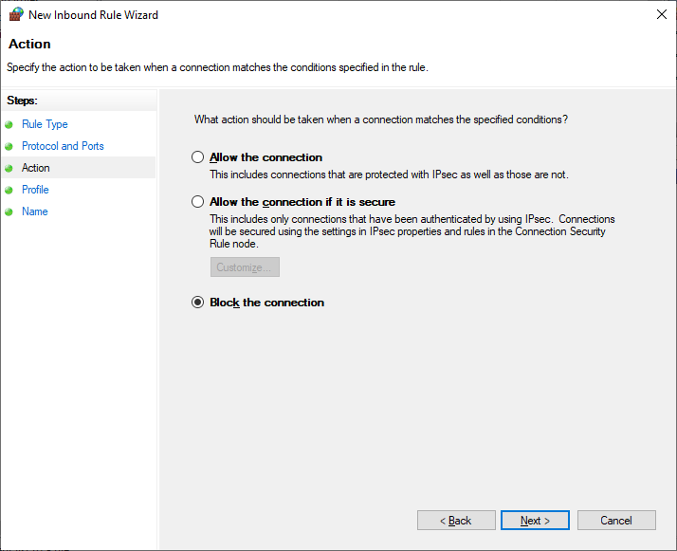

Click ‘Next’ and we get the following

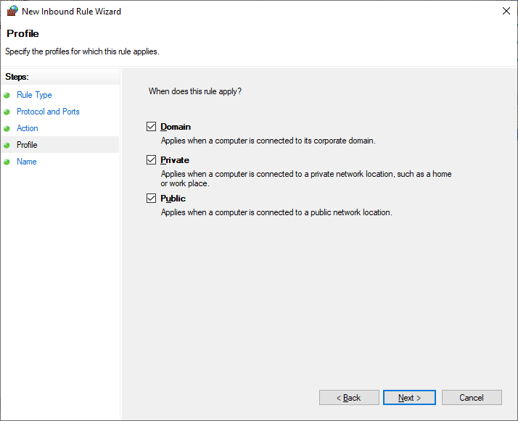

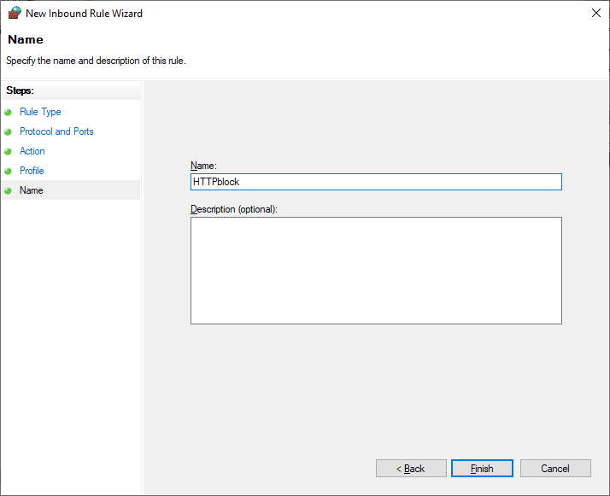After clicking the ‘Next’ button we need to name the rule and click finish

The Inbound rule is added

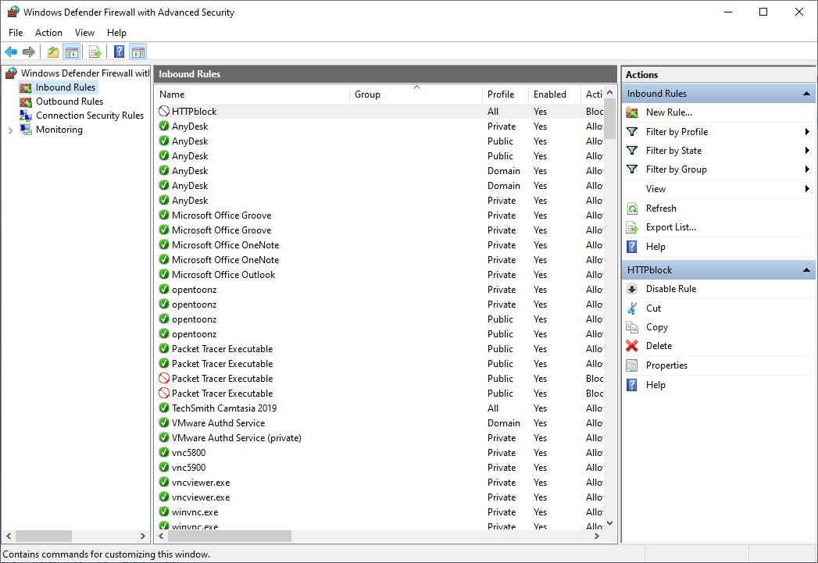

We repeat all the above steps for creating ‘Outbound Rules’, and then try to access the internet.

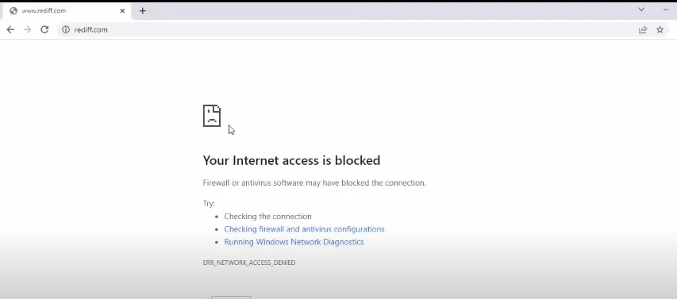We see that the accessed is blocked

### Part 2: Blocking the website [www.android.com](http://www.android.com/)

We open the browser and access the website, which is now accessible

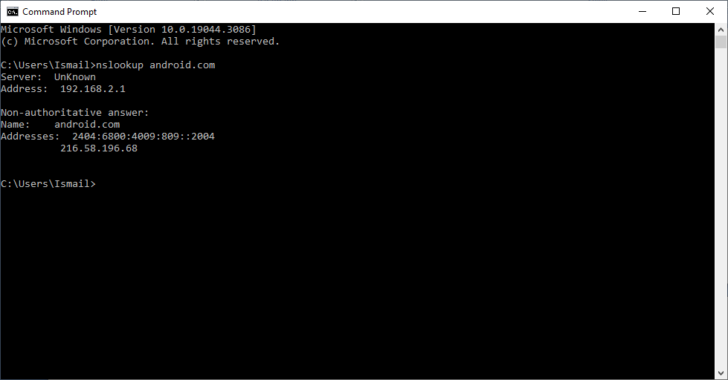We find the IP addresses of the website using the following command

We save the IP addresses

|  |  |
| --- | --- |
| IPv4 | 216.58.196.68 |
| IPv6 | 2404:6800:4009:809::2004 |

We open the windows Firewall settings and apply the Inbound Rule

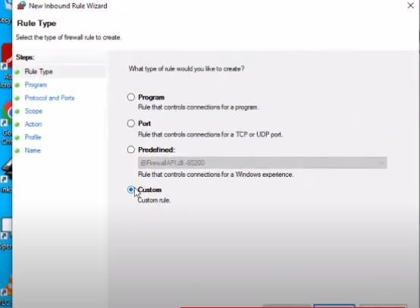

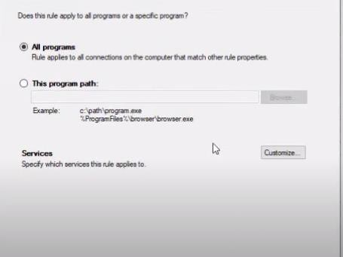

Insert the IP addresses both IPv4 and IPv6

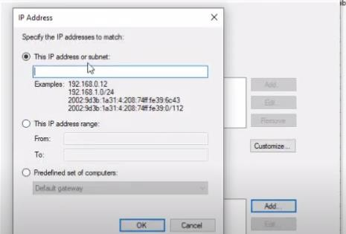

Select Block connection

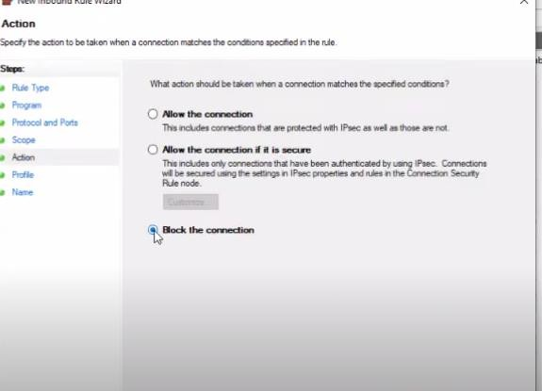

Provide a suitable name and finish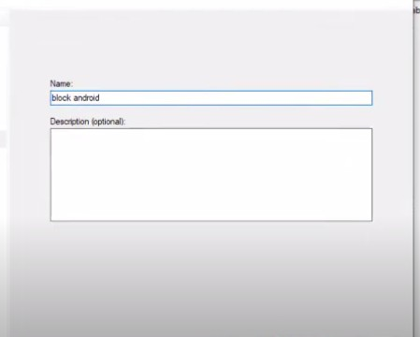––Repeat the above for Outbound Rules

Now if we try to access the website [www.android.com](http://www.android.com/) , it would be blocked

