**Santander payment provider – installation and user guide**

This document describes how to install and use the Santander payment provider in **EPiServer Commerce 8**.

***Apps folder***

In EPiServer Commerce 7.5, the **Apps** folder is located in the EPiServer Commerce Manager Shared Files Folder, typically C:\EPiServer\<YourCommerceManagerSite>\eCommerceFramework\5.3\Shared.

If your Commerce Manager site has been updated to the **latest version via NuGet**, the Apps folder should be located in the wwwroot folder, typically E:\ EPiServer \<YourCommerceManagerSite>\wwwroot\Apps.

Refer to this Apps folder as your corresponding path for the Apps folder mentioned below.

***Installation***

Do the following to install the Santander payment provider module:

1. Copy the **bin/Consid.SantanderCommerce.dll** and **bin/Consid.SantanderCommunication.dll** to the EPiServer Commerce site **Bin** directory.
2. Copy the **bin/Consid.SantanderCommerce.dll** and **bin/Consid.SantanderCommunication.dll** to the EPiServer Commerce Manager site **Bin** directory.
3. Copy **controls/PaymentMethod** control.

* Create a folder named **Santander** in **\Templates\Sample\Units\CartCheckout** in the Commerce front-end site.
* Copy **PaymentMethod.ascx** to the **Santander folder** which has been created.

1. Copy **controls/ConfigurePayment.ascx** control.

* Create a folder named **Santander** in \**Apps\Order\Payments\Plugins in the CommerceManager site.**
* **Copy the ConfigurePayment.ascx** file into the **Santander folder** which has been created.

***Configuration***

Follow the steps below to configure **Santander** in Commerce Manager.

1. In **Commerce Manager**, go to **Administration**> **Order System**> **Payments**> **Your country**.
2. Click **New**to create a new payment method. An example of the configuration is shown below.

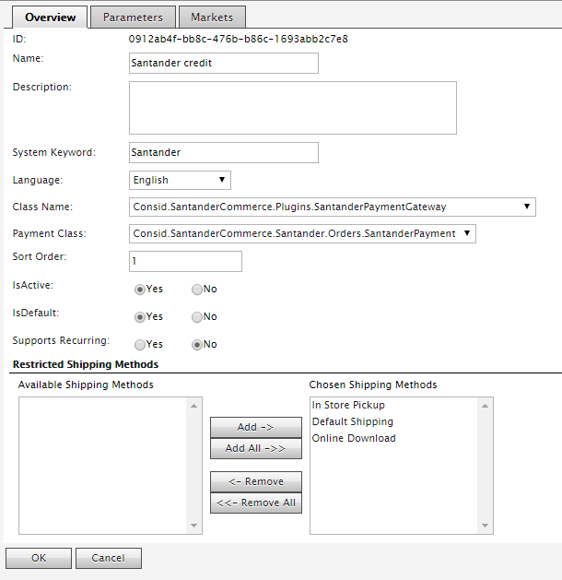

1. In the **Overview**tab, enter the following required information for the **Santander** credit:

|  |  |
| --- | --- |
| **Name** | Santander credit |
| **Description** | [Free description] |
| **System Keyword** | Santander |
| **Language** | [The language of your choice] |
| **Class Name** | Consid.SantanderCommerce.Plugins.SantanderPaymentGateway |
| **Payment Class** | Consid.SantanderCommerce.Santander.Orders.SantanderPayment |
| **IsActive** | Yes |
| **IsDefault** | Yes |
| **Supports Recurring** | No |
| **Restricted Shipping Methods** | Add only if you want to restrict any shipping method. |

1. Click **OK** to save the data.
2. Go to the **Parameters**tab to add the Santander specific configuration information.

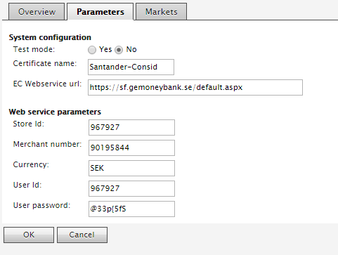

1. Click **OK**to save the data.
2. Go to the **Markets** tab and add the expected markets for this payment.

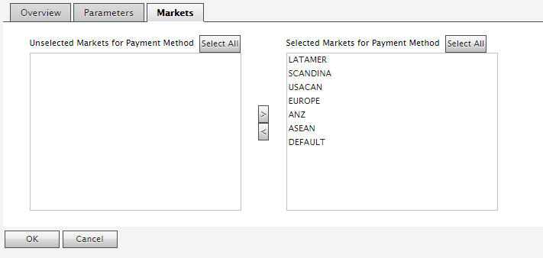

1. In **Commerce Manager**, navigate to **Administration** > **Order System** > **Meta Classes**, and click **Import MetaData** to populate the MetaData import screen. Then select the **metadata/Santander_MetaData.xml** file to import.
2. Open the **\Apps\Order\Config\View\Forms\PurchaseOrder-ObjectView.xml** from the Commerce Manager application.
3. To can see the **AuthorizationCode** in the Payments tab you need to add the following xml column tag to the <Grid placeName="OrderPayment-List">:

<Column width="120" visible="true" allowSorting="false" dataField="SantanderAuthorizationCode" headingText="Authorization Code"></Column>

***Using Santander payment provider***

When you have deployed and configured the Santander payment provider, it will appear as an option in the checkout procedure.

### **Placing an order**

### Add item(s) to a shopping basket and proceed to checkout.

1. Select a shipping address, shipping option and continue to payment options.
2. The Santander credit option will be shown with a selection box.
3. Pressing “**Place Order**” button, the application will get the token and will call the Santander checkout url where the customer can introduce and check the credit informations.
4. If the credit from the Santander is accepted, the order will be placed automatically and the order number and the amount will be displayed on the screen.

**Order management**

1. The finalized orders can be open from the CommerceManager, **Order Management > Purchase Orders.**
2. By opening the corresponding order the **Authorization Code** column is visible under the Payments tab.

