**Online Jwellery Shop**

Technology used:

1. Spring Boot 3.0
2. Spring Security 6
3. Spring MVC
4. Thymeleaf
5. MySQL

Usage

1.Visit the homepage to browse the available products.

2.Click on a product to view its details, including the price and a larger image.

3.Add the product to your cart by clicking the "Add to Cart" button.

4.View your cart by clicking the cart icon in the navigation bar.

5.In the cart, you can adjust the quantity of each product or remove a product entirely.

6.Proceed to checkout by clicking the "Checkout" button in the cart.

7.Fill in your details, including your name and shipping address, and submit the form.

8.On the confirmation page, you will see a summary of your order and a confirmation number.

Additional Notes

1.You can add, update, or delete products by logging in as an admin user.

2.To log in as an admin user, visit the URL /login and enter the username [admin@gmail.com](mailto:admin@gmail.com) and password admin.

3.Once logged in, you can access the product management pages by clicking the "Product Management" link in the navigation bar.

4.From the product management pages, you can add new products, edit existing products, or delete products.

Client End:

Filter by Categories Feature

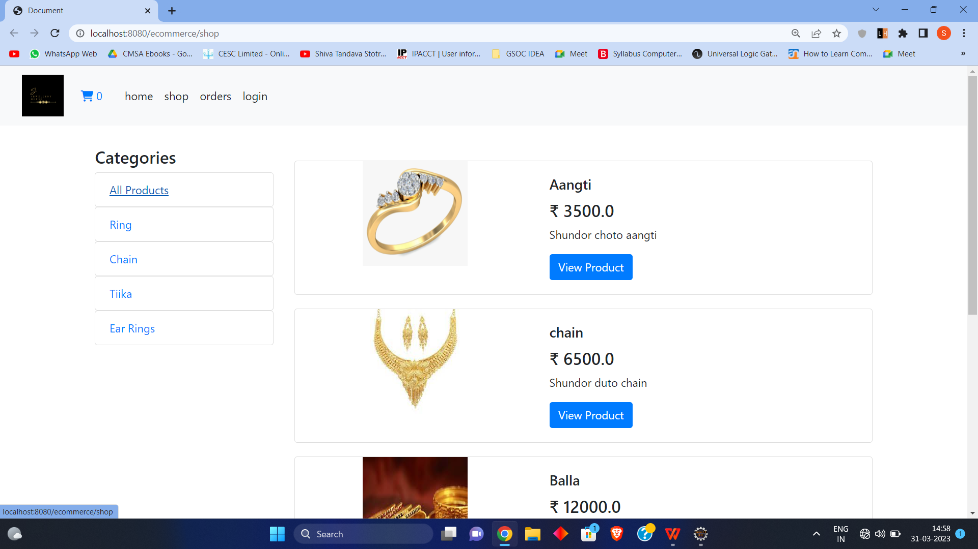

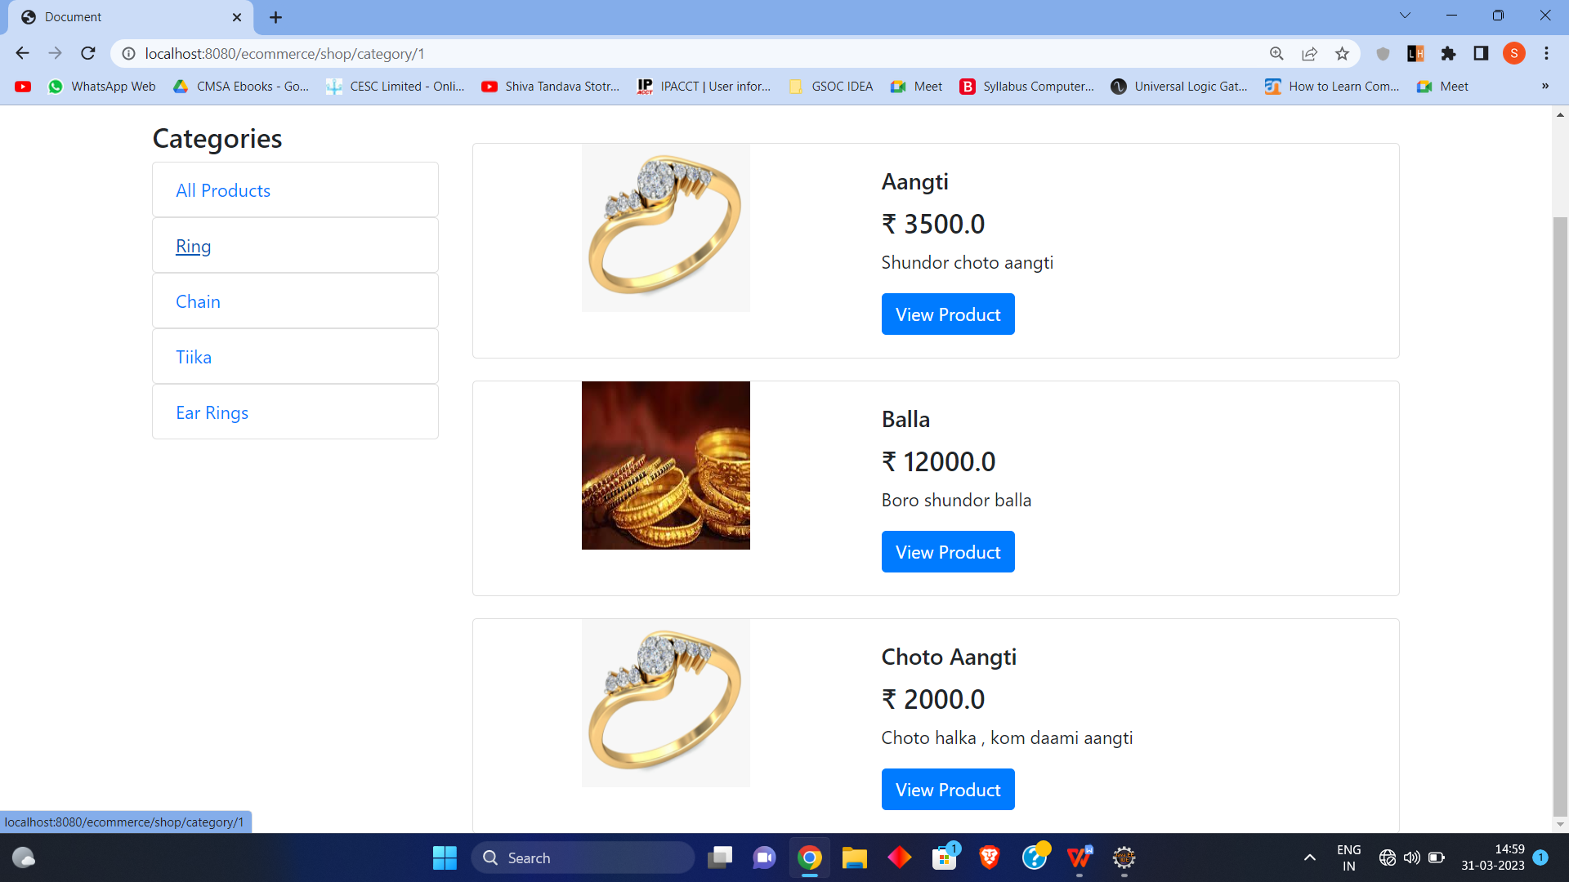

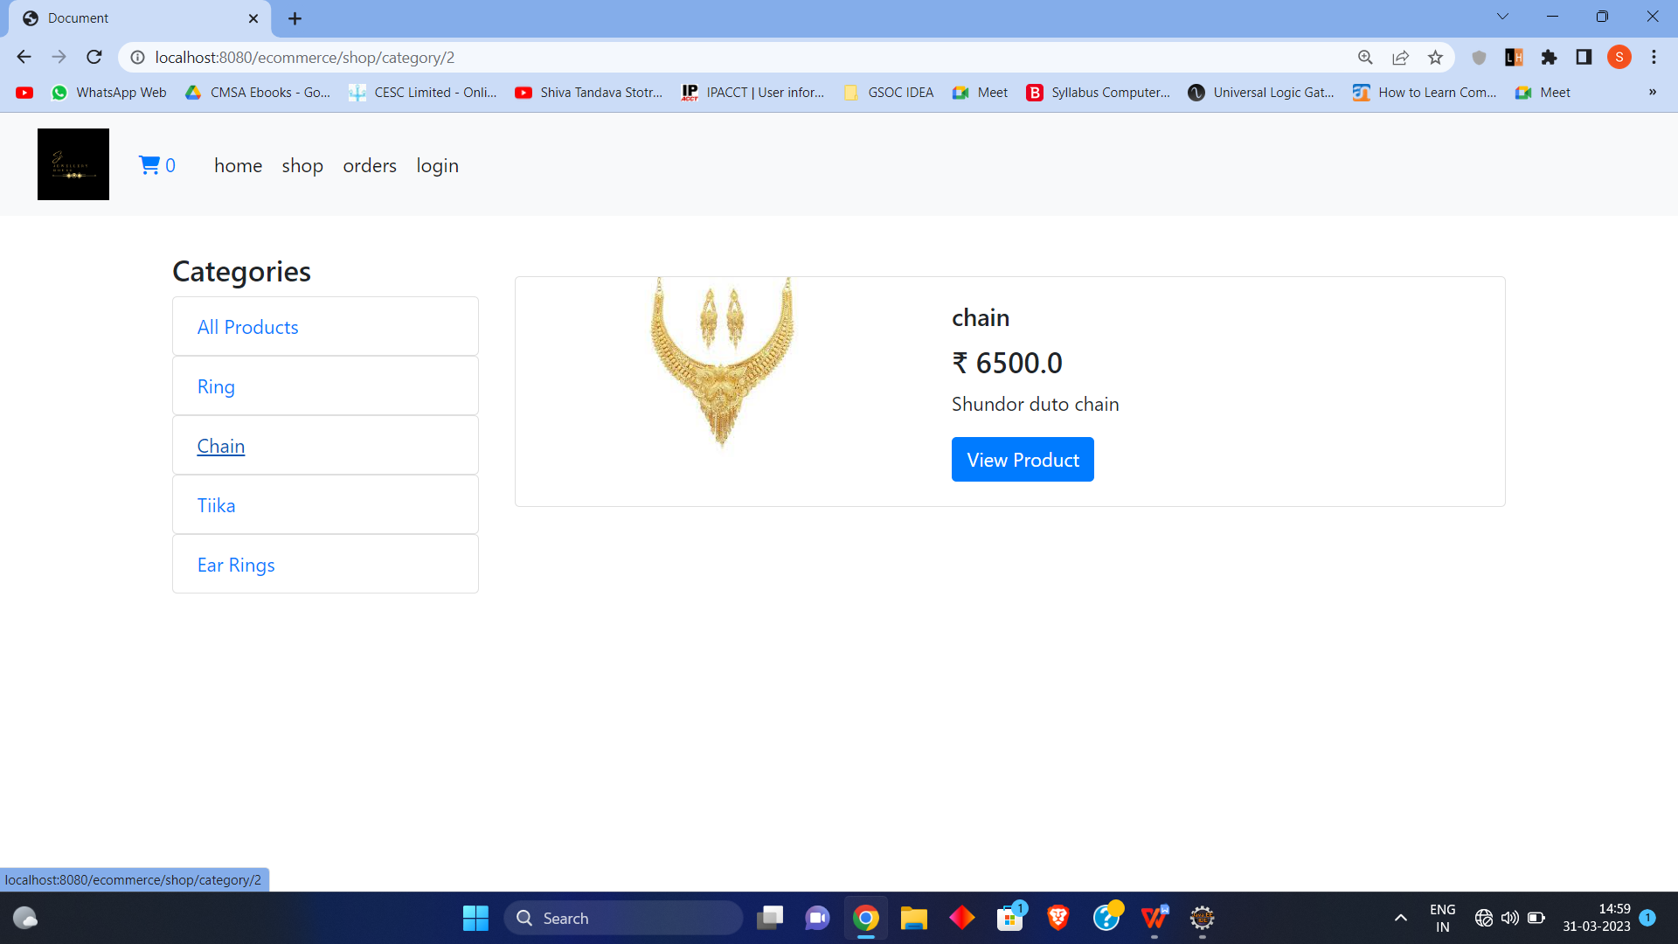

Product Page

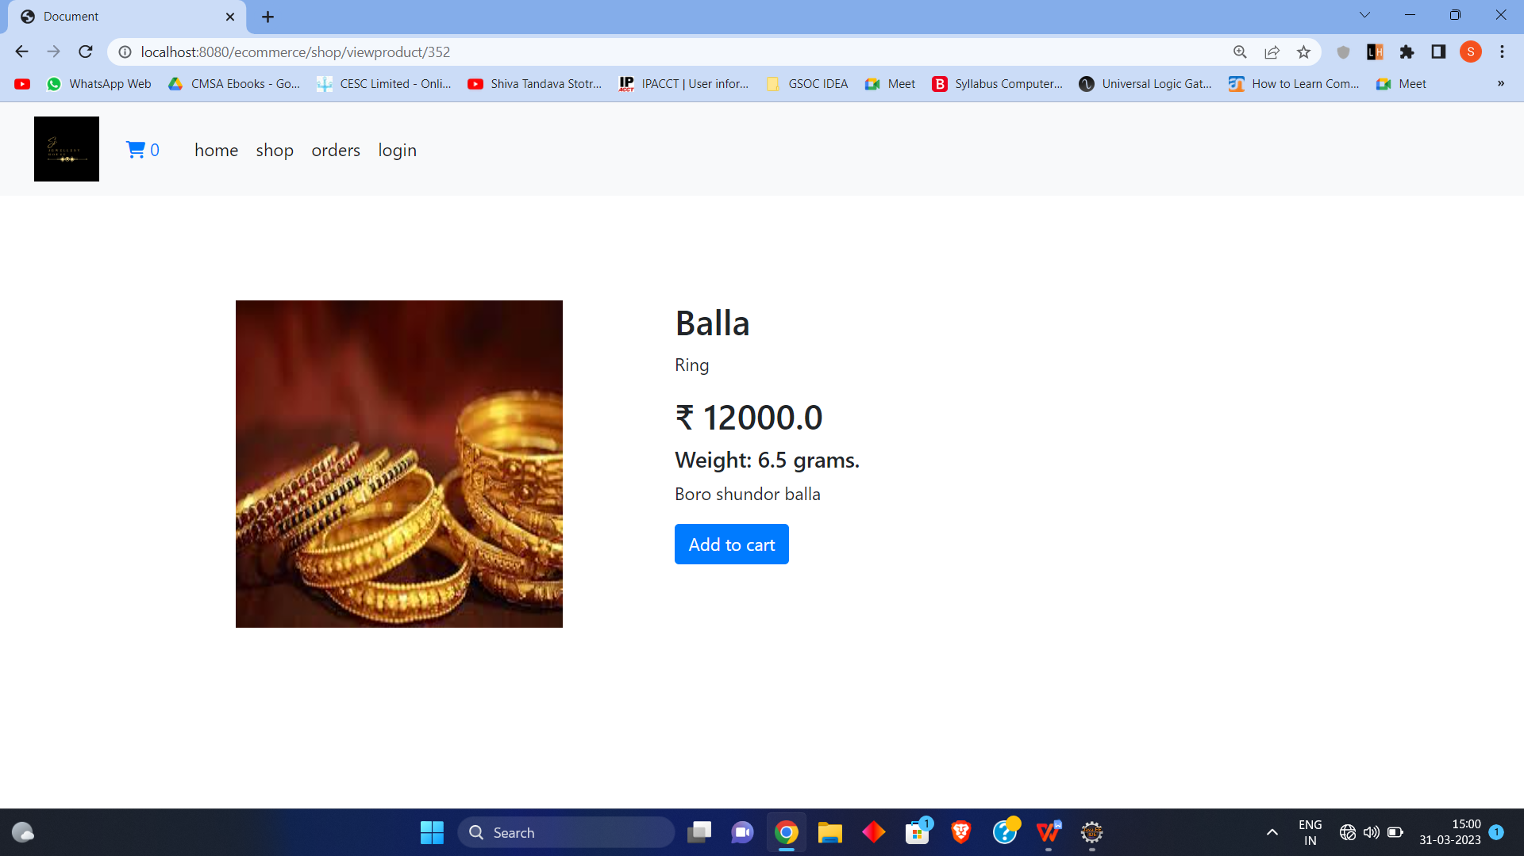

Cart Page:

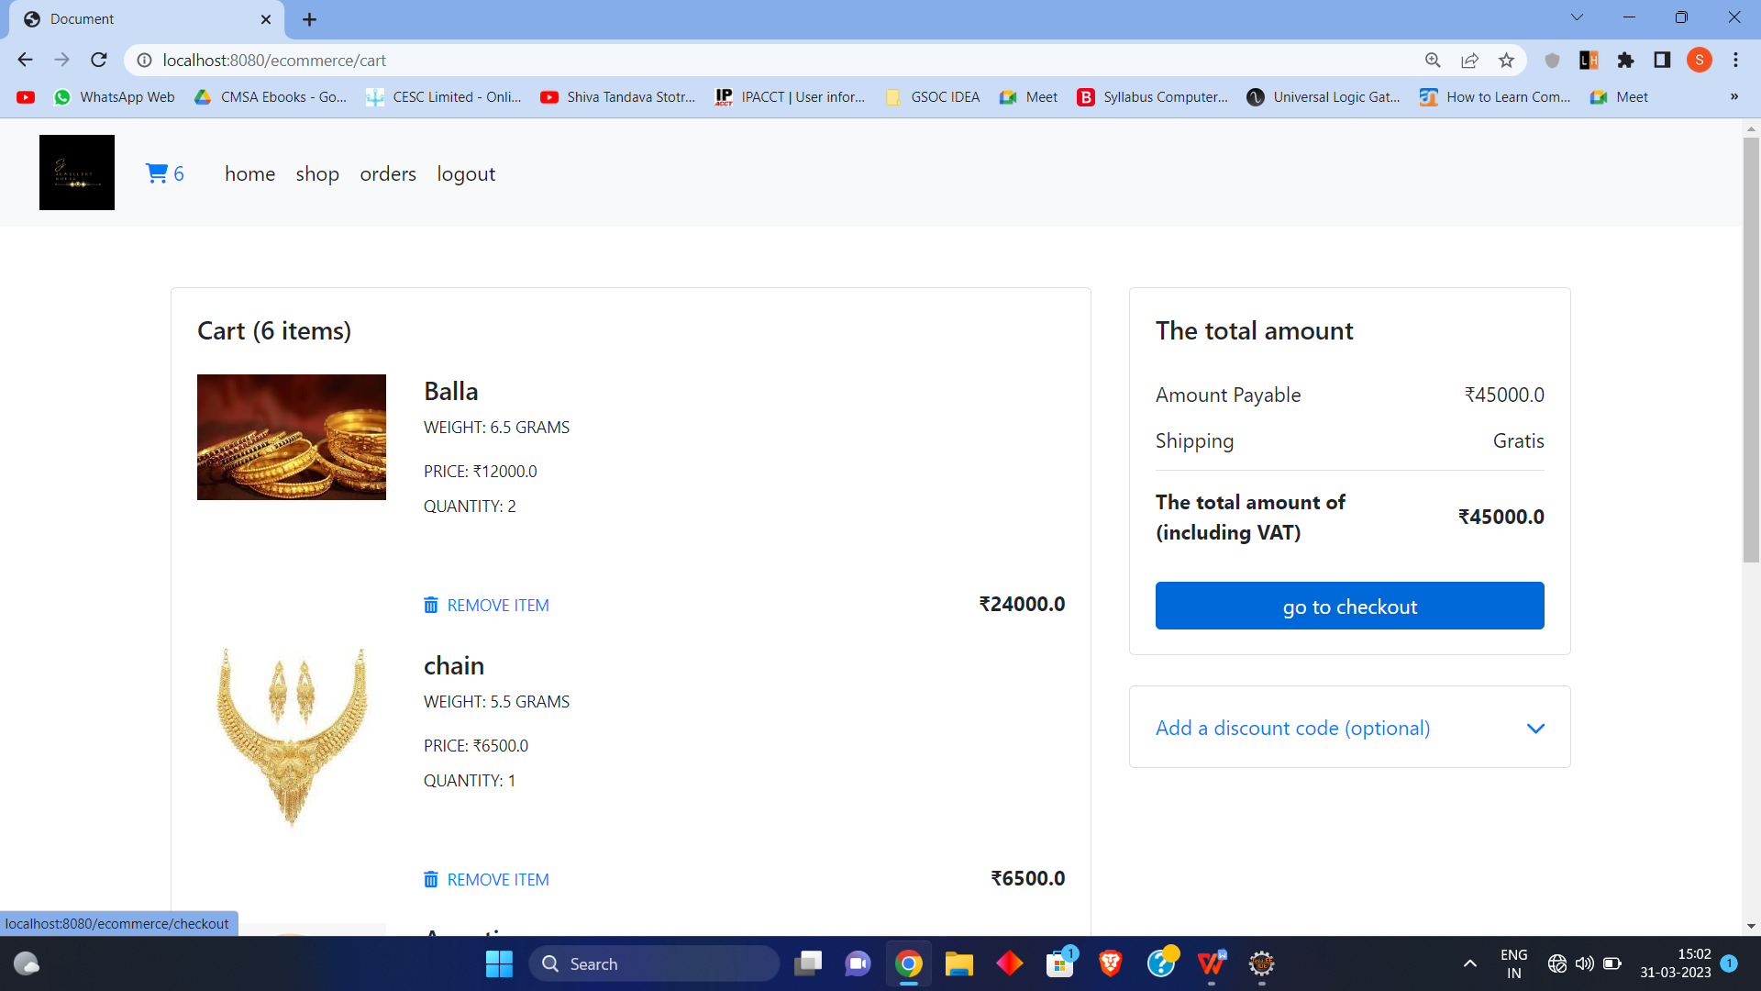

Check Out Page:

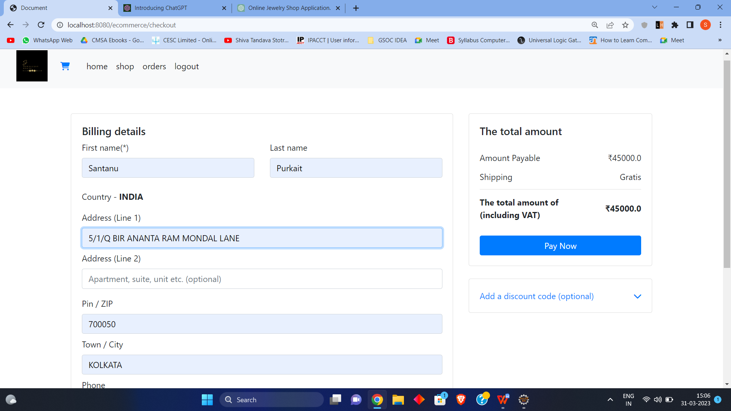

Client can view his Orders in order page:

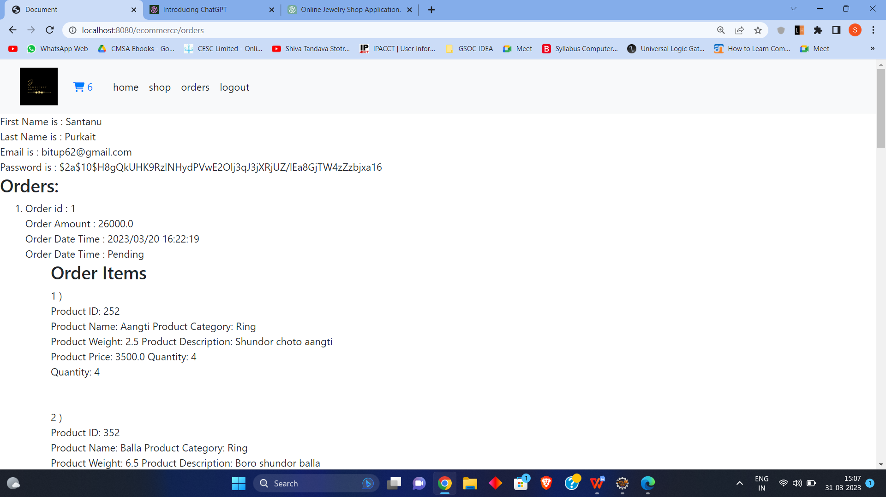

Admin Panel:

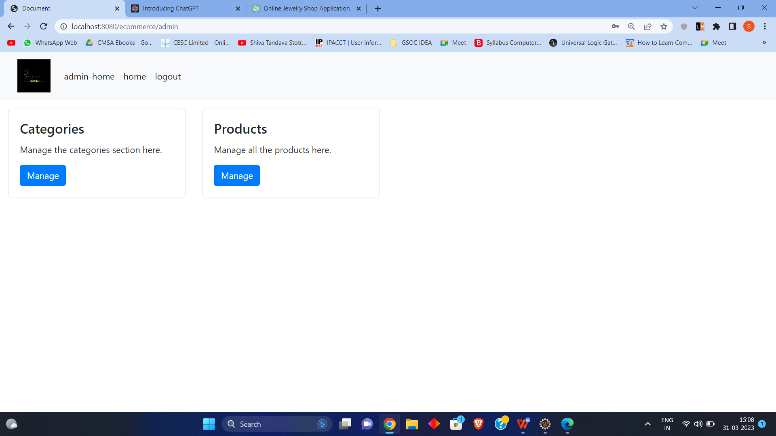

Product Add/ Update page :

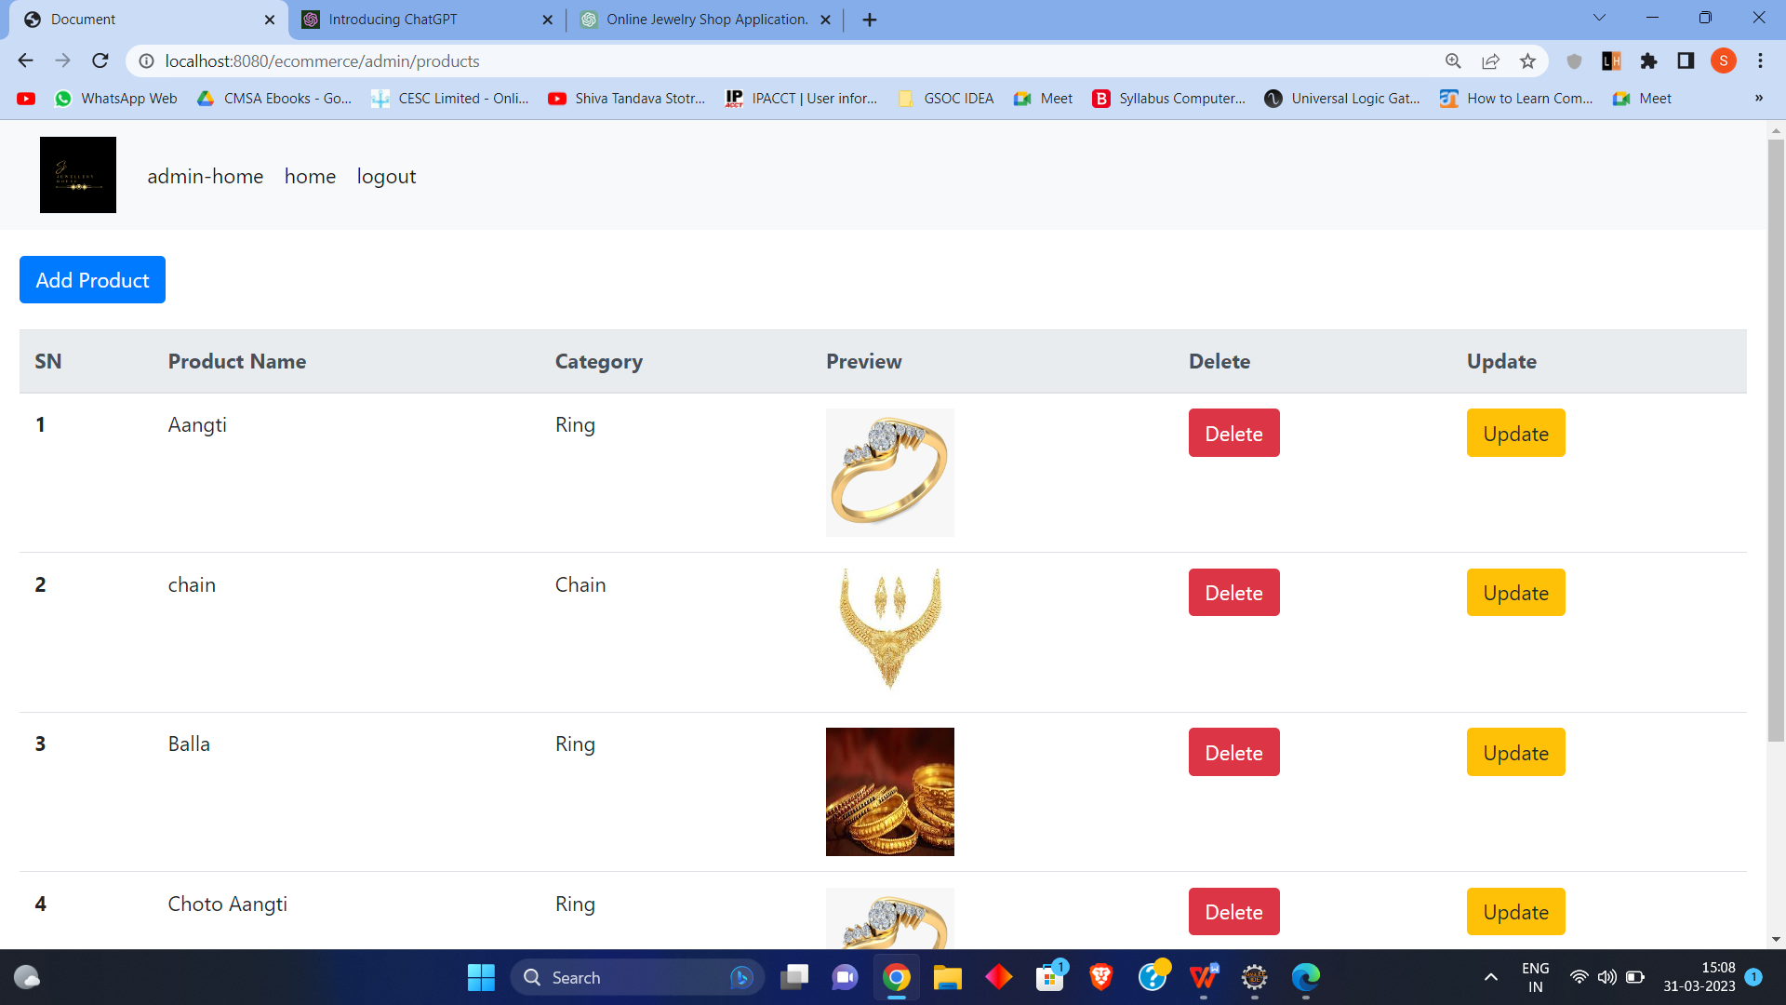

Categories Add/Update page

