Documented by- Santanu Kumar Rana

Project Name- Serverless Web application on AWS

Description-

You will build serverless web application using AWS Lamda, DynamoDB, S3 where application will allow user to do CRUD operation from DynamoDB table.

Project Design----

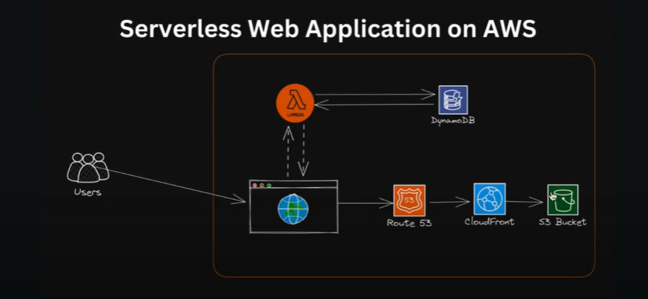

Step1- Create S3 bucket in AWS and upload your html, css and javascript files in the s3 bucket.

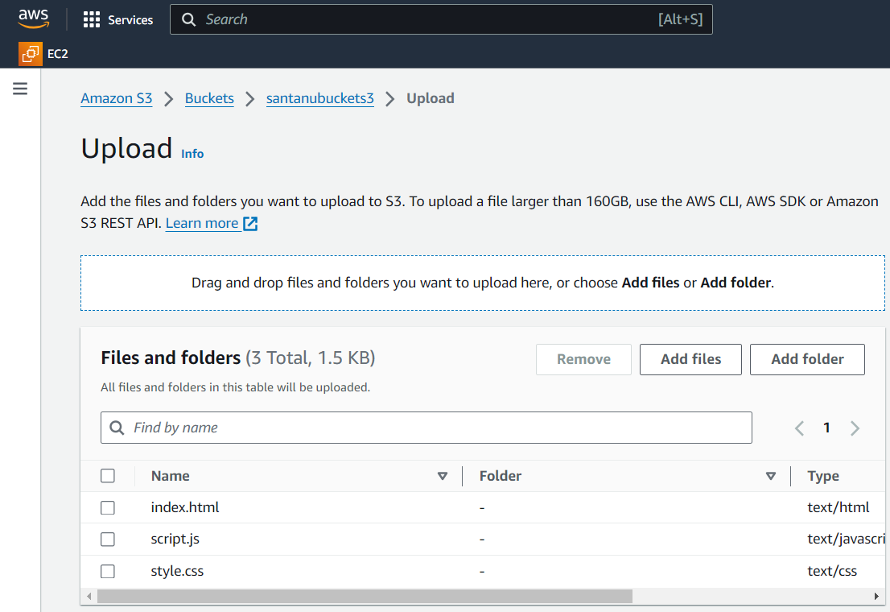

Step2- Go to cloudFront which will speedup your distribution of your static and dynamic web content.

Cloudfront🡪 Provide Name-> origin domain(s3 bucketname)-> origin access-> origin access setting->access control->create control->name(accesscontrol01)->origintypes3->create distribution

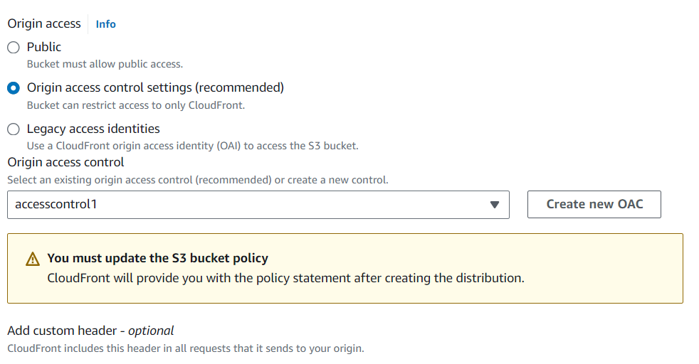

Step3- Now you need to configure so that cloudFront can access s3.

Go to cloud front->click on the control you created(accesscontrol1)->origins->select origin->edit->copy policy

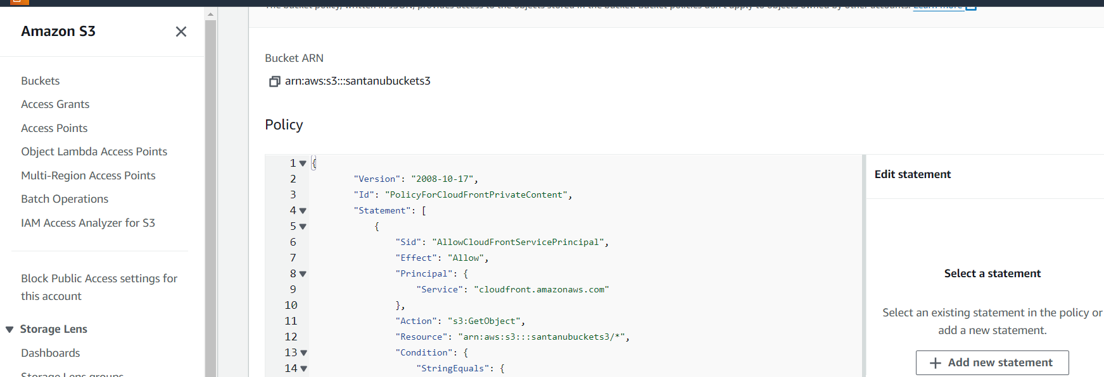

Step4- Now go to s3 and paste this policy

S3-> click the bucket->permission->bucketpolicy->edit->policy(paste the policy)->save change.

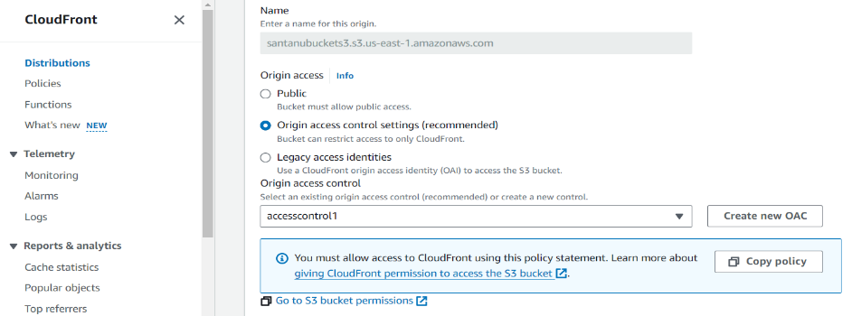

Step5- set the default entry point to index.html file you have.

Go to cloudFront->click the distinct->settings->edit->default root object(index.html)->save

Step6- Enable route53 for cloud front distribution.

Route53->create hoste zone->DomainName(santanuproj.in)->type(PublicHostedZone)->create hostedZone

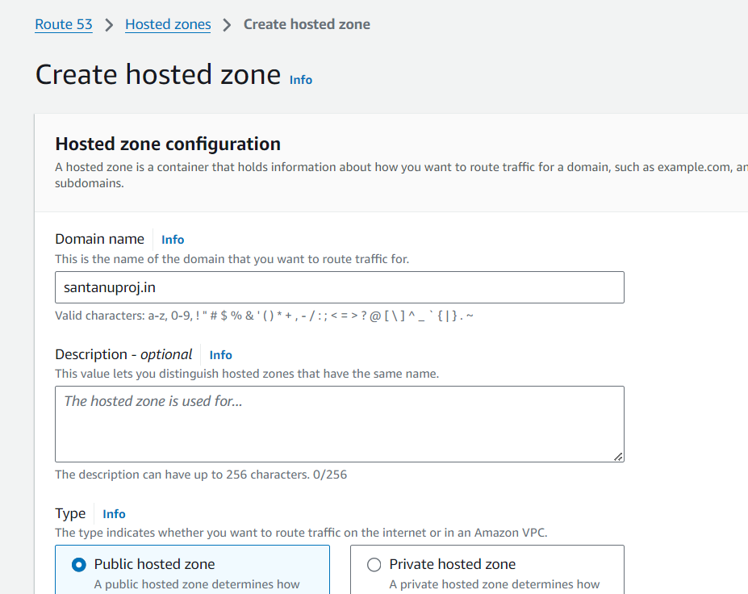

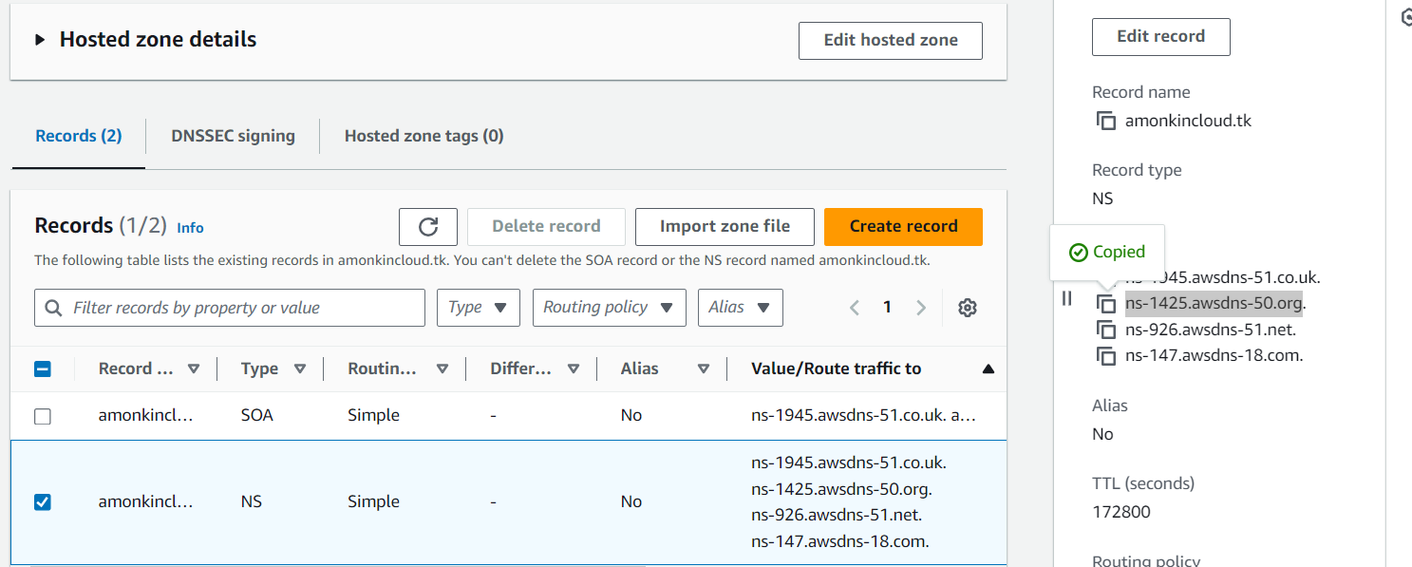

Step7- Go to cloudfront and edit the domain name

Cloudfront->click the distribution you created->settings->edit->alternate domain name-.add item->name(greeting.santanuproj.in)->custom SSL->request Certificate->Go to ACM(Amazon Certificate Management)->Request public ->fully qualified domain(\*.santanuproj.in)->request

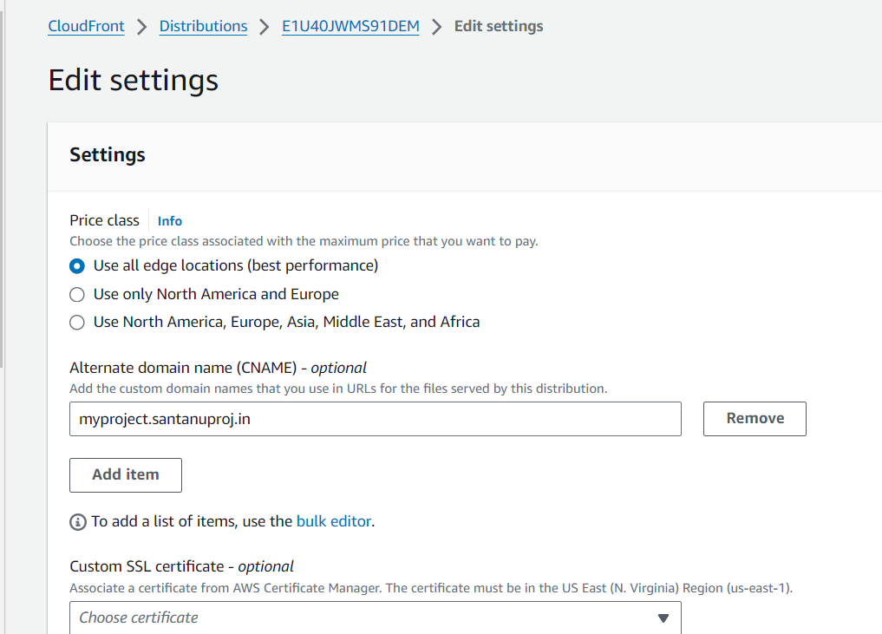

Step8- Go to cloud front and check if the certificate got validated or not.

Customer SSL ->choose certificate

Step9- Validate the certificate

Click on certificate->domains->create records in route53->create record

Note- This will create a CNAME record in route53

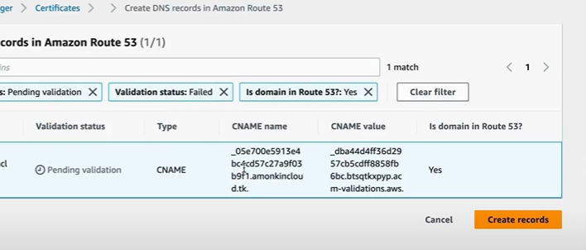

Step10- create another record for subdomain(i.e. greeting.santanuproj.in)

Route53->click the hosted->records->create records->record name(greeting)->enable alias->route traffic to cloudfront-> choose distribution(greeting.santanuproj.in)->create record.

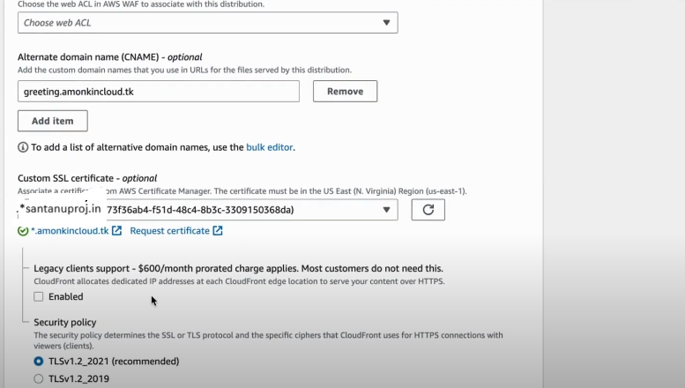

Step11- You need to create a DynamoDB table and create a IAM role for lamda function to give permission to access Dynamo DB.

1. DynamoDB->create->name(SantanuDBtable)->partition key(id)-> create table
2. Click on DB you created->explore table item->create item-> attribute partion key 0-> add attribute (number) views🡪1 create

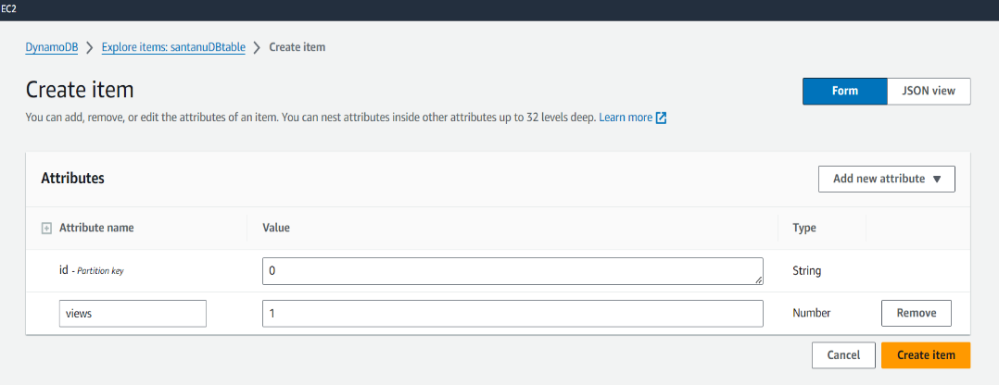

Create IAM ROLE and give access to lamda and full access to DynamoDB and write the code for lamda function

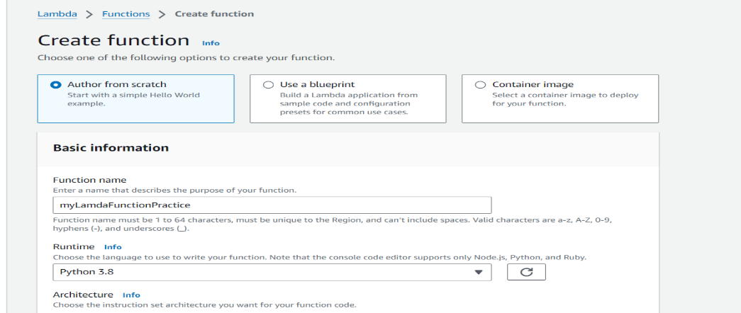

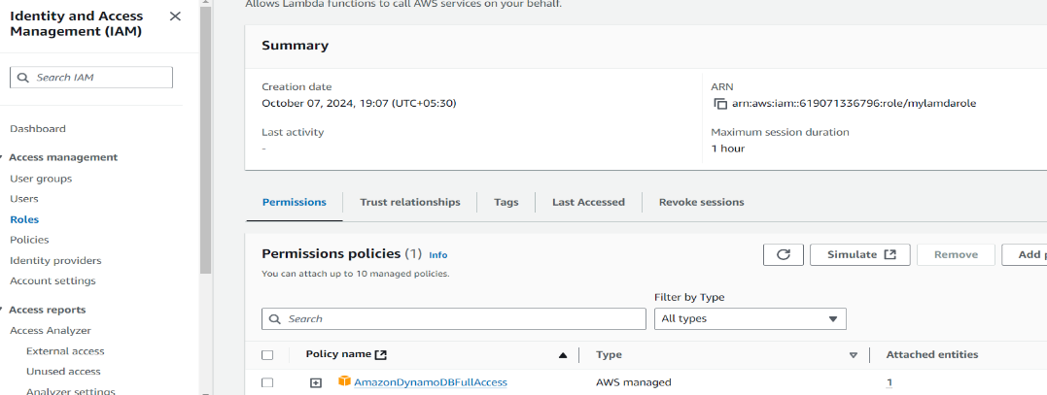

Code-

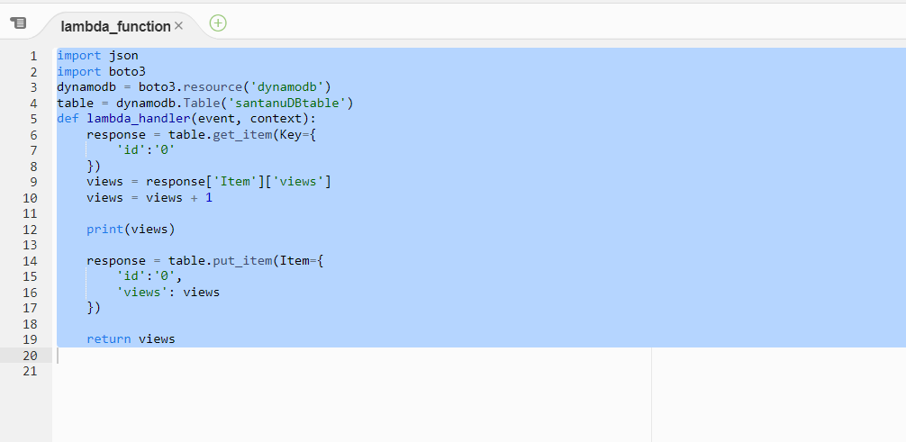

Step12- Go to the javascript file of the website and paste the lamda url

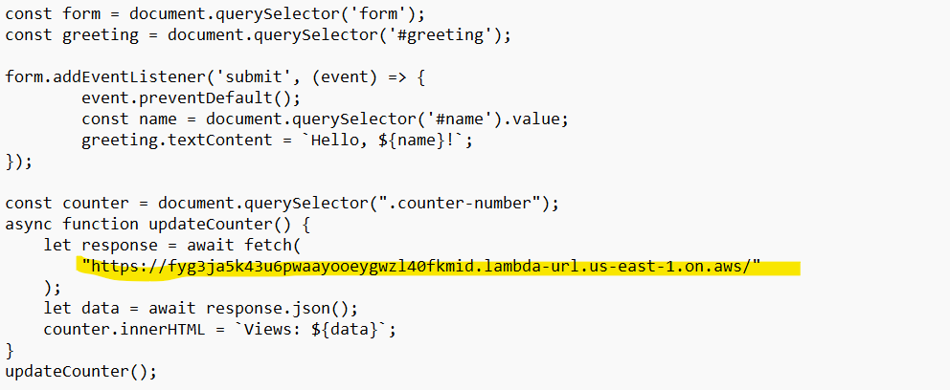

Step13- Check the website working…… You can see the final website…

