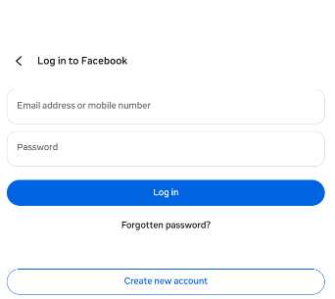
In homepage in header two button 1 is Admin login 2 is Doctors login then one is form like login id and password like this picture two option login and book another is register new user . another is daywise listing of doctor and click the doctors name viewing the doctor details excluding the contact no and a tracking option the booking is confirmed or another date is assigned . For register new user input value is (Name , Mobile No , Address , age ,password ) those are mandatory . after register generate a Unique ID like HP[TWO DIGIT OF SERIAL NO ] HP00.

If ADMIN Login there are also another login form just id and password . when it open the page there are Dashboard showing total booking , patient list department wise with date and doctors name current date is above past date is below and a search section using patient ID. Another option is Register Doc option there is another form of doctors details like Name, Registraion No, Department , Degree , Contact no , picture ,Avilable Day , password after register generate a Unique ID like HD[TWO DIGIT OF SERIAL NO ] HD00

DOCTORS LOGIN here datewise patient name ,age, symtomps showing clickable patient name after click open two things previous medical record and new prescription and here the prescription is printable . if there are multiple record of that particular doctors all prescription open as a list one by one current to older sequence

Patient login in here after login with id password showing Upcoming appointment ,medical history with Departmentwise , Book Appointment . when it click medical history showing the prescription preview along with download option . for booking after login it possible otherwise not and the input are automatically fill like name, age, date , manully input is only symtomps (text input) , departments(created by admin where register a doctor ), doctors .the booking id is generate as a unique logic is HB – Healthsapp Booking , first two digit is patient ID ,last two Digit is Doctors ID

I think including homepage there are total 9 to 10 pages .

