**Salary Table**

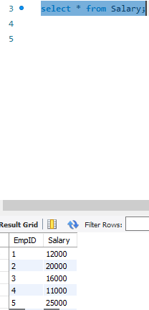

**Employee table**

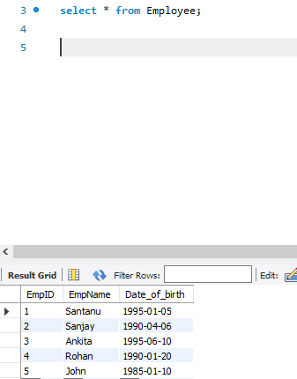

**Q1> Write an SQL query to find nth largest salary along with employee name.**

**Answer:**

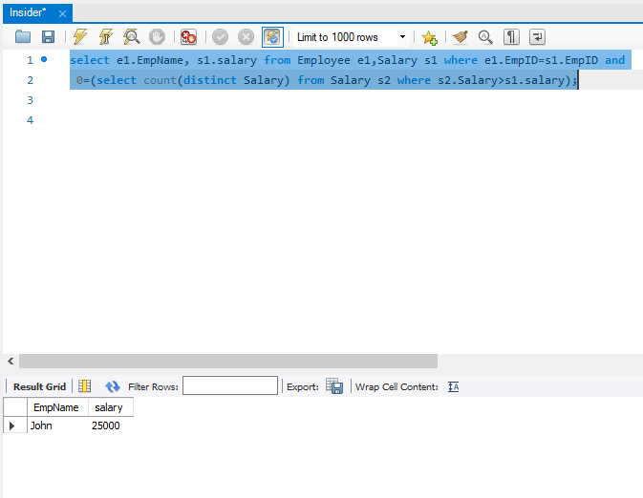

**Table displaying age of employees:**

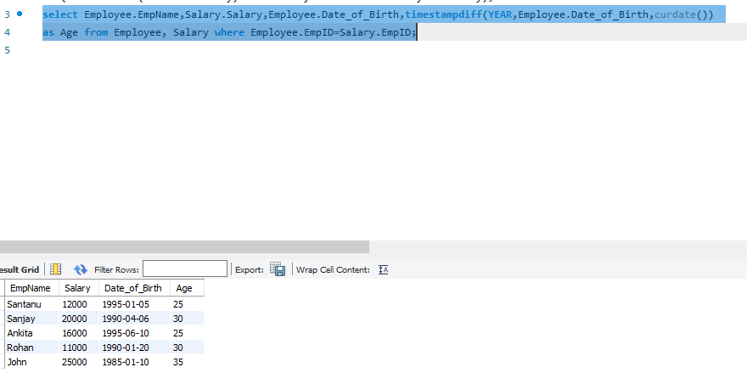

**Q2>Write a query to update salary of employees to 5000 whose age is 30+.**

**Answer:**

**Query:-**

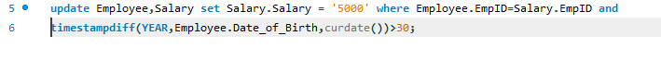

**After update:**

