Protechsoft webtech notes

1. What is HTML?
HTML stands for HyperText Markup Language.
It is used to create the structure of a webpage.

Why is it called HyperText?
- Hypertext means text that contains link for any other page.
- HyperText allows users to navigate between pages using links.

Why is it called Markup Language?
- HTML uses tags to mark and structure content.
- These tags tell the browser how to display content.
1. What is HTML?
Ans: HTML stands for HyperText Markup Language. It is used to create the structure of webpages.
2. Why is HTML called a markup language?
Ans: Because it uses tags to mark and structure content.
3. What is HyperText?
Ans: HyperText is text containing links that allow navigation between webpages.

4. HTML Tags
Tags are predefined keywords enclosed within angle brackets.

Syntax
<tagname> Content </tagname>

Example
<h1>Hello World</h1>

5. What is a tag?
Ans: A tag is a predefined keyword used to define HTML elements.
6. What are opening and closing tags?
Ans:
<h1> Opening Tag
</h1> Closing Tag

7. Structure of HTML

Basic Structure
<!DOCTYPE html>
<html>
<head>
<title>My Page</title>
</head>
<body>

</body>
</html>

Components
Tag | Purpose
<!DOCTYPE html> | Declares HTML5
<html> | Root element
<head> | Contains metadata
<body> | Contains visible content

Interview Questions
Q1. What is the root tag of HTML?
Ans: <html>
Q2. Which section contains visible content?
Ans: <body>
Q3. What is the purpose of <!DOCTYPE html>?
Ans: It tells the browser that the document uses HTML5.

8. Heading Tags
Used to provide headings and titles.

Tags
<h1></h1>
<h2></h2>
<h3></h3>
<h4></h4>
<h5></h5>
<h6></h6>

Note
- <h1> is the biggest heading.
- <h6> is the smallest heading.

Interview Questions
Q1. How many heading tags are available in HTML?
Ans: 6 heading tags (h1 to h6).
Q2. Which is the largest heading tag?
Ans: <h1>
Q3. Which is the smallest heading tag?
Ans: <h6>

9. Meta Tag
Used to provide extra information about the webpage.

Example
<meta charset="UTF-8">
<meta name="viewport" content="width=device-width, initial-scale=1.0">

Q1. What is the purpose of the meta tag?
Ans: It provides additional information about the webpage.

10. Title Tag
Used to provide a name for the browser tab.

Example
<title>Protechsoft Grooming</title>
Q1. Where is the title displayed?
Ans: In the browser tab.

11. Current Version of HTML
Current version is HTML5.

12. Elements and Types of Elements

What is an Element?
Combination of opening tag, content, and closing tag.

Example
<h1>Hello Students</h1>

Inline Elements
- Display content in the same line.
- Height and width cannot be applied effectively.

Examples
<b>hi</b>
<i>bye</i>
<u>hello</u>

Block-Level Elements
- Start on a new line.
- Occupy full width available.
- Height and width can be applied.

Examples
<h2> all the best for protechsoft interview</h2>
<p>this is paragraph tag</p>

Inline-Block Elements
- Display in the same line.
- Height and width can be applied.

Examples
<button>submit</button>
<button>reset</button>
<input type="text">
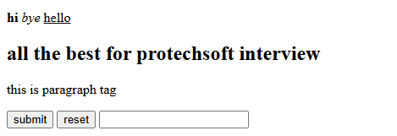

Q1. What is an HTML element?
Ans: Combination of tags and content.
Q2. What is an inline element?
Ans: An element displayed in the same line.
Q3. Give examples of inline elements.
Ans: <b>, <i>, <u>.
Q4. What is a block-level element?
Ans: An element displayed on a new line.
Q5. Give examples of block-level elements.
Ans: <h1>, <p>.
Q6. Give examples of inline-block elements.
Ans: <button>, <input>.

13. Formatting Tags
Used to change the appearance/format of text.
Tag | Purpose
<b> | Bold
<i> | Italic
<u> | Underline
<del> | Strike Through
<mark> | Highlight

Example
<p> we are the student of <b>qspiders</b> </p>
<p> we are the student of <u>qspiders</u> </p>
<p> we are the student of <i>qspiders</i> </p>
<p> we are the student of <del>qspiders</del> </p>
<p> we are the student of <mark>qspiders</mark> </p>

Interview Questions
Q1. Which tag is used for bold text?
Ans: <b>
Q2. Which tag is used for underline?
Ans: <u>
Q3. Which tag is used to highlight text?
Ans: <mark>
Q4. Which tag is used to strike content?
Ans: <del>
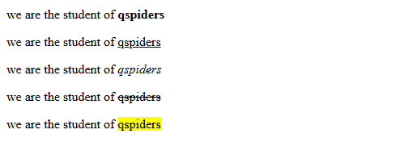

14. Image Tag
Used to add images.

Syntax
<img src="image.jpg" alt="Image">

Attributes
Attribute | Purpose
src | Image path
alt | Alternate text
height | Height of image
width | Width of image

Example
<img src="cat.jpg" alt="cat image" height="200">
Q1. Which tag is used to add an image?
Ans: <img>
Q2. What is the purpose of src?
Ans: It specifies the image path.
Q3. What is the purpose of alt?
Ans: It displays alternate text if the image fails to load.

15. Lists
Used to group related items together.
Q1. How many types of lists are there in HTML?
Ans: 3
Q2. What are they?
Ans:
- Ordered List
- Unordered List
- Description List
Q3. Which tag is used to create list items?
Ans: <li>

Ordered List
<ol >
<li>html</li>
<li>css</li>
<li>javascript</li>
</ol>

Output:
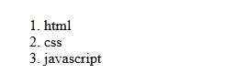

<ol start="50">
<li>html</li>
<li>css</li>
<li>javascript</li>
</ol>

Output:

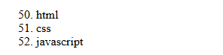

<ol start="50" reversed>
<li>html</li>
<li>css</li>
<li>javascript</li>
</ol>

Output:

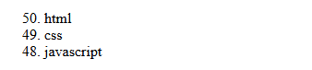
<ol type="I" >
<li>html</li>
<li>css</li>
<li>javascript</li>
</ol>

Output:

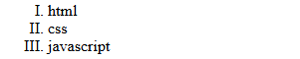

Unordered List
<ul>
<li>html</li>
<li>css</li>
<li>javascript</li>
</ul>

Output:
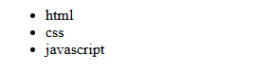

Description List
<h2> description list </h2>

<dl>
<dt>html</dt>
<dd>hyper text markup language</dd>
</dl>

<dl>
<dt>santanu</dt>
<dd>I am webtech and java trainer in qspiders</dd>
</dl>

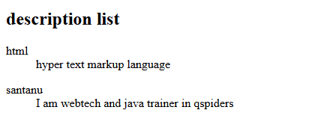

Tags
Tag | Purpose
dl | Description List
dt | Description Term
dd | Description Data

16. Marquee Tag
Used to create scrolling text.

Example
<marquee>
Welcome Students
</marquee>

Attributes
Attribute | Purpose
direction | Change direction
behavior | scroll, alternate
scrollamount | Speed

<marquee behavior="alternate" direction="right" scrollamount="30">

<h1>Interview Update : Tuesday (09/06/2026) you will be having protechsoft Interview</h1>

</marquee>

Q1. What is the purpose of marquee tag?
Ans: To create scrolling text.
Q2. What are the values of behavior attribute?
Ans: scroll, alternate.

17. Iframe
Used to display another webpage inside the current webpage.

Syntax
<iframe src="page.html"></iframe>

Uses
- Add websites
- Add YouTube videos
- Add Google Maps

Q1. What is an iframe?
Ans: It is used to display another webpage inside the current webpage.
Q2. Can we embed YouTube videos using iframe?
Ans: Yes.
Q3. Can we embed Google Maps using iframe?
Ans: Yes.

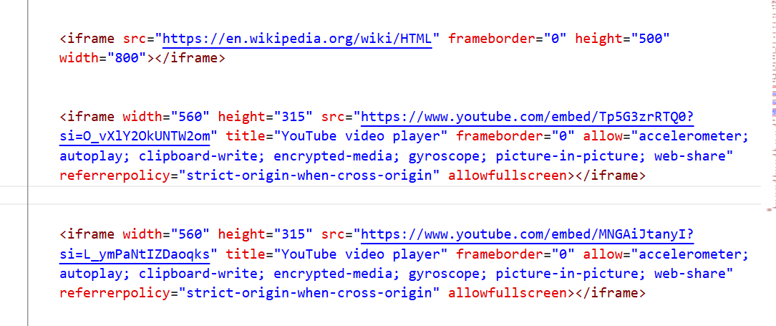

18. Table
A table is a combination of rows and columns.

Tags
Tag | Purpose
table | Creates table
tr | Creates row
td | Creates data cell
th | Creates heading cell

Example

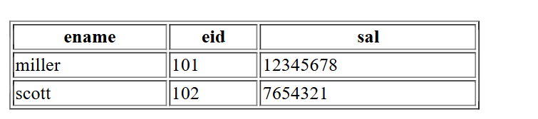

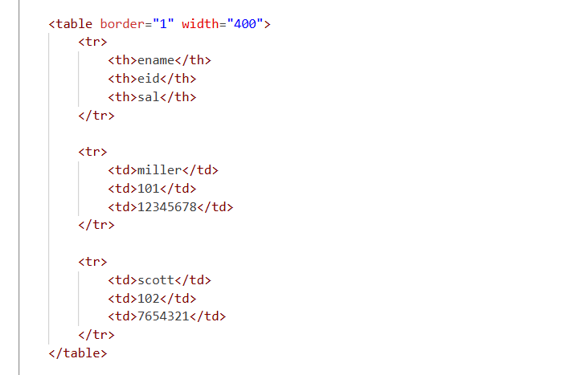

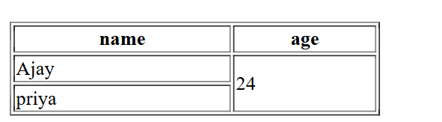
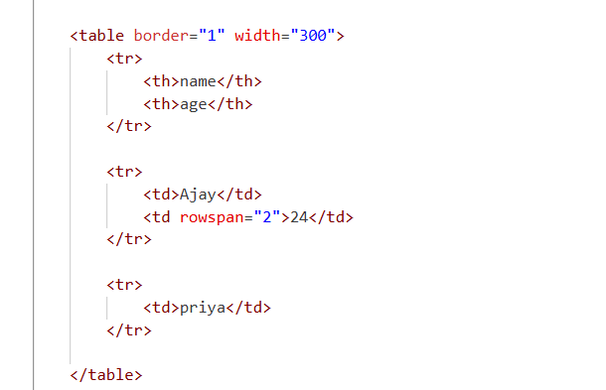

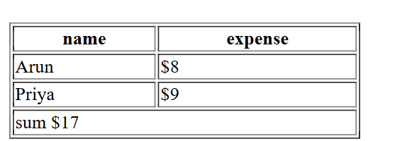

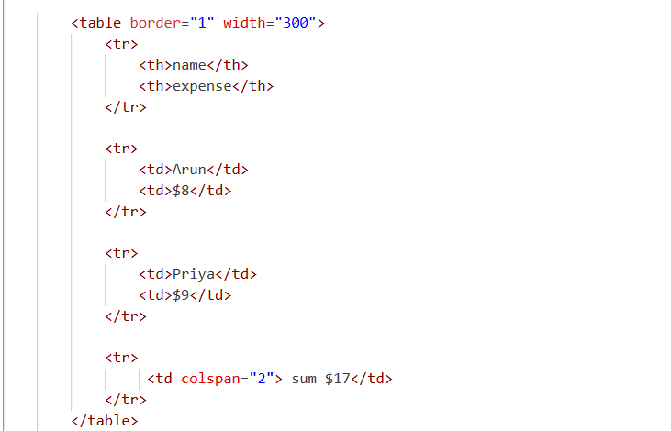

Rowspan
Used to merge multiple rows.
<td rowspan="2">24</td>

Colspan
Used to merge multiple columns.
<td colspan="2">Total</td>

Q1. Which tag creates a table?
Ans: <table>
Q2. Which tag creates rows?
Ans: <tr>
Q3. Which tag creates table data?
Ans: <td>
Q4. Which tag creates table headings?
Ans: <th>
Q5. What is rowspan?
Ans: It merges multiple rows.
Q6. What is colspan?
Ans: It merges multiple columns.

