ENUMGRID
An Honesty-Disciplined, Unprivileged-First Network Enumeration Platform with a Grounded LLM Triage Copilot
Draft — engineering + measurement paper / dissertation core
Santhakumar Parivallal
2026-07-11
Every quantitative claim is produced by a reproducible harness under evaluation/ and cites the exact artifact in evaluation/results/. Written to under-claim, carry confidence intervals, and name its own threats. No fabricated data.

Contents

Abstract
Network enumeration tools face a credibility problem: they blend host discovery, service detection, and CVE correlation into a single verdict and hide the uncertainty in each layer, so a version-string guess and a confirmed exploit look alike. ENUMGRID is a two-tier (single-file CLI + FastAPI/React) purple-team enumeration platform built around a different discipline — no fabrication as a first-class, measurable property. Findings are confidence-banded, unresolved fields are labelled Unknown rather than guessed, the data path is never simulated, and both the deterministic CVE matcher and the LLM triage copilot are measured for false-positive/hallucination behaviour, not only recall.
We make three claims and evaluate each: (1) honesty-as-a-property — the offline CVE matcher scores precision 1.00 / recall 1.00 (0 false positives) on a 33-case adversarial corpus, and the copilot fabricates 0 CVEs across five runs (grounding 1.000 ± 0.000); (2) unprivileged fidelity — a four-signal (TTL + OUI + hostname + mDNS) discovery/OS fusion recalls 0.99 ± 0.02 of hosts across two environments versus 0.53 ± 0.93 for an unprivileged nmap -sn, without root; (3) a grounded triage copilot with structural hallucination guards. We further measure the primary live-NVD CVE path (recall 1.00, 8/8; version-scoping precision 1.00, 7/7) and report where it fails — a CPE-dictionary drift between nmap and NVD that the harness surfaced rather than hid. We position ENUMGRID honestly: it is an integration + measurement contribution, not a new algorithm, and its evaluation is deliberately bounded, with every limit stated.

1. Introduction

1.1 Motivation
A practitioner scanning a network wants three things at once: what is here (discovery), what is it running (service/version detection), and what is wrong with it (vulnerability correlation). Existing tools each do a slice well — nmap for services, Fing for inventory, Nessus/OpenVAS for deep vuln assessment, Nuclei for active proof-of-concept confirmation — but the stitched-together result tends to launder uncertainty: a CVE inferred from a banner version is presented with the same visual weight as one confirmed by a probe. On a back-ported distro build, that laundering produces a confident false positive. In an LLM-assisted workflow it gets worse: a fluent model will invent a plausible CVE id to answer "what is exploitable here?"
ENUMGRID is built on the premise that for a security tool an invented finding is categorically worse than a missing one — a missed detail is recoverable, a fabricated CVE that sends an analyst down a wrong path is not — and that a scanner should therefore quantify and bound its own over-claiming as a headline property, not bury it.

1.2 The gap
Most scanners report recall-like coverage and are silent on false-positive and, in the LLM era, hallucination behaviour. Where precision is discussed it is rarely measured against an adversarial corpus with closed-world scoring, and the primary live path (a CPE→NVD query, not an offline table) is almost never precision/recall-evaluated at all. ENUMGRID treats those omissions as the contribution surface.

1.3 Contributions
- A two-tier enumeration platform (§3) that runs the same scan engine unprivileged-first, from a single-file CLI and a FastAPI/React dashboard, with runtime privilege auto-adaptation.
- An honesty discipline (§4) — confidence banding, Unknown labelling, a never-simulated data path, provenance manifests — operationalised so it can be measured, not merely asserted.
- A measurement suite (§6) scoring each layer with closed-world precision/recall, Wilson CIs, cross-environment macro-averaging, and multi-run CIs for the LLM — all through the same code paths as the product, all reproducible in CI.
- Two findings that only an honest harness surfaces: the CPE-dictionary drift that breaks a live-NVD query for vsftpd (§6.5), and a real substring false positive (httpd ⊂ lighttpd) the precision corpus caught and regression-locked (§6.4).

1.4 Scope and honest positioning
This is an engineering + measurement paper. The individual techniques (ping/ARP/TCP discovery, nmap -sV, CPE→NVD lookup, KEV/EPSS prioritisation, LLM summarisation) are established; the contribution is their integration and the discipline imposed on the result. On novelty alone this is a strong Master’s dissertation and a credible tool/demo or workshop paper, not a top-tier research-venue submission. We say so plainly, and the evaluation is scoped to what it can honestly support (§7).

2. Background and Related Work

2.1 The two schools of vulnerability detection
CVE detection tools fall into two schools, and the distinction drives our evaluation design:
- Version-match (nmap vulners NSE, and ENUMGRID’s CPE→NVD path): map a detected product/version to its known CVEs. High recall, but a back-ported fix makes it over-report — a candidate false positive.
- Active-PoC (Nuclei): send a probe that confirms the bug. High precision, but only covers vulnerabilities someone wrote a template for, and only fires when the exploitable configuration — not merely the version — is present.
Neither dominates; they trade recall for precision in opposite directions. A fair evaluation must show both alongside the tool under test, which is exactly what §6.6 does on real hosts.

2.2 Positioning
Tool / class | What it does | What ENUMGRID adds relative to it
Fing / Angry IP (asset discovery) | Fast device inventory | Service/version depth, live CVE correlation, honesty labelling on top of inventory
nmap / Zenmap (port/service scanner) | Authoritative service/version/OS, NSE | Whole-network orchestration, unprivileged auto-adaptation, CVE/KEV/EPSS enrichment around the same engine it invokes
masscan / ZMap (high-rate scanners) | Breadth at very high packet rates | Not a speed competitor; targets authorised, local estates with depth + honesty
OpenVAS / Nessus (vuln scanners) | Deep authenticated + network vuln assessment | Lighter-weight, unprivileged-first, confidence-transparent; these remain the stronger scanners — ENUMGRID is measured against them, not claimed to replace them
Nuclei (active-PoC) | Confirms vulns by probe | Used as an evaluation baseline (§6.6)
nmap vulners (version-match) | CVE ids from CPE/version | Same school as ENUMGRID’s path; used as a second baseline

ENUMGRID sits between asset-discovery tools (which do not assess vulnerability) and vulnerability scanners (which do not give a fast, honest, unprivileged inventory). Its value is the integration and the honesty discipline, not out-scanning Nessus or out-running masscan.

3. System Design

3.1 Two-tier architecture
ENUMGRID ships as (a) a single-file CLI (purple_recon.py) for scriptable, terminal-first use, and (b) a FastAPI backend (~30 modules) driving a React/Vite dashboard for interactive triage. Both tiers share the same core: a ScopeValidator (authorisation gate), the scan engine, the CVE-correlation pipeline, and the report/provenance layer. A scan proceeds in two phases — Phase 1 multi-method host discovery (ICMP/ARP/TCP), then Phase 2 nmap service/version enumeration — streamed to the UI over SSE (Fig. 3).

3.2 Four-signal unprivileged discovery and OS fusion
Without root, ICMP echo and raw-socket OS fingerprinting are unavailable, so a naive unprivileged scan collapses to a weak TCP-connect ping sweep (the failure mode we quantify against nmap -sn in §6.2). ENUMGRID recovers fidelity by fusing four independently-available signals: the ICMP/TCP reply TTL (OS family hint), the IEEE OUI from the ARP/neighbour table (vendor), reverse-DNS / mDNS hostname, and the mDNS model= record. The fused inference drives the device-type and OS columns (Fig. 4) and degrades to Unknown — never a guess — when the signals disagree or are absent.

3.3 Privilege auto-adaptation
Rather than fail or demand root, ENUMGRID rewrites root-only nmap flags (-sS, -sU, -O) to their safe unprivileged equivalents and annotates the residual gap. When the operator chooses to elevate, the dashboard collects a sudo password that is validated against sudo and held only in the backend’s memory for the session — never written to disk, logged, or returned (Fig. 2). Elevation is gated to the local operator (or an admin token when RBAC is enabled).
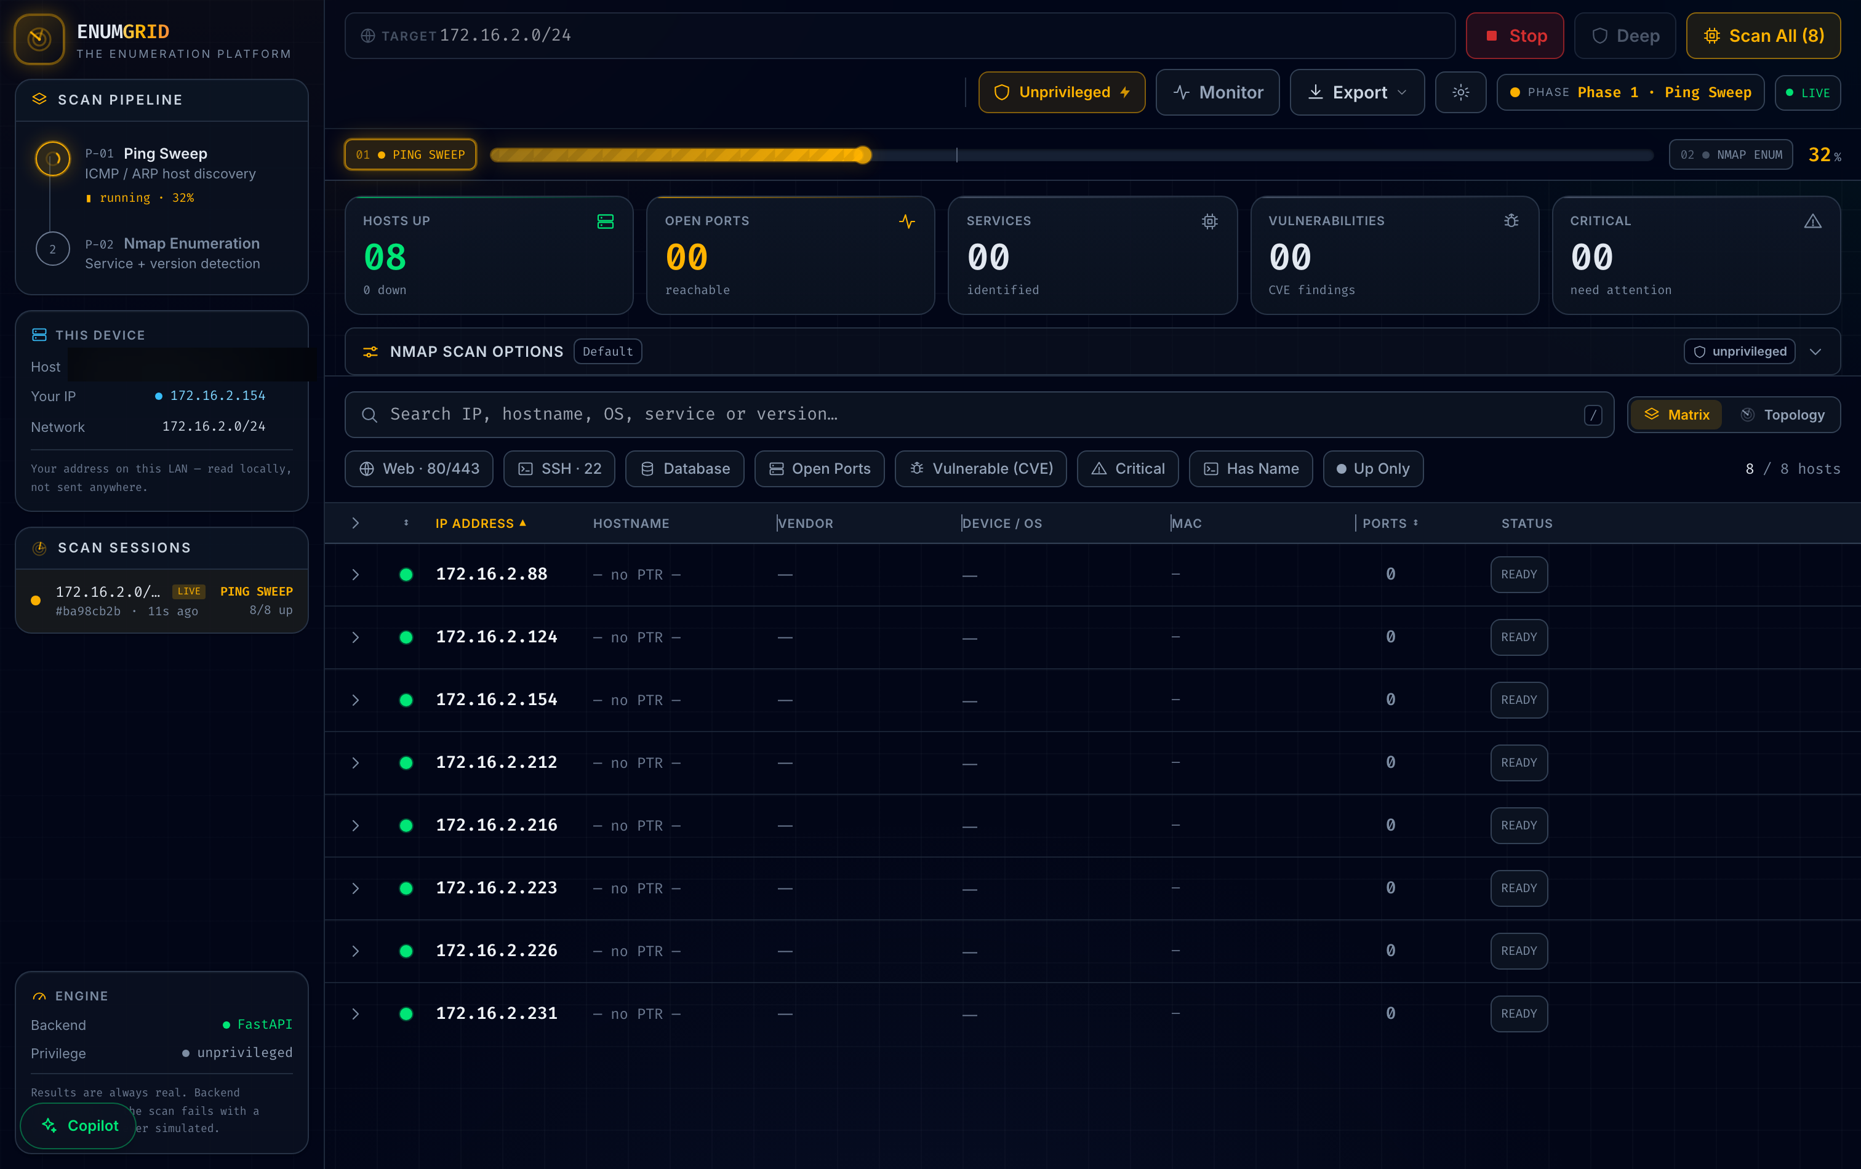
Figure 3. Live scan in progress — Phase 1 ping sweep at 32%, hosts populating the matrix in real time (operator hostname/MACs redacted).
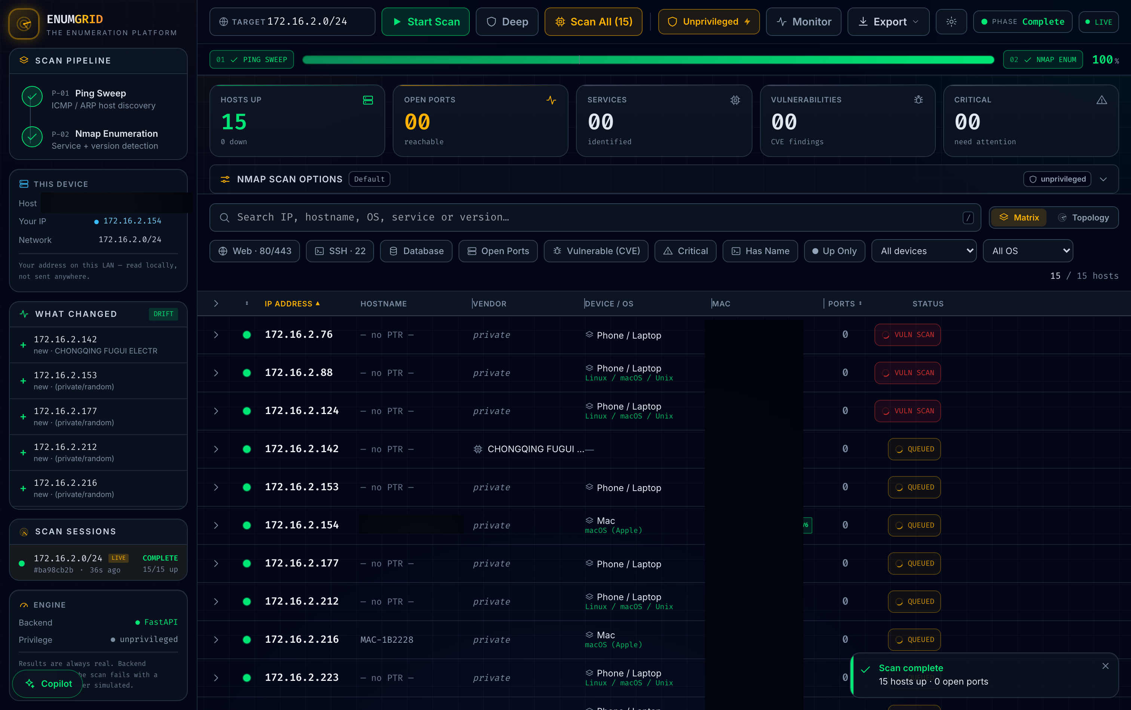
Figure 4. Completed scan — 15/15 hosts, unprivileged OS fusion (Mac/Linux/Phone), IPv6 badges, and the drift panel (hostname/MAC column redacted).

4. The Honesty Discipline
The project’s thesis is that no-fabrication can be a first-class, measurable property of a scanner. Four mechanisms operationalise it:
- Confidence banding. Every finding carries a band: confirmed (actively probed, nmap confidence ≥ 7) vs version (inferred from a banner). The UI renders them distinctly and the benchmark scores accuracy per band (§6.3), so "high-confidence detections are more accurate than low-confidence guesses" is a measured claim.
- `Unknown` over guessing. An unresolved OS, vendor, or version is labelled Unknown; the matcher never emits a CVE for a version-less banner or an untabled product.
- Never-simulated data. There is no mock/demo mode in the evidence path; if a scan fails it says so rather than fabricating hosts.
- Provenance. Each scan carries a provenance manifest; golden-file tests fix the parser→model→report pipeline byte-for-byte.
The same discipline extends to the LLM copilot: the context block feeds the model the real CVE identifiers from the scan, and a deterministic guard flags any id the model emits that is not in the scan — measured in §6.8.

5. Implementation
The backend is Python/FastAPI (~30 modules: scanner, CVE correlation across NVD/vulners/OSV, KEV/EPSS triage, report/PDF, auth with per-IP throttling, structured logging). The frontend is React/Vite/TypeScript. Engineering rigour is part of the credibility argument, not the research claim: the repository carries 1,307 automated tests (Python 1,101 — CLI 197 + backend 726 + evaluation 178; frontend 206), CI-gated line-coverage floors (100% on load-bearing modules), clean SAST (bandit) and dependency audit (pip-audit), an SBOM, and a digest-pinned non-root Docker image. Critically, the evaluation harnesses call the same code paths as the product (the detection benchmark calls scanner._service_scan; the offline CVE benchmark calls vulndb.lookup_offline_cves; the live-NVD benchmark calls cve.parse_nvd), so the measured numbers are ENUMGRID’s own, not a re-implementation’s.

6. Evaluation

6.1 Methodology
- Ground truth. On the pinned docker testbed the expected ports/services/versions/planted-CVEs are known exactly, enabling true precision/recall. Off-testbed (real LANs) we use the union of tools as a proxy — a host no tool sees is invisible to the metric, so off-testbed recall is an upper bound, stated as such.
- Closed-world scoring. For the offline CVE corpus, each banner pins the exact CVE set expected: any extra id is a false positive, any missing id a false negative.
- Uncertainty. Binomial proportions carry Wilson 95% CIs; cross-environment results are macro-averaged (each network = one sample) with a 95% CI across environments; the nondeterministic LLM is run multiple times with mean ± CI.
- Two layers per harness. All scoring math is pure and unit-tested (runs in CI with no Docker/network); the live runners are operator-run. A missing baseline is reported unavailable, never "found nothing".
The environments are a real home /24 (172.16.2.0/24, unprivileged) and the 9-host synthetic testbed (172.28.0.0/24, brought up on a colima VM).

6.2 Host discovery
Three runs on the real 172.16.2.0/24 LAN, unprivileged (benchmark_172-16-2.json):
Tool | Recall (mean ± 95% CI) | Precision | Hosts (of 18) | Time
EnumGrid | 0.98 ± 0.04 | 1.00 | 17.7 | 22.7 s
nmap -sn (unpriv.) | 0.06 ± 0.00 | 1.00 | 1.0 | 51.2 s

An unprivileged nmap -sn sees one host on this ICMP-filtered consumer LAN; ENUMGRID’s four-signal discovery sees ~18×. Pooling this LAN with the testbed (pooled_recall.json, n = 2 envs):
Tool | Recall (mean ± 95% CI across envs) | 172.16.2.0/24 | 172.28.0.0/24
EnumGrid | 0.99 ± 0.02 | 0.98 | 1.00
nmap -sn | 0.53 ± 0.93 | 0.06 | 1.00

The honest headline is nmap -sn’s enormous CI: it is environment dependent, crippled on the filtered LAN yet perfect on the clean testbed, whereas EnumGrid is consistently high. n = 2 (one real LAN + one synthetic testbed) is small and reported as such — COLLECTING_NETWORKS.md is the turnkey runbook to widen it.
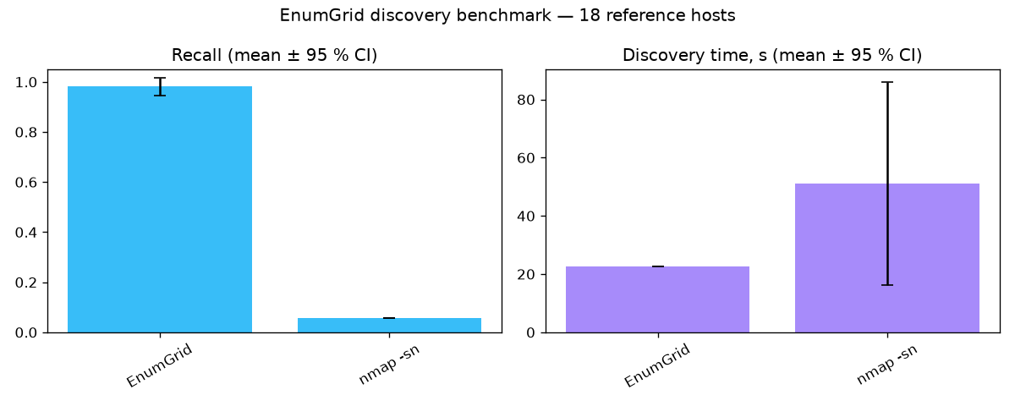
Figure 6a. Discovery recall on the real /24 LAN across three runs — EnumGrid vs unprivileged nmap -sn.
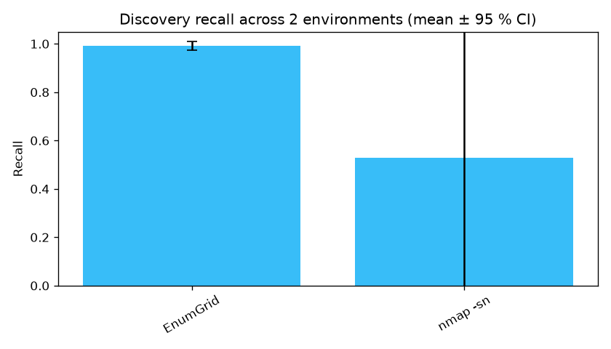
Figure 6b. Cross-environment discovery recall (mean ± 95% CI, n = 2). nmap -sn’s large error bar is the honest headline.

6.3 Service, port, and version detection
Against the 9-host testbed through scanner._service_scan (detection_172-28.json):
Metric | Result
Open ports | precision 1.00, recall 1.00, F1 1.00 (9 TP, 0 FP, 0 FN)
Service-name accuracy | 0.89 (8/9; the mongo banner is the one low-confidence miss)
Version-string accuracy | 0.83 (5/6 versioned ports)
Planted-CVE recall | 1.00 (3/3)
Unexpected CVEs | 56, surfaced for review, not scored as FPs (a rolling image’s full CVE set is unknowable a priori)

Split by confidence band: high (conf ≥ 7, n = 8) — service accuracy 1.00, version 0.83; low (n = 1) — service 0.00. The single low-confidence detection is the single service miss: the banding predicts the error, which is the point of measuring it.

6.4 CVE matching — offline precision corpus
The highest-stakes claim — attach the right CVE to the right version, and never a wrong one. A 33-case adversarial corpus run through the real offline matcher with closed-world scoring (cve_precision.json):
Metric | Value | 95% Wilson CI
Precision | 1.000 | [0.816, 1.000]
Recall | 1.000 | [0.816, 1.000]
F1 | 1.000 | —

0 false positives, 0 false negatives, across categories exact (16), boundary (8), wrong-product (4), backport (1), control (4). The corpus embeds the traps that break naive matchers: version-range boundaries (2.4.49 matches, 2.4.51 must not), substring collisions, magic-version collisions, and a RHEL backport.
A real bug this caught. Building the corpus surfaced a genuine false positive: the matcher’s substring keyword match let "httpd" match inside "lighttpd", so a patched lighttpd was flagged with Apache’s path-traversal CVE. The fix (whole-token matching in vulndb._kw_hit) is locked in by a regression test.
The 0.816 Wilson lower bound is reported honestly: it reflects that 17 positive matches is a modest sample, not that any match was wrong. This runs offline and deterministic in CI, gated at --min-precision 1.0 --min-recall 1.0.

6.5 CVE matching — the primary live-NVD path
The offline corpus tests the fallback. The primary path is a version-scoped CPE query to the live NVD API → parse_nvd → top-N by CVSS. nvd_precision.py measures it against the real feed on a 12-case labelled corpus (nvd_live.json):
Metric | Value | 95% Wilson CI | Counts
Recall (documented CVEs surfaced) | 1.00 | [0.68, 1.00] | 8/8
Version-scoping precision | 1.00 | [0.65, 1.00] | 7/7 excluded, 0 violations
Top-N truncation loss | 0 |  | none dropped by the CVSS cap

Finding — surfaced, not hidden. The first authoritative run scored recall 7/8. The harness attributed the miss to absence (NVD returned 0 rows), not truncation. Root cause: NVD indexes the vsftpd 2.3.4 backdoor (CVE-2011-2523) under vendor vsftpd_project, while nmap’s fingerprint emits vsftpd — a CPE-dictionary drift. This is a real construct-validity limitation of the live-NVD layer in isolation, not a defect to bury: it is why ENUMGRID does not rely on live-NVD alone — the in-scan vulners NSE and the offline table both recall CVE-2011-2523 independently. With the canonical CPE the live pipeline recalls it (8/8); the drift is retained as a documented threat (ACCURACY §10).
To remove the author-curation ("fit-to-matcher") risk on these numbers, nvd_corpus_heldout.json is a frozen, empty held-out template carrying a blind-sampling protocol; the same harness scores it unchanged. We expect held-out recall to be lower than the curated 1.00 — and report it as-is when run.

6.6 CVE detection versus baselines
The "compared to what?" question, three detectors on the same planted hosts, one from each school (cve_baselines_172-28.json):
Tool | School | Planted-CVE recall | Unexpected
nmap-`vulners` | version-match | 1.00 (3/3) | 133
EnumGrid | version-match (conservative) | 0.67 (2/3) | 13
Nuclei | active-PoC | 0.00 (0/3) | 0

The two schools trade off exactly as theory predicts, now on real hosts: version-match maximises recall (nmap-vulners 3/3) but at 10× the noise (133 vs EnumGrid’s 13); EnumGrid deliberately trades a little recall for far fewer false alarms; active-PoC (Nuclei) fires nothing because the vanilla images expose the version but not the exploitable config (e.g. the CVE-2021-41773 PoC needs a cgi-bin/alias the default image omits) — high precision, config-dependent recall.
Two honesties we keep rather than smooth over: EnumGrid’s own recall varied 2/3 ↔ 3/3 between this run and §6.3 — real live-scan nondeterminism on the incomplete-fix 2.4.50 twin, which is why the project measures run-to-run stability (--repeat); and on the clean testbed EnumGrid’s discovery merely ties nmap -sn at 1.00 (§6.2) — it dominates only on real ICMP-filtered LANs, and we say so. The heavyweight scanners (OpenVAS/Nessus) are supported via report-file adapters (cve_baselines.py --tools openvas,nessus), awaiting an operator export.

6.7 Scalability
scalability_benchmark.py swept /28 → /24 inside the authorised 172.16.2.0/24 (scalability_172-16-2.json): discovery time fits 46.5 ms/address + 9.1 s fixed overhead (R² = 0.83), a throughput of ~6.4 addresses/s. Peak-RSS is best-effort and noisy on macOS (getrusage children), so we report the timing fit and flag the memory figure as indicative only.
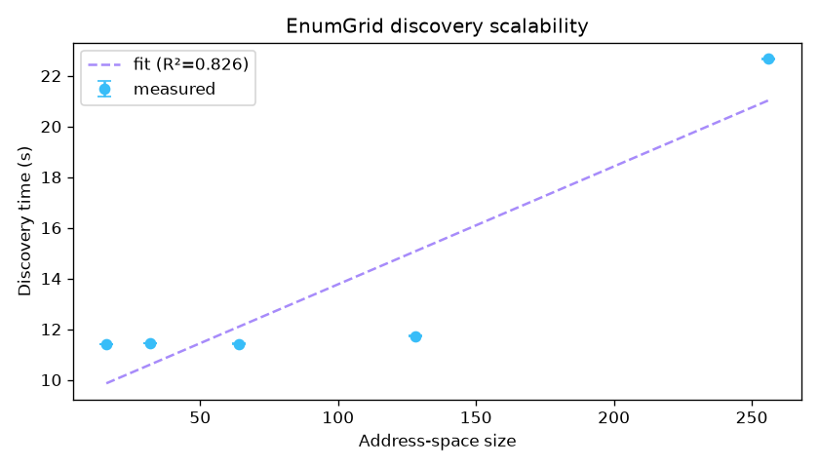
Figure 7. Discovery time vs address-space size (/28 → /24), OLS fit 46.5 ms/address + 9.1 s, R² = 0.83.

6.8 LLM triage copilot
The copilot summarises scan findings and is measured for grounding (does it cite only hosts/CVEs present in the scan) as well as coverage. Five runs of copilot_eval.py against a local Ollama model (llama3.2_x5.json):
Metric | Mean ± 95% CI | Min / Max
Grounding | 1.000 ± 0.000 | 1.00 / 1.00
Coverage | 0.760 ± 0.078 | 0.60 / 0.80
Score | 0.880 ± 0.039 | 0.80 / 0.90

Grounding is perfectly stable at 1.00 across all five runs — the model fabricated nothing, five times out of five, because the guarantee is structural (real ids into the context, a deterministic guard on the way out), not sampled. The only variance is coverage (recall): the residual failure mode of a grounded model is silence on a fact, never invention of one — exactly the right trade for a security tool. A larger 7B model (qwen2.5) reaches coverage 1.00 / grounding 1.00. A --self-test proves grounding collapses to 0 on an adversarial fabricated reply, so the metric cannot be gamed.

7. Threats to Validity
- External (the largest). Results come from few environments — two real /24s plus one synthetic testbed — on one operator’s hardware. Generalisation to enterprise, IoT-dense, or cloud-VPC networks is unestablished; the discovery pool is n = 2. Scaffolded but not closed (COLLECTING_NETWORKS.md).
- Construct. Off-testbed discovery uses union-of-tools as a proxy, so recall is an upper bound. CVE precision is scored deterministically on the offline corpus, not on rolling images. CPE-dictionary drift (§6.5) means the live-NVD layer alone has recall gaps where nmap’s and NVD’s vendor strings disagree — measured, mitigated by independent layers.
- Internal. Live scans are nondeterministic; addressed by stability measurement and multi-run CIs. Coverage is line, not branch.
- Statistical. With small n the CIs are wide; a "1.00" on a small corpus means "no error observed in this sample", not "error-free in general" — the corpora (33 offline / 12 live CVE cases, 3 planted instances) are small and author-curated, which the held-out template is designed to address.

8. Ethics and Legal
- Authorisation is enforced, not assumed. ScopeValidator hard-refuses loopback, multicast, broadcast, link-local, reserved, and (by default) public/Internet-routable space — a technical control, part of the contribution.
- No third-party scanning. All evaluation targets are the operator’s own /24 or containers the operator owns. Active scanning without written authorisation is out of scope and refused.
- Responsible disclosure for any real vulnerability found on an authorised third-party estate; ENUMGRID’s own issues go through SECURITY.md.
- Data handling. Published figures redact identifying fields; secrets (NVD key, sudo password) are owner-only (0600), in-memory where possible, never logged.
- Dual-use. ENUMGRID is a defensive enumeration tool; the refusal guards and the honesty discipline are deliberate mitigations of offensive potential.

9. Reproducibility
The testbed is pinned to fixed image tags; all scoring math is pure and unit-tested, so the published numbers run in CI with no Docker or network. Baselines are declared (a missing one is unavailable, never "found nothing"); the copilot eval pins models and reports multi-run mean ± CI. Every headline number maps to a command and an artifact in REPRODUCE.md and Appendix B.

10. Limitations and Future Work
Ordered by leverage: (1) scale the discovery evaluation to 3–5 distinct authorised real networks (runbook ready); (2) add a held-out, independently-sourced CVE corpus (template + protocol ready) to retire the fit-to-matcher risk; (3) add OpenVAS/Nessus baselines (report-file adapters ready) for a broader precision picture; (4) run the pre-registered analyst user study (USER_STUDY_PROTOCOL.md). Items 1–4 are scaffolded but not fabricated — each needs real networks, an independent sampler, an operator export, or human participants, respectively.

11. Conclusion
ENUMGRID does not claim a new algorithm. It claims that a network enumeration tool can treat no fabrication as a measurable property — banding its confidence, saying Unknown instead of guessing, never simulating its data, and measuring the false-positive/hallucination behaviour of both its deterministic matcher and its LLM copilot — and it backs that claim with reproducible numbers: precision 1.00 / recall 1.00 on an adversarial CVE corpus with the one false positive it did find fixed and regression-locked; 0 fabricated CVEs across five copilot runs; 0.99 ± 0.02 unprivileged discovery recall across two environments versus a highly environment-dependent 0.53 ± 0.93 baseline; and a primary live-NVD path measured to 1.00 recall with its one real failure mode surfaced and attributed. The evaluation is deliberately bounded and every limit is named. The contribution is the discipline and its measurement.

Appendix A — Figure manifest (redacted)
Figures are real runs of an authorised scan (172.16.2.0/24, unprivileged) or the standby UI; the *-redacted.png copies (produced by docs/screenshots/redact.py) blur the operator hostname and MAC column and are the ones to publish.
Fig | File (publish the -redacted) | Shows
1 | command-center-standby-redacted.png | Full app shell, standby (0/0 hosts)
2 | privilege-elevation-redacted.png | Sudo elevation dialog + in-memory-only note
3 | scan-live-redacted.png | Live scan, Phase 1 at 32%, 8 hosts populating
4 | scan-complete-redacted.png | Completed scan, 15/15, OS fusion, IPv6, drift panel
5a | topology-redacted.png | Radial topology map
5b | mobile.png | Responsive 390px layout (no host data on screen)
6 | benchmark / pooled_recall / scaling .png | Generated eval figures

Honest caveat on Figs 3–4. On this real consumer LAN the discovered hosts are firewalled phones/laptops, so Open Ports / Services / CVEs read 00 — the true unprivileged result, not a gap papered over. Populating those columns needs a host that actually exposes services (the docker testbed). Nothing is simulated.
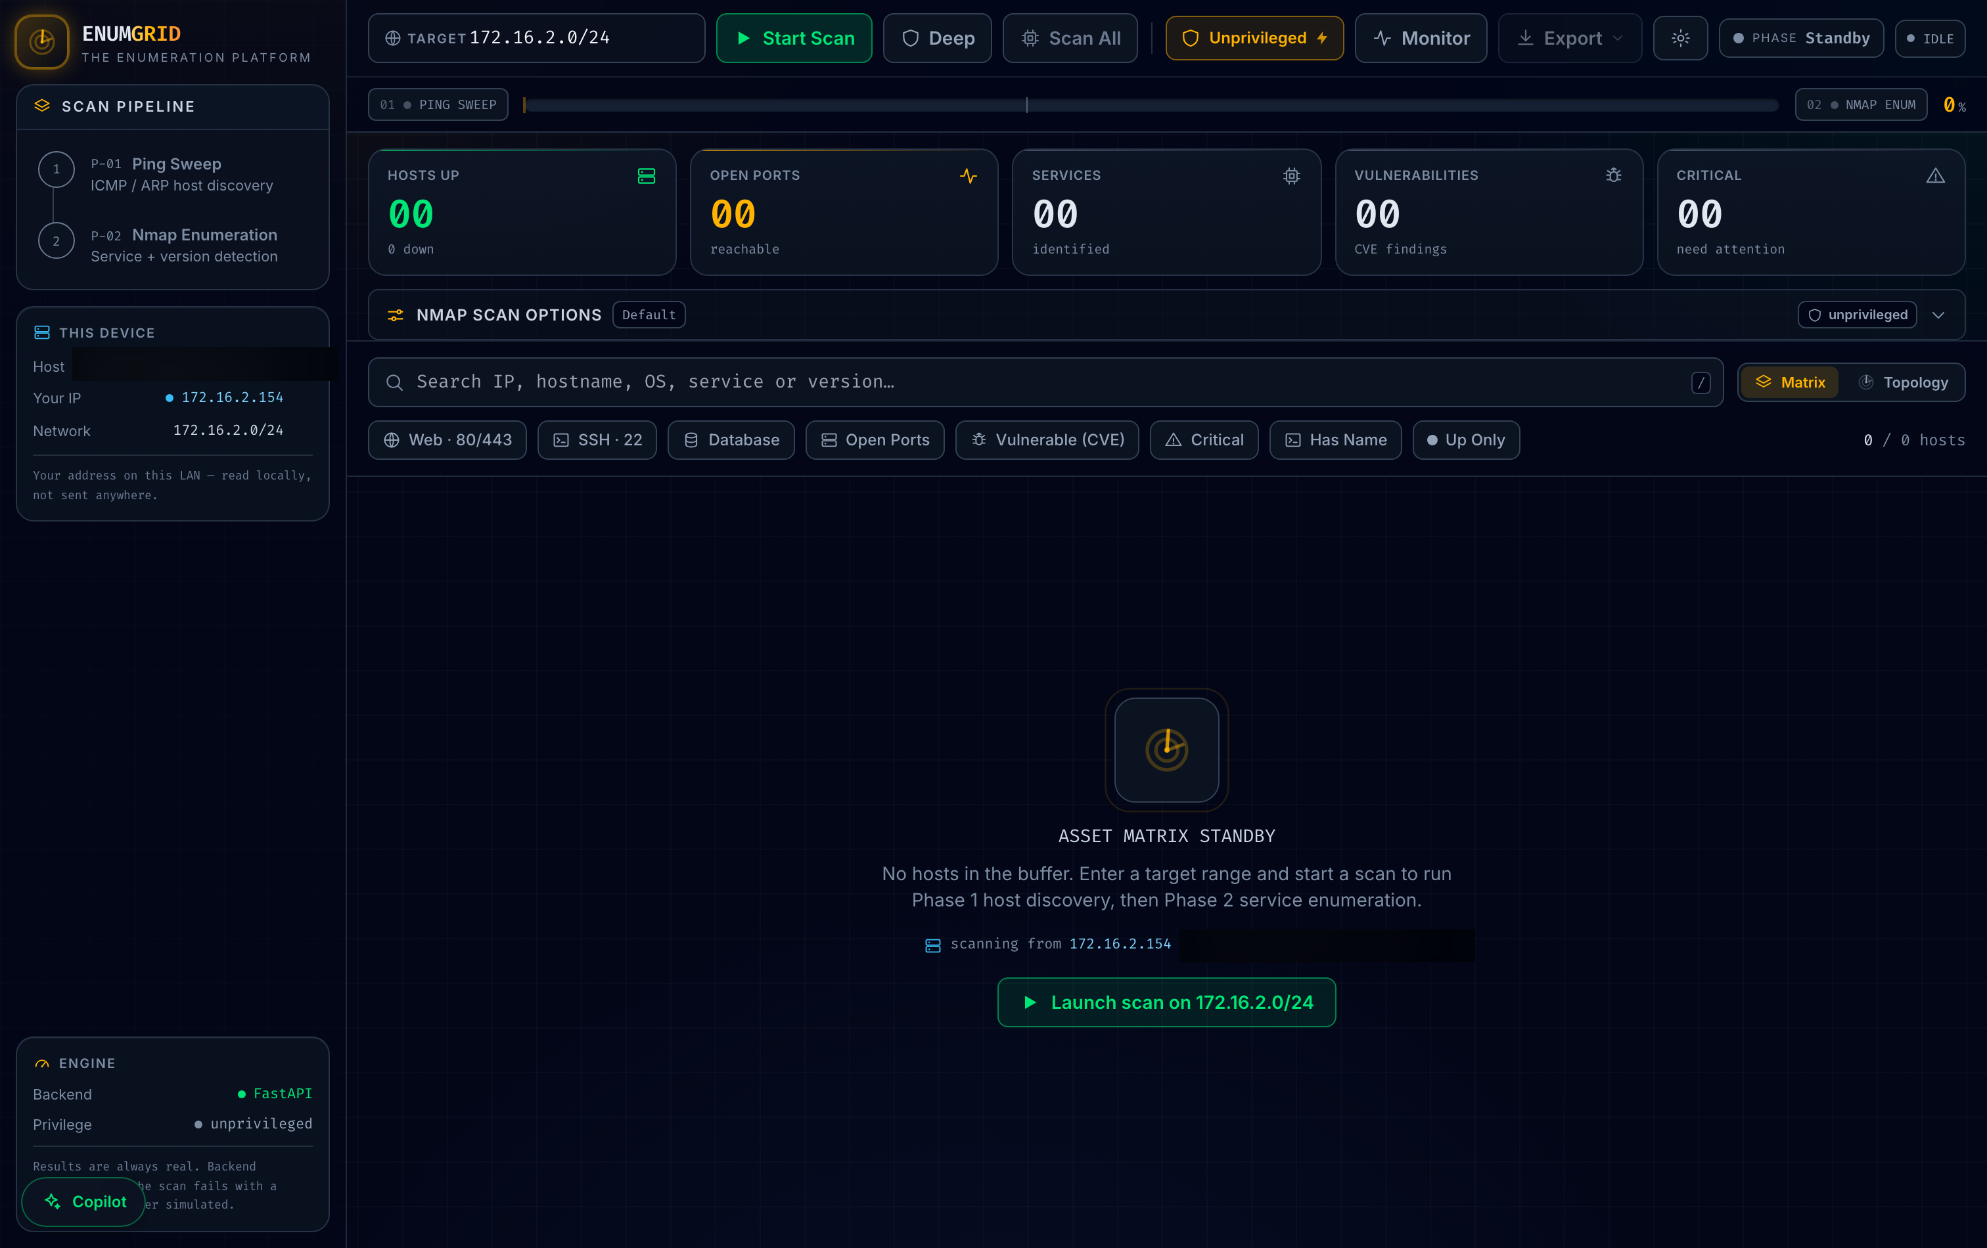
Figure 1. Command-center standby shell (hostname redacted).
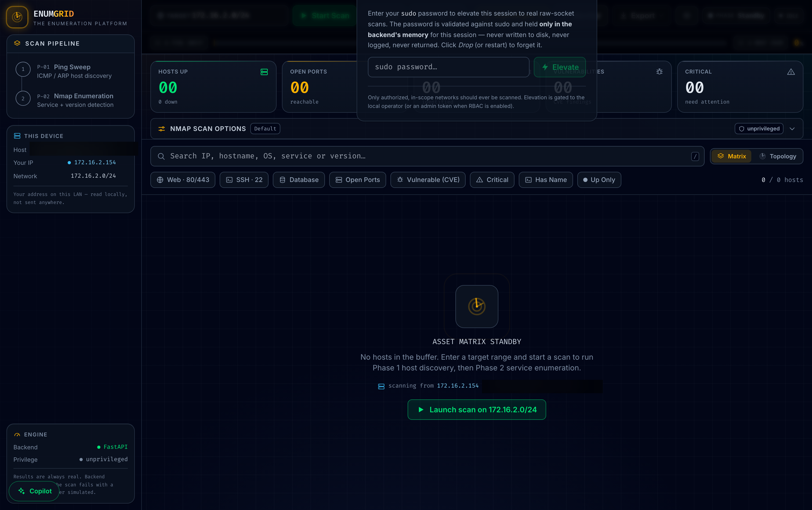
Figure 2. Runtime privilege-elevation dialog with the in-memory-only sudo-password note (hostname redacted).
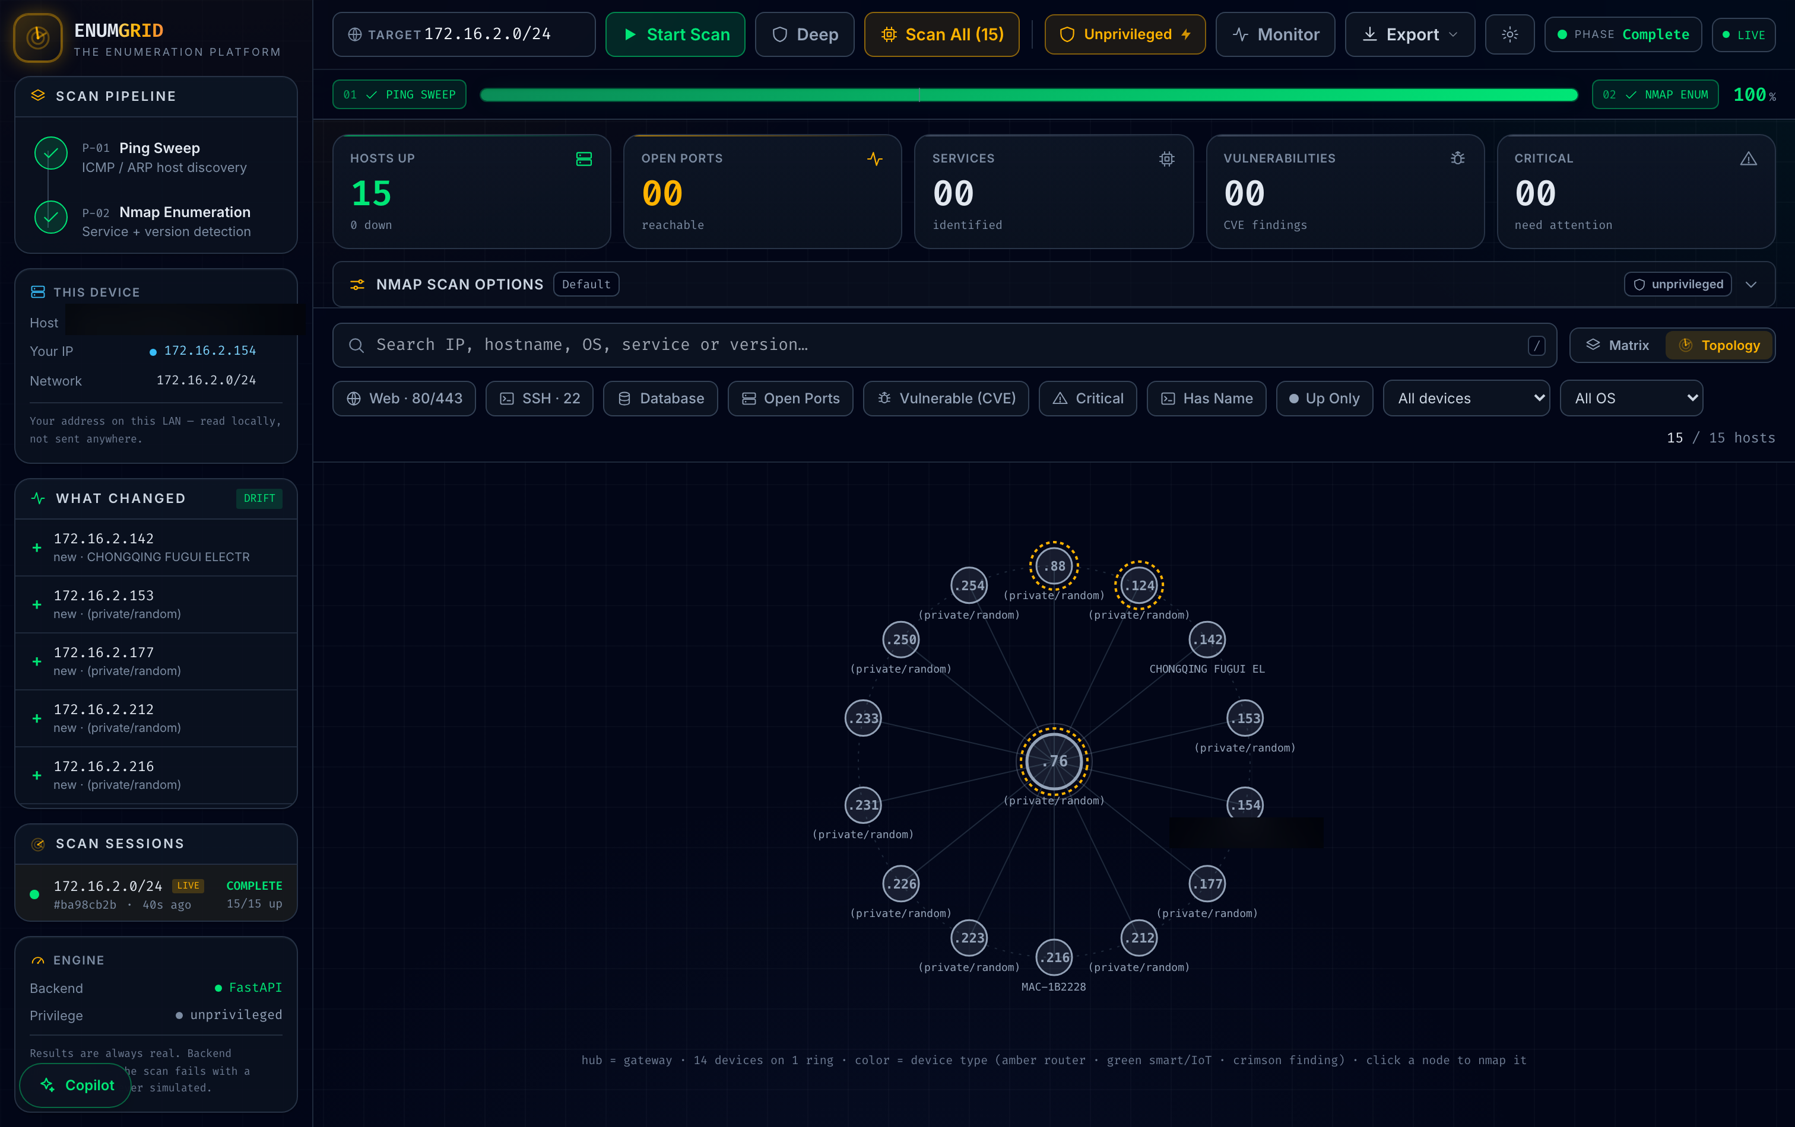
Figure 5a. Radial topology map — gateway hub + device ring (node label redacted).

Appendix B — Reproduce every number
Every headline maps to a command and an artifact; full list in docs/REPRODUCE.md. All scoring math re-runs in CI with no Docker/network via python -m pytest evaluation/ (178 tests).
Claim (paper §) | Command | Artifact
Offline CVE P/R (§6.4) | python evaluation/cve_precision.py | cve_precision.json
Live-NVD path (§6.5) | python evaluation/nvd_precision.py --live | nvd_live.json
Detection (§6.3) | python evaluation/detection_benchmark.py | detection_172-28.json
CVE baselines (§6.6) | python evaluation/cve_baselines.py | cve_baselines_172-28.json
Discovery (§6.2) | python evaluation/benchmark.py 172.16.2.0/24 --runs 3 | benchmark_172-16-2.json
Cross-env pool (§6.2) | python evaluation/aggregate_runs.py results/benchmark_*.json | pooled_recall.json
Scalability (§6.7) | python evaluation/scalability_benchmark.py 172.16.2.0/28 … /24 | scalability_172-16-2.json
Copilot grounding (§6.8) | python evaluation/copilot_eval.py --runs 5 | llama3.2_x5.json

