Design and Analysis of Algorithm

KURRA MUNI SANTHAN KUMAR REDDY

CH.SC.U4CSE24225

1.Write a program to find the sum of first n natural numbers using user defined function .

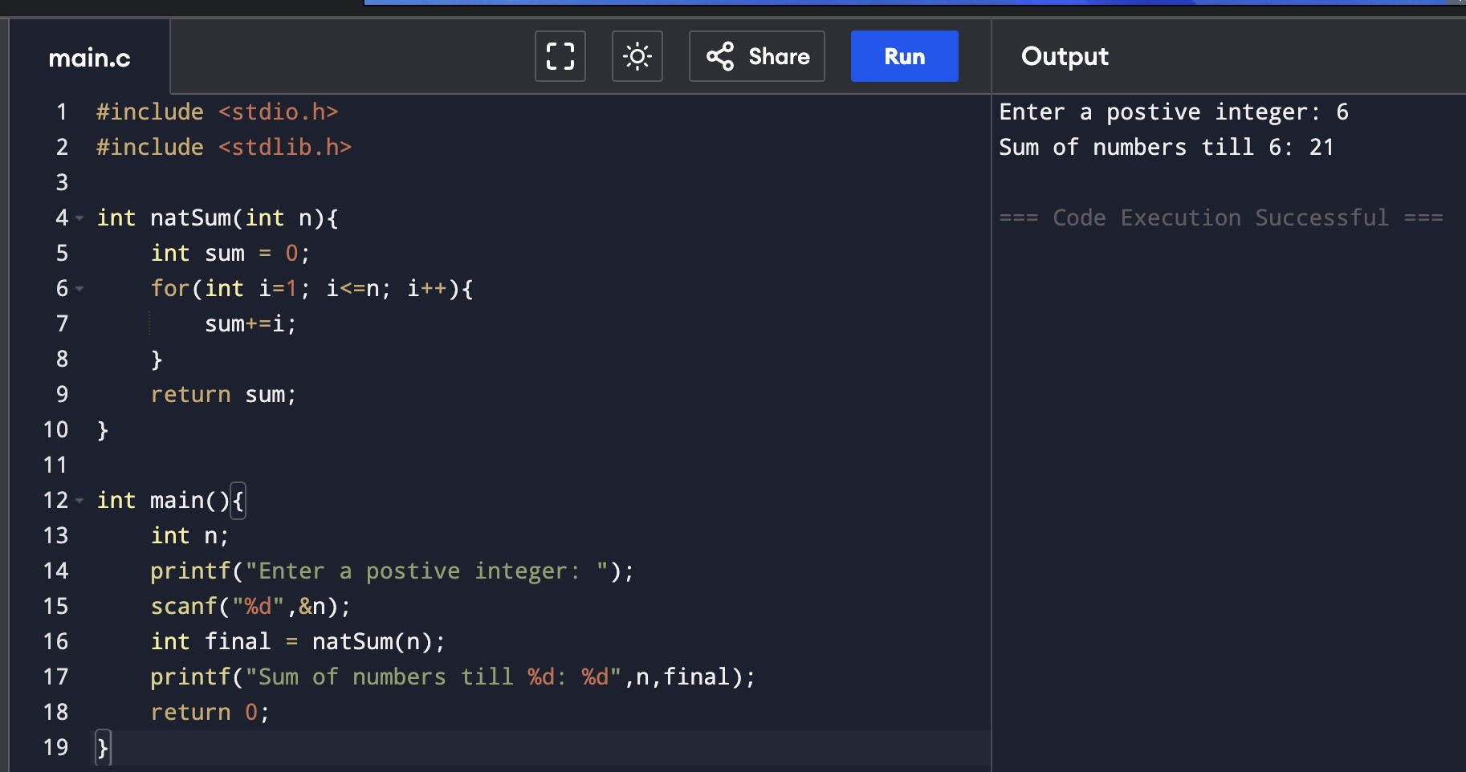
2.Write a program to find the sum of squares of first n natural numbers using user defined function.
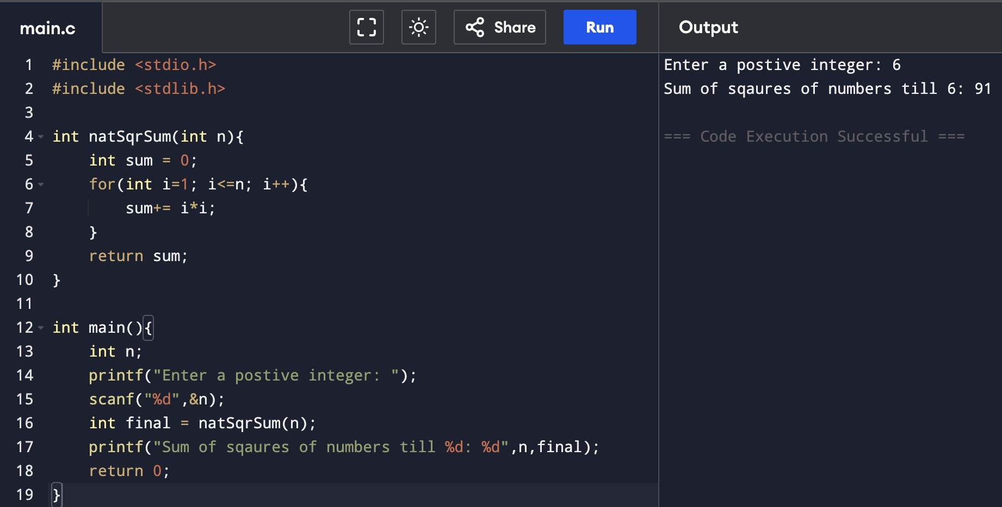

3.Write a program to find the sum of cubes of fours n natural numbers .

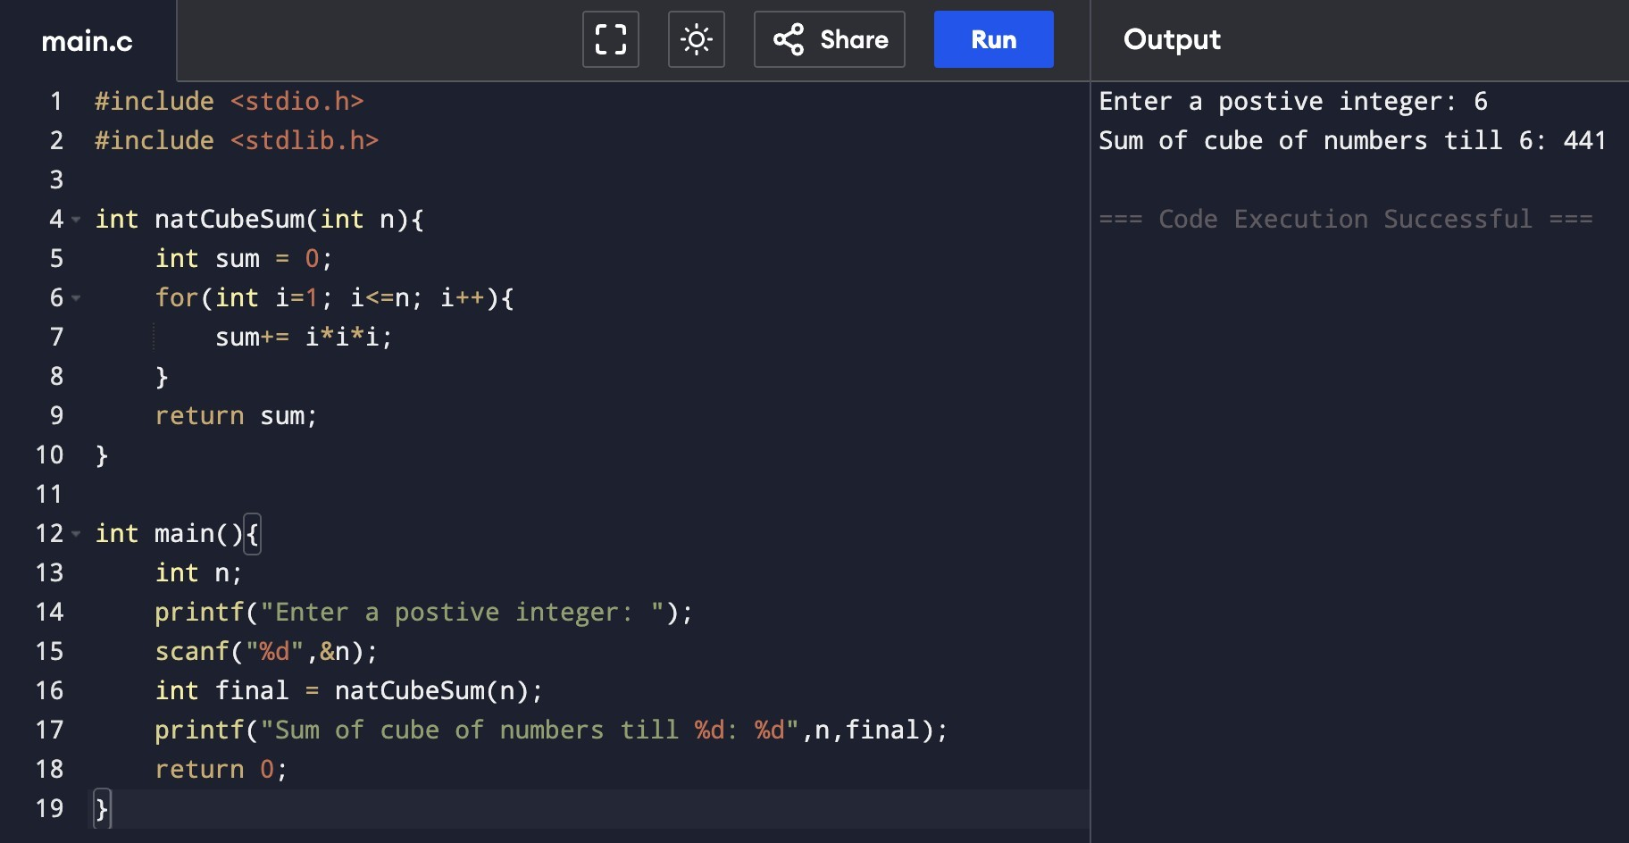
4.Write a program to find the factorial of a number using recursive functions.

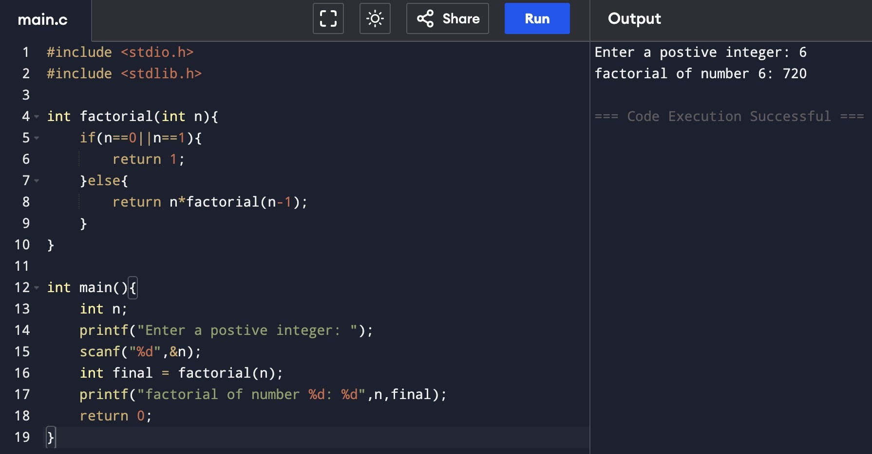

5.Write a program to transpose a 3x3 matrix.

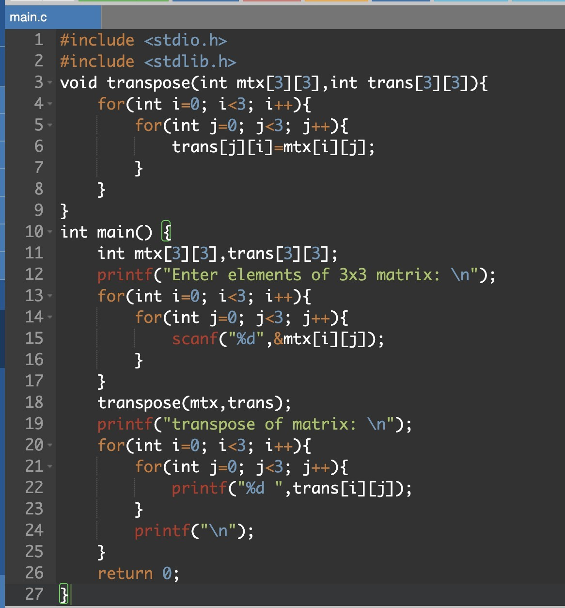

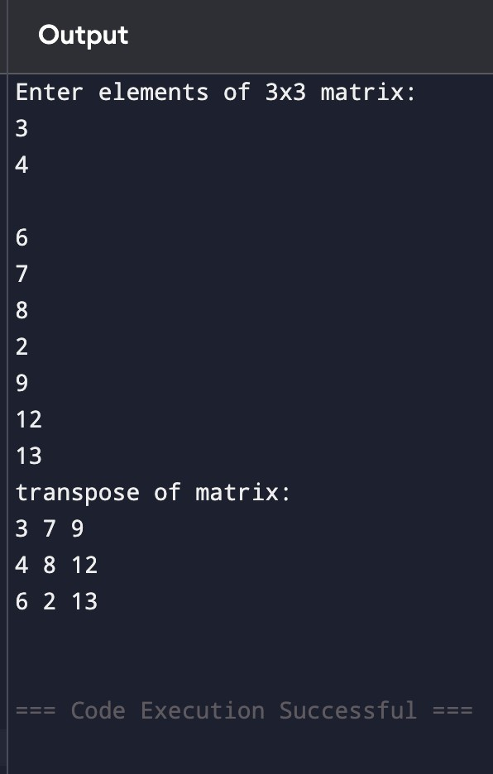

6.Write a program to print the fibonacci series for the first n natural numbers using user defined function.

