Travel Expense Management System

Submitted to the

SAVEETHA INSTITUTE OF MEDICAL AND TECHNICAL SCIENCES

by

Pv santhan (192211165)

Under the guidance of

Dr. Jay Shakti velmurugan

Professor



Institute of Computer Science and Engineering

SAVEETHA SCHOOL OF ENGINEERING CHENNAI – 602 105 TAMILNADU, INDIA

JUNE 2024

# BONAFIDE CERTIFICATE

This is to certify that the project report entitled “Travel Expense Management System” submitted by “ pv santhan (192211165) ” to Saveetha School of Engineering, Saveetha Institute of Medical and Technical Sciences, Chennai, is a record of bonafide work carried out by him/her under my guidance. The project fulfils the requirements as per the regulations of this institution and in my appraisal meets the required standards for submission.

**DR Jay Shakti velmurugan**

Professor

Engineering,

Saveetha School of Engineering

SIMATS, Chennai – 602 105

Internal examiner External Examiner

**TABLE OF CONTENTS**

| **S.NO** | **CONTENTS** | **PAGE NO** |
| --- | --- | --- |
| 1 | ABSTRACT | 1 |
| 2 | INTRODUCTION | 2 |
| 3 | DESCRIPTION | 4 |
| 4 | SYSTEM REQUIREMENTS | 6 |
| 5 | EXISTING WORK | 8 |
| 6 | PROPOSED WORK | 10 |
| 7 | TECHNOLOGY USED | 12 |
| 8 | USE CASE DIAGRAM | 14 |
| 9 | SOURCE CODE | 15 |
| 10 | SCREENSHOTS(OUTPUTS) | 18 |
| 11 | CONCLUSION | 20 |
| 12 | FUTURE ENHANCEMENT | 20 |
| 13 | REFERENCES | 21 |



# ABSTRACT

The Travel Expense Management System (TEMS) is a comprehensive software solution designed to streamline and automate the process of managing travel-related expenses within an organization. In today's globalized world, where business travel is common, organizations face challenges in tracking, approving, and reimbursing travel expenses efficiently. The TEMS addresses these challenges by providing a centralized platform for managing all aspects of travel expenses, from submission to reimbursement.



| 1. | **Expense Submission:** | Employees can easily submit their travel expenses through the TEMS |
| --- | --- | --- |
| platform. They can upload receipts, specify the purpose of travel, dates, destinations, and details of incurred expenses such as airfare, lodging, meals, transportation, and other miscellaneous expenses.   1. **Approval Workflow:** The system implements a customizable approval workflow where submitted expenses are routed to the appropriate managers for review and approval. Managers can view expense details, verify compliance with company policies, and approve or reject expense reports accordingly. 2. **Policy Compliance:** TEMS ensures adherence to company travel policies and regulatory requirements. It automatically validates expenses against predefined rules, such as allowable spending limits, preferred vendors, and travel policies, minimizing errors and reducing the risk of policy violations. 3. **Reimbursement Processing:** Approved expenses are processed for reimbursement through the system. TEMS calculates the total amount to be reimbursed based on approved expenses and company reimbursement policies. Reimbursement requests are then initiated, and funds are disbursed to employees via the designated payment method. 4. **Reporting and Analytics:** The system provides comprehensive reporting and analytics capabilities, allowing administrators to gain insights into travel spending patterns, expense trends, policy compliance, and budget allocations. Customizable reports enable stakeholders to make   informed decisions, optimize travel budgets, and identify areas for cost-saving opportunities. | | |

# INTRODUCTION

| In today's fast-paced business environment, where globalization is the norm, organizations frequently engage in travel-related activities for various purposes such as client meetings, conferences, training sessions, and project assignments. However, managing travel expenses effectively poses significant challenges for businesses of all sizes. The manual handling of expense reports, reimbursement processes, and ensuring policy compliance can be time-consuming, error-prone, and resource-intensive.  To address these challenges, the Travel Expense Management System (TEMS) emerges as a vital tool for organizations seeking to streamline and automate the management of travel-related expenses. TEMS is a comprehensive software solution designed to simplify the entire process of expense management associated with business travel. | | |
| --- | --- | --- |
| **Purpose:** |  | |
| The primary purpose of the Travel Expense Management System is to provide organizations with a centralized platform for efficiently managing travel expenses from submission to reimbursement. By leveraging technology, TEMS aims to optimize expense tracking, approval workflows, policy enforcement, and reporting, thereby enhancing transparency, accountability, and cost control in managing travel expenditures. | | |
| **Key Objectives:** | |  |
|  | |

| 1. | **Efficiency:** | TEMS aims to streamline and automate the tedious tasks involved in expense |
| --- | --- | --- |
| management, reducing the administrative burden on employees and finance teams. By providing an intuitive interface and seamless workflows, TEMS simplifies the process of submitting, reviewing, and approving travel expenses.  2. **Compliance:** Ensuring compliance with company travel policies, industry regulations, and tax laws is crucial for organizations to avoid financial risks and regulatory penalties. TEMS incorporates policy enforcement mechanisms to validate expense claims against predefined rules  and guidelines, minimizing the likelihood of non-compliance. | | |

**DESCRIPTION**

| The Travel Expense Management System (TEMS) is a software solution designed to streamline and automate the management of travel-related expenses within organizations. It provides a centralized platform for employees to submit travel expenses, for managers to review and approve them, and for finance teams to process reimbursements efficiently. TEMS aims to simplify the entire expense management lifecycle, from expense submission to reimbursement, while ensuring compliance with company policies and regulatory requirements. | |
| --- | --- |
| **Key Features and Functionality:** |  |
|  |

| 1. | **Expense Submission:** | Employees can easily submit their travel expenses through TEMS. They |
| --- | --- | --- |
| can upload receipts, specify the purpose of travel, dates, destinations, and details of incurred expenses such as airfare, lodging, meals, transportation, and other miscellaneous expenses.   1. **Approval Workflow:** TEMS implements a customizable approval workflow where submitted expenses are routed to the appropriate managers for review and approval. Managers can view expense details, verify compliance with company policies, and approve or reject expense reports accordingly. 2. **Policy Compliance:** The system ensures adherence to company travel policies and regulatory requirements. It automatically validates expenses against predefined rules, such as allowable spending limits, preferred vendors, and travel policies, minimizing errors and reducing the risk of policy violations. 3. **Reimbursement Processing:** Approved expenses are processed for reimbursement through TEMS. It calculates the total amount to be reimbursed based on approved expenses and company reimbursement policies. Reimbursement requests are then initiated, and funds are disbursed to employees via the designated payment method. 4. **Reporting and Analytics:** TEMS provides comprehensive reporting and analytics capabilities, allowing administrators to gain insights into travel spending patterns, expense trends, policy compliance, and budget allocations. Customizable reports enable stakeholders to make informed   decisions, optimize travel budgets, and identify areas for cost-saving opportunities. | | |



|  | **Benefits:** |  |
| --- | --- | --- |
|  | | |

| ∙ | **Efficiency:** | TEMS streamlines and automates expense management processes, reducing |
| --- | --- | --- |
| administrative workload and processing time.   * **Cost Control:** By providing insights into travel spending and identifying cost-saving opportunities, TEMS helps optimize travel budgets. * **Compliance:** TEMS ensures compliance with company policies and regulatory requirements, minimizing the risk of policy violations and financial penalties. * **Transparency:** TEMS enhances transparency by providing visibility into expense status, approval workflows, and reimbursement processes. * **User Satisfaction:** TEMS offers a user-friendly interface and mobile accessibility, improving   the overall user experience for employees, managers, and administrators. | | |

# SYSTEM REQUIREMENTS

## Hardware Requirements:

* + Desktops, laptops, or mobile devices (smartphones, tablets) with internet connectivity.
  + Sufficient processing power and memory to run the TEMS software efficiently.
  + Adequate storage space to store expense data, attachments, and system logs.

## Operating System:

* + TEMS should be compatible with common operating systems, including:
    - Microsoft Windows (Windows 7, 8, 10, or later)
    - macOS (macOS 10.12 or later)
    - Linux distributions (Ubuntu, CentOS, etc.)
    - Mobile platforms (iOS, Android)

## Web Browser:

* + Support for modern web browsers such as:
    - Google Chrome
    - Mozilla Firefox
    - Microsoft Edge
    - Safari
  + Browser compatibility ensures that users can access TEMS through their preferred web browser without compatibility issues.

## Database Management System (DBMS):

* + TEMS may require integration with a relational database management system (RDBMS) for data storage and retrieval.
  + Compatible database systems include:
    - JAVA SWING
    - PostgreSQL
    - Oracle Database

## Software Dependencies:Java Runtime Environment (JRE) or Java Development Kit (JDK) for running Java-based components of TEMS.

Web server software (e.g., Apache Tomcat, Nginx) for hosting the TEMS application.

* + Application frameworks and libraries used for development and runtime operations.

## Network Requirements:

* + Stable internet connection with sufficient bandwidth to support TEMS operations.
  + Firewall and network security configurations to ensure secure data transmission and protection against cyber threats.
  + Support for HTTP/HTTPS protocols for web-based access to TEMS.

## Security Measures:

* + Implementation of encryption protocols (e.g., SSL/TLS) to secure data transmission between clients and the TEMS server.
  + Role-based access control (RBAC) mechanisms to manage user permissions and restrict access to sensitive features and data.
  + Regular software updates and patches to address security vulnerabilities and protect against cyber attacks.

## Scalability and Performance:

* + TEMS should be designed to scale according to the organization's needs, supporting a growing number of users, transactions, and data volumes.
  + Performance tuning and optimization to ensure responsive user experience and efficient system operation, even under heavy usage loads.

## Backup and Disaster Recovery:

* + Implementation of backup and data recovery mechanisms to safeguard against data loss due to hardware failures, software errors, or other unforeseen events.
  + Regular data backups and testing of recovery procedures to ensure the integrity and availability of TEMS data.

## Documentation and Support:

* + Comprehensive documentation covering installation instructions, system configuration, user guides, and troubleshooting procedures.
  + Access to technical support resources, including online helpdesk, knowledge base, and user forums, to assist users with system-related issues and inquiries.

# EXISTING WORk

| 1. | **Concur:** | Concur, now part of SAP, offers a comprehensive travel and expense management |
| --- | --- | --- |
| solution used by businesses worldwide. It provides features such as expense reporting, travel booking, invoice management, and analytics. Concur automates expense tracking, enforces policy compliance, and integrates with other enterprise systems for seamless financial management.   1. **Expensify:** Expensify is a popular expense management platform that simplifies the process of tracking and reporting expenses. It allows users to capture receipts, categorize expenses, and generate reports quickly. Expensify offers features such as real-time expense tracking, automated reimbursement, and integrations with accounting software. 2. **SutiExpense:** SutiExpense is a cloud-based expense management software designed to streamline expense reporting and approval workflows. It offers features such as receipt capture, mileage tracking, policy enforcement, and multi-level approval routing. SutiExpense provides customizable reports and integrates with accounting systems for efficient financial management. 3. **Certify:** Certify is a travel and expense management solution that helps organizations manage their travel expenses efficiently. It offers features such as expense reporting, travel booking, receipt capture, and audit capabilities. Certify simplifies expense reimbursement processes and provides insights through robust reporting and analytics tools. 4. **Rydoo:** Rydoo (formerly known as Xpenditure) is a user-friendly expense management platform that simplifies expense reporting for businesses. It offers mobile expense tracking, receipt scanning, mileage tracking, and policy compliance features. Rydoo integrates with accounting software and provides insights into travel spending patterns. 5. **Zoho Expense:** Zoho Expense is part of the Zoho suite of business applications and offers a user-friendly platform for managing travel expenses. It provides features such as expense tracking, receipt scanning, approval workflows, and policy enforcement. Zoho Expense integrates with other Zoho applications and third-party accounting software for seamless data synchronization. 6. **Abacus:** Abacus is an expense management platform that focuses on automating expense reporting and reimbursement processes. It offers features such as real-time expense tracking, automatic receipt scanning, and policy enforcement. Abacus streamlines approval workflows and   integrates with accounting systems for efficient financial management. | | |

**PROPOSED WORK**

| 1. | **Mobile Accessibility:** | |  | | | | |
| --- | --- | --- | --- | --- | --- | --- | --- |
|  | | | | | | | |
|  | | * The system will be accessible through mobile applications, allowing users to submit expenses, capture receipts, and track approvals conveniently from their smartphones or tablets. * Mobile accessibility will enable employees to manage expenses on the go, improving   efficiency and reducing processing time. | | | | | |
| 2. | **Automated Receipt Capture and OCR:** | | | |  | | |
|  | | | | | | | |
|  | | * NextGen Expense Manager will leverage Optical Character Recognition (OCR) technology to automatically capture and extract information from receipts uploaded by users. * OCR capabilities will eliminate manual data entry tasks, reduce errors, and expedite the   expense reporting process. | | | | | |
| 3. | **Policy Enforcement and Compliance Checks:** | | | | |  | |
|  | | | | | | | |
|  | | * The system will incorporate intelligent policy enforcement mechanisms to ensure compliance with company travel policies, expense guidelines, and regulatory requirements. * Automated compliance checks will flag non-compliant expenses and provide real-time   feedback to users, reducing the likelihood of policy violations. | | | | | |
| 4. | **Real-Time Expense Tracking and Notifications:** | | | | | |  |
|  | | | | | | | |
|  | | * NextGen Expense Manager will provide real-time tracking of expense submissions, approvals, and reimbursements through notifications and status updates. * Users and managers will receive instant alerts on pending actions, policy violations, and   reimbursement status, improving transparency and accountability. | | | | | |
| 5. | **Advanced Reporting and Analytics:** | | |  | | | |
|  | | | | | | | |
|  | | * The system will offer advanced reporting and analytics tools to provide stakeholders with actionable insights into travel spending patterns, expense trends, and cost-saving opportunities. * Customizable dashboards, interactive visualizations, and predictive analytics will enable   users to make informed decisions and optimize travel budgets effectively. | | | | | |



# TECHNOLOGY USED

|  | **Web Technologies:** | |  | |
| --- | --- | --- | --- | --- |
|  |  | | | |
|  | |  | |  |
| 1. **JAVA-**  Java is a programming language which is simple in use but very powerful. It was started by sun microsystems in 1991. It is totally platform independent. 2. **SWING**- Swing is basically a widget GUI toolkit which is used for java. This is also a part of java foundation classes (jfc) by oracle– this provides a GUI for java programs. Swing was developed to provide a better as well as more sophisticated approach towards few set of basic components of GUI rather than earlier AWT (earlier abstract window toolkit). Swing provides more advanced components to the user such as scroll panes, trees, tabbed panels etc. 3. **MY SQL**- My-SQL is a very famous open source relation SQL also a database management system. It is one of the best relational database management system used for developing various projects on web 4. **JDBC (Java Database Connectivity)**:Used for connecting and interacting with the MySQL database 5. **Amazon Web Services (AWS), Microsoft Azure, Google Cloud Platform (GCP):** These cloud service providers offer scalable infrastructure, storage, and computing resources for hosting the TEMS application, ensuring reliability, scalability, and availability. 6. **Heroku, DigitalOcean:** Platform-as-a-Service (PaaS) providers like Heroku and DigitalOcean   offer managed hosting environments suitable for deploying and scaling web applications like TEMS with ease. | | | | |

**USE CASE DIAGRAM**

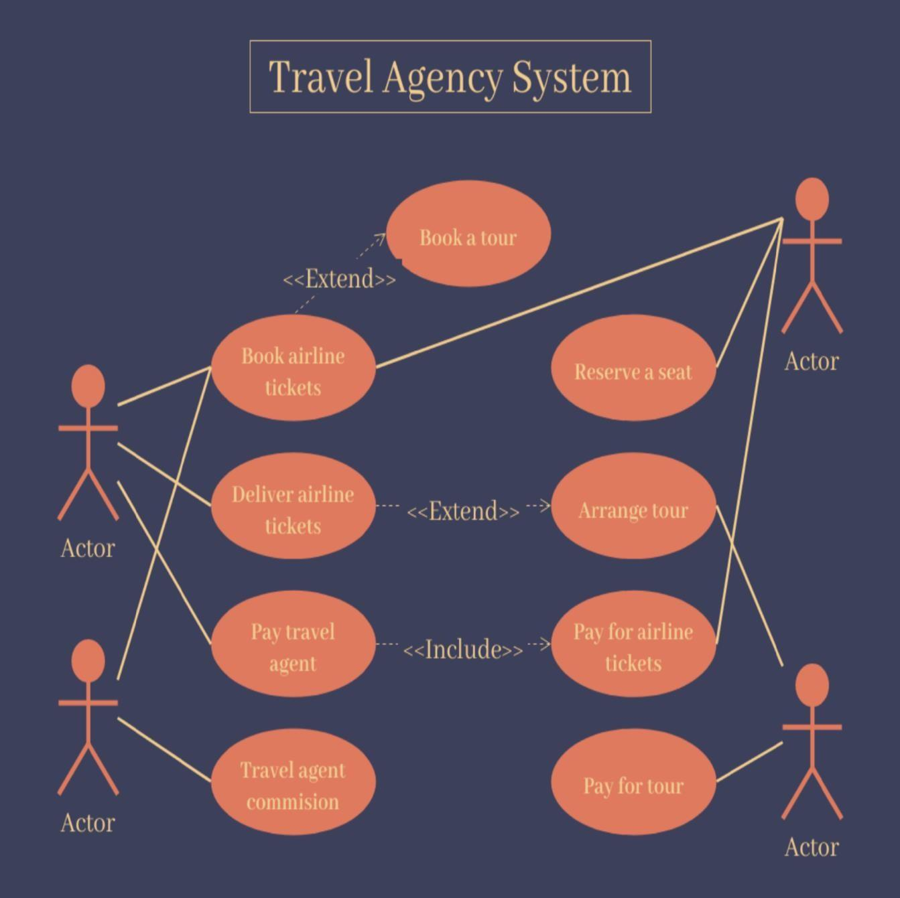

# SOURCE CODE

import javax.swing.*;

import java.awt.*;

import java.awt.event.ActionEvent;

import java.awt.event.ActionListener;

import java.util.HashSet;

import java.util.Set;

public class TravelExpenseManagementSystem1 extends JFrame implements ActionListener {

private JTextField expenseField;

private JComboBox<String> categoryComboBox;

private JTextArea expenseListArea;

private double totalExpenses;

private Set<String> enteredCategories;

private static final String USERNAME = "admin";

private static final String PASSWORD = "password";

public TravelExpenseManagementSystem1() {

setTitle("Travel Expense Management System");

setSize(400, 300);

setDefaultCloseOperation(EXIT_ON_CLOSE);

setLayout(new FlowLayout());

enteredCategories = new HashSet<>();

JLabel expenseLabel = new JLabel("Expense Amount:");

expenseField = new JTextField(20);

add(expenseLabel);

add(expenseField);

JLabel categoryLabel = new JLabel("Expense Category:");

String[] categories = {"Food", "Lodging", "Transportation", "Others"};

categoryComboBox = new JComboBox<>(categories);

add(categoryLabel);

add(categoryComboBox);

JButton addButton = new JButton("Add Expense");

addButton.addActionListener(this);

add(addButton);

JButton calculateButton = new JButton("Calculate Total");

calculateButton.addActionListener(this);

add(calculateButton);

JButton clearButton = new JButton("Clear");

clearButton.addActionListener(this);

add(clearButton);

expenseListArea = new JTextArea(10, 30);

expenseListArea.setEditable(false);

JScrollPane scrollPane = new JScrollPane(expenseListArea);

add(scrollPane);

setVisible(true);

}

@Override

public void actionPerformed(ActionEvent e) {

if (e.getActionCommand().equals("Add Expense")) {

try {

double expenseAmount = Double.parseDouble(expenseField.getText());

String category = (String) categoryComboBox.getSelectedItem();

if ("Food".equals(category)) {

if (enteredCategories.contains("Food")) {

JOptionPane.showMessageDialog(this, "Food expense has already been added!", "Error", JOptionPane.ERROR_MESSAGE);

} else if (expenseAmount >= 1000) {

JOptionPane.showMessageDialog(this, "Food expense must be below $1000!", "Error", JOptionPane.ERROR_MESSAGE);

} else {

totalExpenses += expenseAmount;

expenseListArea.append(String.format("Category: %s, Amount: %.2f%n", category, expenseAmount));

expenseField.setText("");

enteredCategories.add(category);

}

} else if ("Lodging".equals(category)) {

if (enteredCategories.contains("Lodging")) {

JOptionPane.showMessageDialog(this, "Lodging expense has already been added!", "Error", JOptionPane.ERROR_MESSAGE);

} else if (expenseAmount >= 5000) {

JOptionPane.showMessageDialog(this, "Lodging expense must be below $5000!", "Error", JOptionPane.ERROR_MESSAGE);

} else {

totalExpenses += expenseAmount;

expenseListArea.append(String.format("Category: %s, Amount: %.2f%n", category, expenseAmount));

expenseField.setText("");

enteredCategories.add(category);

}

} else if ("Transportation".equals(category)) {

if (enteredCategories.contains("Transportation")) {

JOptionPane.showMessageDialog(this, "Transportation expense has already been added!", "Error", JOptionPane.ERROR_MESSAGE);

} else if (expenseAmount >= 20000) {

JOptionPane.showMessageDialog(this, "Transportation expense must be below $20000!", "Error", JOptionPane.ERROR_MESSAGE);

} else {

totalExpenses += expenseAmount;

expenseListArea.append(String.format("Category: %s, Amount: %.2f%n", category, expenseAmount));

expenseField.setText("");

enteredCategories.add(category);

}

} else {

totalExpenses += expenseAmount;

expenseListArea.append(String.format("Category: %s, Amount: %.2f%n", category, expenseAmount));

expenseField.setText("");

enteredCategories.add(category);

}

} catch (NumberFormatException ex) {

JOptionPane.showMessageDialog(this, "Invalid expense amount!", "Error", JOptionPane.ERROR_MESSAGE);

}

} else if (e.getActionCommand().equals("Calculate Total")) {

JOptionPane.showMessageDialog(this, String.format("Total Expenses: $%.2f", totalExpenses), "Total", JOptionPane.INFORMATION_MESSAGE);

} else if (e.getActionCommand().equals("Clear")) {

expenseListArea.setText("");

totalExpenses = 0;

enteredCategories.clear();

}

}

public static void main(String[] args) {

SwingUtilities.invokeLater(() -> {

if (showLoginDialog()) {

new TravelExpenseManagementSystem1();

} else {

System.exit(0);

}

});

}

private static boolean showLoginDialog() {

JPanel panel = new JPanel(new GridLayout(3, 2));

JLabel userLabel = new JLabel("Username:");

JTextField userField = new JTextField();

JLabel passLabel = new JLabel("Password:");

JPasswordField passField = new JPasswordField();

panel.add(userLabel);

panel.add(userField);

panel.add(passLabel);

panel.add(passField);

int result = JOptionPane.showConfirmDialog(null, panel, "Login", JOptionPane.OK_CANCEL_OPTION, JOptionPane.PLAIN_MESSAGE);

if (result == JOptionPane.OK_OPTION) {

String username = userField.getText();

String password = new String(passField.getPassword());

return USERNAME.equals(username) && PASSWORD.equals(password);

} else {

return false;

}

}

}

# SCREEN SHOTS(OUTPUTS)

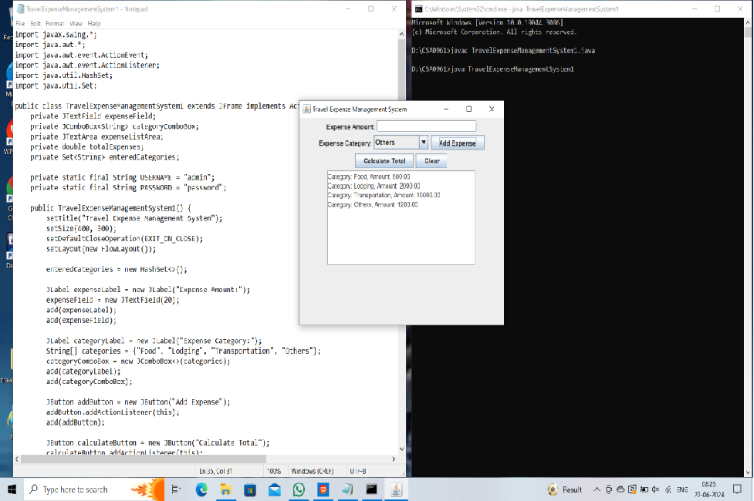

Fig 1: Add Expenses For All Category

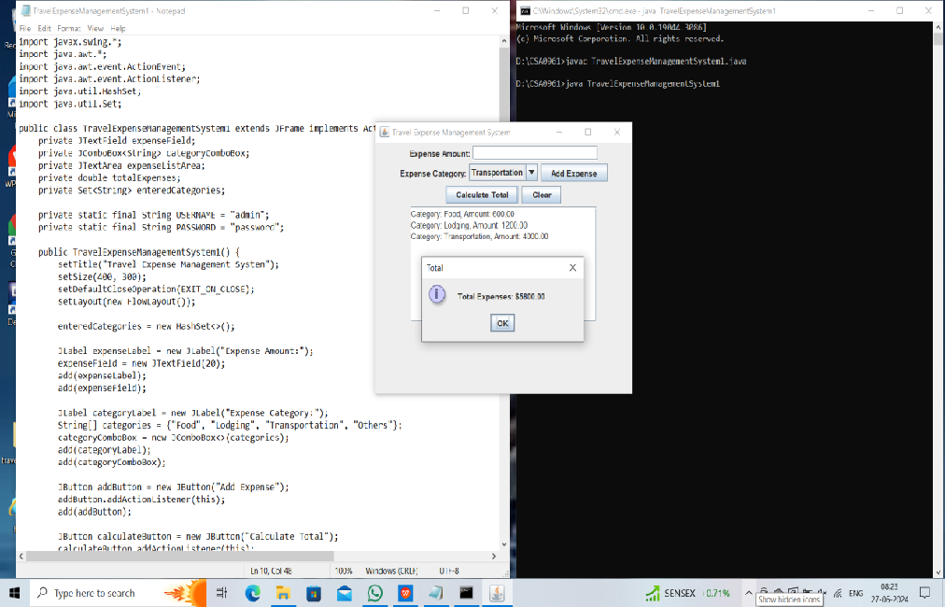

Fig 2: Calculate Total Expenses

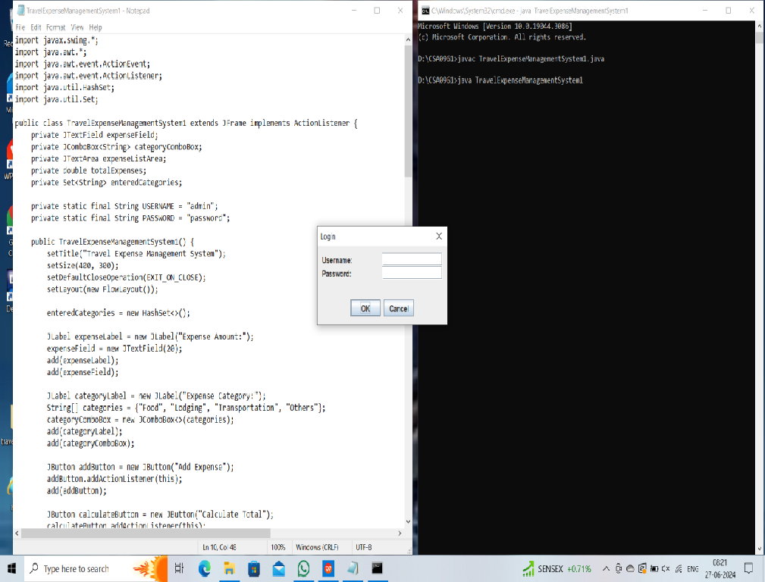

Fig 3: login page

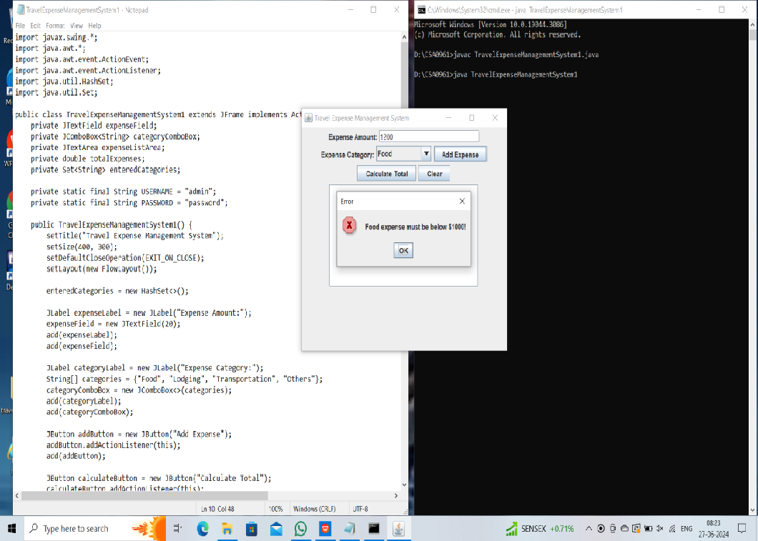

Fig 4: Adding more Amount

# CONCLUSION

In conclusion, the development of a Travel Expense Management System (TEMS) offers significant benefits to organizations by streamlining the process of tracking, managing, and analyzing travel-related expenses. Through this system, businesses can achieve greater efficiency, cost control, and compliance with travel policies and regulations.

TEMS facilitates the automation of expense reporting, receipt management, and reimbursement processes, reducing the administrative burden on employees and finance teams. By leveraging technologies such as web-based interfaces, mobile applications, and cloud hosting, TEMS provides users with convenient access to expense management tools anytime, anywhere.

Furthermore, TEMS enhances visibility and transparency into travel spending patterns, enabling organizations to identify cost-saving opportunities, enforce policy compliance, and make data-driven decisions. With advanced reporting and analytics capabilities, stakeholders gain insights into expense trends, vendor performance, and travel budgets, empowering them to optimize expenses and improve financial outcomes.

In today's dynamic business environment, where travel is integral to operations, TEMS plays a crucial role in ensuring efficient utilization of resources, minimizing financial risks, and enhancing overall productivity. By investing in a robust and scalable TEMS solution, organizations can effectively manage travel expenses, mitigate fraud, and achieve greater control over their financial processes, ultimately driving business success.

**FUTURE ENHANCEMENT**

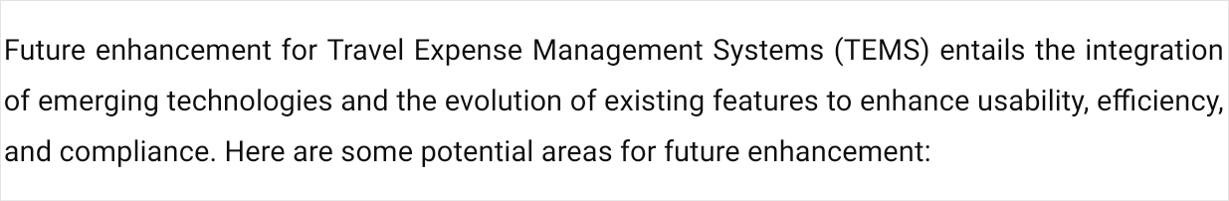

| 1. | **Artificial Intelligence (AI) and Machine Learning (ML) Integration:** | | | |  |
| --- | --- | --- | --- | --- | --- |
|  | | | | | |
|  | | * Implement AI and ML algorithms to automate expense categorization, detect anomalies, and provide personalized insights based on historical data. * Utilize natural language processing (NLP) to extract information from receipts and   invoices, improving accuracy and reducing manual data entry. | | | |
| 2. | **Blockchain for Transparency and Security:** | | |  | |
|  | | | | | |
|  | | * Leverage blockchain technology to create immutable records of expense transactions, ensuring transparency and preventing fraud. * Implement smart contracts for automated verification and approval of expenses, reducing   processing time and enhancing security. | | | |
| 3. | **Mobile and Voice-Enabled Interfaces:** | |  | | |
|  | | | | | |
|  | | * Develop voice-enabled interfaces and mobile applications to enable hands-free expense reporting and approval processes, enhancing user convenience and accessibility. * Integrate augmented reality (AR) for real-time receipt scanning and expense visualization,   improving the user experience. | | | |
| 4. | **Predictive Analytics for Cost Optimization:** | | |  | |
|  | | | | | |
|  | | * Utilize predictive analytics to forecast travel expenses, identify cost-saving opportunities, and optimize travel budgets. * Incorporate predictive models to anticipate future expense trends and recommend budget   adjustments based on changing business needs. | | | |



| **REFERENCES** | | |
| --- | --- | --- |
|  | 1. Koeppen, E., Wimmer, J., & Krcmar, H. (2017). Travel expense management systems: A literature review. In *Proceedings of the 50th Hawaii International Conference on System Sciences*. 2. Ojha, M., & Singh, A. (2018). An integrated approach for travel expense management using machine learning algorithms. *International Journal of Computer Applications*, 180(28), 36-42. 3. Xiao, B., & Shen, X. L. (2020). Design and implementation of a travel expense management system based on cloud computing. *Journal of Physics: Conference Series*, 1519(1), 012023. 4. Zhu, M., & Zhou, C. (2019). Design and implementation of a mobile-based travel expense | |
| management system. In | *Proceedings of the International Conference on Education Technology,* |
| *Management and Humanities Science*.  5. Hsieh, C. J., & Chang, Y. H. (2021). Development of a cloud-based travel expense management system with blockchain technology. *Journal of Advanced Transportation*, 2021, 8870836. | |



21