**Observation:**

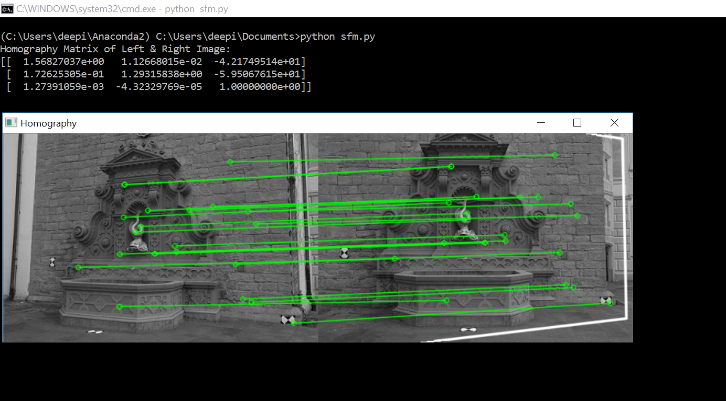

**Result:**

The result we obtain after performing key point extraction and matching, is consistent in filtering out the weak matches. Another interesting observation was that upon scaling down the given pair of test images, we obtain more feature matches in the image foreground. In higher resolutions, most of the matched features were in the background(wall) thus leading to no significant depth difference observation in SFM.

**Observation:  
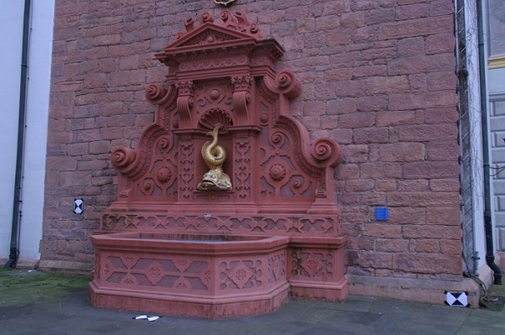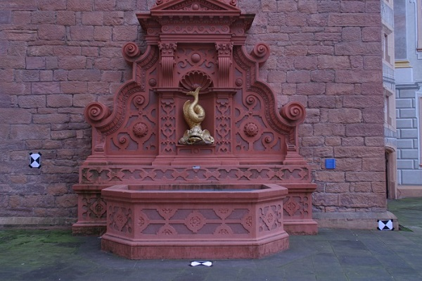**

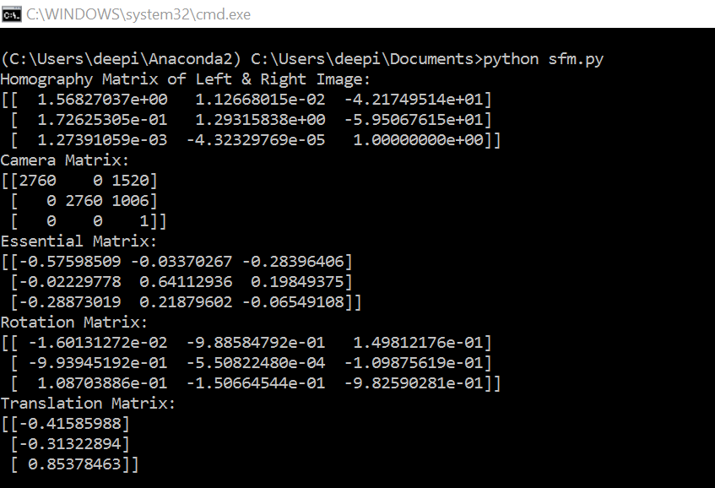

**Result:**The evaluation of essential matrix and its consequent decomposition into Rotation and Translation components works well. The function ‘recoverpose’ essentially gives the relative positions of the two cameras. But since we have fixed the coordinate system as one of the cameras, the output of the function is thus the relative position of the other camera. Our observation of the Translation Matrix is quite intuitively consistent with what is expected (After observing the 2 images ‘myleft’ and ‘myright’).

**Observation:**

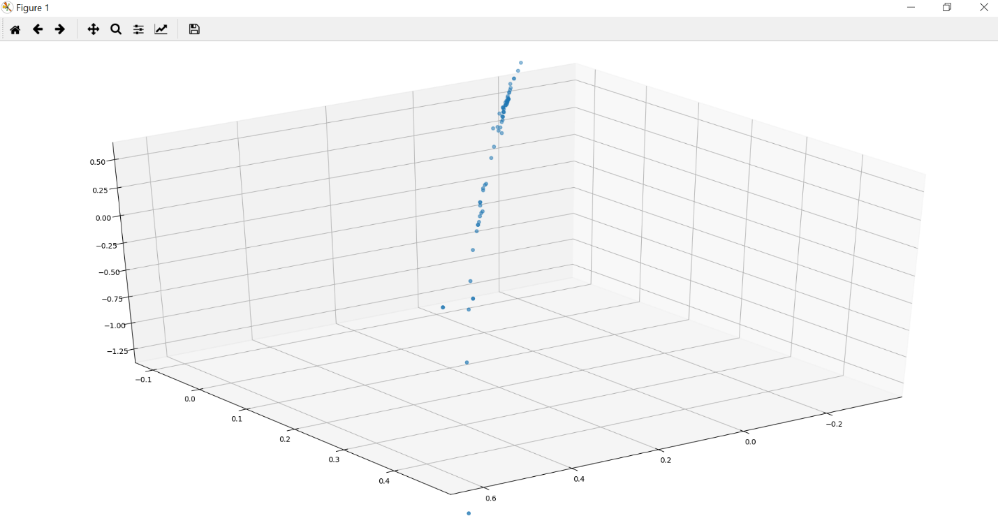

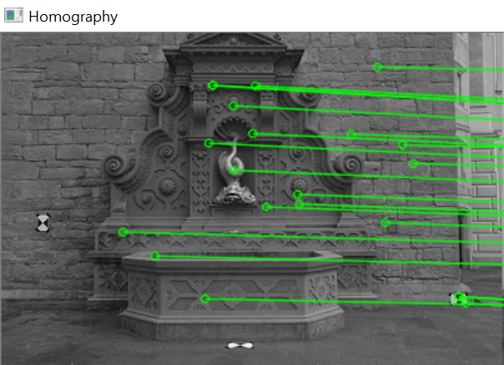

**Result:**The 3-D plot of the image, models the depth of the object interestingly well. But however, to get a complete map of the object, it is important to extract a high number of precise features. From our observation, the circled sections of the image show us clearly the relative difference in depths.

**Inference:**The pipeline for Structure from Motion works well in capturing image depths with an acceptable error rate. The disadvantage is that, to capture and create a 3D model of the object, we need more feature points that in turn translates to more camera angles.

**Proposal:**Given K best matching points between a pair of images, we can obtain a one-one map of the rest of the pixels by considering the relative positions of points with respect to the matching points. This would give us a larger umbrella of matching feature points that can then be used in SFM to create a 3D model.