Ref: <https://pnpm.io/installation>

### Node.js is preinstalled

On Linux or macOS:

curl -f https://get.pnpm.io/v6.16.js | node - add --global pnpm

## Via npx resolution

npx pnpm add -g pnpm

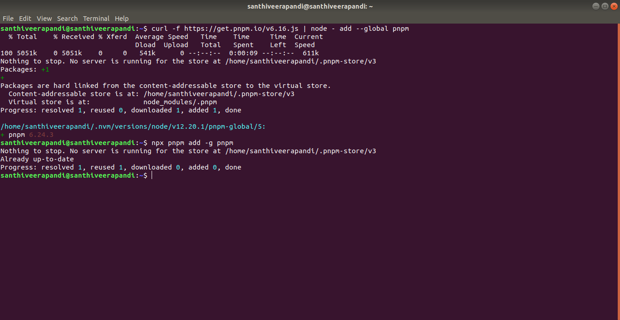

Config Settings:

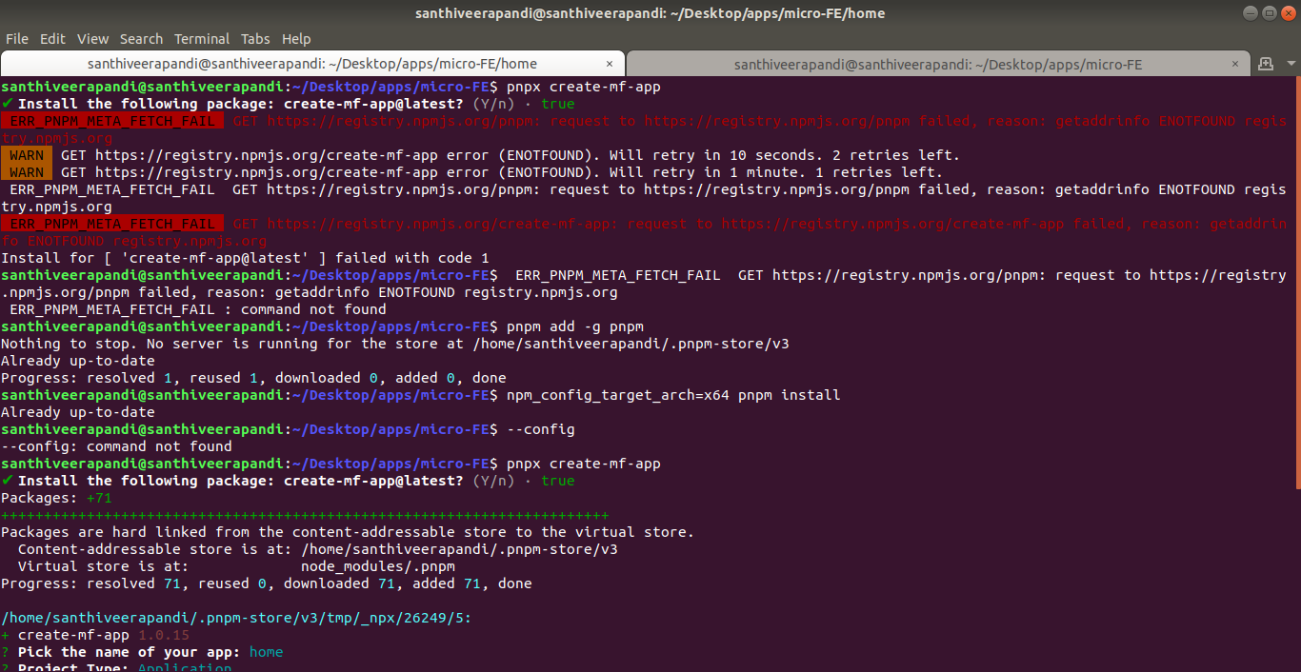

santhiveerapandi@santhiveerapandi:~/Desktop/apps/micro-FE$ **pnpm add -g pnpm**

santhiveerapandi@santhiveerapandi:~/Desktop/apps/micro-FE$ **npm_config_target_arch=x64 pnpm install**

**Yarn Installation:**

ref: [https://classic.yarnpkg.com/lang/en/docs/install/#debian-stable](https://classic.yarnpkg.com/lang/en/docs/install/" \l "debian-stable)

ref: <https://phoenixnap.com/kb/how-to-install-yarn-ubuntu>

**> npm install --global yarn**

> yarn --version

**Application Creation:**

**> pnpx create-mf-app**

**> yarn && yarn start**

|  |  |  |
| --- | --- | --- |
| S.No. | Package | Version |
| 1 | pnpm | 6.24.3 |
| 2 | Yarn | 1.22.17 |
| 3 | Npm | 8.3.0 |

**Application Build Architecture:**

**Architect.dio Graph**

**Explains NPM, Asset Store, Module Federation**