
DEPARTMENT OF INFORMATION SCIENCE AND TECHNOLOGY
CEG CAMPUS, ANNA UNIVERSITY, CHENNAI

IOT BASED SMART SYSTEMS

Servo-Based Flame Tracking Fire Fighting Robot

SUBMITTED BY:
Karizhma J (2023115112)
Santhiya B (2023115313)

Introduction:
Fire accidents pose a serious threat to human life and property in residential, commercial, and industrial environments. Early detection and immediate action are essential to reduce damage and ensure safety.
This project presents an Servo-Based Flame Tracking Fire Fighting Robot that detects fire using a flame sensor and automatically activates a water pump to suppress it. The system also tracks the flame direction using servo motors, ensuring accurate targeting.

Problem Statement:
Traditional fire safety systems mainly rely on alarms that only alert people but do not take automatic action to control the fire. Additionally, manual fire extinguishing may cause delay and increase risk. There is a need for a low-cost, automatic fire detection and suppression system that can:
- Detect flame quickly
- Identify flame direction
- Automatically activate a water pump
- Reduce human intervention

Requirements:
The proposed system requires:
● Arduino UNO R4 Minima (Microcontroller)
● KY-026 Flame Sensor Module
● Two Servo Motors (SG90/MG90S)
● 1-Channel Relay Module
● Mini DC Water Pump / Fan
● LM2596 DC-DC Buck Converter
● External Power Supply (7–12V DC)
● Jumper wires and mounting setup

Working Principle:
● The flame sensor continuously scans the surroundings by rotating left and right using a servo motor.
● When flame is detected (value exceeds threshold), the system:
- Stops scanning
- Locks the second servo toward the flame direction
- Activates the relay
- Turns ON the water pump
● When no flame is detected:
- The pump remains OFF
- The scanning servo continues sweeping
This ensures automatic detection and suppression.

Architecture diagram:
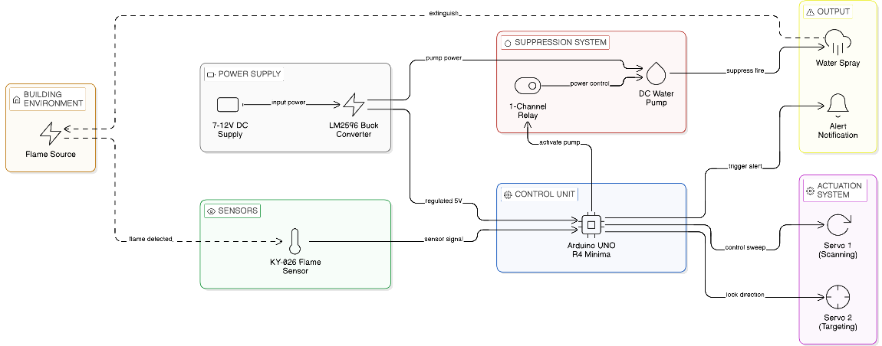
Result:
● The system successfully detects flame in real time.
● Automatically activates water pump upon detection.
● Accurately points toward the flame source.
● Operates at low cost with reliable performance.

Conclusion:
The proposed Servo-Based Flame Tracking Fire Fighting Robot provides a simple, cost-effective, and efficient solution for early fire detection and suppression. By combining flame sensing, servo-based directional tracking, and automatic pump activation, the system enhances fire safety and reduces human risk.It is suitable for small-scale safety applications in homes, laboratories, and workshops.

