**DATA CLEANING IN HOUSING DATA OF US CITIES – RESULTS**

**1.STANDARDIZE DATE FORMAT**

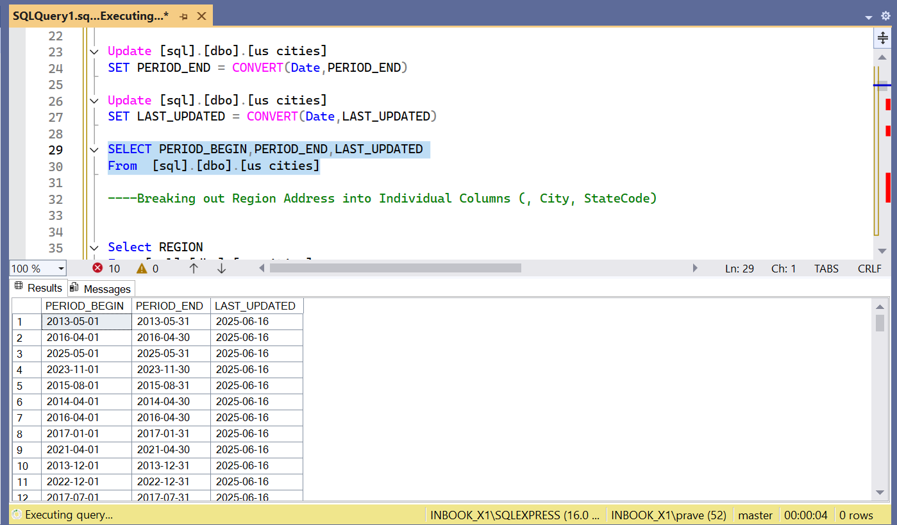

2. **2. BREAKING OUT REGION ADDRESS INTO INDIVIDUAL COLUMNS   
( CITY, STATECODE)**

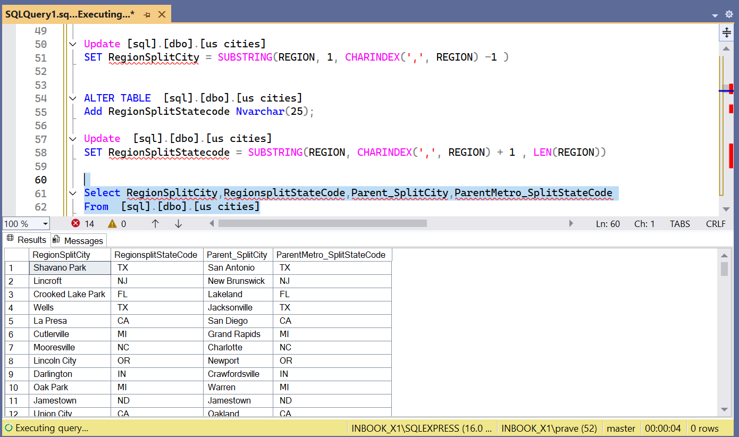

3**. FORMATTED THE COLUMN BY CHANGING NA TO N/A T IN "PRICE DROPS" FIELD**

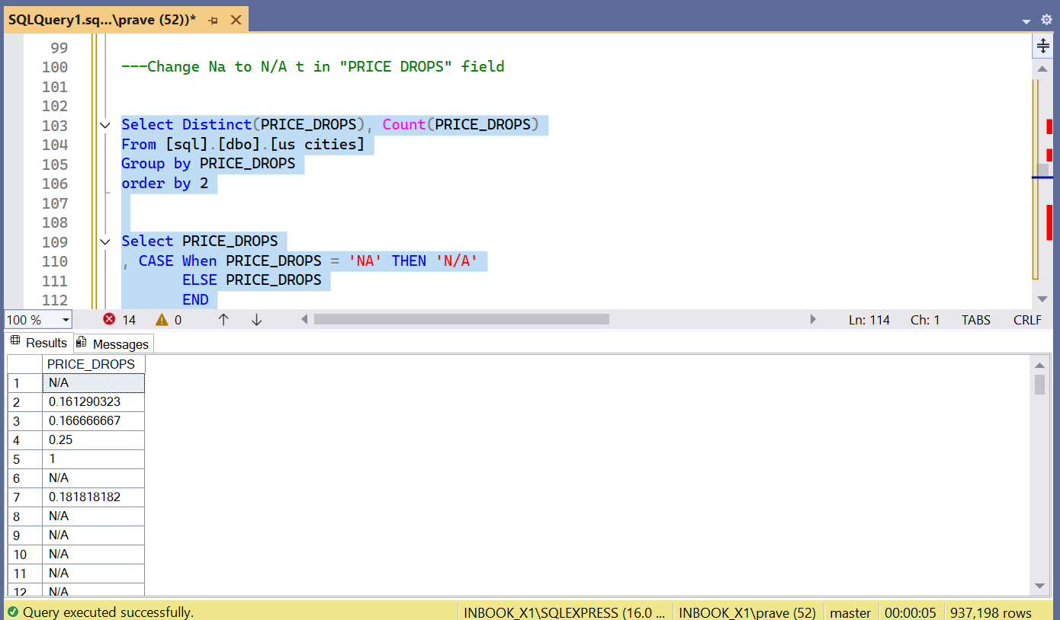

**4. ROUNDED OF DECIMAL PLACES**

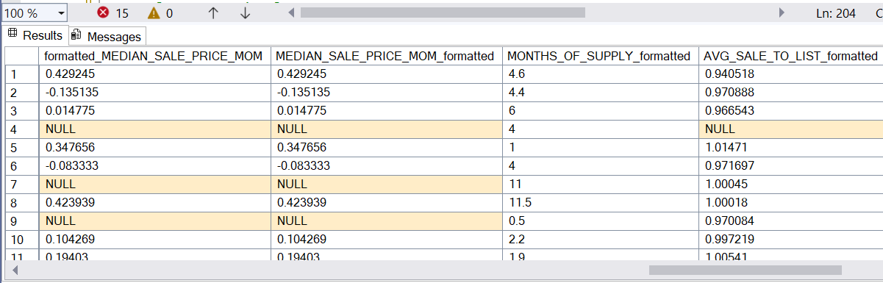

**5. REMOVED DUPLICATE DATA**

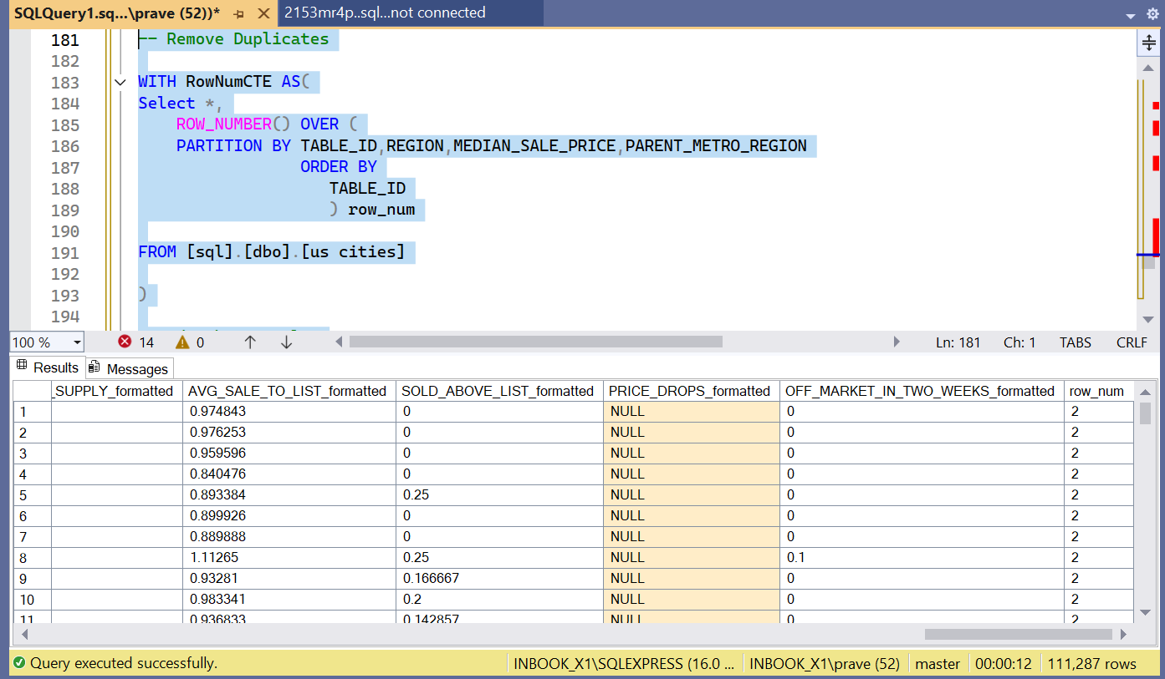

**CHECKING FOR DUPLICATED AFTER REMOVAL**

