**Deploying Azure protected Geo-Redundant Solution having path based routing**

**1.Creating a Resource Group:**

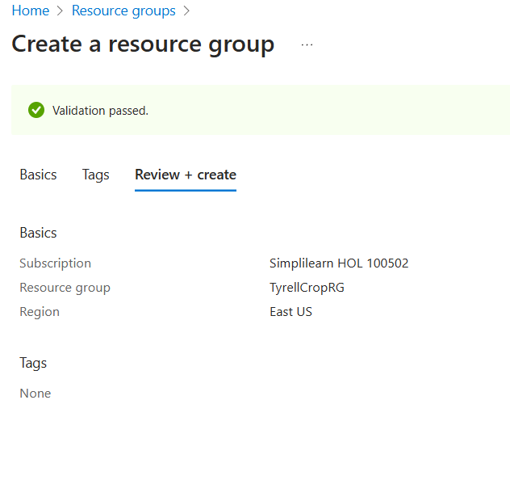

**2.Creating a Traffic Manager profile:**

Create and setup Traffic manager profile to provides global DNS load balancing. While setting it up select Performance routing to send the requestor to the closest endpoint in terms of latency

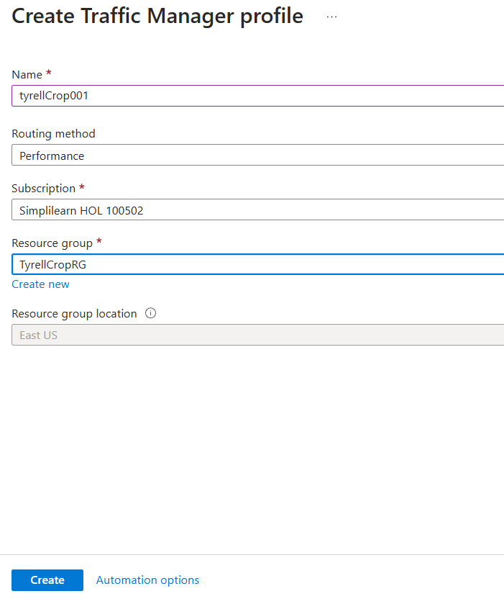

Change the Traffic Manager DNS TTL to 30 seconds

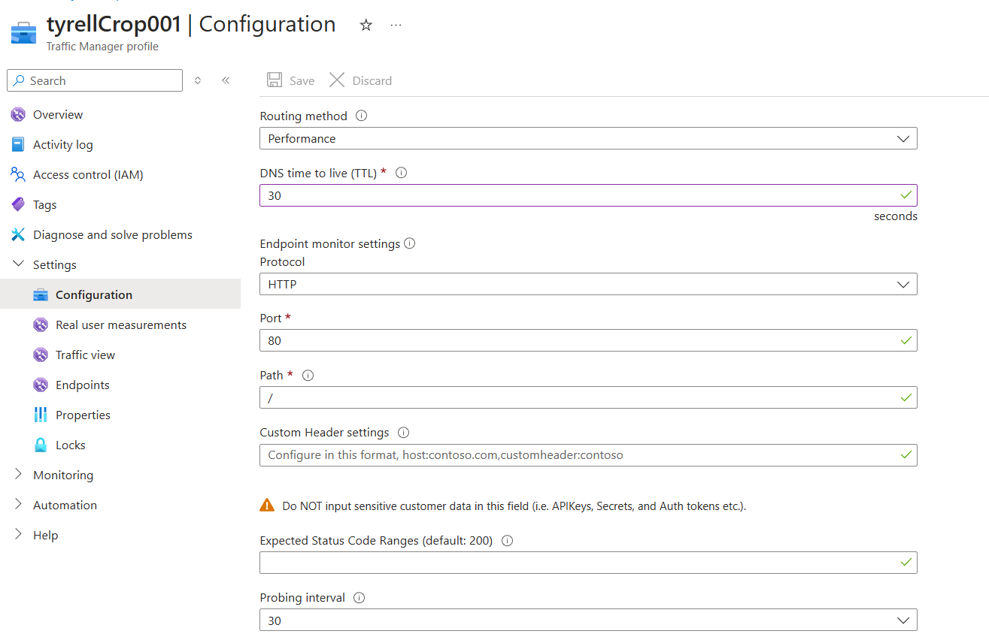

**3.Create virtual network.**

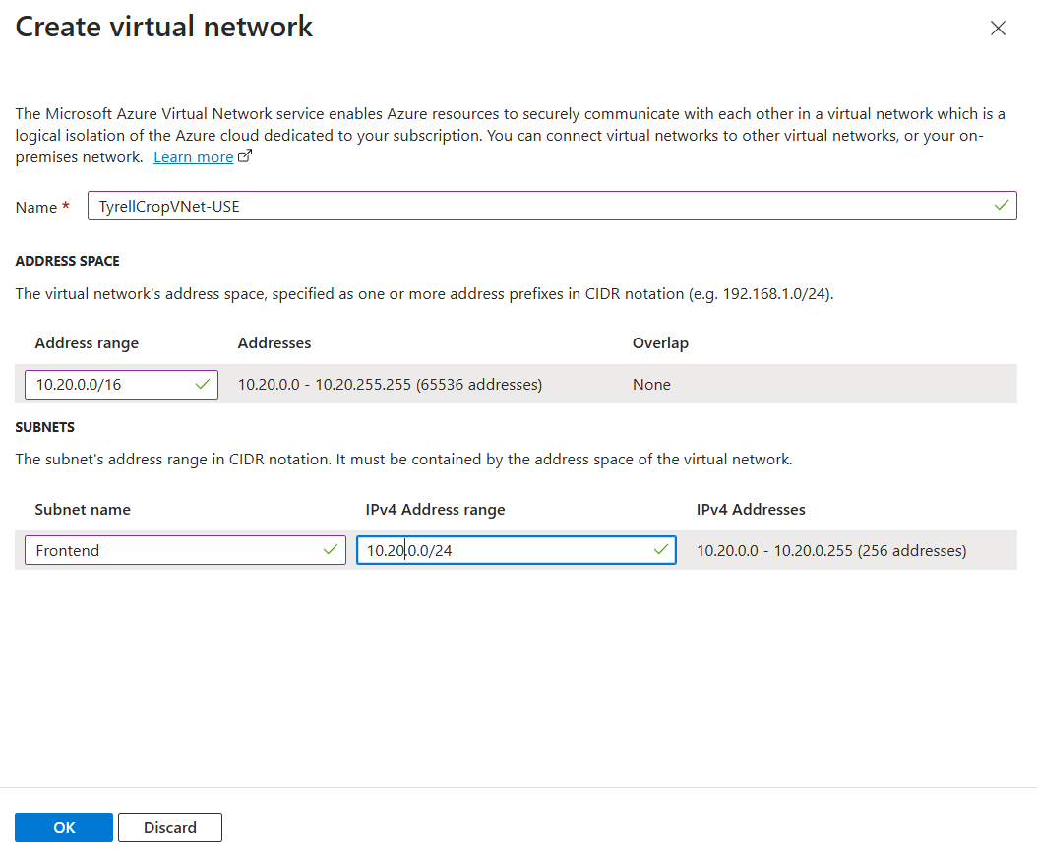

**4.Add a subnet for image and web under virtual network:**

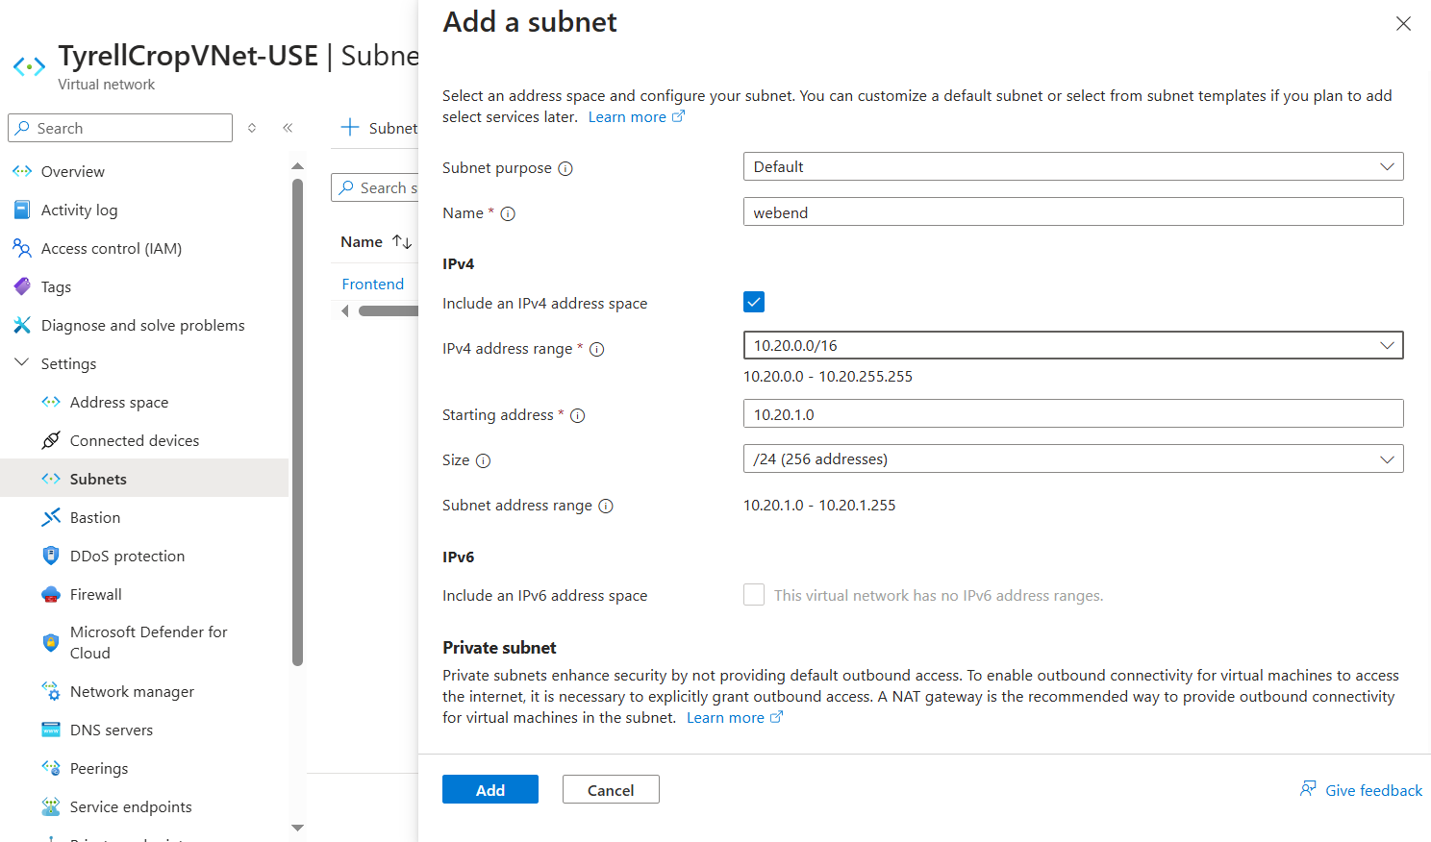

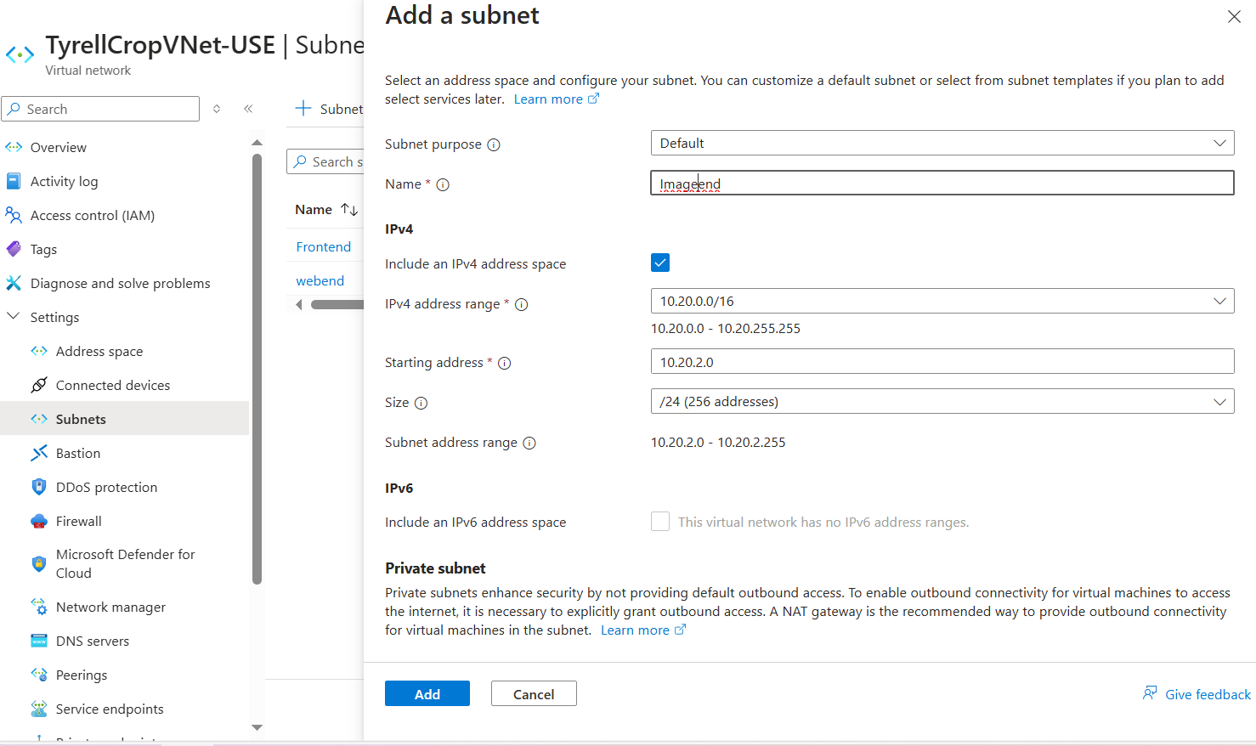

**5.Create application gateway**

**1.Create Public IP Address:**

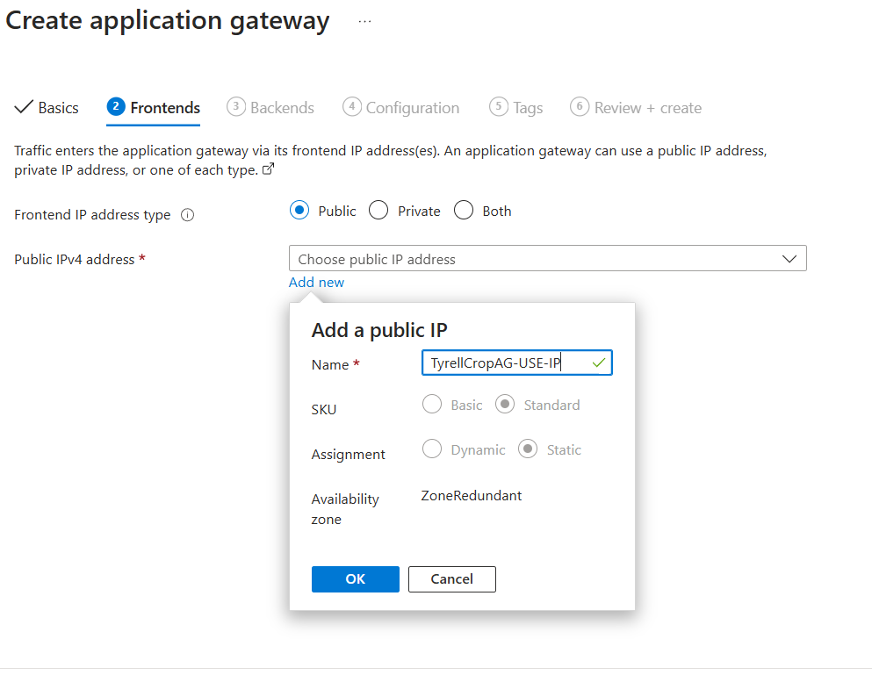

**2.Create two backend pools**:

Image Pool:

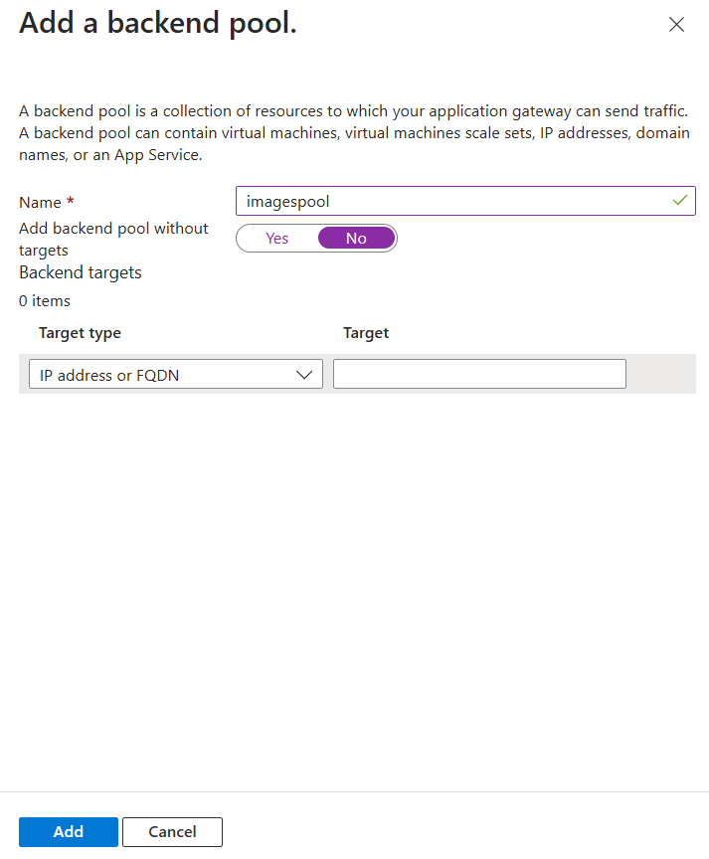

Web Pool:

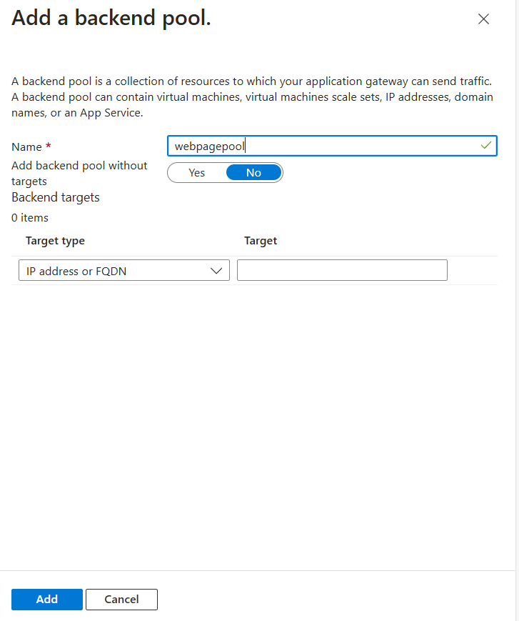

**3.Create Routing Rules for image and webpage**:

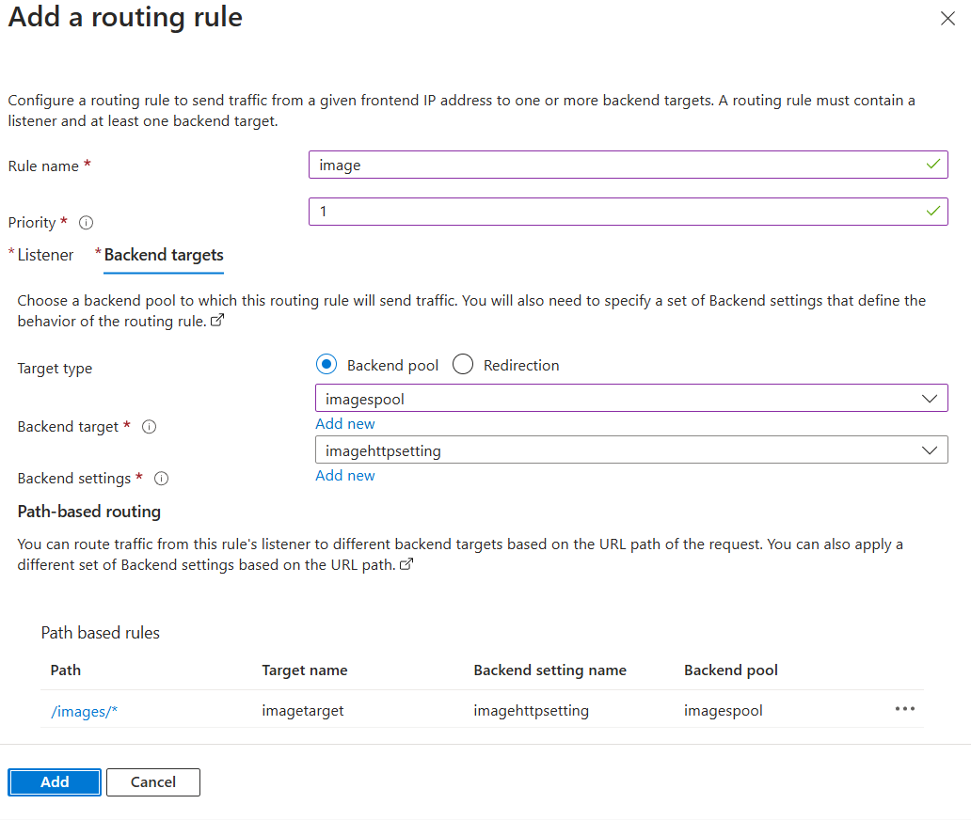

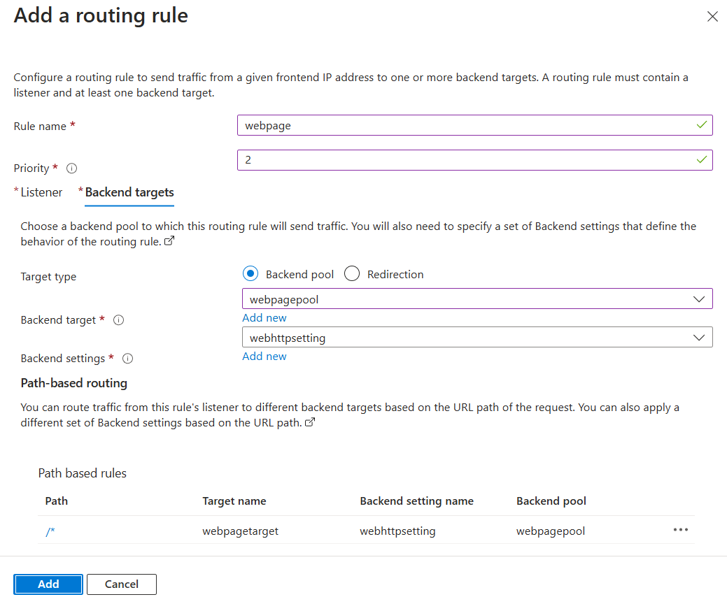

**4.Finally Create application gateway**

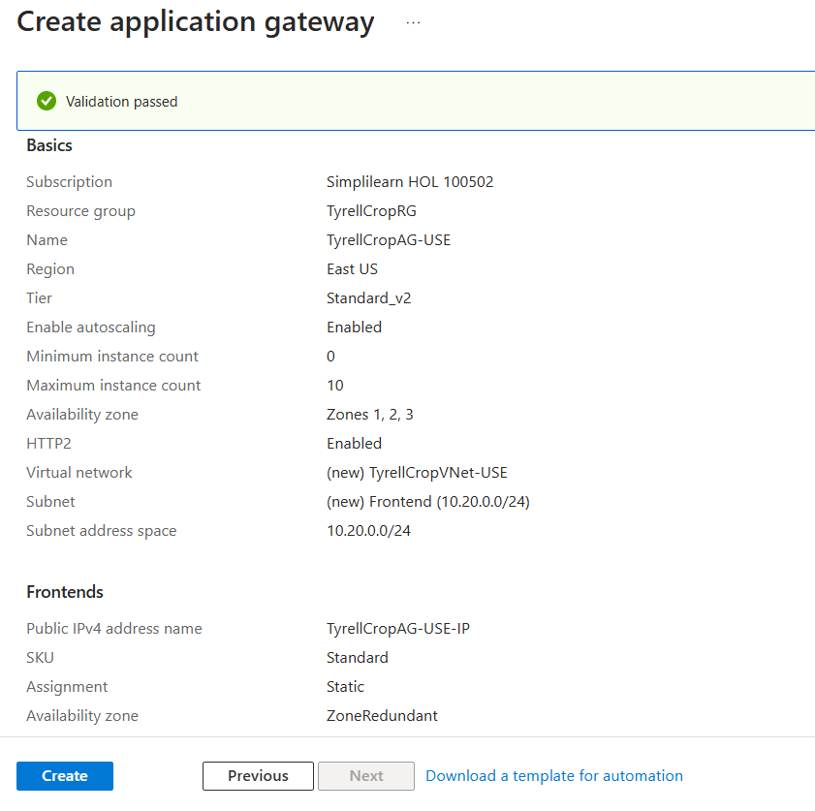

**6.Create Availability Set for image and web:**

**For Web:**

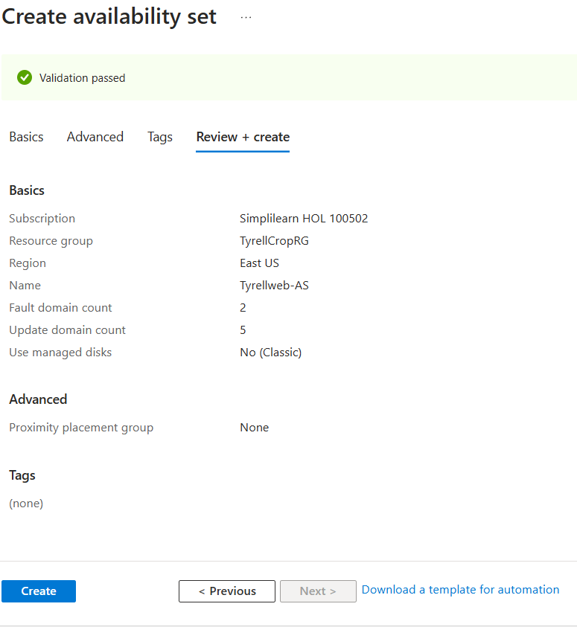

**For Image:**

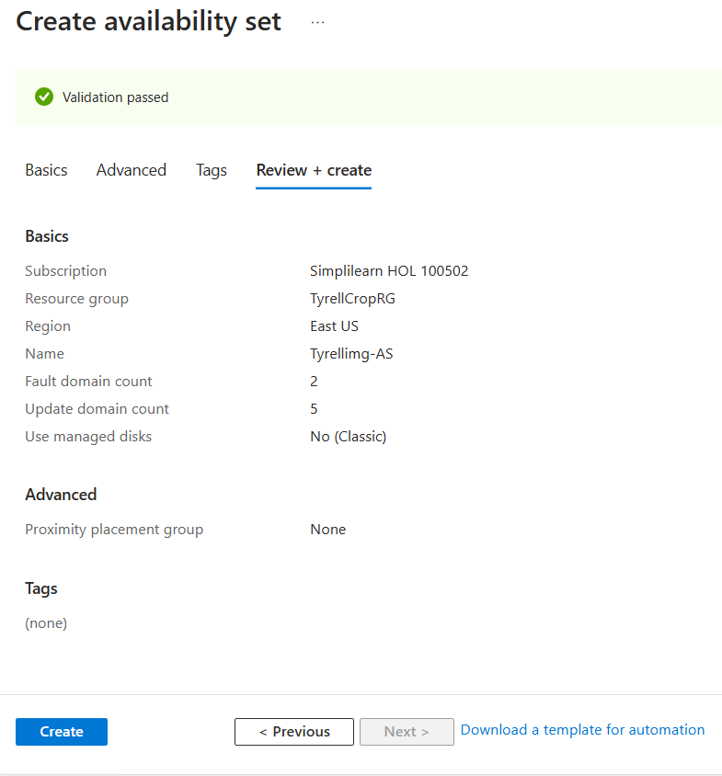

**7.Create VM’s – For web Application:**

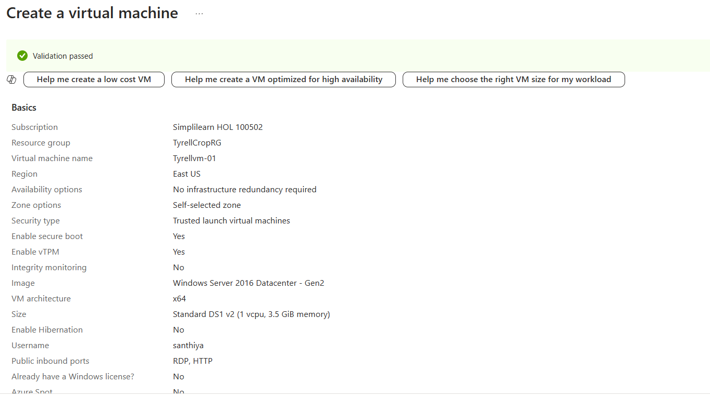

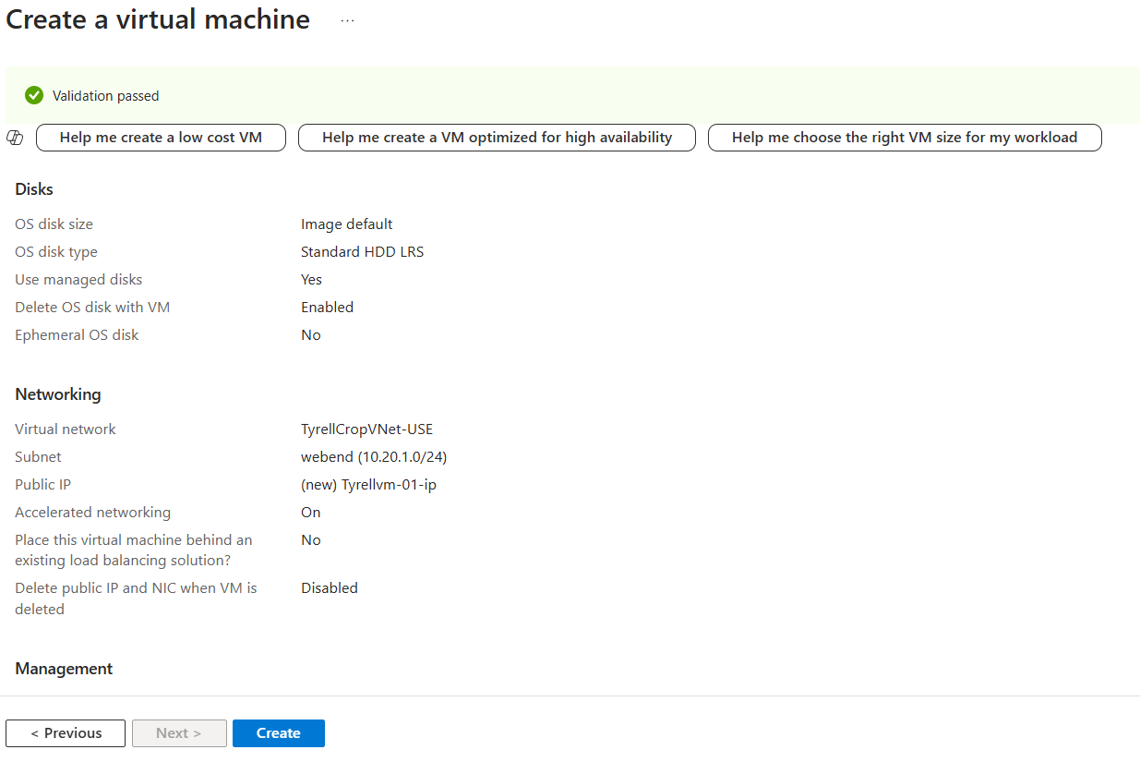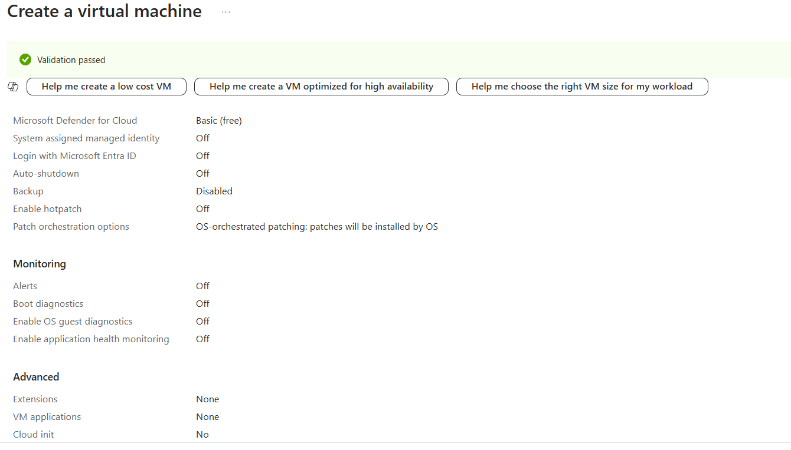

**Create VM’s – For Images:**

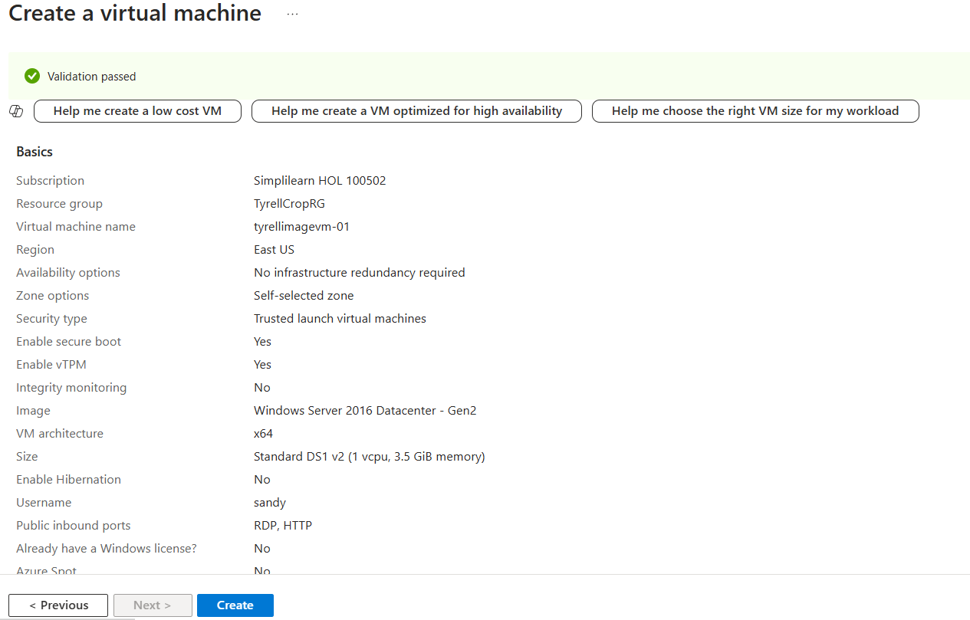

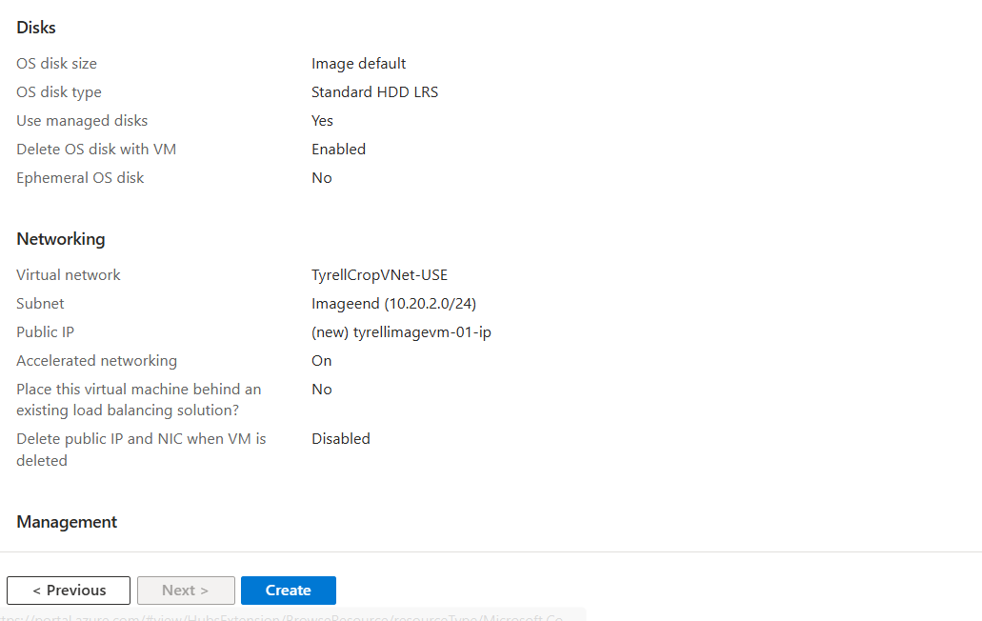

**8.Add image VM to image backend pool:**

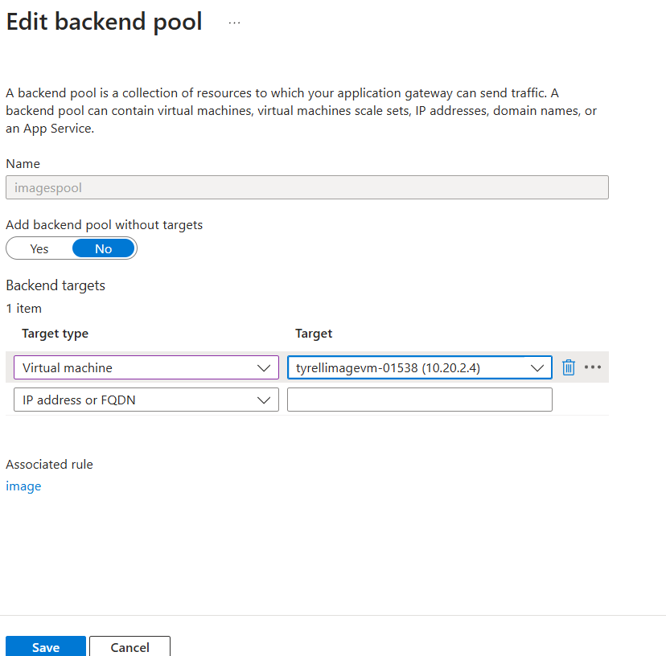

**Add web VM to web backend pool:**

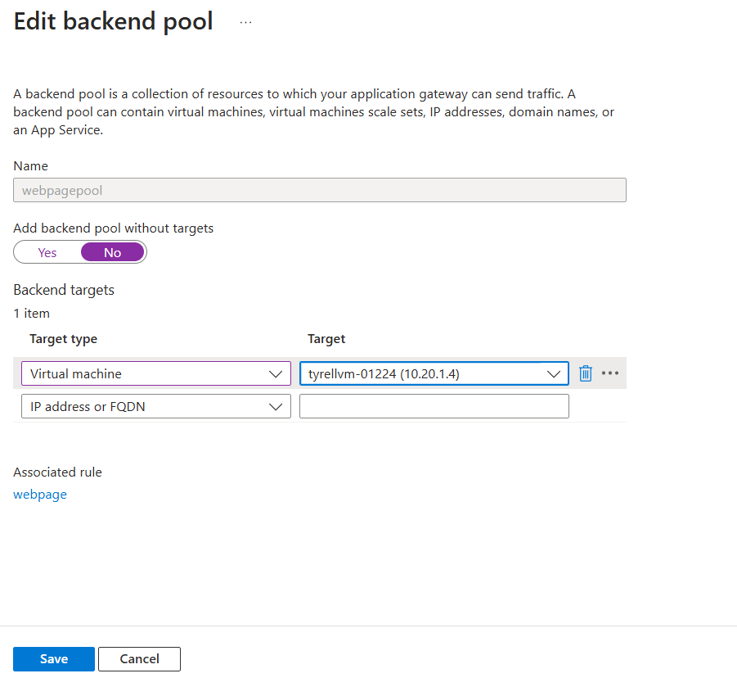

**9.Add Application Gateways to Traffic Manager:**

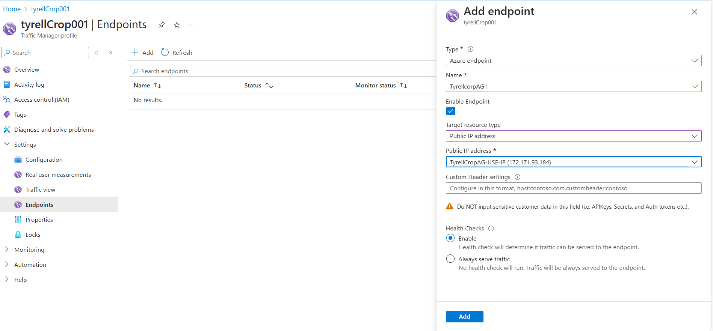

**10.Add IIS role to the Windows Servers:**

1.After each virtual machine is provisioned login using remote desktop by clicking the Connect button on the virtual machine configuration blade and logging in with the administrative credentials.

2. Once inside the VM, click the PowerShell icon on the task bar.

3. In the PowerShell console execute the following command to install IIS

**Add-WindowsFeature -Name "Web-Server"**

4.After Once IIS has completed installation open the file C:\InetPub\wwwroot\iisstart.htm in notepad on each server. Inside the tag insert-

**This content comes from web server !!**

**This content comes from IMG server !!**

5. Repeat the steps for both virtual machines to install IIS.

**Image VM:**

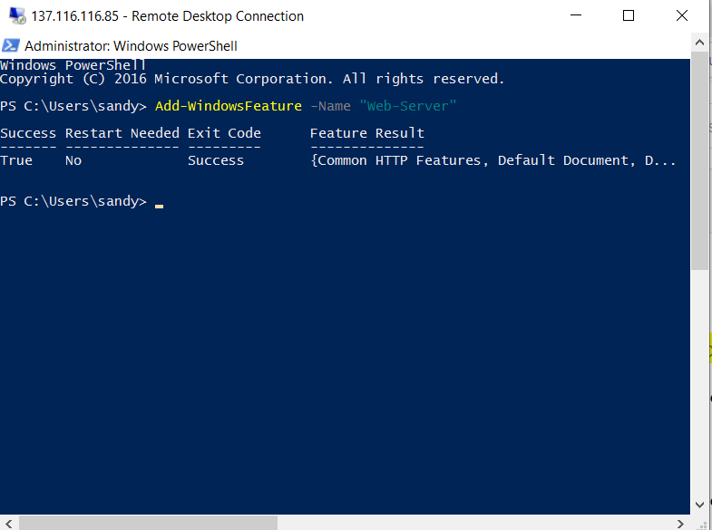

**Web VM:**

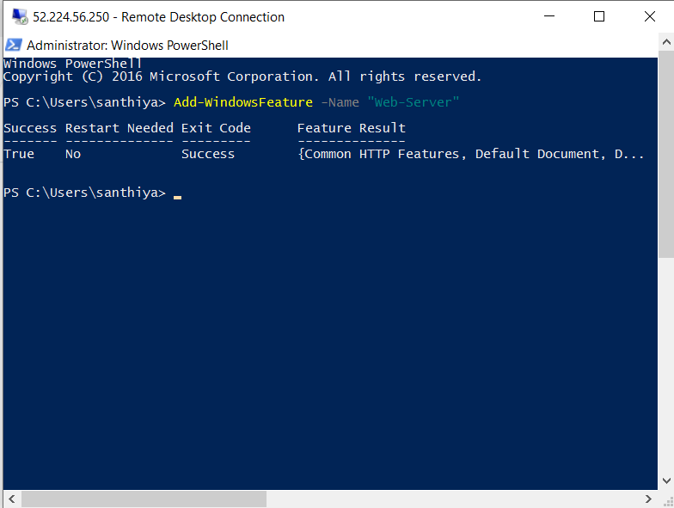

**11.Test the Functionality**

<http://tyrellcrop.trafficmanager.net:8080/> (response from imageVM)

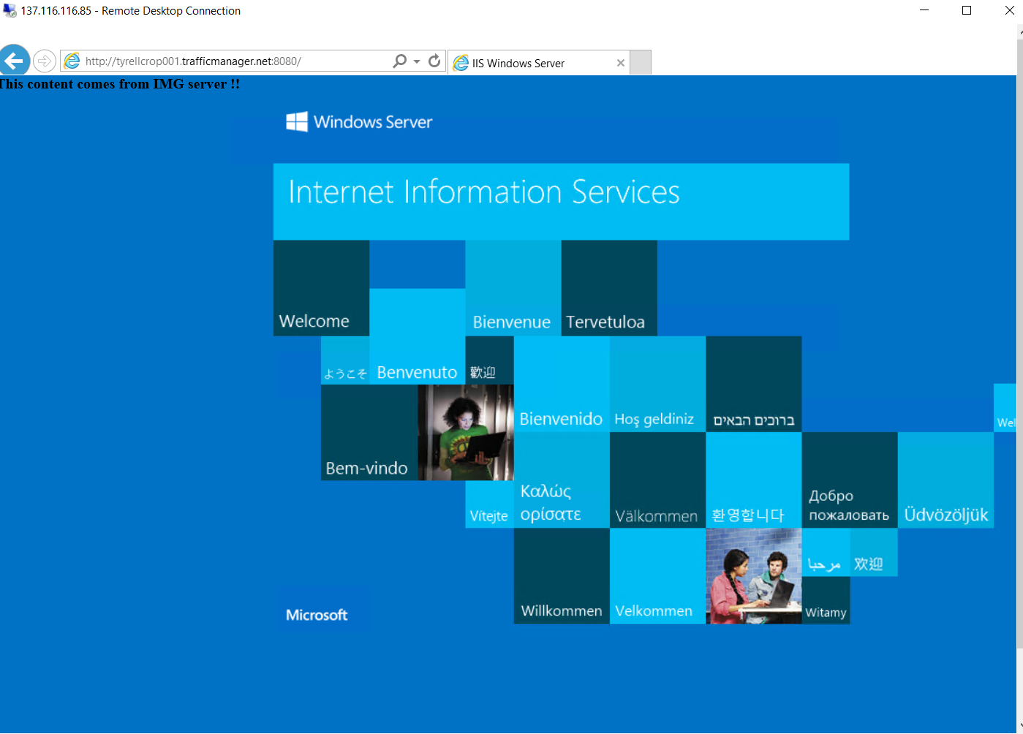

<http://tyrellcrop.trafficmanager.net/> (response from webVM)

