**Implement the Azure IaaS**

1.Create a Resource Group named HQResourceGroup and BranchResourceGroup:

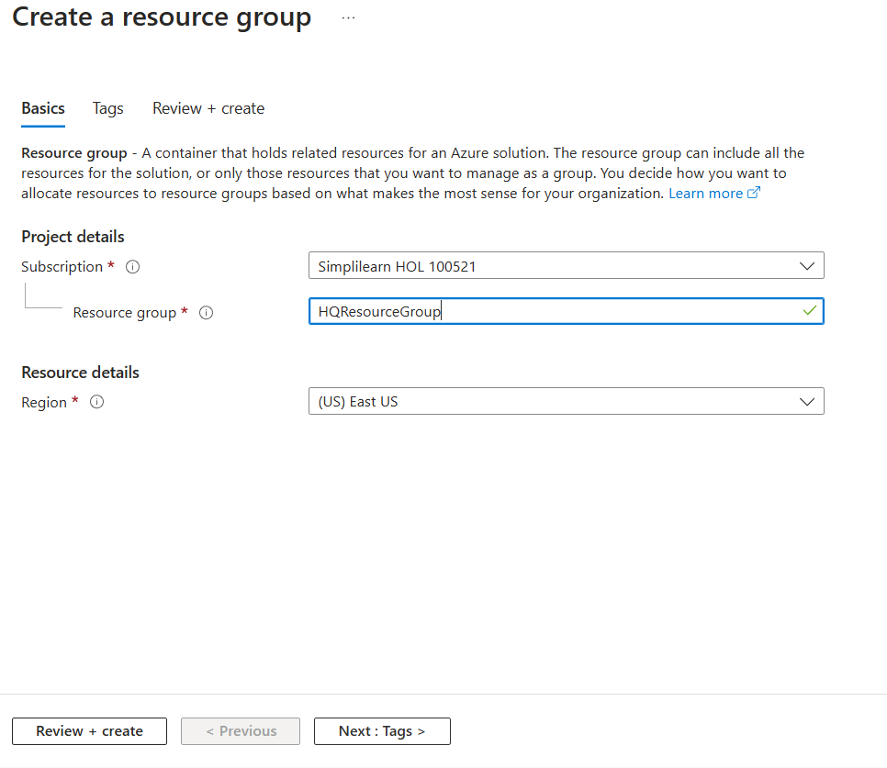

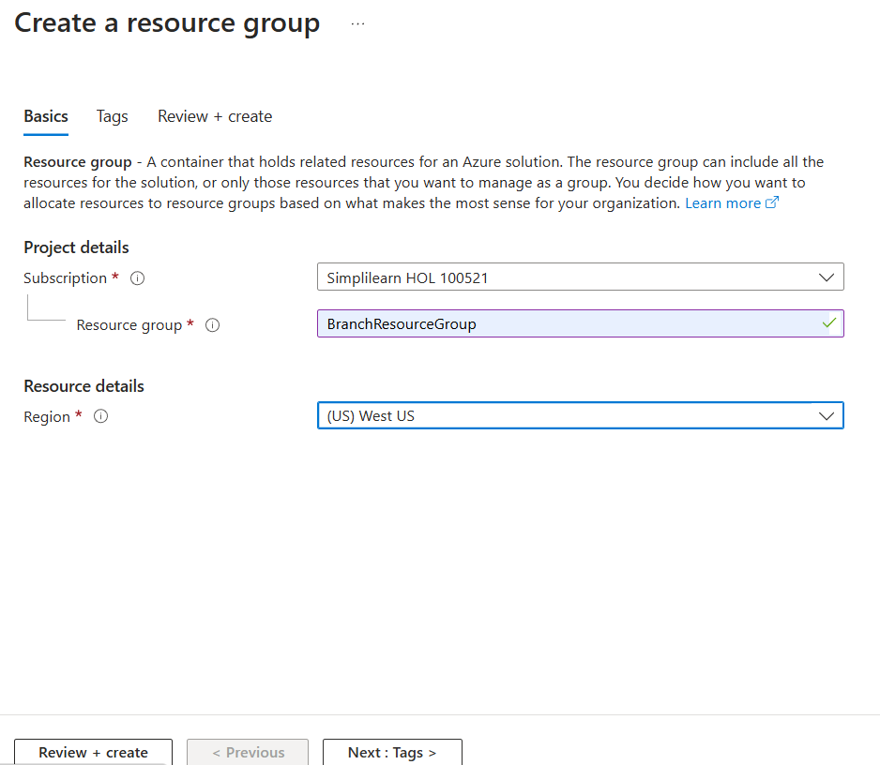

2. Create a Virtual Network BranchqVNet and subnet AppbranchSubnet:

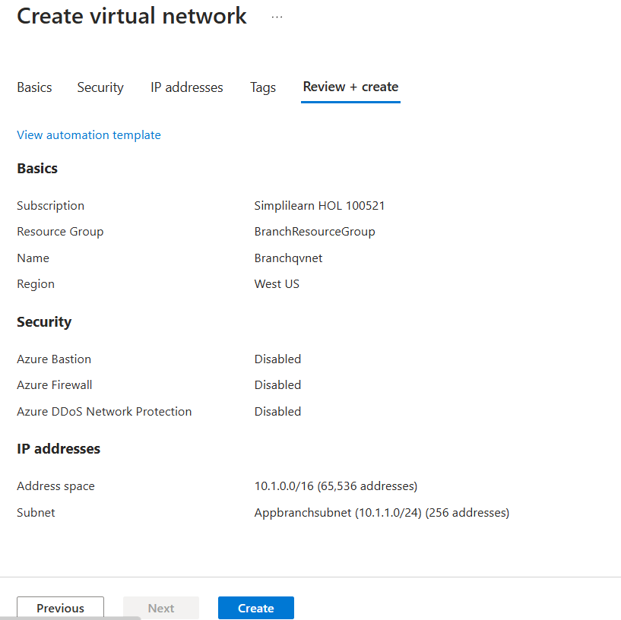

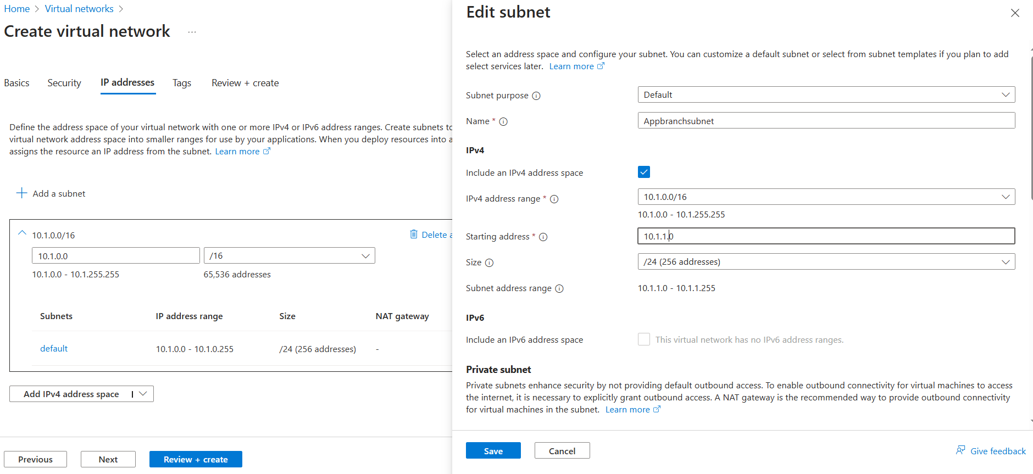

3. Create a Virtual Network HeadQVNet and subnet DatabasehqSubnet:

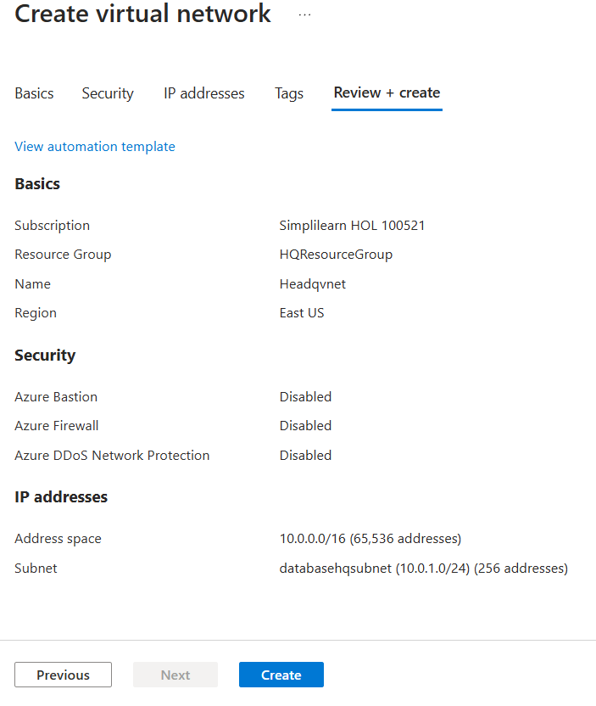

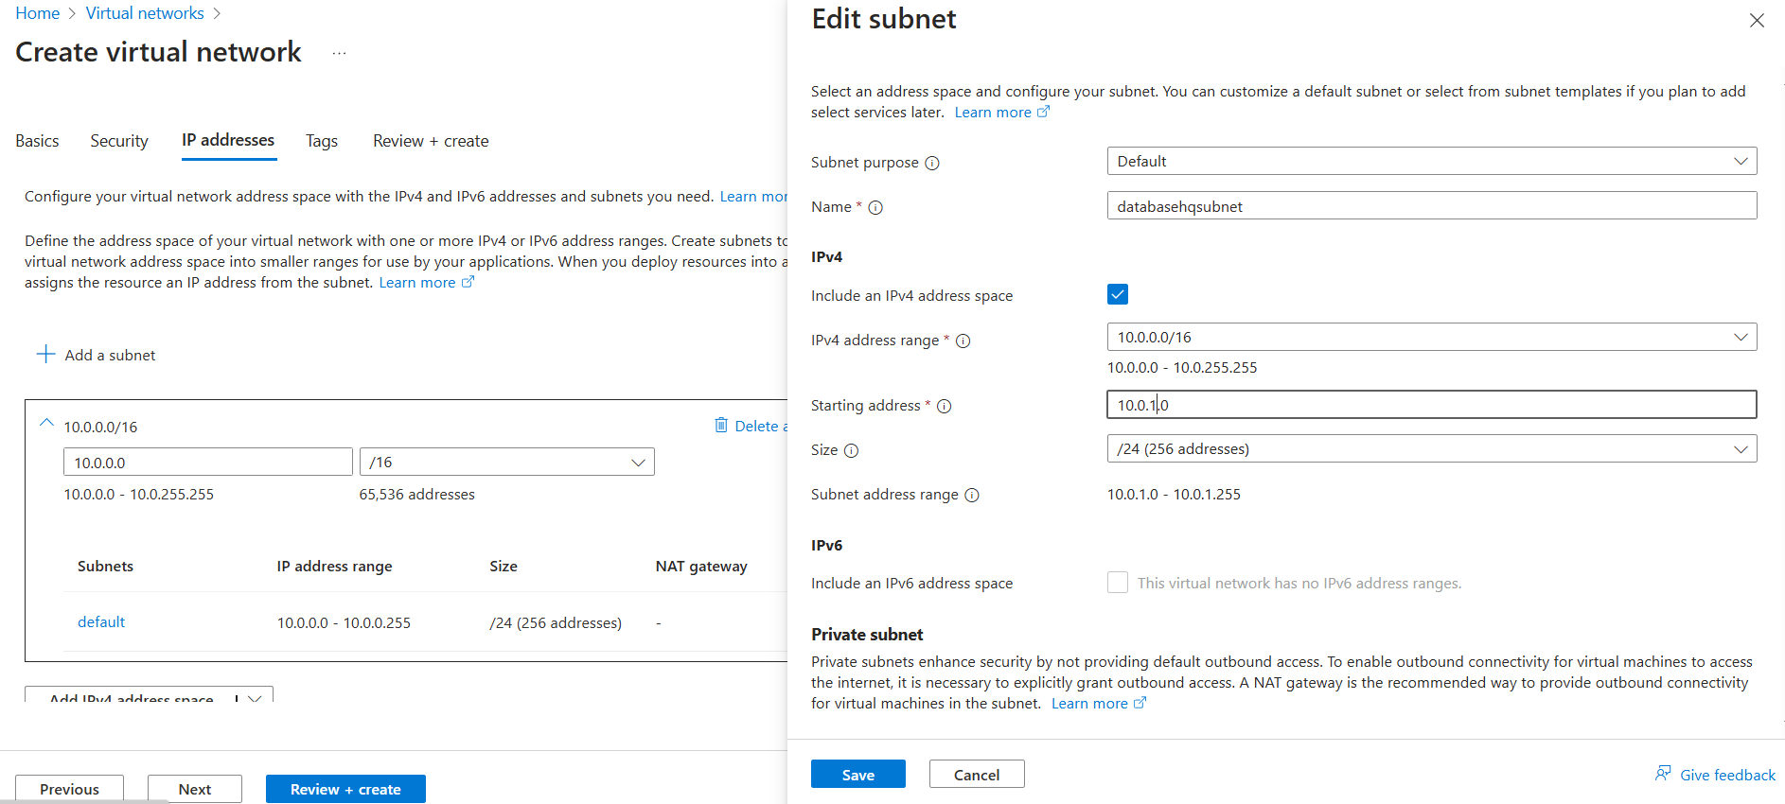

4.Create a Virtual Machine headqVM:

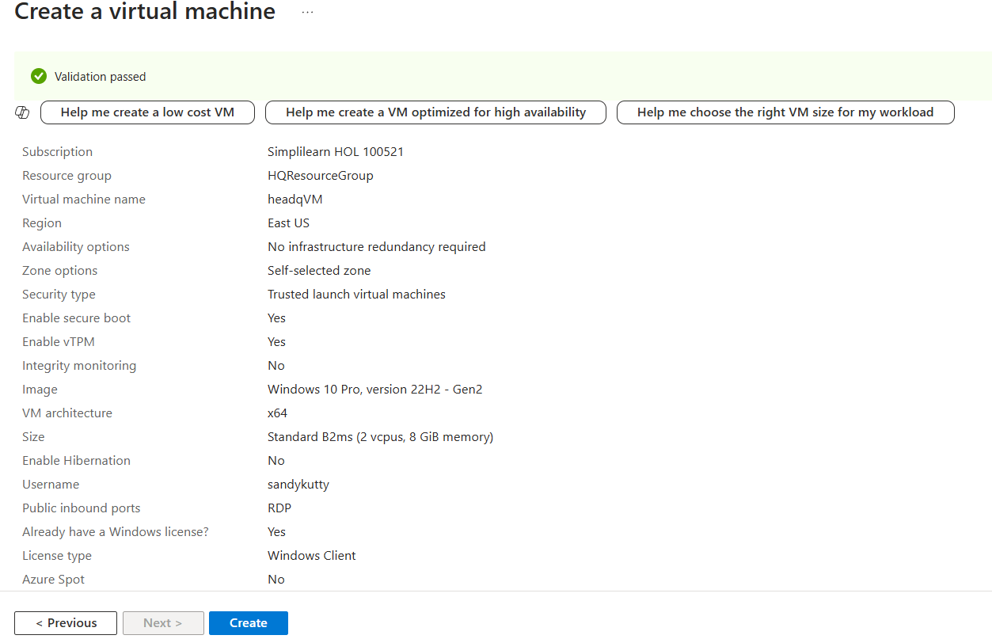

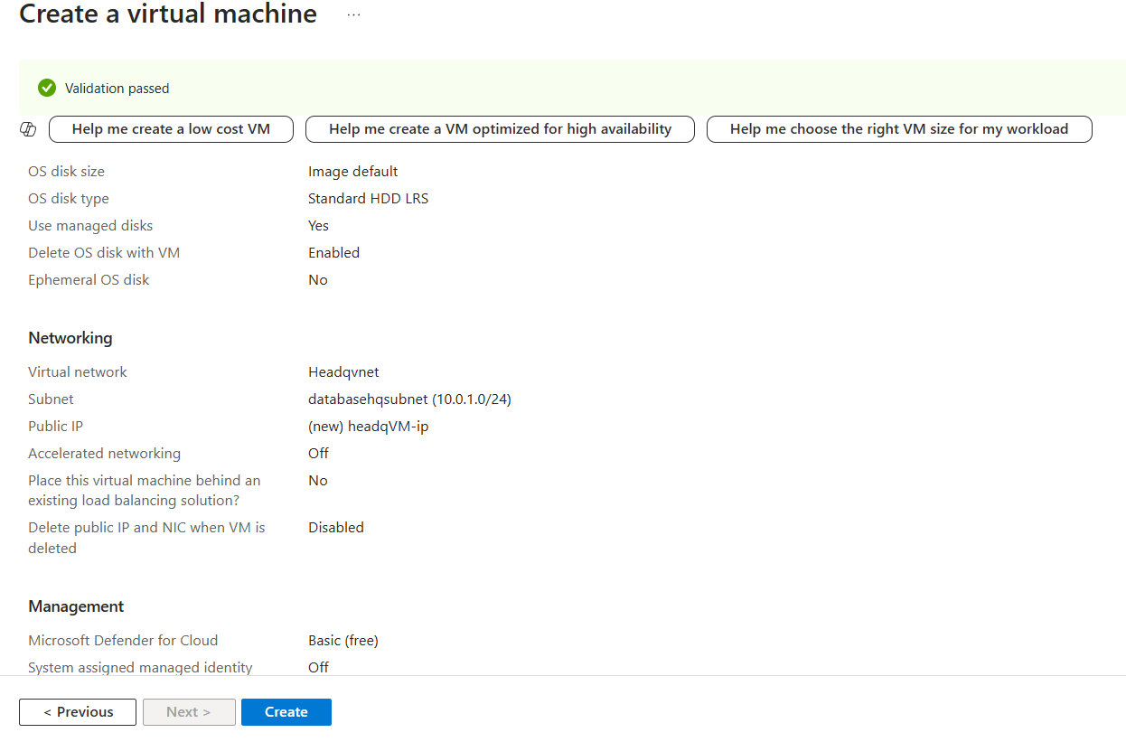

5.Create a Virtual Machine BranchqVM:

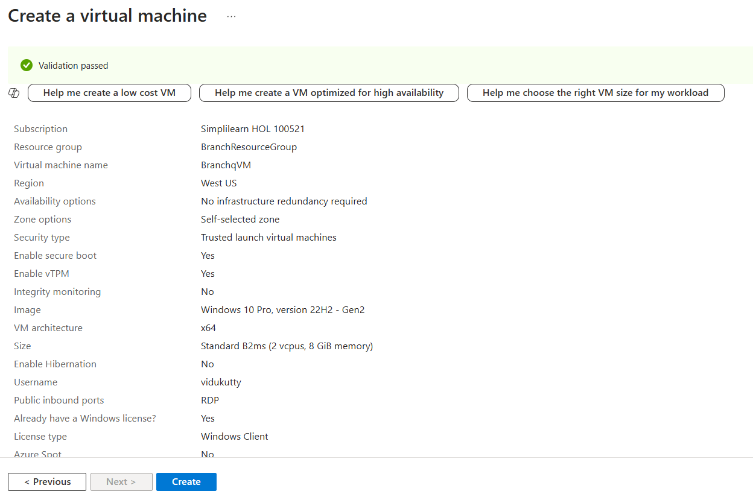

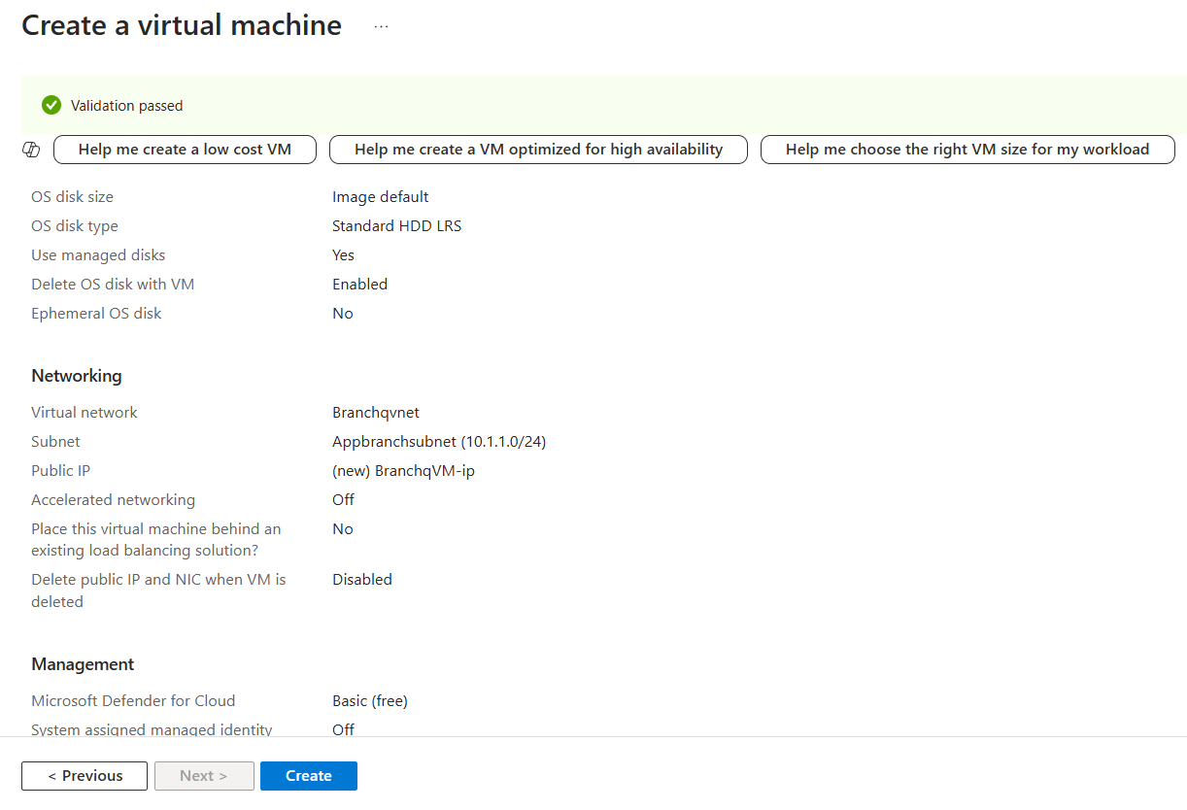

6.Establish Peering from HeadQVNet to BranchqVNet and BranchqVNet to HeadQVNet:

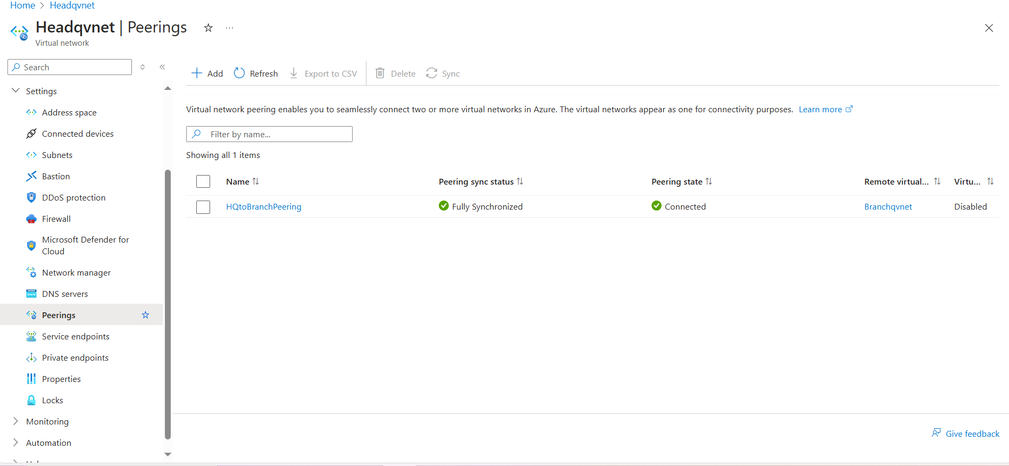

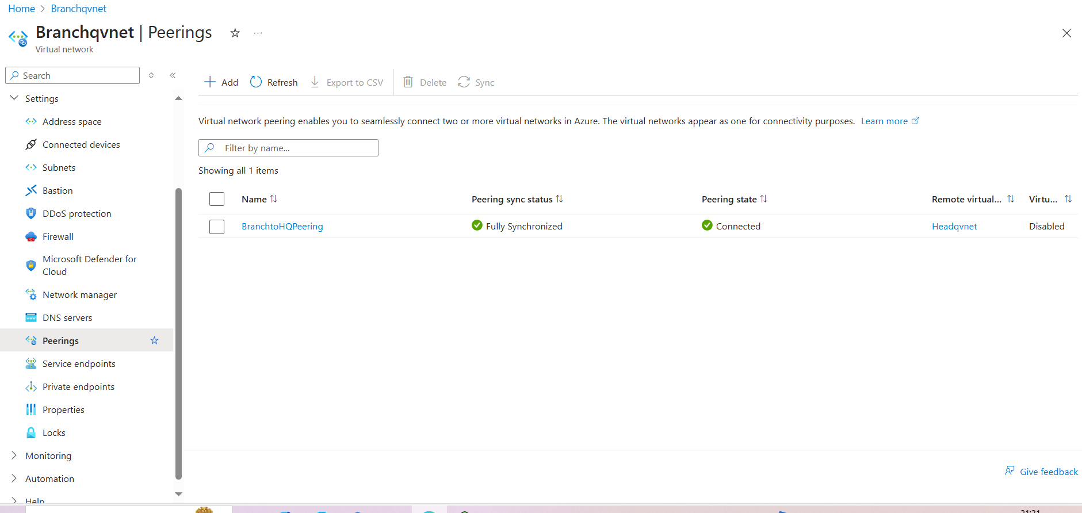

7.Create route table for Headquarters and Associate HQ Route Table with Database Subnet

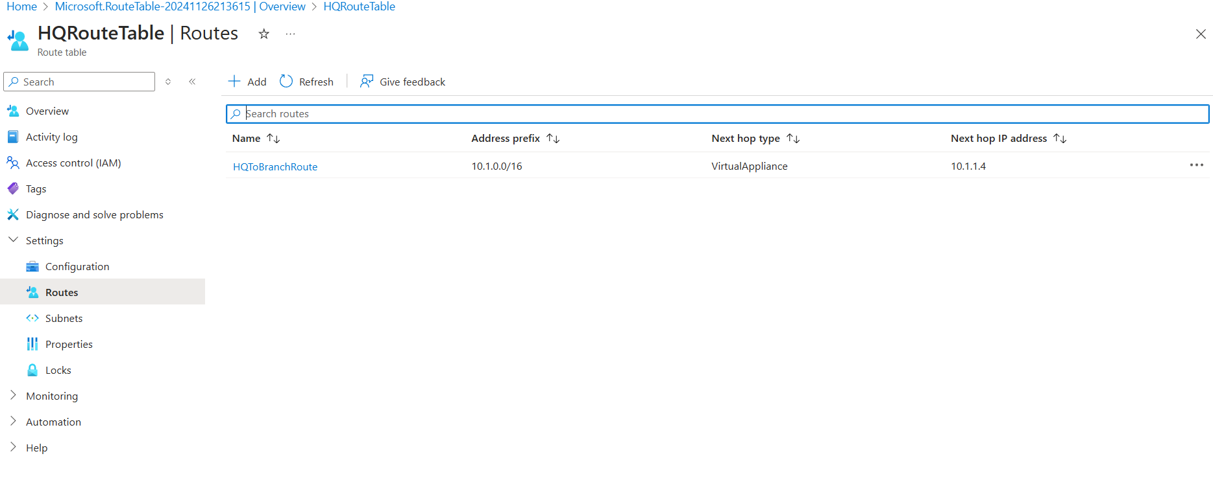

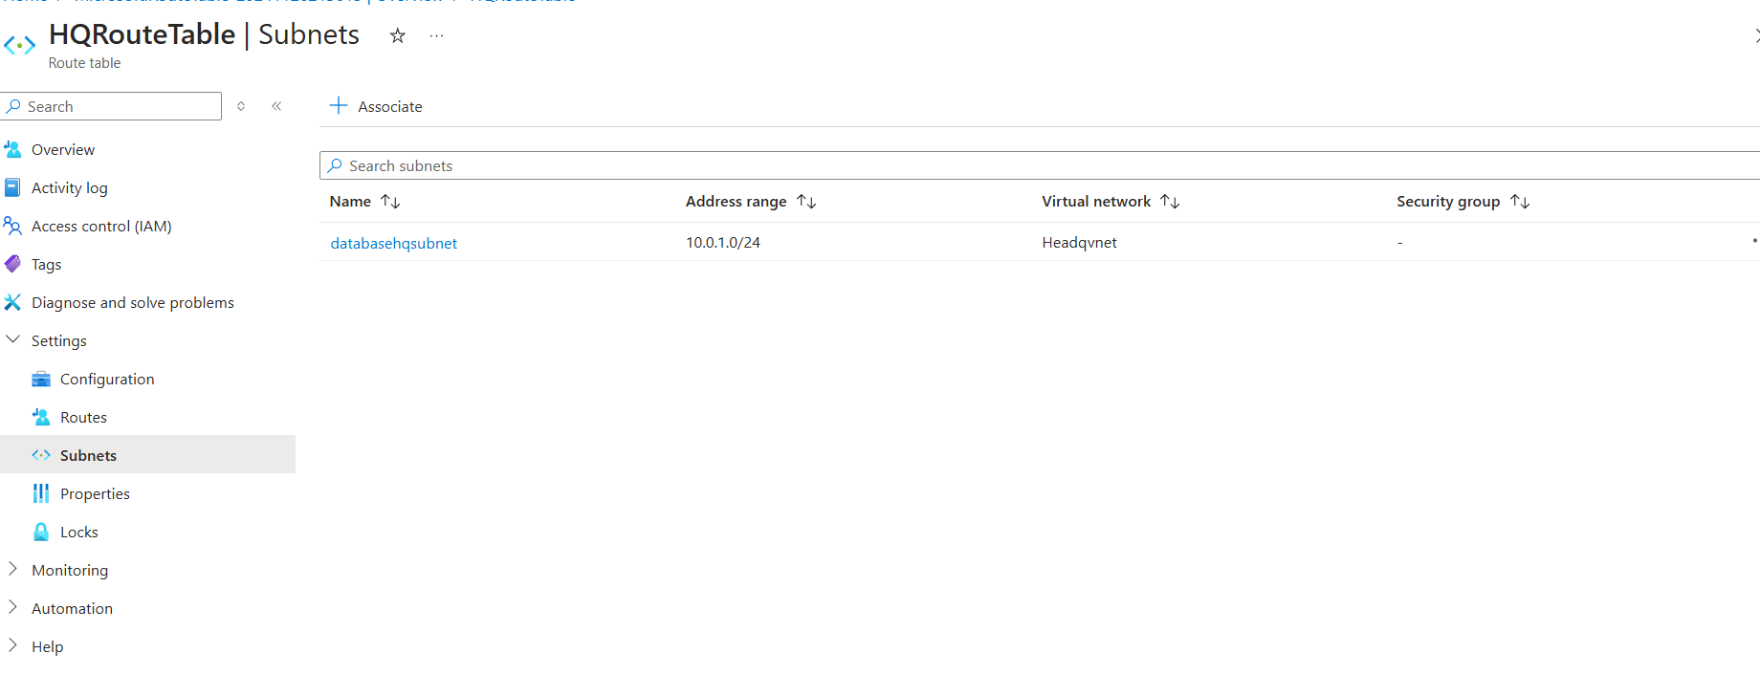

8.Create route table for branch and Associate branch Route Table with Application Subnet:



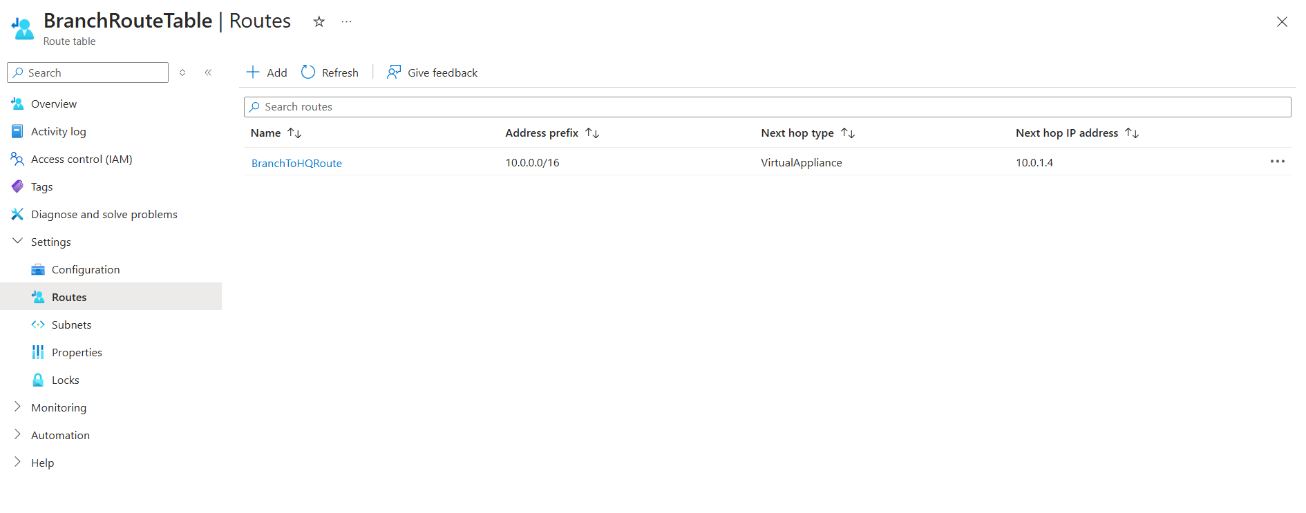

9.Launch both VM through RDP and Check the peering to Verify and also enable inbound port rule:

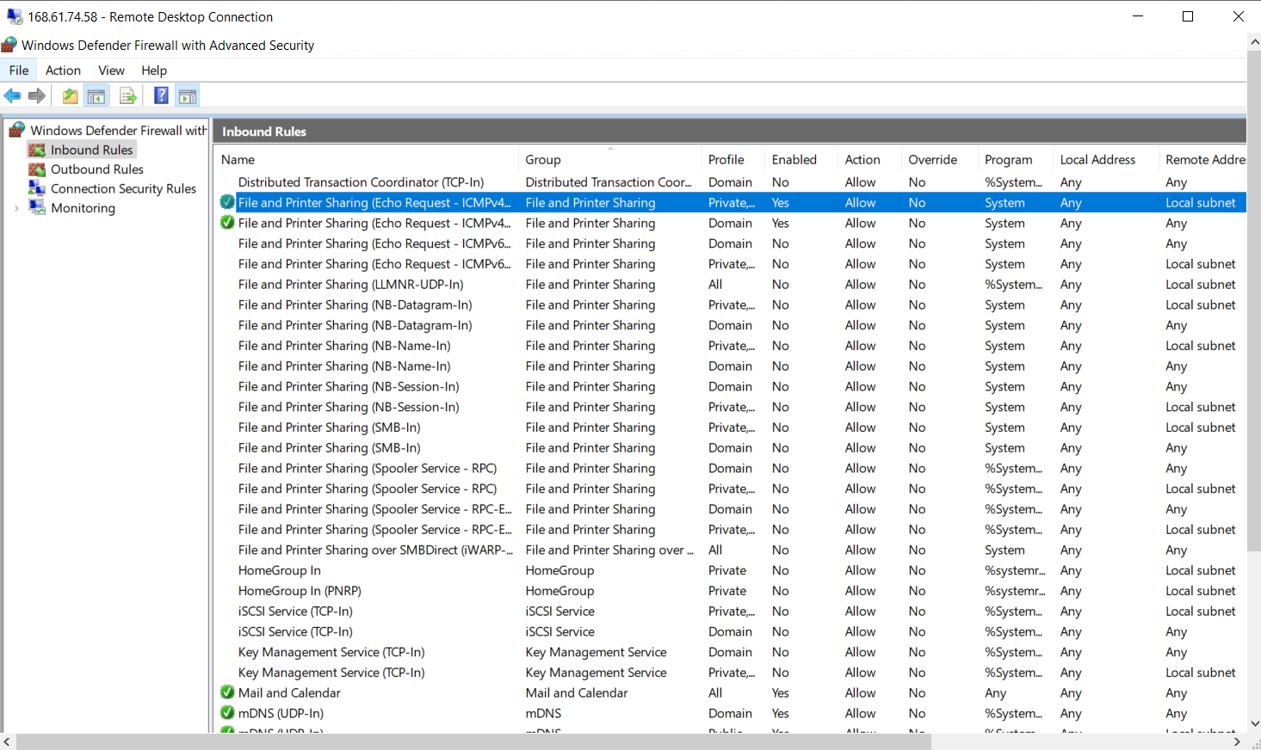

Use the ping command to test connectivity to the private IP address of the branchqVM from headqVM:

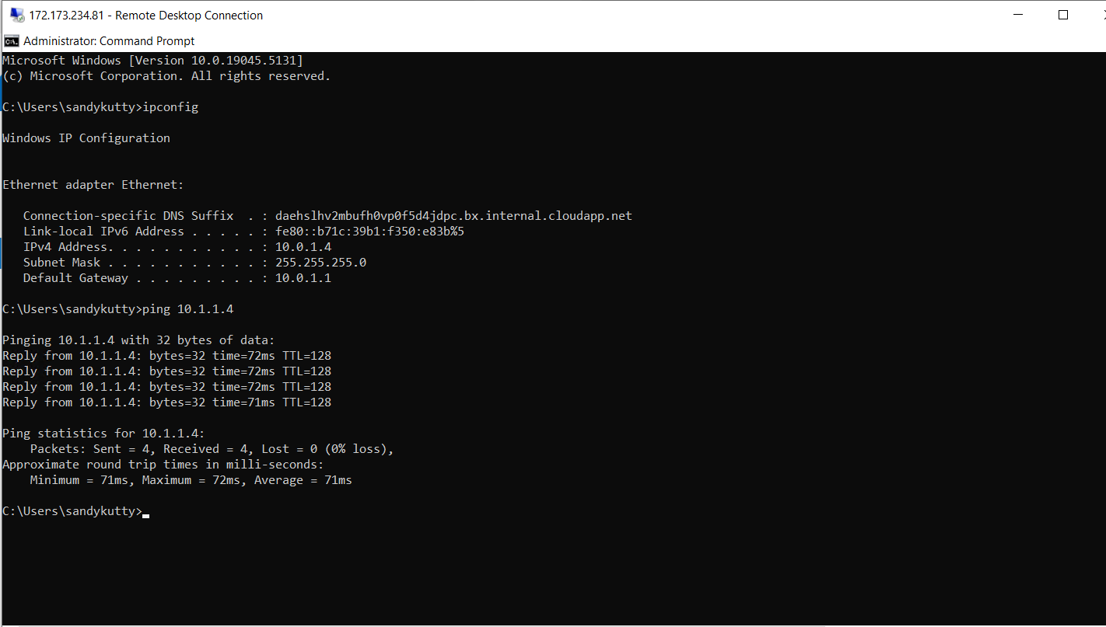

Use the ping command to test connectivity to the private IP address of the HeadqVM from branchqVM:

