# ANNA UNIVERSITY REGIONAL CAMPUS COIMBATORE

**CHATBOT DEPLOYMENT WITH IBM CLOUD WATSON ASSISTANT**

**ELECTRONICS AND COMMUNICATION ENGINEERING**

**SUBMITTED BY**

**SANTHIYA P**

**710021106317**

**PROBLEM STATEMENT: ( Development Part 1 ) In this part you will begin building your project.**

**Start building the chatbot using IBM Cloud Watson Assistant. Define the chatbot's persona and design the conversation flow.**

**Configure intents, entities, and dialog nodes in Watson Assistant to handle user queries.**

# Step 1: Defining the Chatbot's Persona

We will give a name for the chatbot, say, Dalia. The tone of the chatbot will be friendly and casual

This chatbot serves as a virtual guide to provide information ,answer frequently asked questions , and engage users in a friendly and conversational manner.

# Step 2: Designing the Conversation Flow

Designing the conversation flow involves planning how the chatbot will interact with users.A basic flowchart that outlines the key steps in the conversation. For example:

Greeting: How will the chatbot greet users?

Main Menu: What are the primary options or services the chatbot can provide? User Queries: How will the chatbot handle various types of user queries?

Error Handling: What happens when the chatbot doesn't understand a query or encounters an error?

Goodbye: How will the chatbot conclude the conversation?

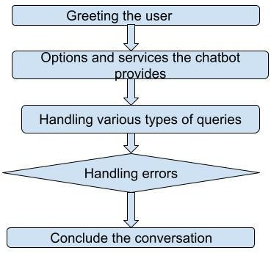

# Step 3: Configuring Intents

Intents represent the user's intention or what they want to achieve. In the Watson Assistant tool:

We will go to the "Intents" section and,

Define intents based on common user queries. For example, the chatbot has intents like , "Greetings",”Information”,”Queries” ,”thankyou” ,etc..,

# Step 4: Configuring Entities

Entities represent specific pieces of information within a user's query. In the Watson Assistant tool:

We will go to the "Entities" section and,

Define entities related to the chatbot's use case. For example, entities might include "Location," "Dates," etc.

# Step 5: Create Dialog Nodes

Dialog nodes are where we define how the chatbot responds to user inputs. For each intent:

We will go to the "Dialog" section ,

Create a dialog node for each intent and Define the response for each node.

# Step 6: Configure Dialog Flow

In each dialog node:

We will configure conditions based on intents and entities, Define multiple responses for variety, and

Set context variables to remember user information or choices. Include options for user navigation and provide clear guidance.

# Step 7: Testing and Refining

Testing the chatbot within the Watson Assistant interface. Trying different user queries to ensure it responds correctly. Refining the dialog nodes and improving responses based on user feedback.

1. Creating a chatbot using watson Assistant

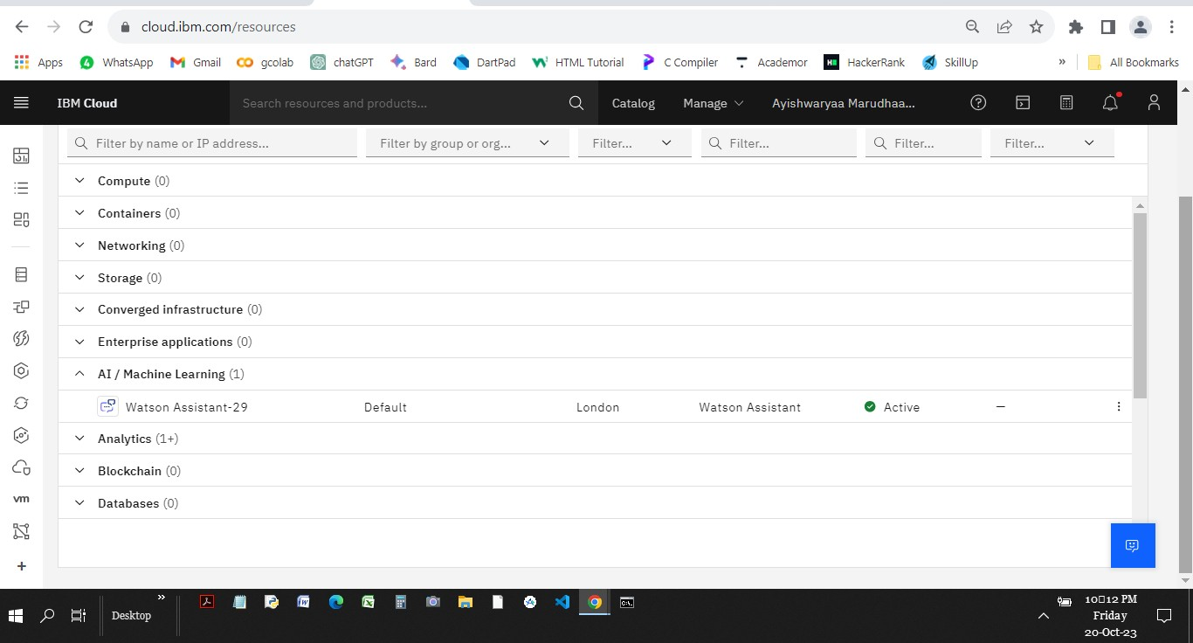

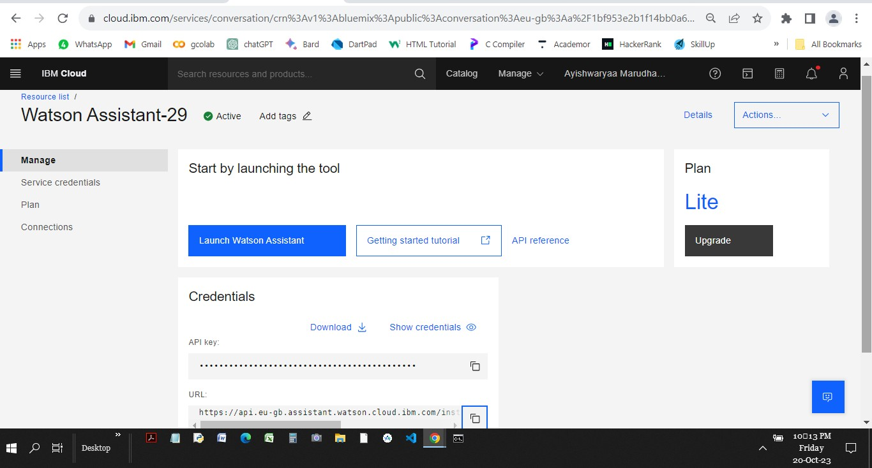

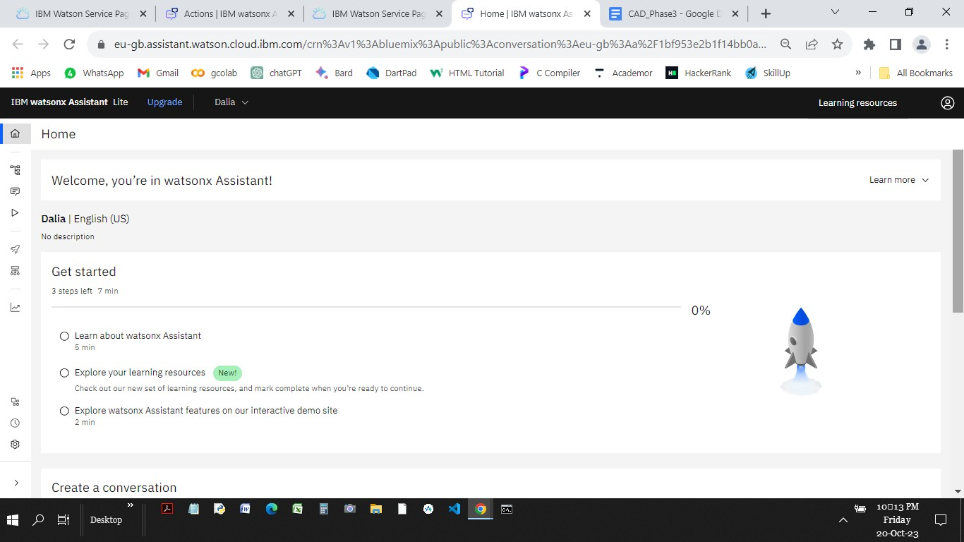

1. Creating Intents..

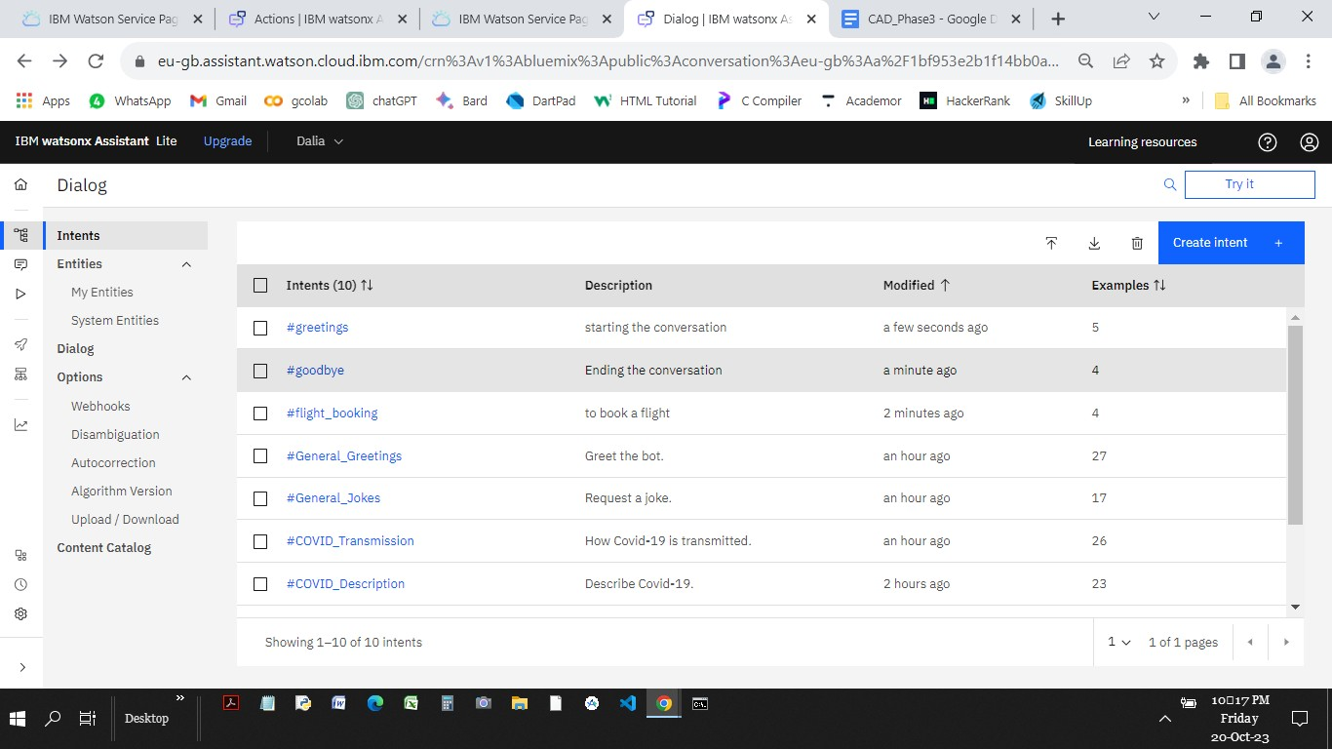

1. Using system Entities..

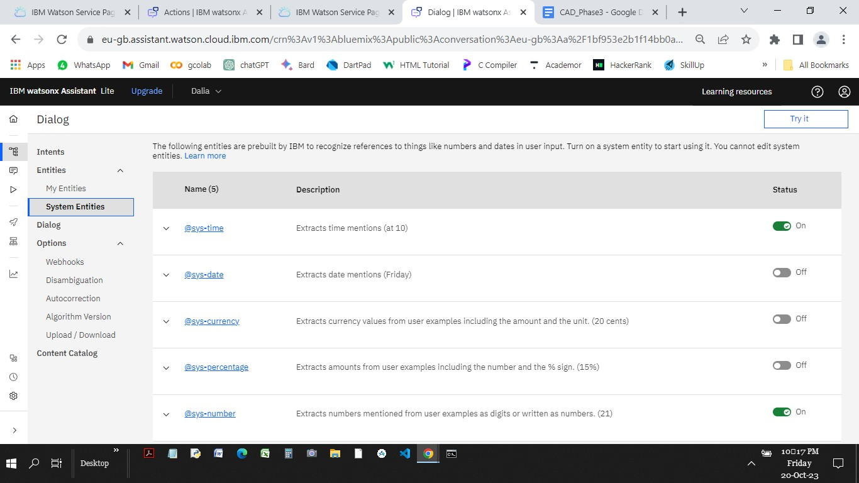

1. Building dialog nodes for the created intents and entities..

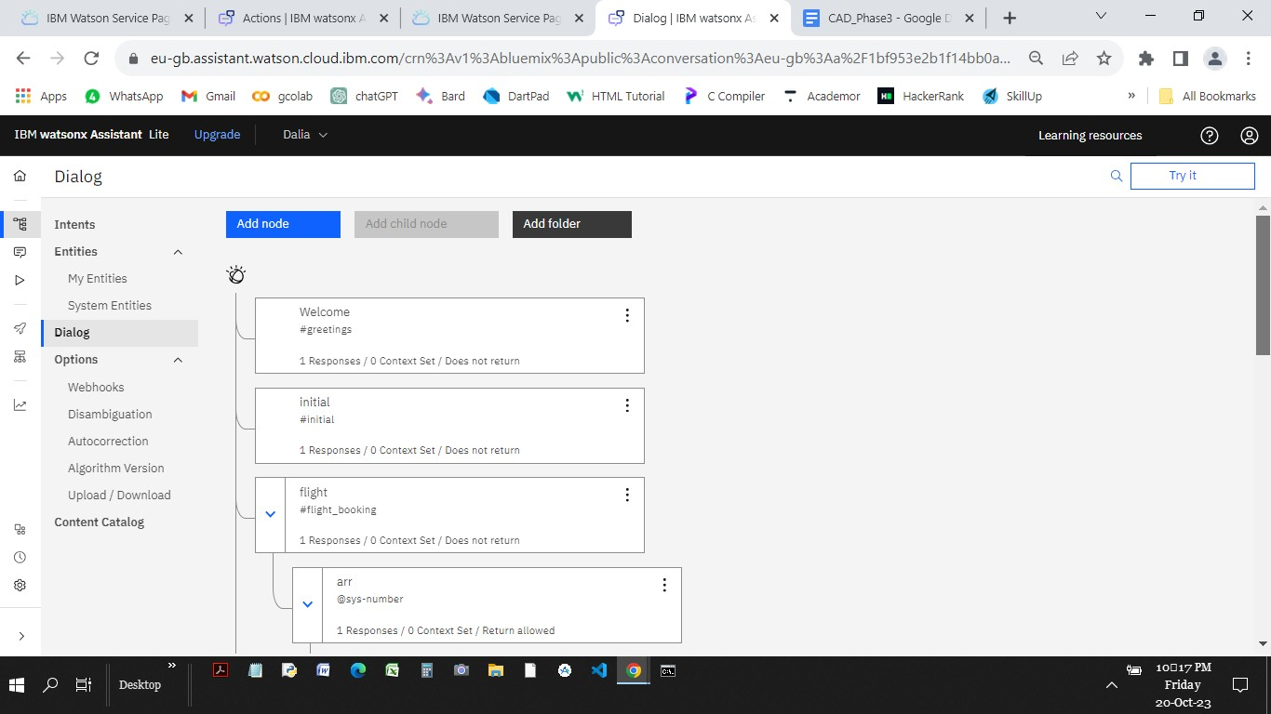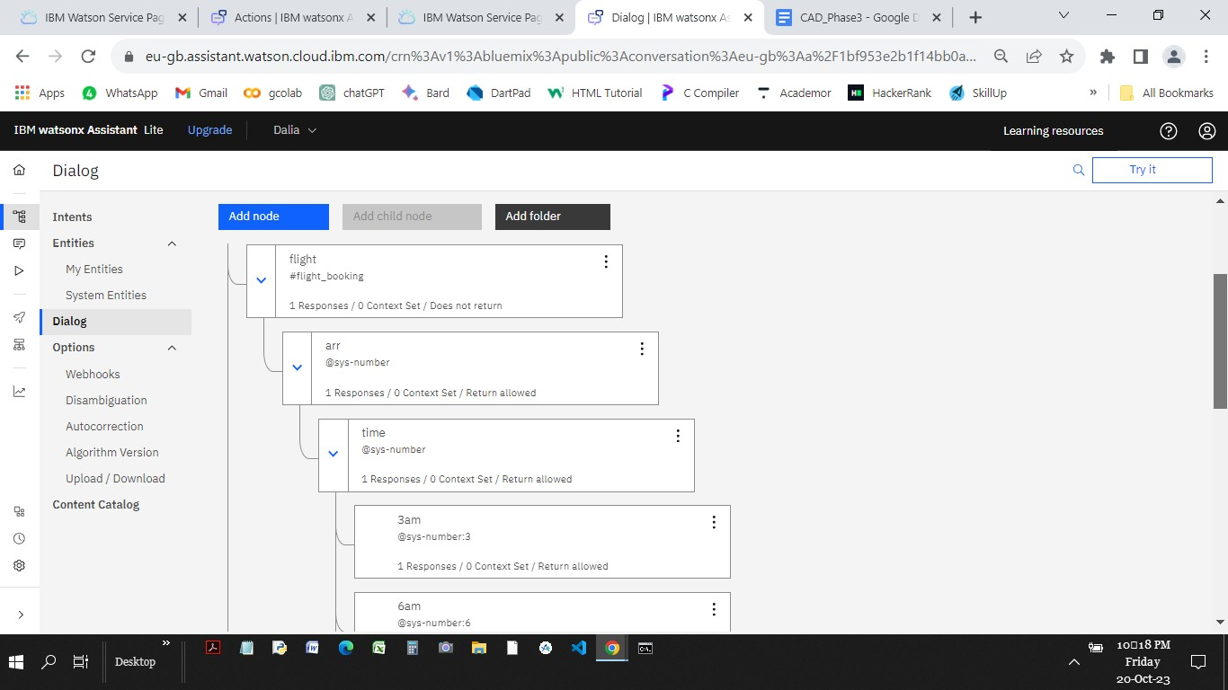

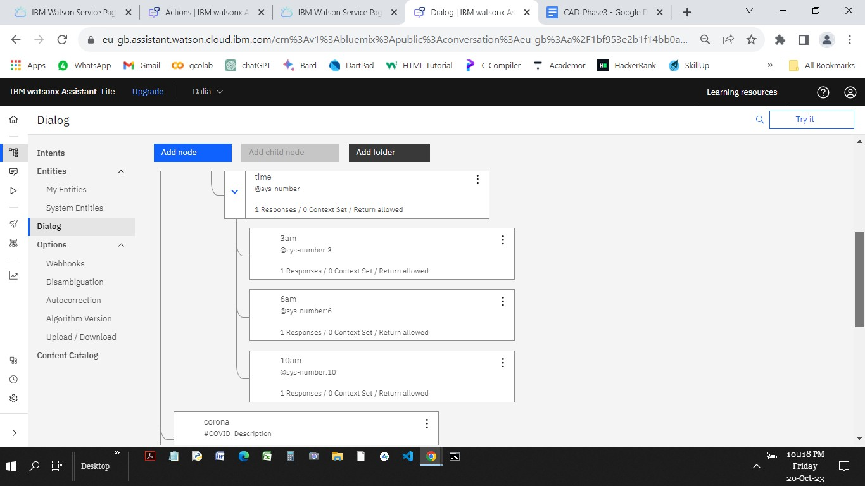

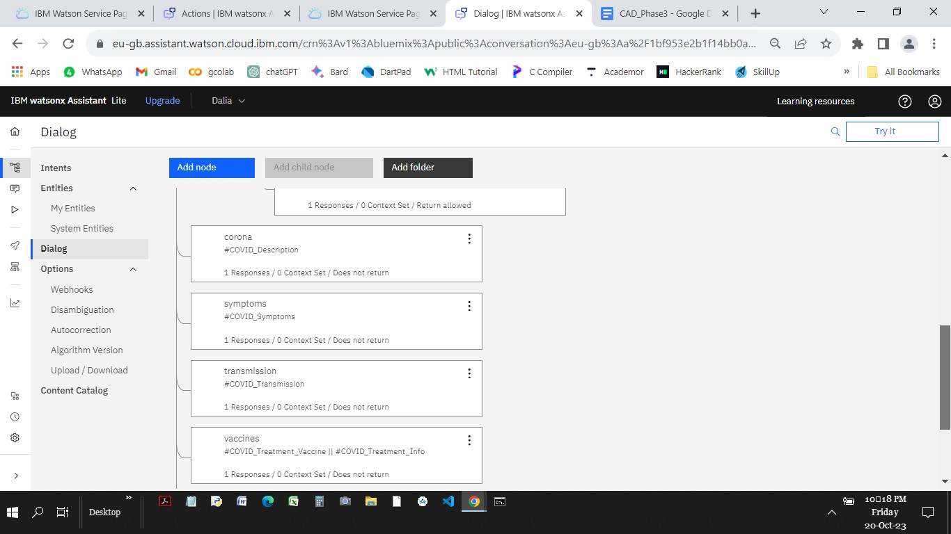

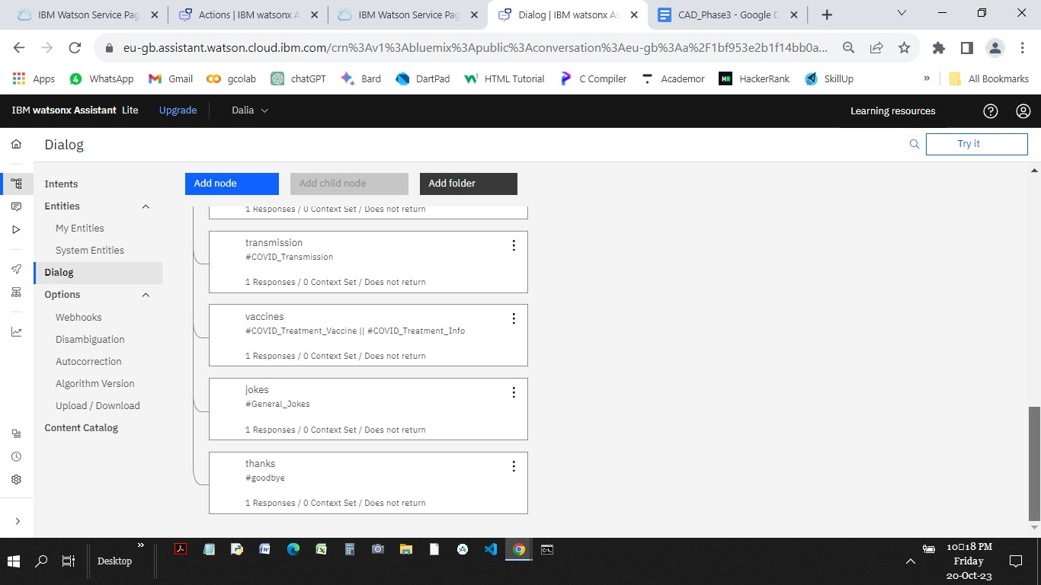

1. Testing the chatbot with some user queries..

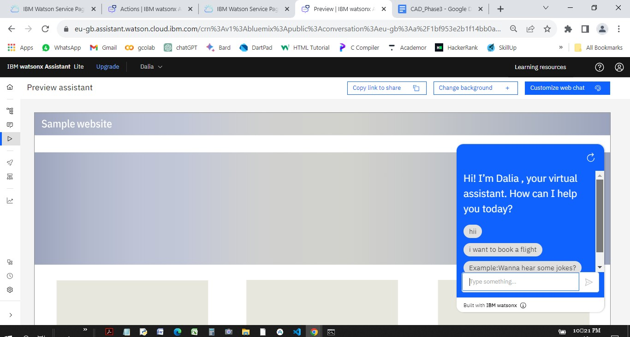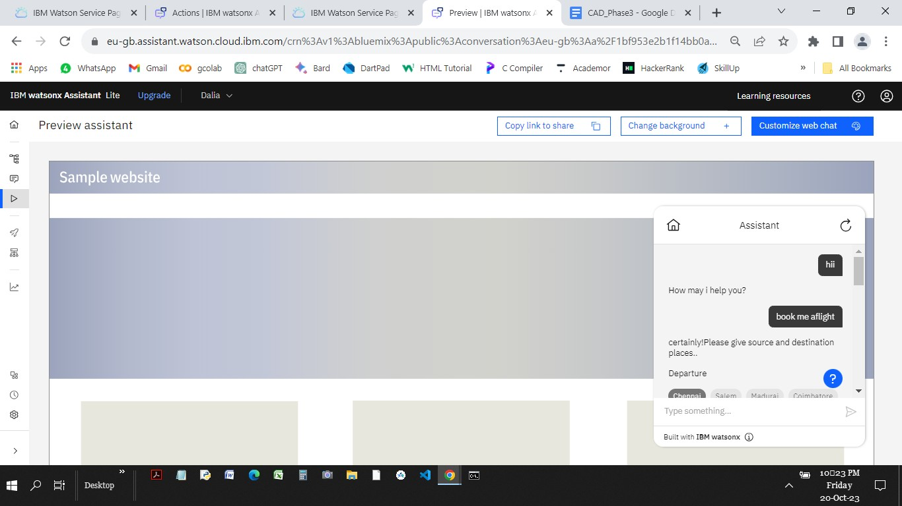

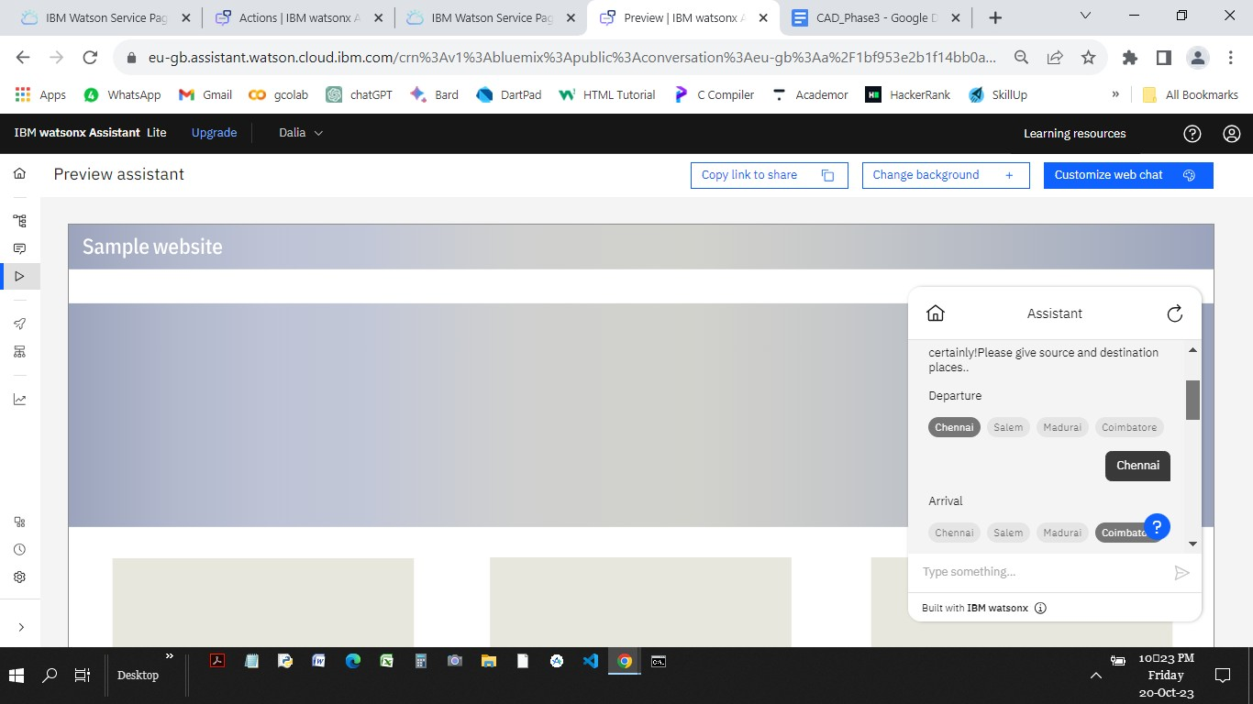

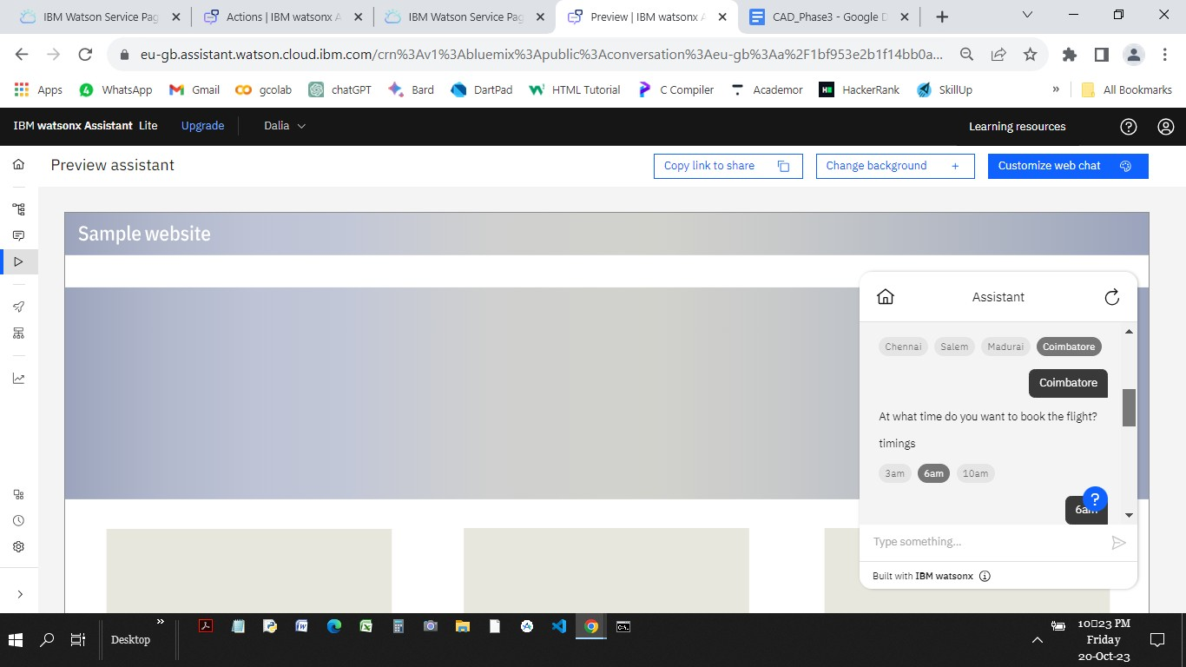

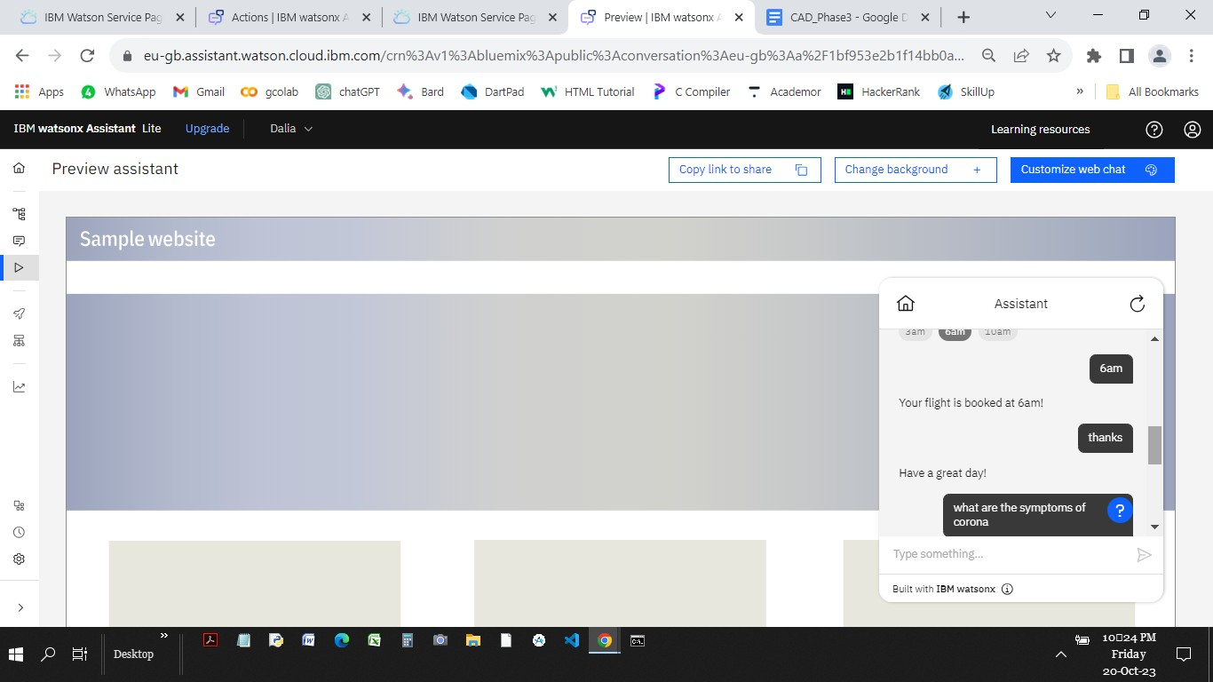

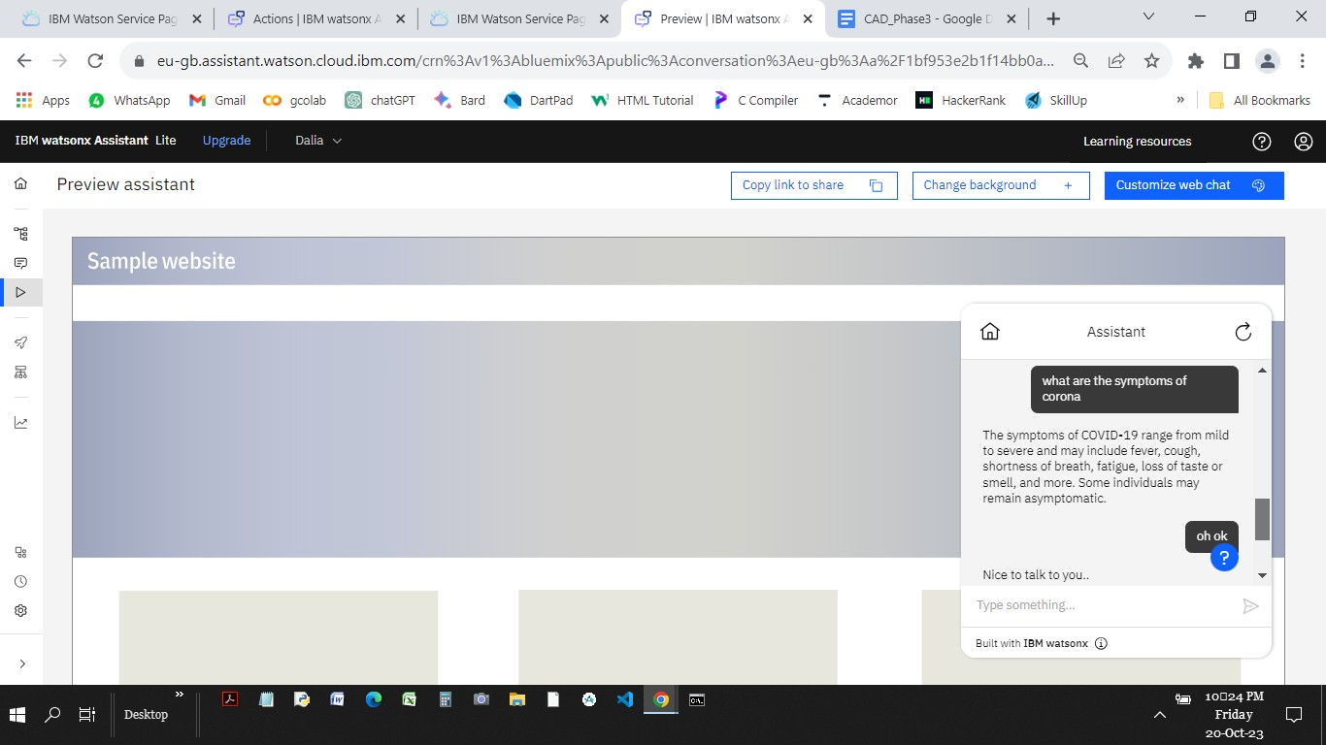

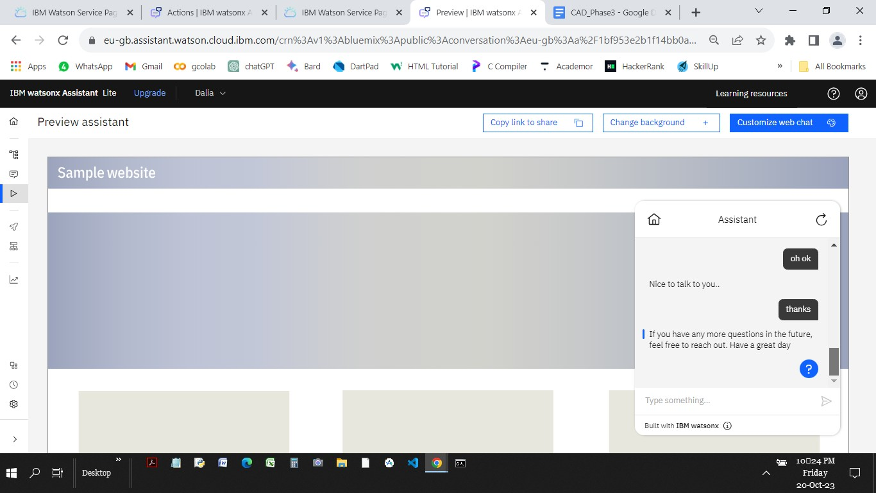

**ACTIONS:**

Creating actions..

