Cloud Operation Assessment

santhosh

**Table of Contents**

1 Create an Azure free trial account 2

2 Setup SSH connection for both machine 2

3 Exercise 3

3.1 Basic metrics of the machine 3

Article I. Communicate with each other server 3

Article II. Basic metric of the Linux machine 4

3.2 Elasticsearch Installation in a docker container 6

Article III. Installing Elasticsearch using Docker 6

3.3 Linux Problem solving 7

Article IV. Ubuntu Diagnose and solve the Redis server issue 7

3.4 Windows problem solving 9

Article V. Windows Web applications diagnose 9

4 Conclusion 11

# Create an Azure free trial account

Created two ubuntu instance for exercise in Azure free trail account.

|  |  |  |  |
| --- | --- | --- | --- |
| IP ADDRESS | USERNAME | vCPUs | RAM |
| 40.80.92.13 | santhosh | 1 | 3.5 GB |
| 52.172.141.163 | santhosh | 1 | 3.5 GB |

# Setup SSH connection for both machine

Created ssh-key and configured both machines.

**Server 1:**

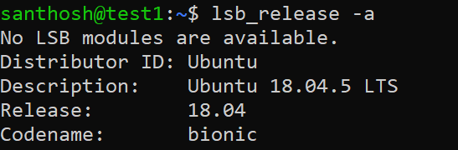

**Server 2:**

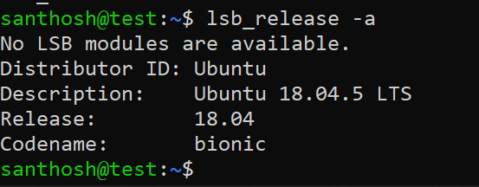

# Exercise

## Basic metrics of the machine

# Communicate with each other server

**Step 1:** need to generate ssh key in both machines.  
 command: ssh-keygen

**Step 2:** add ssh key into another machine.

command: vi ~/.ssh/authorized_keys

#server hosts

52.172.141.163 test1

40.80.92.13 test

**Output:**

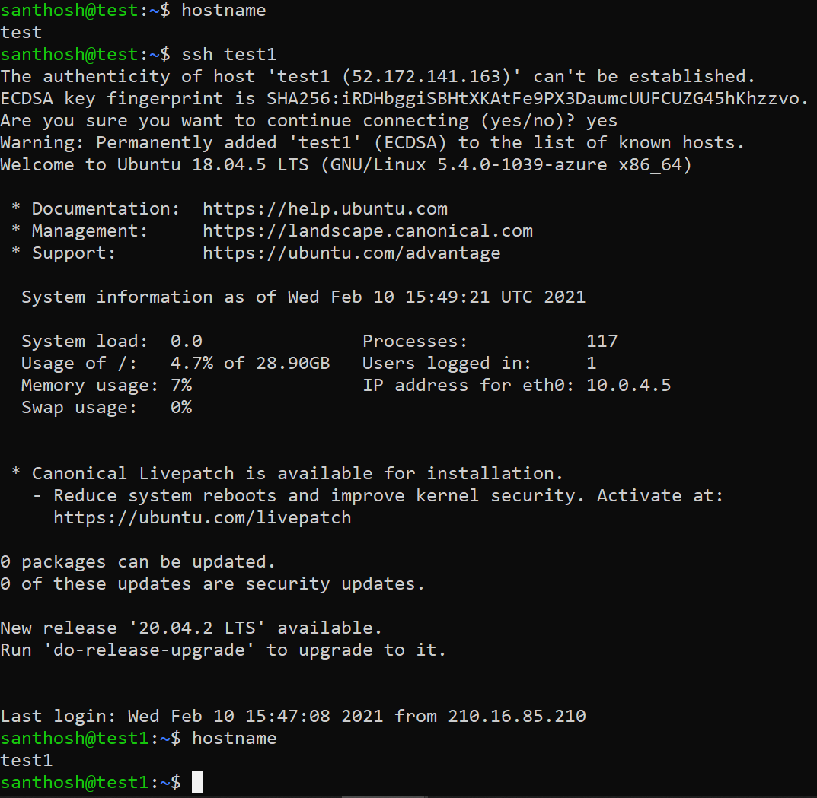

# Basic metric of the Linux machine

**Step 1:** CPU, Disk, RAM, and Network Usage:

|  |  |  |  |
| --- | --- | --- | --- |
| #No | Items | Scripts | comments |
| 1 | CPU | top -bn1 | grep load | awk '{printf "%.2f%%\t\n", $(NF-2)}' | List the percentage of CPU usage |
| 2 | DISK | df -h | awk '$NF=="/"{printf "%s\t", $5}' | List the percentage of Disk usage |
| 3 | RAM | free -m | awk 'NR==2{printf "\t%.2f%%\t", $3*100/$2 }' | List the percentage of RAM usage |
| 4 | Network Usage | sudo apt-get install ifstat  ifstat -T | List the percentage of Network usage |

**Step 2:** Automation script creating for the environment

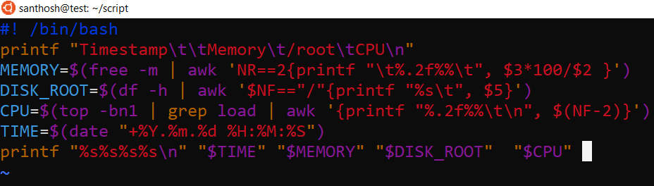

**Step 3:** Automated script using cronjob.



**Step 4:** Appended output from metrics.log files.  
**output:**  
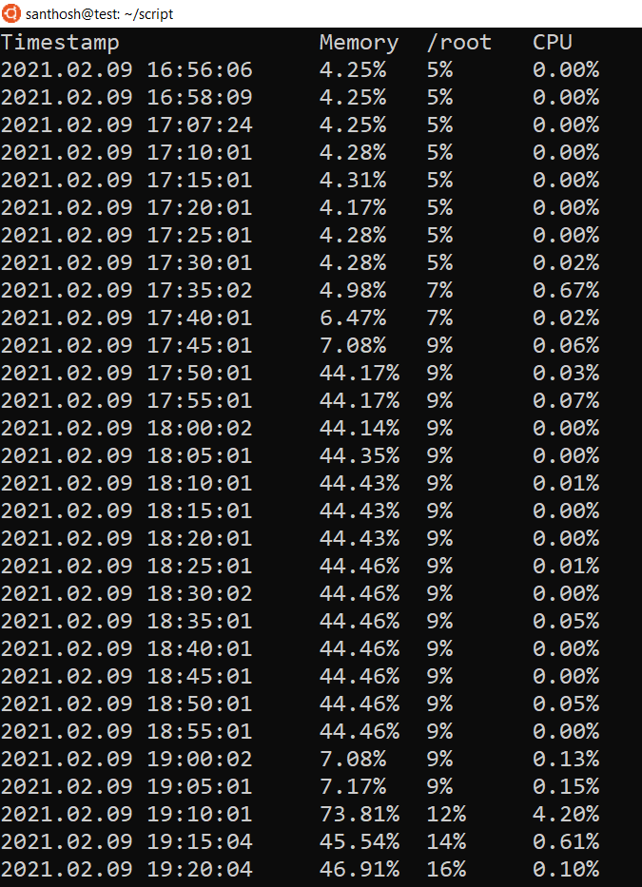

Network Usage report:

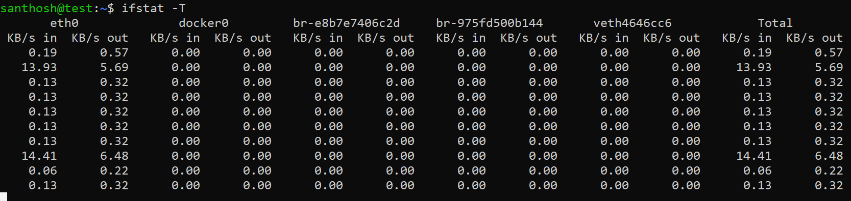

## Elasticsearch Installation in a docker container

# Installing Elasticsearch using Docker

**Step 1:**

Installed docker in the machine. Need to follow the list of steps.

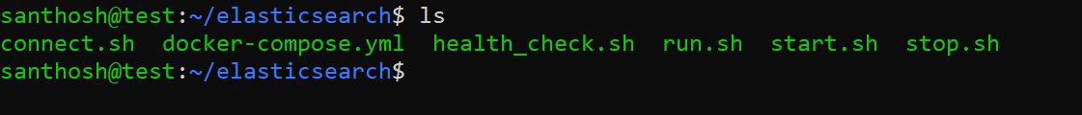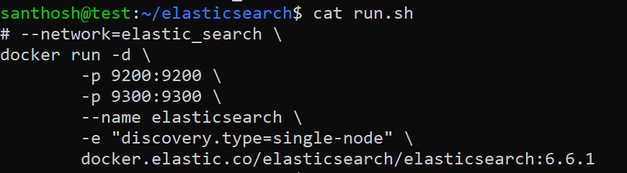

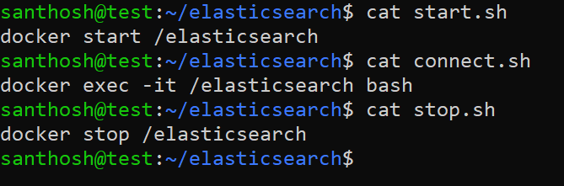

**Output:**



**Step2:** check the Elasticsearch health  
**script:** curl -s localhost:9200/_cat/health

curl -X GET "localhost:9200/_cat/nodes?v=true&pretty"  
**output:**

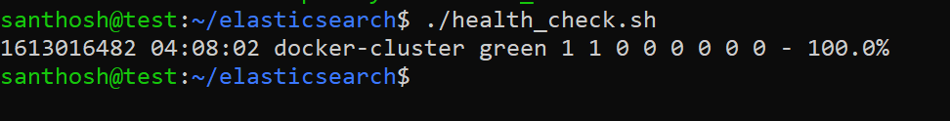

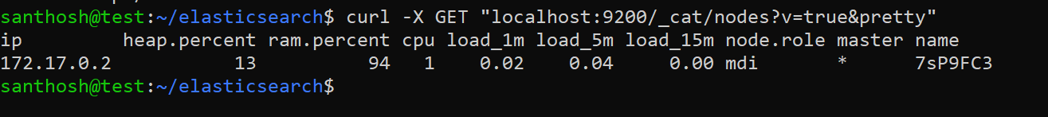

## Linux Problem solving

# Ubuntu Diagnose and solve the Redis server issue

**Step 1:** Need to check the status of Redis server.

**Script:** sudo systemctl status redis.service

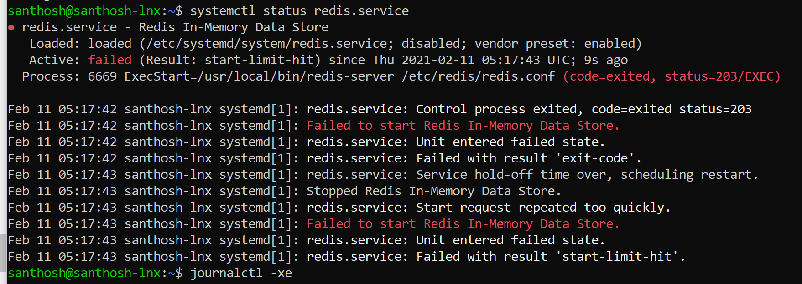

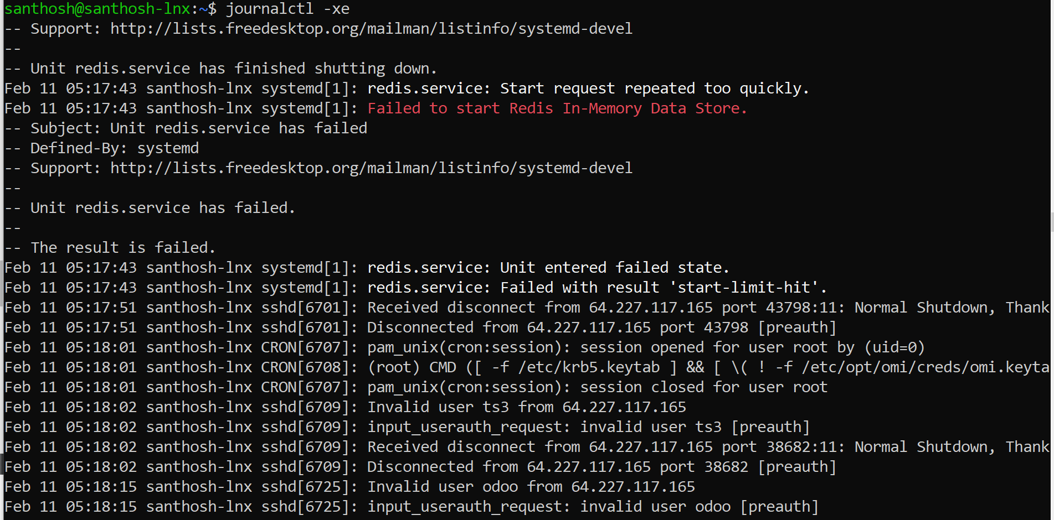

Although Even rebooting the system could not help, in my case it was because of a running background process which was found using:

ss -tulpn

killed it.

kill [process id/number]

Afterwards I could start redis service again.

Sudo systemctl service start redis

**Step 2:** Missed to add list of items in /etc/systemd/system/redis.service.  
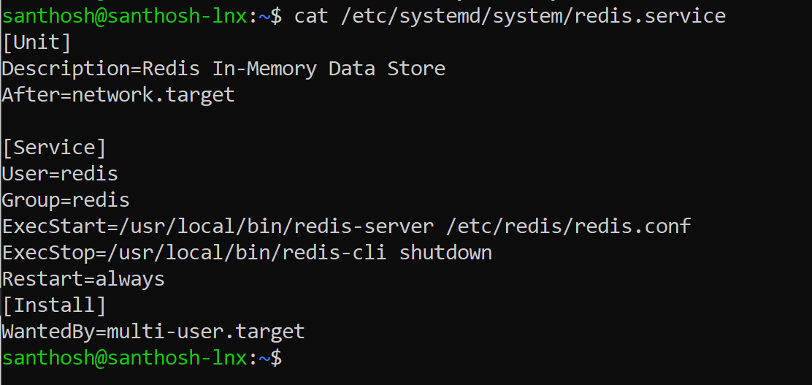

**Step 3:** Need to start Redis-server as well. Redis-server –daemonize yes

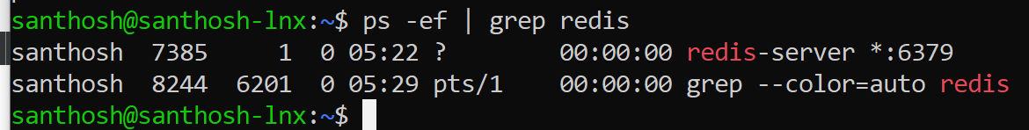

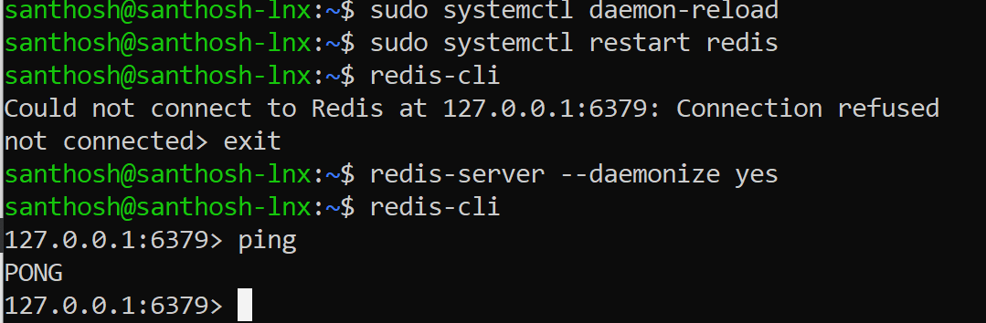

## Windows problem solving

# Windows Web applications diagnose

Step 1: Need to check widows errors log

C:\Windows\System32\LogFiles\HTTPERR

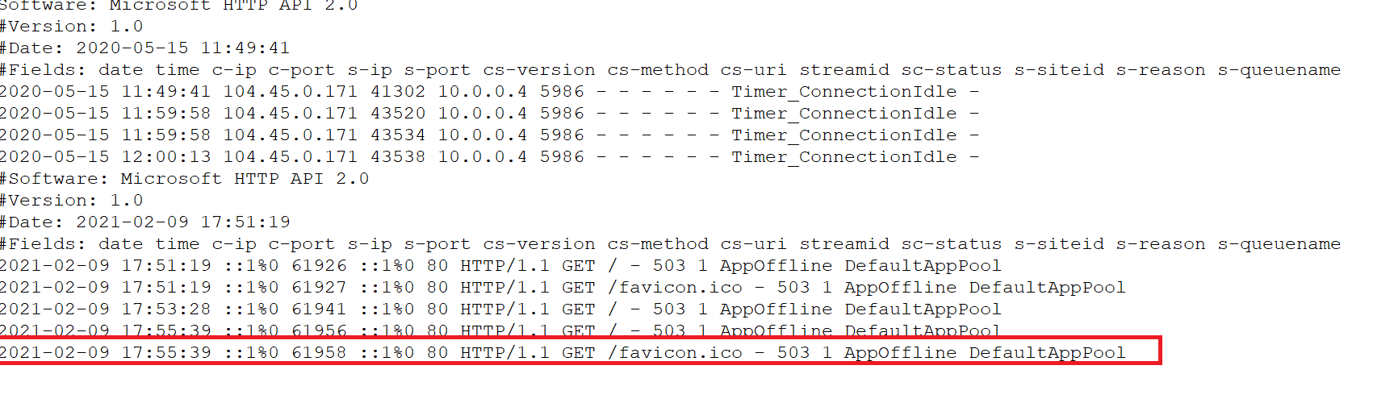

Step 2: Enabled HTTP Activation.

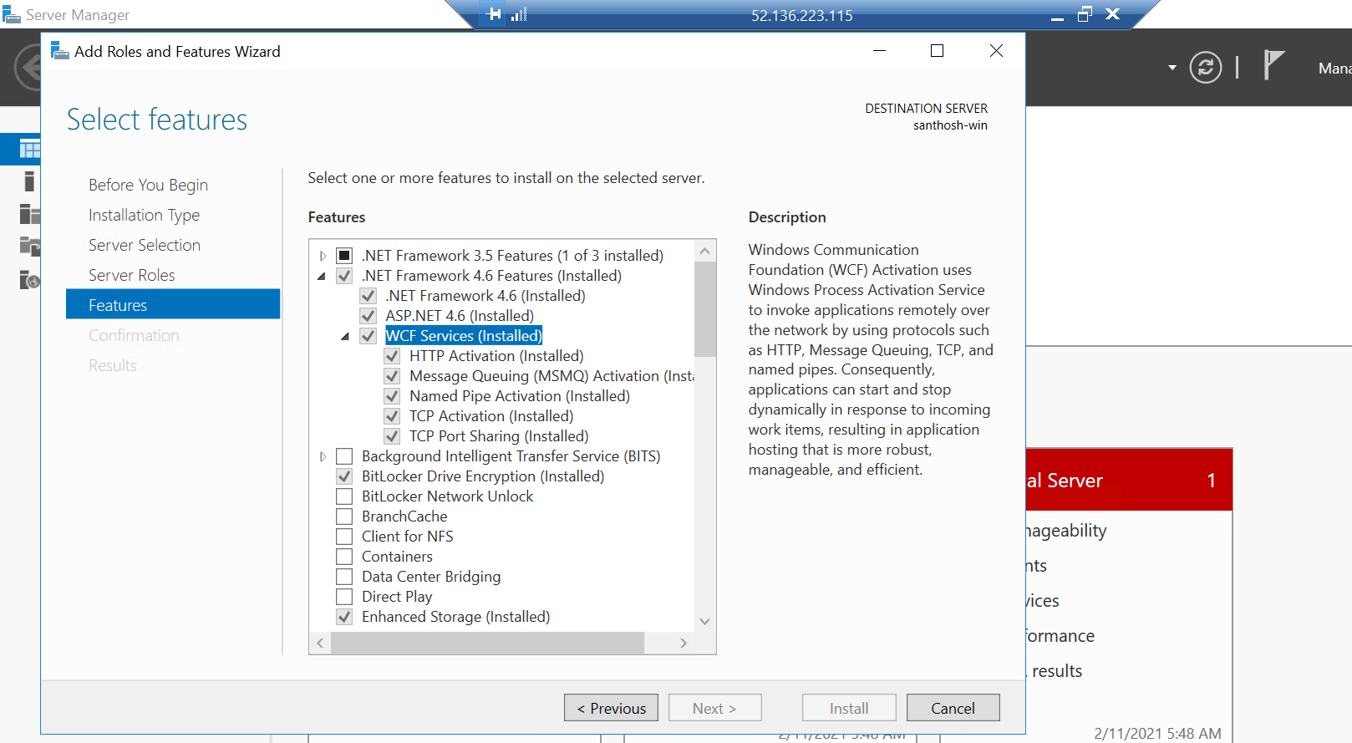

Step 3: Started Application pools as well.

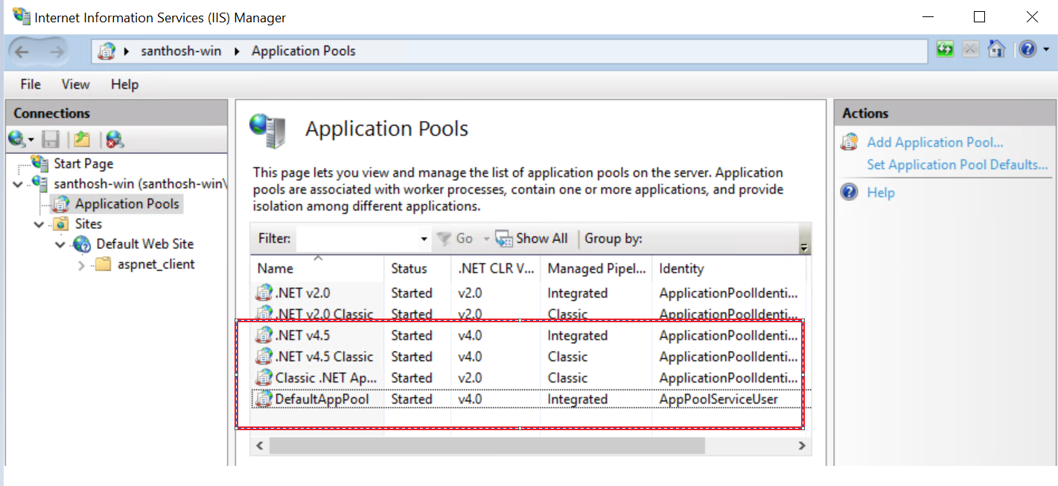

**Output:**  
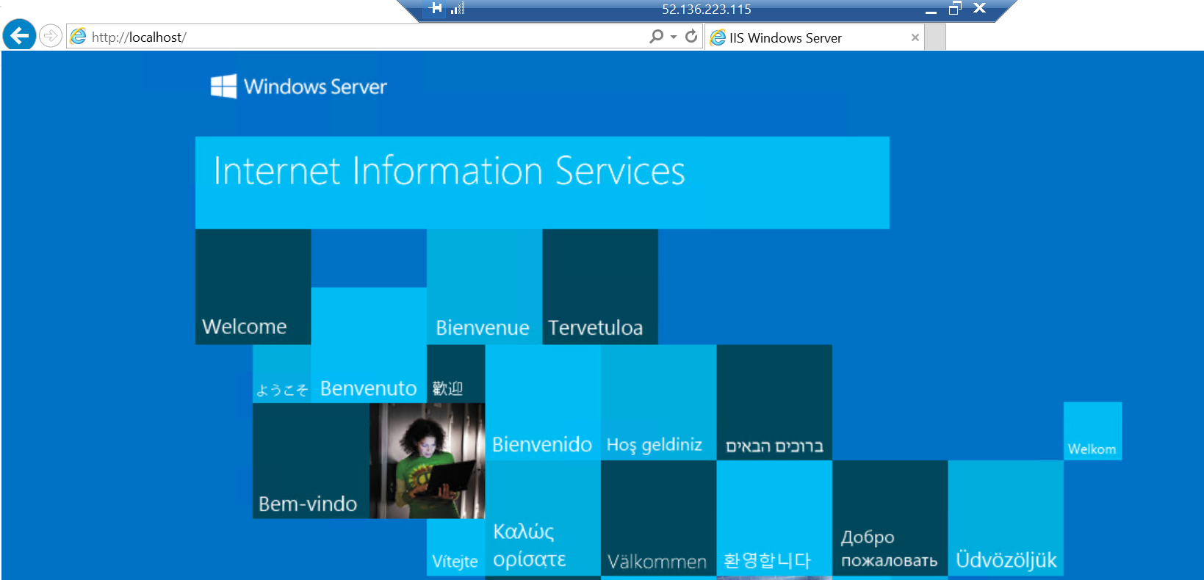

# Conclusion

As per the given tasks hereby I’m submitting my assignment. Review the document and send your feedback.