Question 1: Creating a blank file named “myfile” and checking its presence.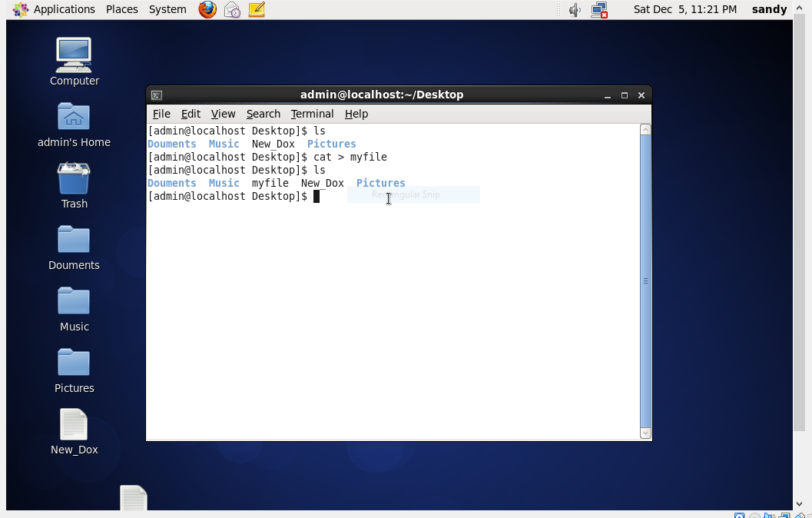

Question 2: Opening “myfile” in vi editor

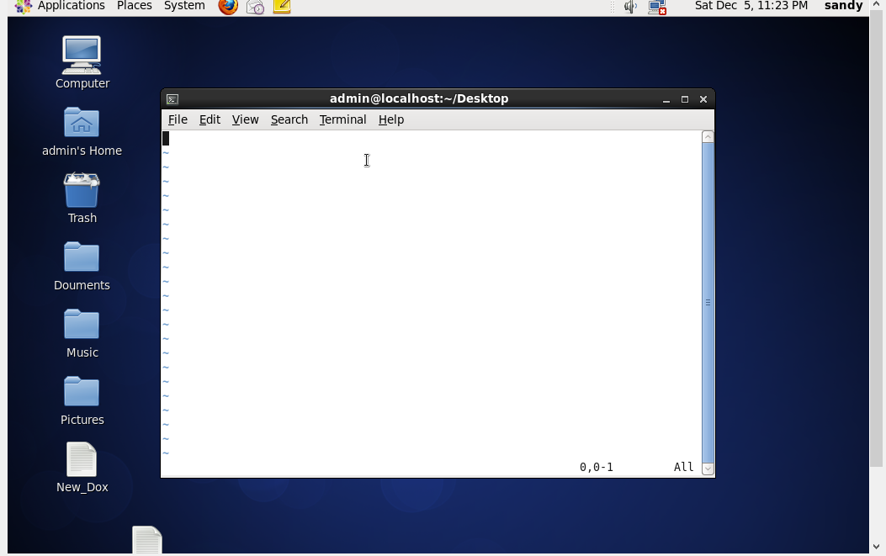

Question 3: Writing Name , Address , Email id , Phone Number and Blood Group in 5 different lines

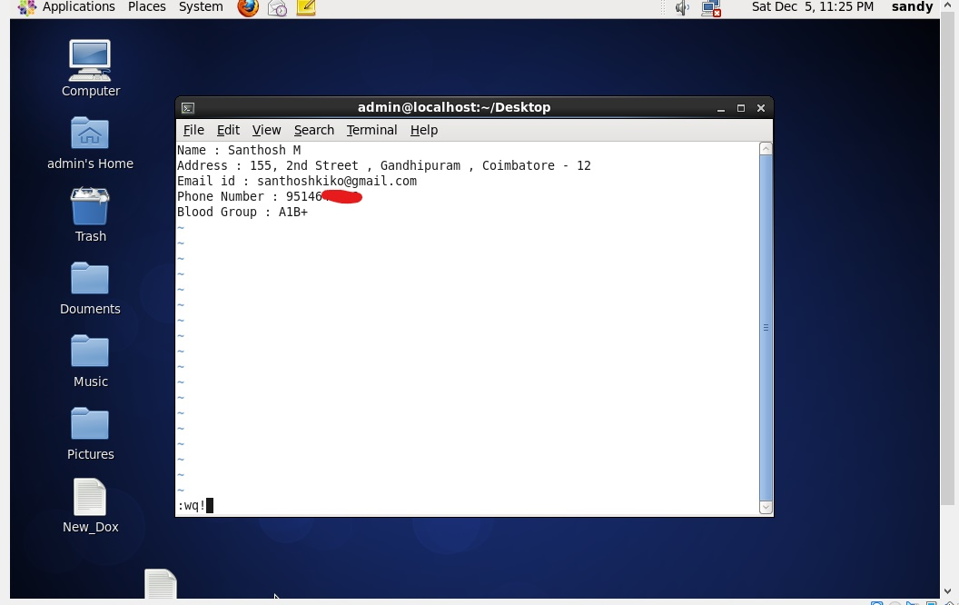

Writing the contents and saving it using the command “wq!”

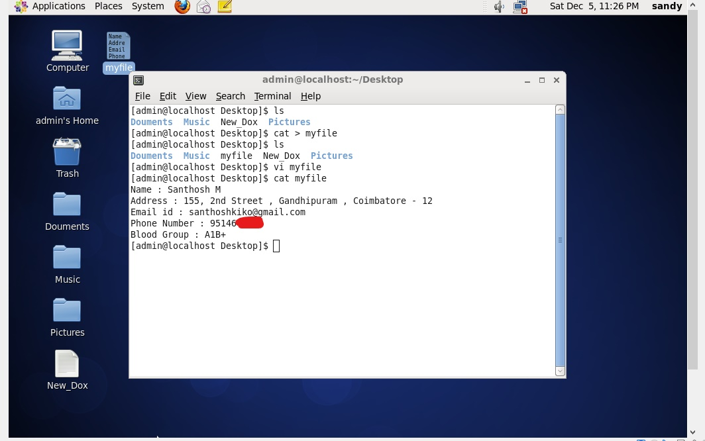

Verifying it using the terminal.

Question 4: Build an expression to see the line with your name and blood group in myfile.

