Question 1: Add a 10GB disk to Centos.

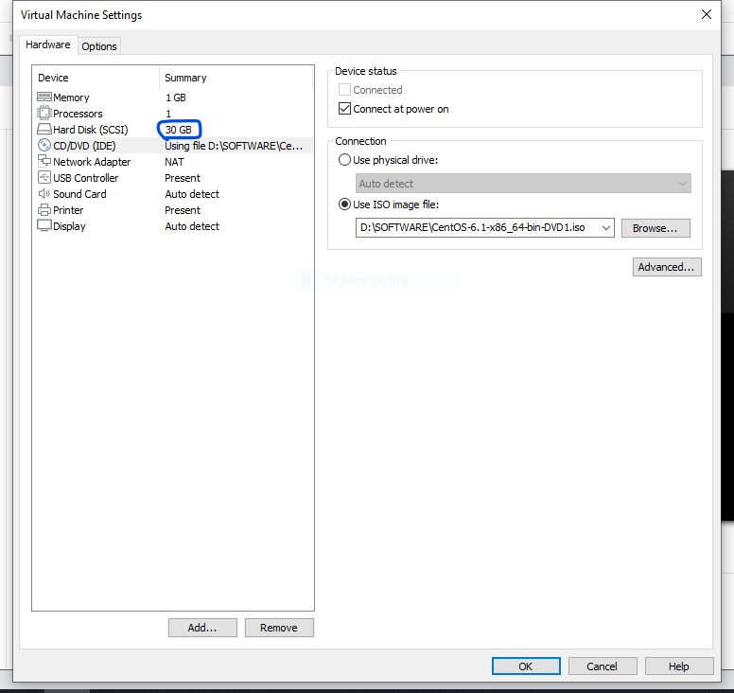

Initially using 30GB of disk space.

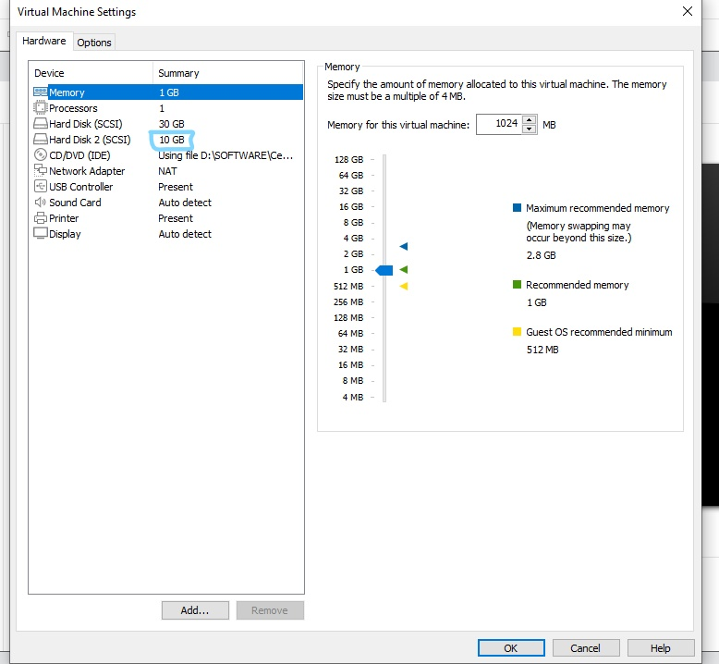

Adding 10GB to the disk space.

Question 2: Create 2 partitions 4GB and 6GB of space respectively.

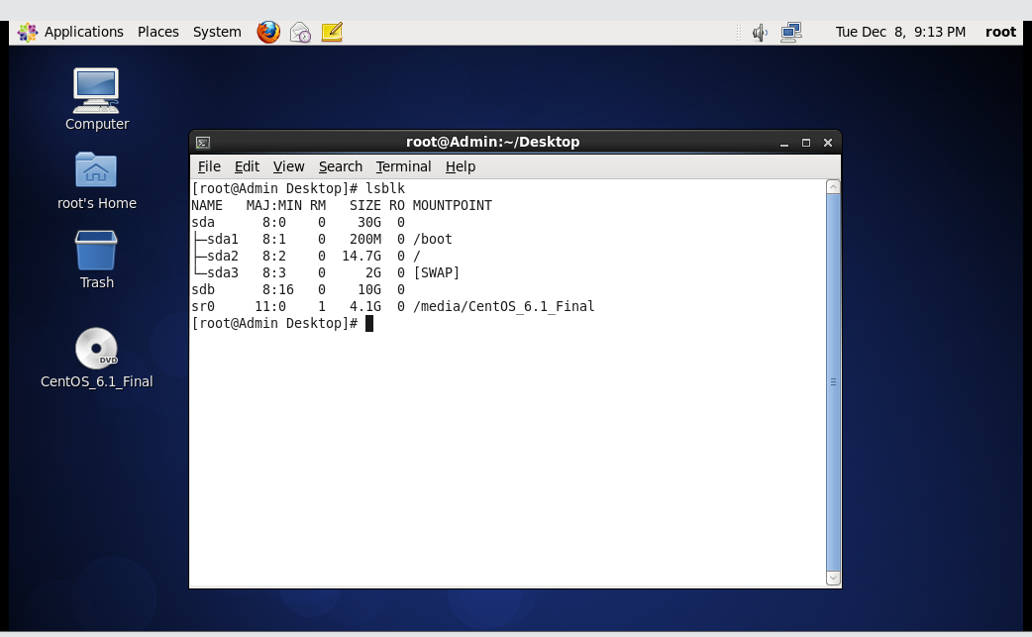

Using lsblk to check the current partiton.

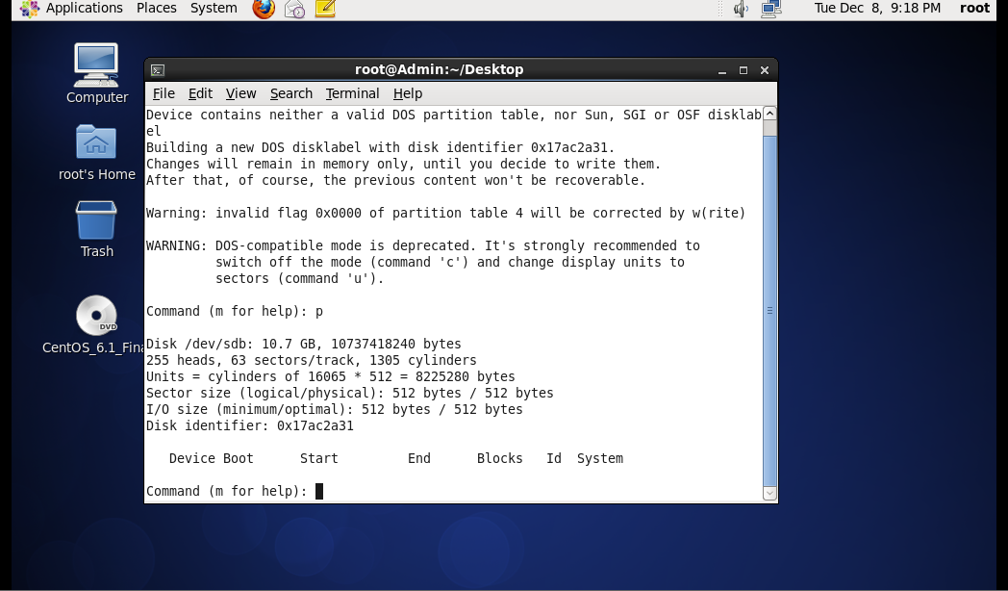

Using fdisk -l to check the partition table.

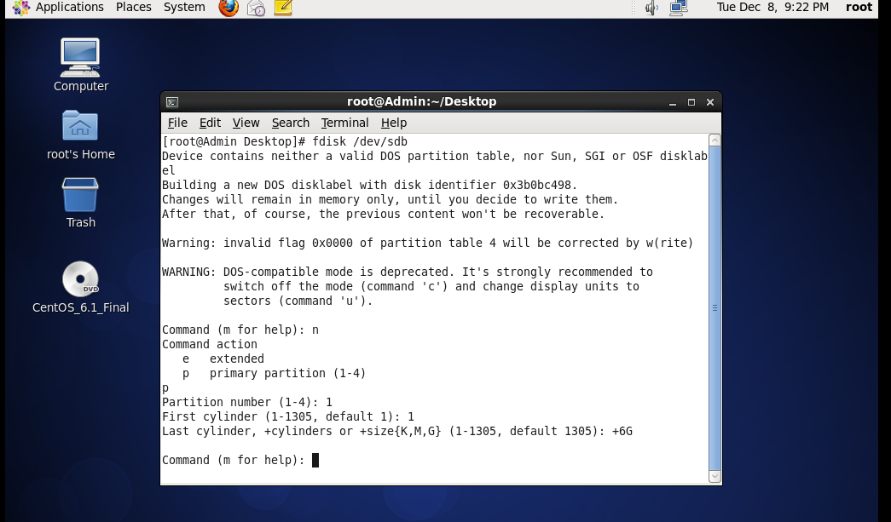

Creating a new partition using fdisk /dev/sdb

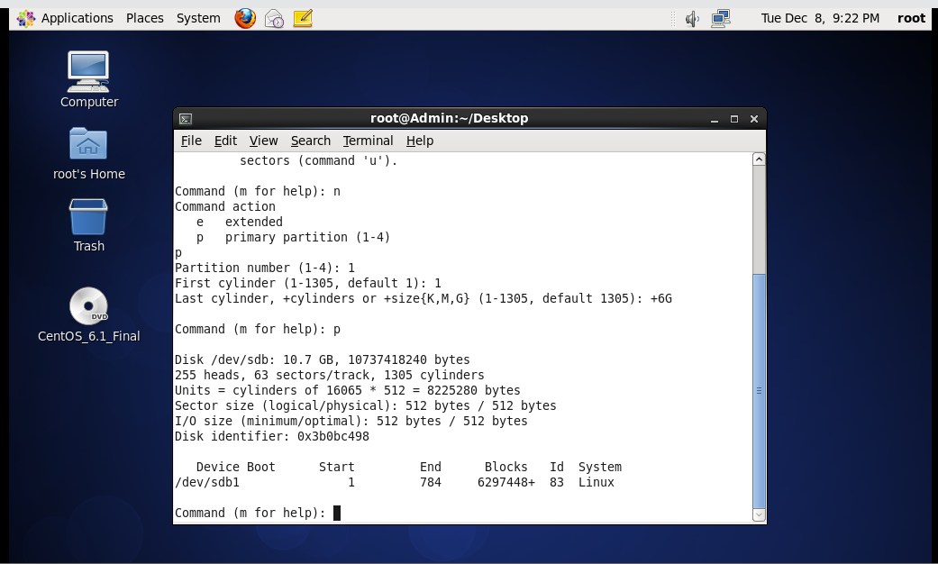

First partition of 6GB

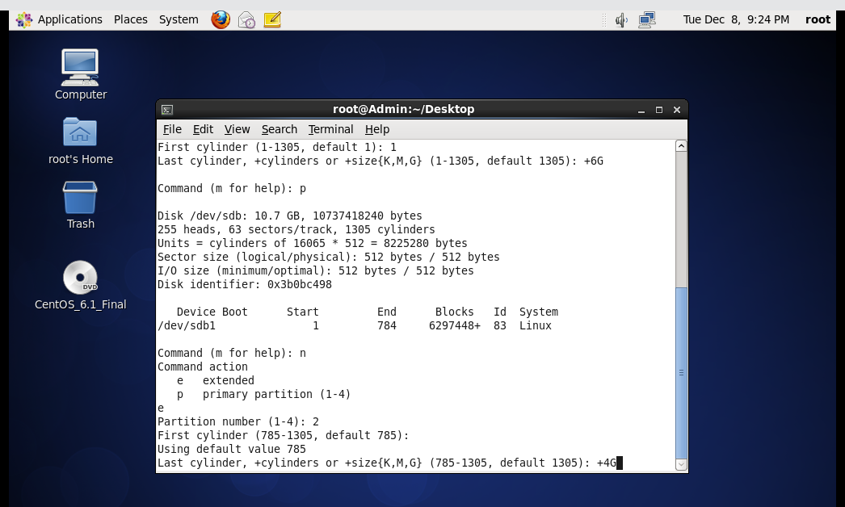

Creating the next partition of 4GB.

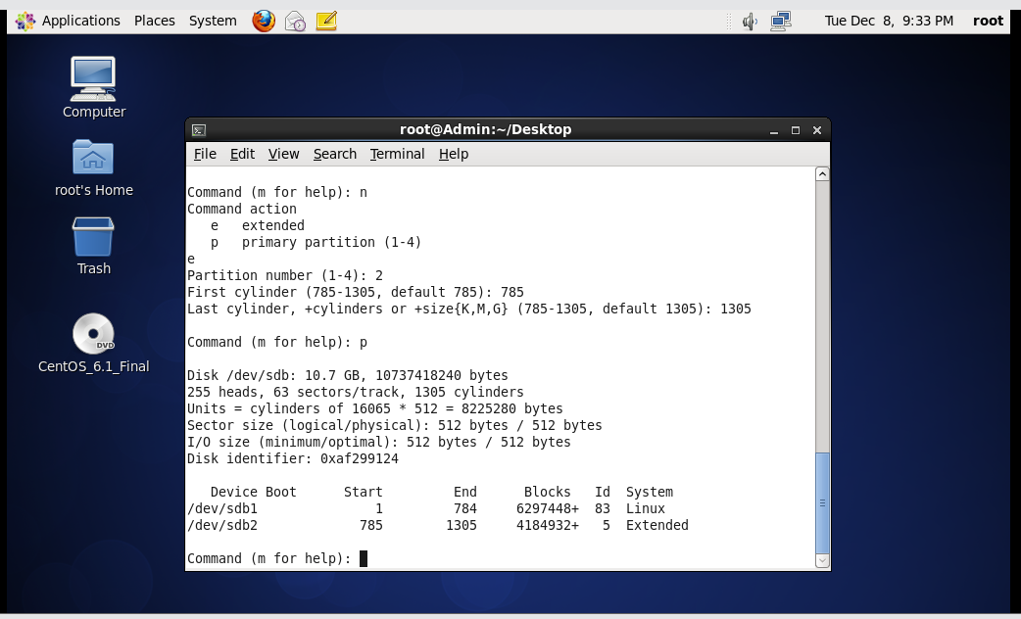

After creation of both the partitions

Question 3: Formating both the partitions.

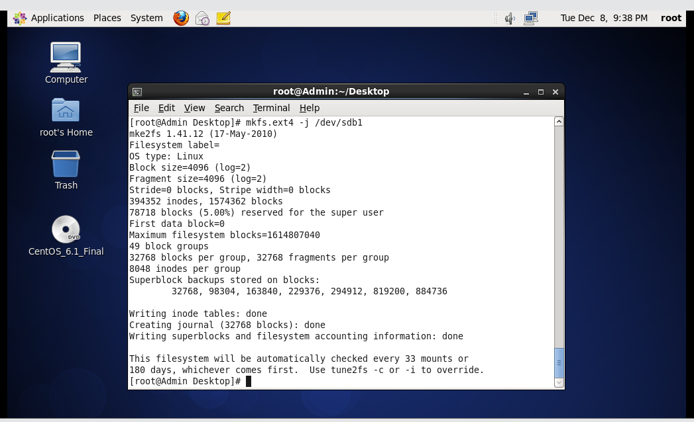

Formatting sdb1 with ext4(6GB)

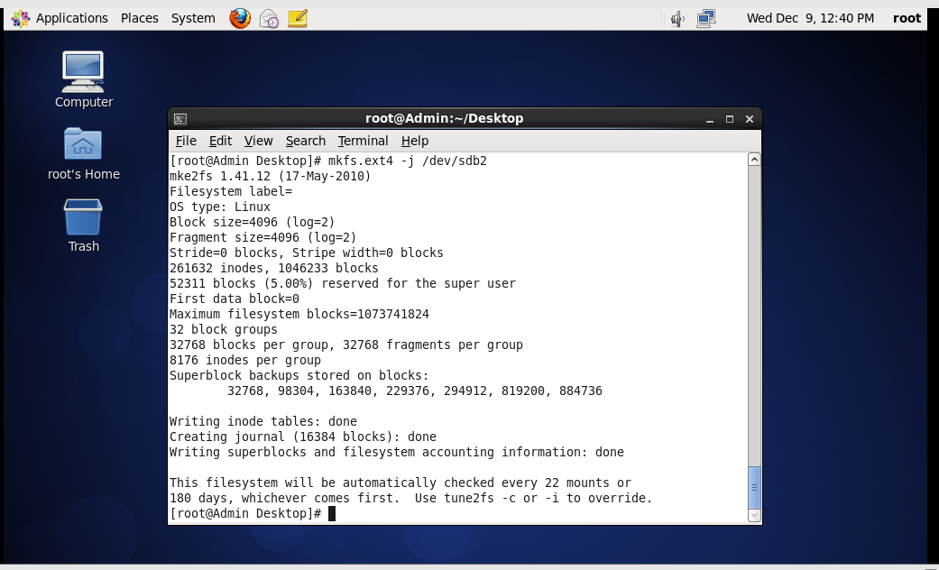

Formatting sdb2 with ext4(4GB) as xfs not supported.

Question 4: Mount 4GB and 6GB with /data and /music respectively.

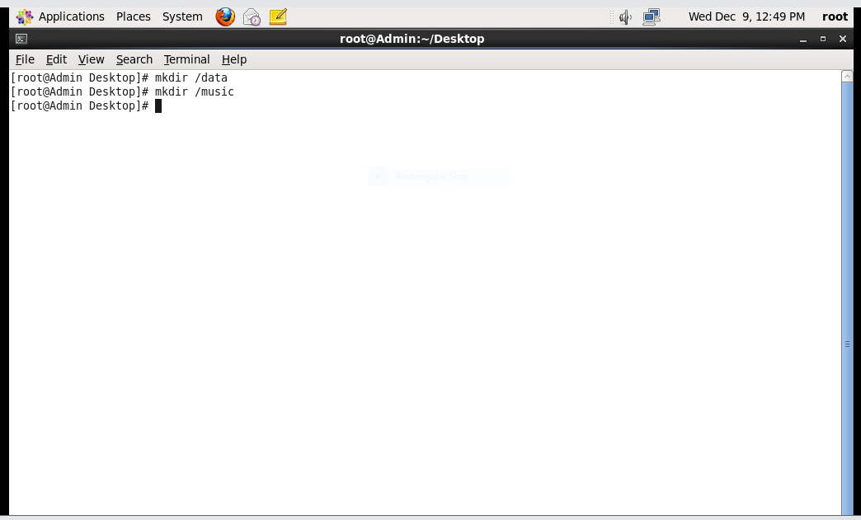

Creating 2 directories for mounting.

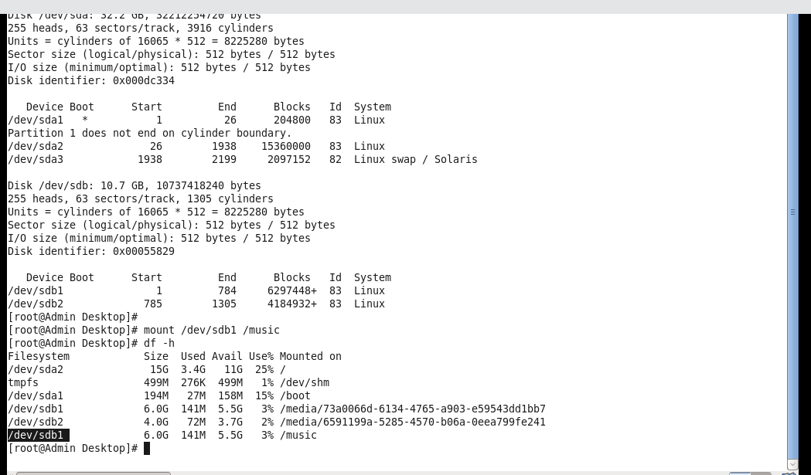

Mounting sdb1(6GB) with /music

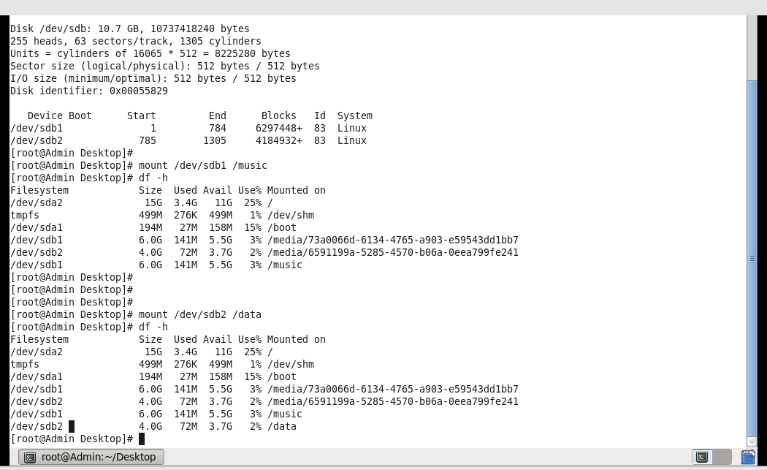

Mounting sdb2(4GB) with /data

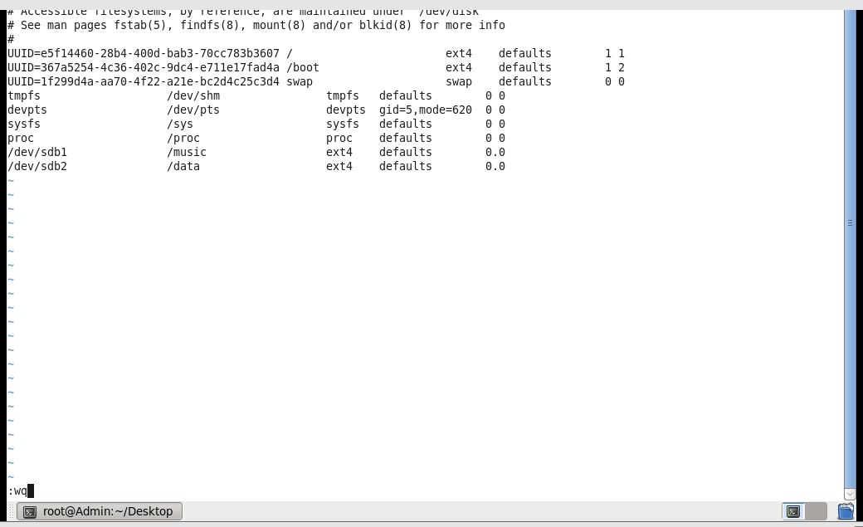

Editing at /etc/fstab to the FS permanently.

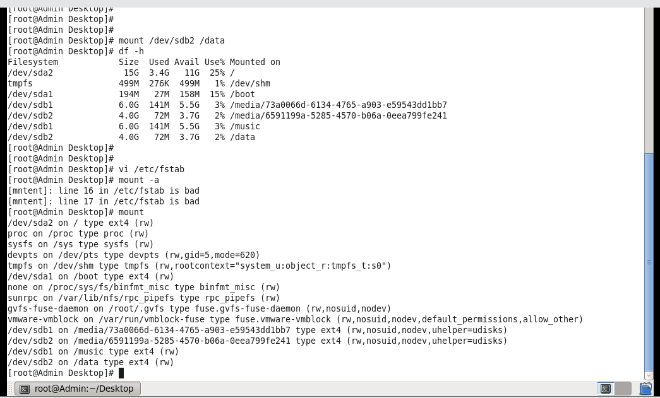

Checking it using mount command

Question 5: Create one file in each of the mount point created

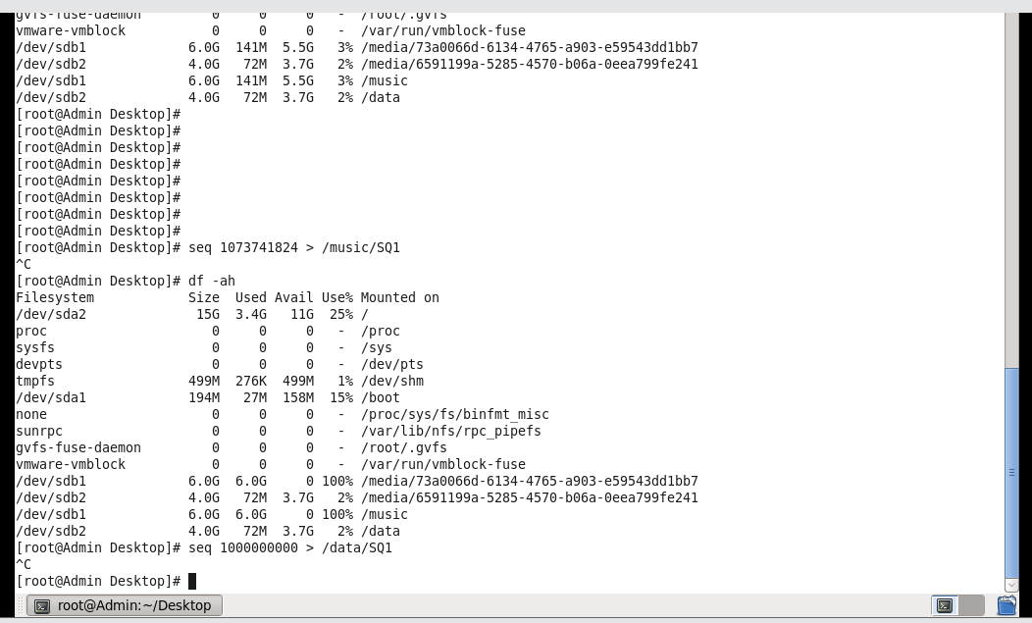

Creating files at /data and /music

Question 6: Verify the disk consumption and the disk space in the mounted partitions

