Question 1: Use “ps” to search for “systemd” process by name.

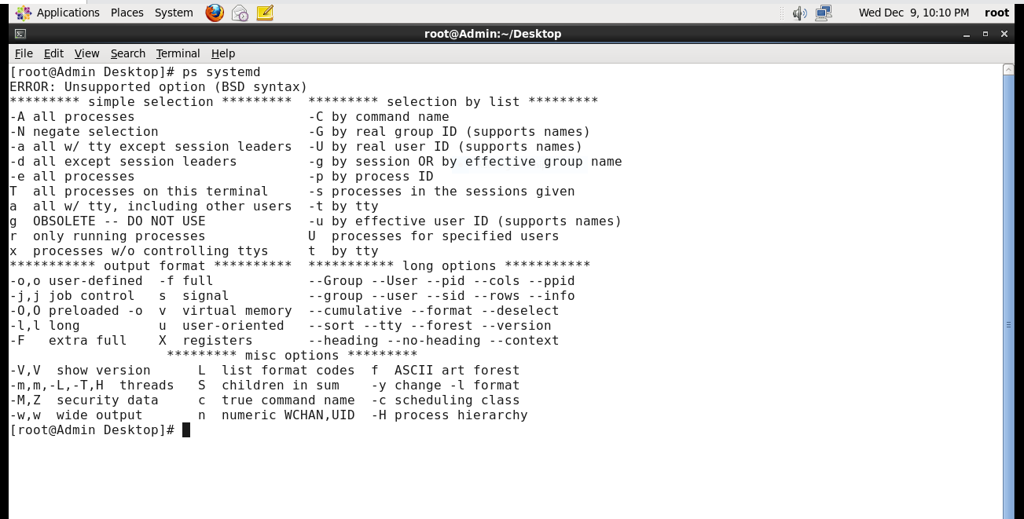

Question 2: Find out your terminal name. Using your terinal name ,use ps to find all processes associated with your terminal.

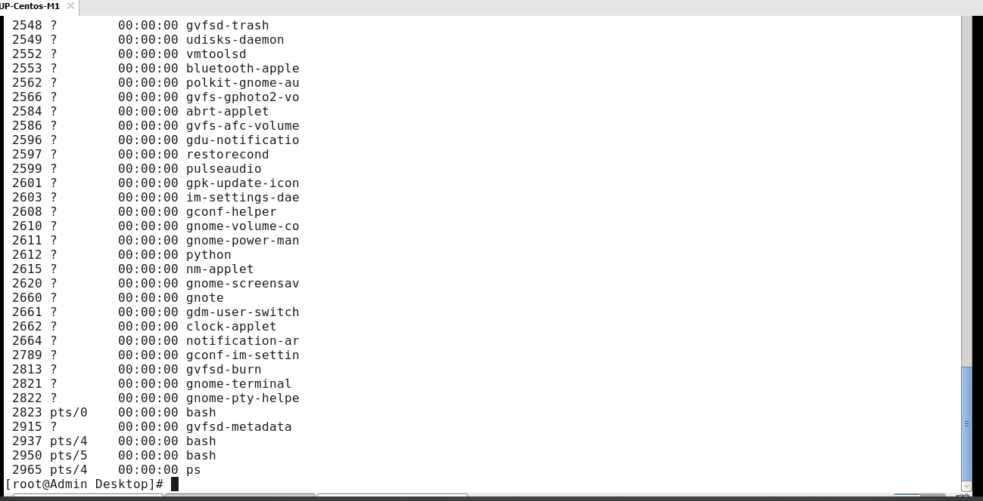

The terminal currently used is pts/4 were ps command is ran

Question 3: Check and note the process id of the shell



The process id of the shell is 2965

Question 4: Start 3 instances of “sleep 123” in the background

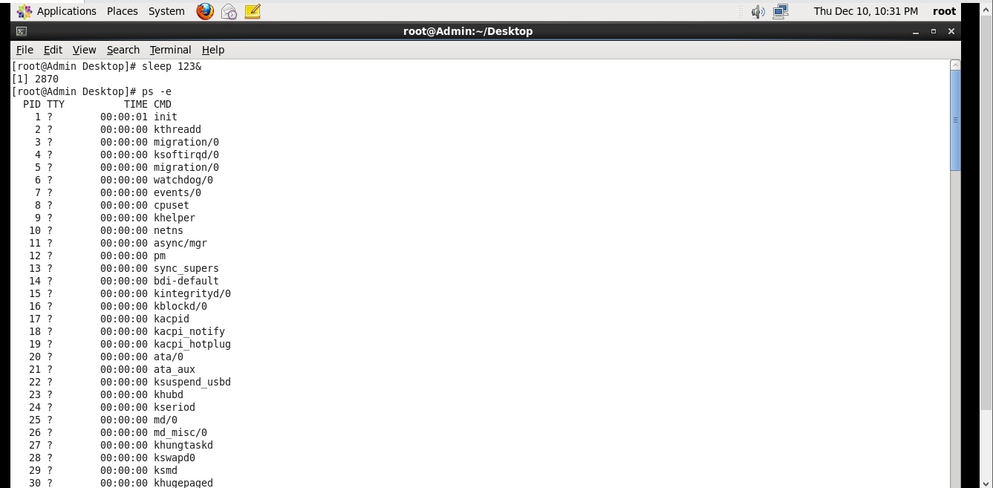

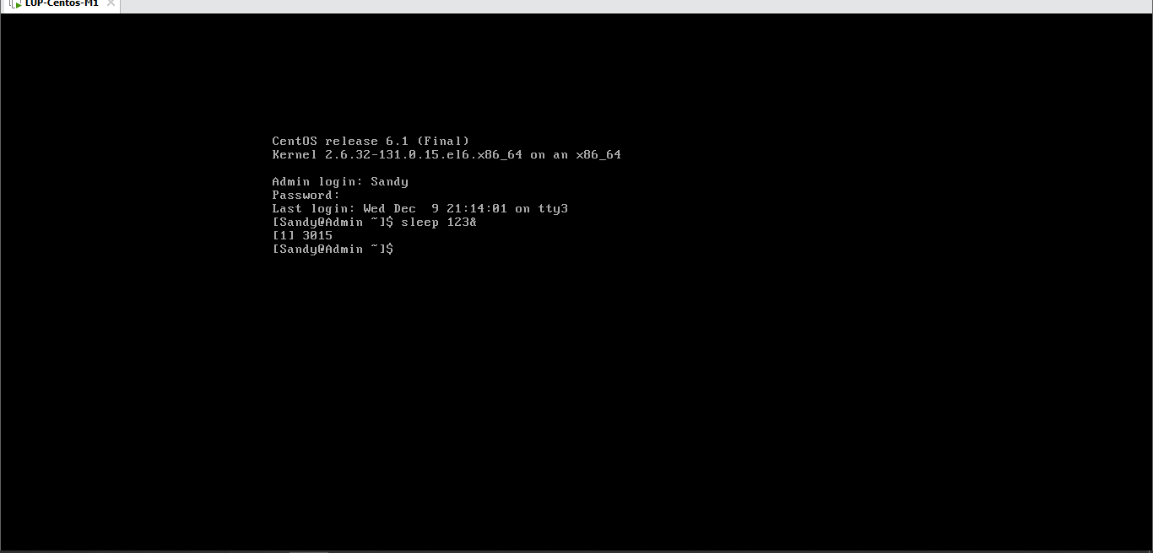

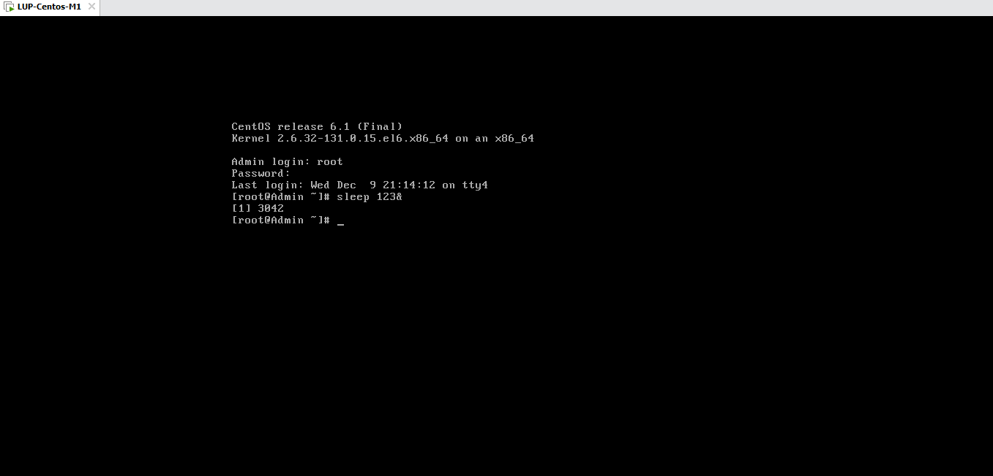

3 sleep process has been started in the background using &.

Question 5: Check and note their process id of all the sleep processes

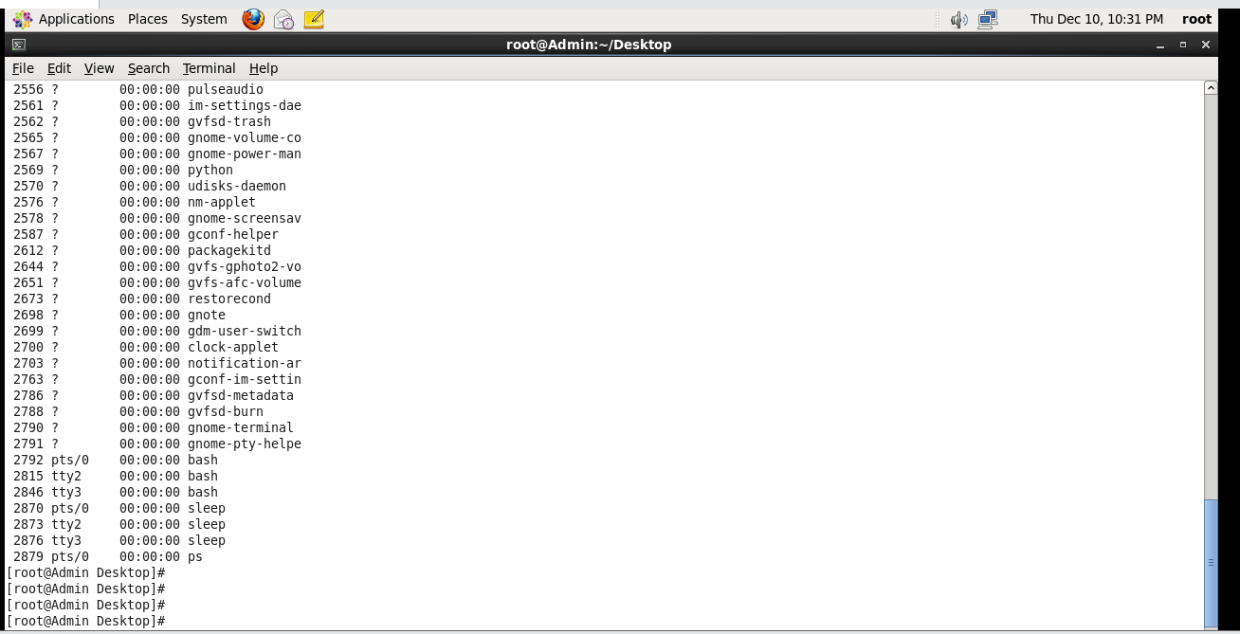

The process id’s of the sleep processes are 2870,2873 and 2879.

Question 6: Display only those 3 sleep processes on top. Then quit top.

