**MEDIA STREAMING WITH IBM CLOUD VIDEO STREAMING**

**PHASE -5 PROJECT**

**PROJECT OBJECTIVE:**

The objective of our movie streaming platform project is to create a comprehensive and user-centric online movie-watching experience that combines an extensive library of high-quality movies with advanced technology and a seamless user interface. This platform aims to meet the following specific goals and objectives:

**Content Library Expansion:**

To curate a diverse and extensive library of movies that encompasses a wide range of genres, languages, and eras, ensuring that users have access to a rich and varied selection of films.

**High-Quality Video Delivery:**

Implement a robust and adaptive streaming infrastructure to ensure that users can enjoy movies in the highest quality possible, with minimal buffering and quick load times, regardless of their internet connection.

**Personalized Recommendations:**

Develop an intelligent recommendation engine that analyzes user behavior and preferences to suggest relevant movies, enhancing content discovery and user engagement.

**User-Friendly Interface:**

Create an intuitive and visually appealing user interface that offers a seamless and enjoyable movie-watching experience on both web and mobile platforms, facilitating easy navigation, content selection, and account management.

**Video Upload Process:**

Establish a streamlined content ingestion process for content providers, including video upload, transcoding, and quality control, to ensure that the platform's content remains up-to-date and of high quality.

**Monetization Strategies:**

Implement flexible monetization models, including subscription-based plans, pay-per-view options, and ad-supported viewing, to cater to a broad audience and generate revenue for platform sustainability.

**Security and Rights Management:**

Ensure the security of content and compliance with copyright and licensing agreements, allowing for content providers to trust the platform with their movies.

**Performance Analytics:**

Implement a robust analytics and reporting system to track user engagement, content performance, and platform usage, using data insights to continually improve the platform.

**Cross-Device Compatibility:**

Guarantee that the platform is accessible and functions smoothly on various devices, enabling users to enjoy movies on their preferred screens.

**Community Engagement:**

Foster a sense of community among users, enabling discussions, reviews, and social features to enhance the overall movie-watching experience.

**Innovative Features:**

Explore and incorporate innovative features and technologies that set the platform apart from competitors and deliver a unique and immersive movie-watching experience.

By pursuing these objectives, our movie streaming platform aims to become a leading destination for movie enthusiasts, offering a dynamic and ever-evolving collection of movies while maintaining a user-centric focus on providing a seamless and immersive experience for viewers across the globe.

**DESIGN THINKING**

**1.DEFINITION:**

Media streaming with IBM Cloud Video Streaming is a multimedia service that enables users to seamlessly access, upload, download, and view video content. This comprehensive platform facilitates the live streaming of videos with exceptional quality, making it a versatile solution for both on-demand and real-time video distribution and consumption.d

**2.USER INTERFACE:**

**Navigation:**

A simple and intuitive menu structure that allows users to easily browse and find content. Use clear labels and icons for navigation.

**Content Thumbnails:**

Display visually appealing thumbnails for movies, TV shows, and other media to help users quickly identify and select what they want to watch.

**Search and Recommendations:**

Implement a robust search feature that allows users to find specific content. Use recommendation algorithms to suggest content based on user preferences.

**Player Controls:**

An user-friendly media player with standard playback controls play, pause, rewind, forward and features like subtitles, quality settings, and audio options.

**User Profiles:**

Allow users to create profiles and customize their viewing experience. This can include personalized watchlists, viewing history, and settings.

**Content Categories:**

Organize content into categories and genres to make it easier for users to discover new content.

**Streaming Quality:**

Provide options for users to select streaming quality to accommodate different internet connections and device capabilities.

**User Feedback:**

Include options for users to rate and review content, as well as report issues or suggest improvements.

**Cross-Platform Compatibility:**

Ensure that the UI work on various devices and screen sizes, including smartphones, tablets, smart TVs, and web browsers.

**Accessibility:**

Make the app accessible to a wide range of users, including those with disabilities.

**Offline Viewing:**

If applicable, offer the ability to download content for offline viewing.

**Subscription and Payment:**

If app includes paid content, integrate a secure payment system and clearly communicate subscription options.

**Security:**

Prioritize the security of user data and payment information.

**Updates and Support:**

Regularly update the app to fix bugs, add new features, and improve performance. Provide customer support channels for users to get assistance if needed.

**3.VIDEO UPLOAD:**

**User Authentication:**

Ensure that users are authenticated before they can upload content. Implement user registration and login features to verify the uploader's identity.

**File Format and Compression:**

Define supported video file formats and compression settings. Common formats include MP4, AVI, and MKV. Implement encoding and compression tools to optimize video files for streaming.

**Upload Interface:**

Create a user-friendly interface for uploading videos. This may include a file picker, drag-and-drop functionality, or integration with cloud storage.

**Metadata and Thumbnails:**

Allow users to add metadata such as title, description, tags, and category to their uploaded videos. Automatically generate or let users upload custom video thumbnails.

**Storage and Hosting:**

Set up a robust storage solution for hosting uploaded videos. Ensure

scalability to handle increasing video content.

**Video Transcoding:**

Transcode uploaded videos into multiple quality levels to support adaptive streaming. This helps optimize playback for different devices and network conditions.

**Privacy and Permissions:**

Define privacy settings for uploaded videos, such as public, private, or restricted to specific users. Implement permission controls to allow or restrict access to content.

**Content Delivery:**

Utilize a CDN to efficiently distribute and deliver video content to users worldwide, reducing latency and ensuring smooth streaming.

**User Notifications:**

Notify users when their video uploads are complete and ready for viewing. Use email notifications.

**Security:**

Implement robust security measures to protect user data, prevent unauthorized access, and secure video content against piracy.

**Testing:**

Thoroughly test the video upload process to identify and fix any issues, such as upload failures or playback problems.

**4.STREAMING INTEGRATION:**

**Video Players:**

Integrate video players that support the chosen streaming protocol on your web or mobile applications. Examples include Video.js, JW Player, and Shaka Player.

**5.USER EXPERIENCE:**

**Accessibility:**

Cloud video streaming makes content accessible from anywhere with an internet connection. Users can watch videos on various devices, including smartphones, tablets, smart TVs, and computers.

**Quality:**

Cloud streaming services often offer high-quality video and audio, with the ability to stream in HD, 4K, or even higher resolutions. This enhances the viewing experience for users with compatible devices and internet connections.

**Scalability:**

Cloud streaming services can easily scale to accommodate high traffic loads. This means that even during peak usage times, users are less likely to experience buffering or downtime.

**Content Variety:**

Streaming platforms offer a wide range of content, from movies and TV shows to live sports and events. Users can choose from a vast library of option preferences.

**Convenience:**

Users can start watching content instantly without the need to download files. This convenience is especially appreciated when users want to watch something spontaneously.

**Offline Viewing:**

Some streaming platforms allow users to download content for offline viewing, which is beneficial for those with limited internet access or when traveling.

**FEATURES:**

Incorporating user-generated playlists and real-time chat can indeed enhance the movie-watching experience by promoting interactivity and social engagement. Here are some ideas on how to implement these features:

**User-Generated Playlists:**

* **Playlist Creation:** Allow users to create and share playlists of movies or TV shows. Users can curate their collections based on themes, genres, or moods.
* **Collaborative Playlists:** Enable users to collaborate on playlists, so they can collectively build lists for movie nights or themed marathons with friends.
* **Recommendation Engine:** Implement a recommendation engine that suggests movies to add to a playlist based on a user's viewing history and preferences.

**Real-Time Chat:**

* **Live Chatrooms:** Create chatrooms for each movie or show where users can join and discuss the content as they watch it simultaneously. This provides a sense of community and shared experience.
* **Emoji and Reactions**: Allow users to send emojis, reactions, or comments about specific scenes in the movie to express their emotions.
* **Moderation Tools:** Implement moderation tools to ensure a safe and respectful environment for users to interact. Users should be able to report inappropriate behavior.

**DEVELOPMENT PHASES**

The development of a video streaming application in IBM Cloud computing typically involves several phases. These phases help ensure a well-structured and functional streaming solution. Here are the key development phases for video streaming in IBM Cloud:

**Planning and Requirements Gathering:**

* Define the purpose and goals of your video streaming application.
* Gather requirements related to content, audience, quality, scalability, and security.
* Decide on the target platforms and devices for streaming.

**Design and Architecture:**

* Create an architectural plan for your streaming application.
* Determine the necessary components, such as servers, storage, encoding, transcoding, and content delivery.
* Plan for redundancy, load balancing, and failover to ensure high availability.
* Design the user interface (if applicable) for the streaming platform.

**Content Creation and Preparation:**

* Create or gather the video content you intend to stream.
* Ensure that the content meets the required formats and quality standards.
* Set up video encoding profiles for different resolutions and bitrates.

**IBM Cloud Setup:**

* Sign up for an IBM Cloud account if you don't already have one.
* Provision the required IBM Cloud services, such as IBM Video Streaming (formerly Ustream) or other relevant services based on your design and architectural plan.

**Application Development:**

* Develop or configure the streaming application, which may include front-end components for users and back-end components to manage streams and users.
* Integrate the IBM Cloud video streaming services into your application using relevant SDKs or APIs.
* Implement user authentication and authorization mechanisms if needed.

**Video Encoding and Transcoding:**

* Set up video encoding and transcoding pipelines to prepare the content for streaming.
* Configure encoding parameters based on your target audience's devices and bandwidth.
* Implement adaptive streaming for different quality levels.

**Security Implementation:**

* Implement security measures to protect your video streams.
* Set up access controls, authentication, and encryption to safeguard your content.
* Consider implementing digital rights management (DRM) for content protection if necessary.

**Testing and Quality Assurance:**

* Perform thorough testing of your video streaming application, including functional, performance, and security testing.
* Test the application on various devices, browsers, and network conditions to ensure compatibility.
* Address any issues or bugs that arise during testing.

**Content Delivery and Distribution:**

* Implement a content delivery network (CDN) to ensure efficient and reliable content distribution to viewers.
* Configure the CDN for optimal content delivery and global reach.

**Monitoring and Analytics:**

* Set up monitoring and analytics tools to track the performance of your streaming application.
* Collect data on viewer engagement, streaming quality, and other relevant metrics.
* Use insights from analytics to improve your streaming service.

**Launch and Deployment:**

* Deploy your video streaming application to the production environment.
* Make your application accessible to users and begin streaming content.

**Maintenance and Scaling:**

* Continuously monitor and maintain your streaming service to ensure it performs optimally.
* Plan for scalability to accommodate increasing viewer numbers or content.

**User Support and Updates:**

* Provide user support for any issues or inquiries.
* Regularly update your application to add new features, improve performance, and address security vulnerabilities.

**Content Management:**

* Manage your video content, including uploading, archiving, and categorizing videos.
* Consider implementing content moderation and filtering if user-generated content is part of your platform.

**Compliance and Regulations:**

* Ensure that your streaming service complies with relevant regulations, such as copyright laws and data protection regulations.

These phases provide a structured approach to developing a video streaming application in IBM Cloud computing. It's essential to adapt these phases to your specific project requirements and continuously iterate and improve your streaming service to meet the evolving needs of your user.

**VIDEO WATCHING EXPERIENCE:**

A seamless and immersive movie-watching experience in video streaming is achieved through the integration of various technological and user experience elements that enhance the quality, convenience, and engagement of the viewer. Here's how our platform can provide such an experience:

**High-Quality Streaming:**

High-Resolution Video: The platform should support high-definition (HD) and, ideally, 4K video streaming to ensure that viewers can enjoy sharp, detailed visuals.

Adaptive Bitrate Streaming: The platform should use adaptive streaming technology to adjust the video quality in real-time based on the viewer's internet connection, ensuring a smooth playback experience.

**User-Friendly Interface:**

Easy Navigation: A user-friendly interface with intuitive menus and search functionality allows users to easily find the content they want to watch.

Personalization: The platform should offer personalized recommendations based on a user's viewing history, preferences, and ratings, helping users discover new content.

**High-Quality Audio:**

Surround Sound: Support for surround sound formats like Dolby Atmos or DTS:X can provide a cinematic audio experience.

Audio Customization: Allowing users to adjust audio settings, such as volume and equalization, can enhance the experience.

**Streaming Quality Control:**

Streaming Resolution Selection: Allowing users to manually select the streaming quality helps those with limited data plans or slower internet connections.

**PROCESS OF PROJECT:**

**IBM Watson studio:**

Creating a channel in IBM Watson

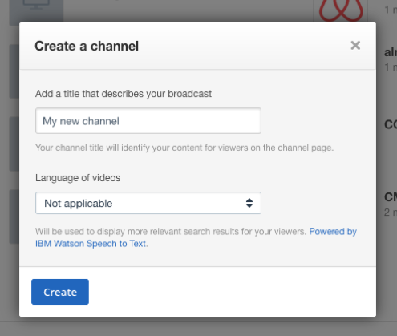

Uploading videos:

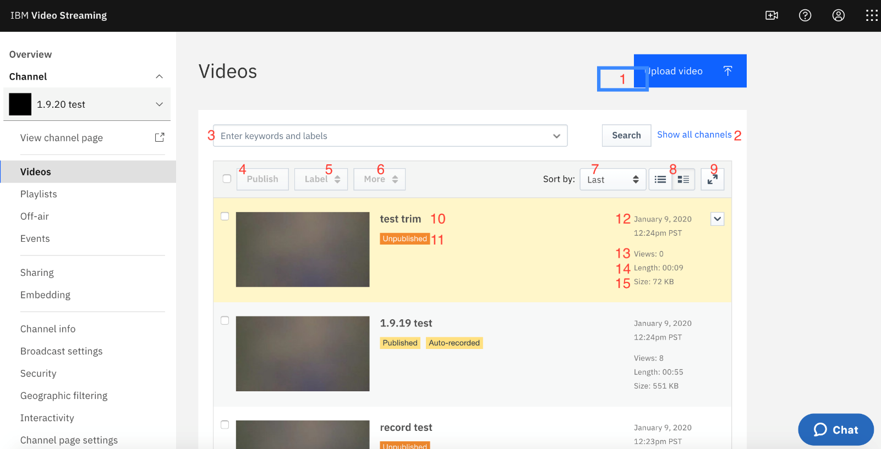

OUTPUT OF VIDEO STREAMING:

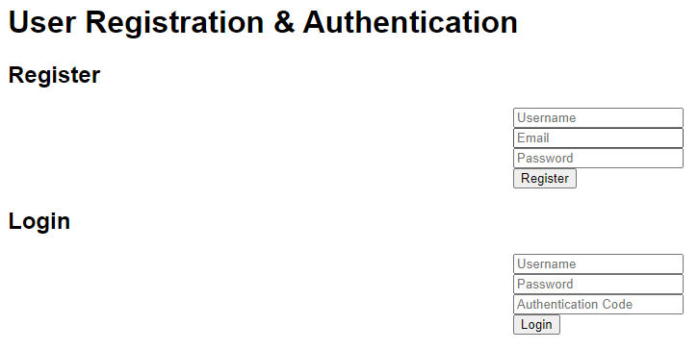

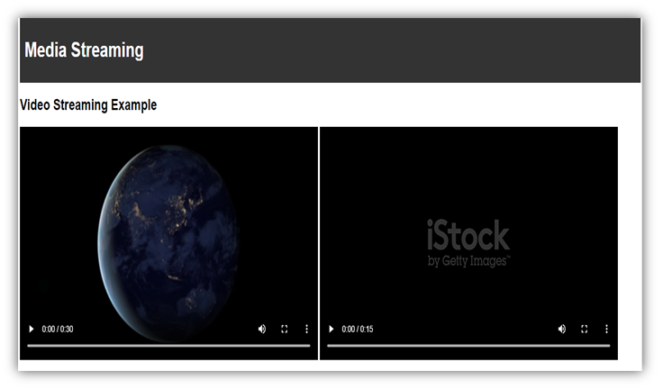

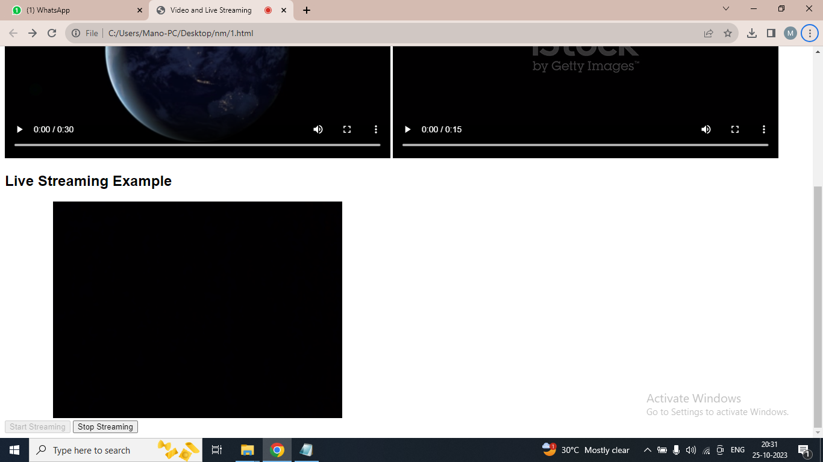

**BROADCASTING:**

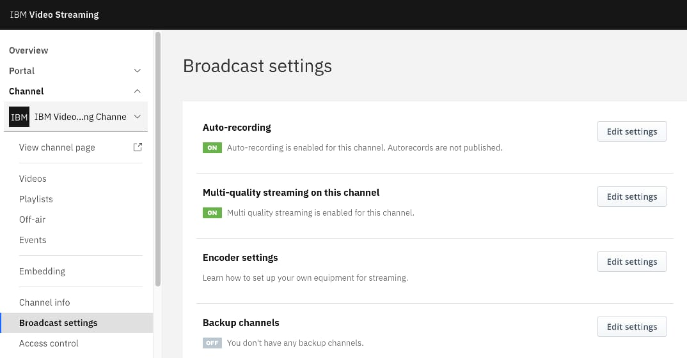

**CREATING** **PLAYLIST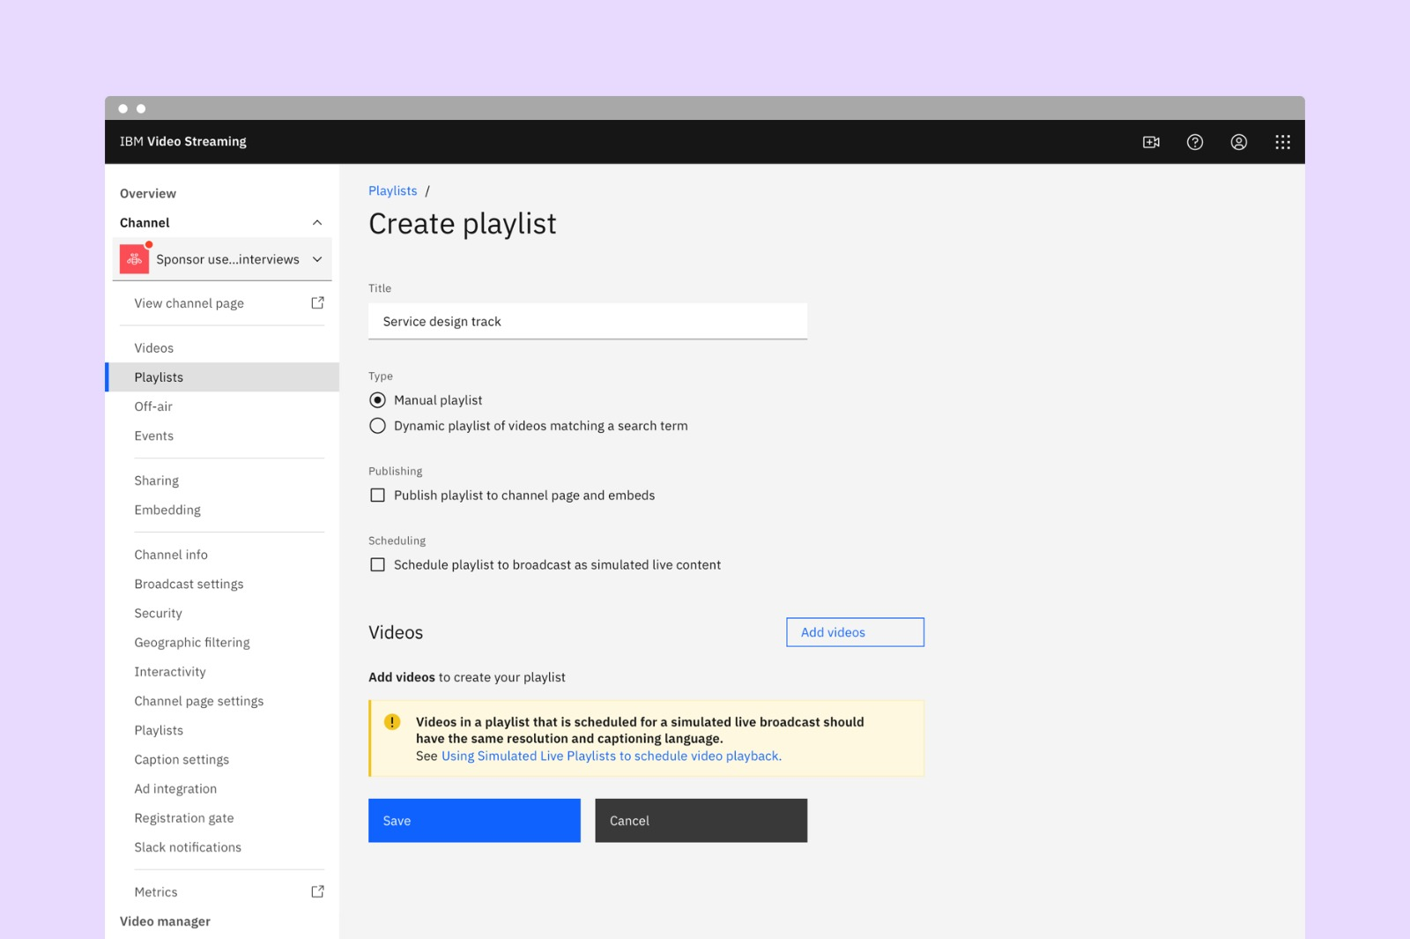**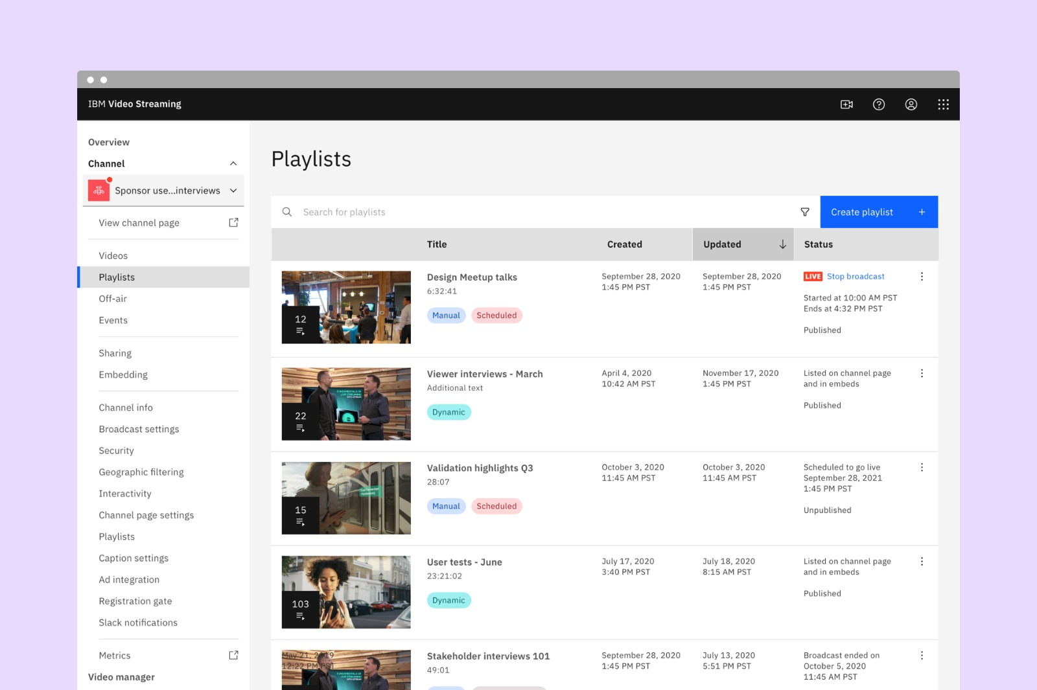

**STREAM SETUP:**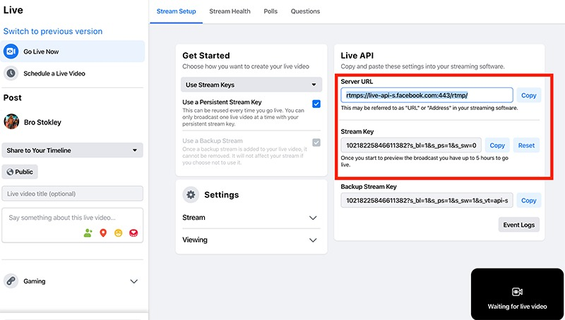

**VIDEO ENGAGEMENT:**

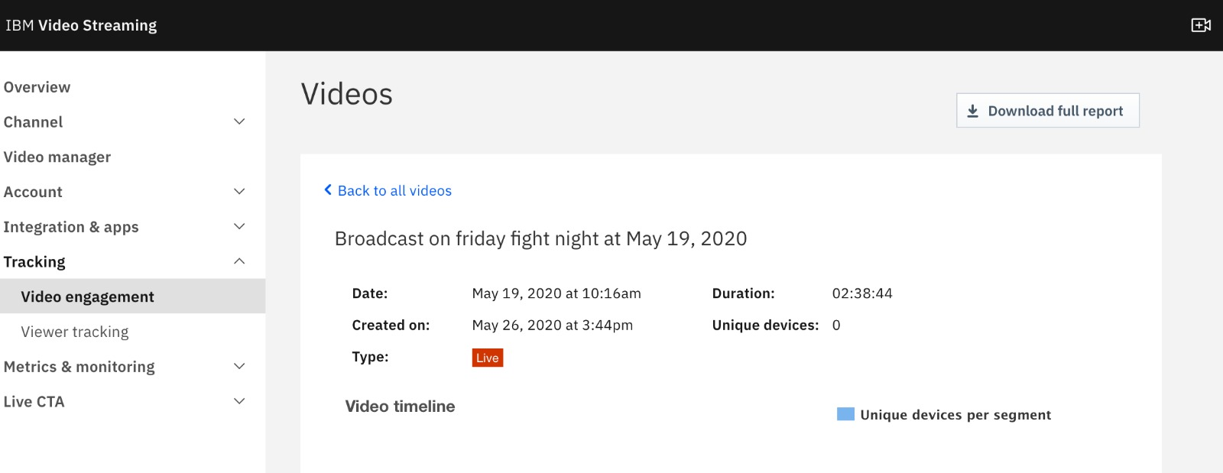

**LIVE MONITORING:**

