16.

Program:

%{

int nchar, nword, nline;

%}

%%

\n { nline++; nchar++; }

[^ \t\n]+ { nword++, nchar += yyleng; }

. { nchar++; }

%%

int yywrap(void) {

return 1;

}

int main(int argc, char *argv[]) {

yyin = fopen(argv[1], "r");

yylex();

printf("Number of characters = %d\n", nchar);

printf("Number of words = %d\n", nword);

printf("Number of lines = %d\n", nline);

fclose(yyin);

}

Input file:

 #include <stdio.h>

 int main()

 {

      int number1, number2, sum;

 printf("Enter two integers: ");

 scanf("%d %d", &number1, &number2);

 sum = number1 + number2;

      printf("%d + %d = %d", number1, number2, sum);

  return 0;

 }

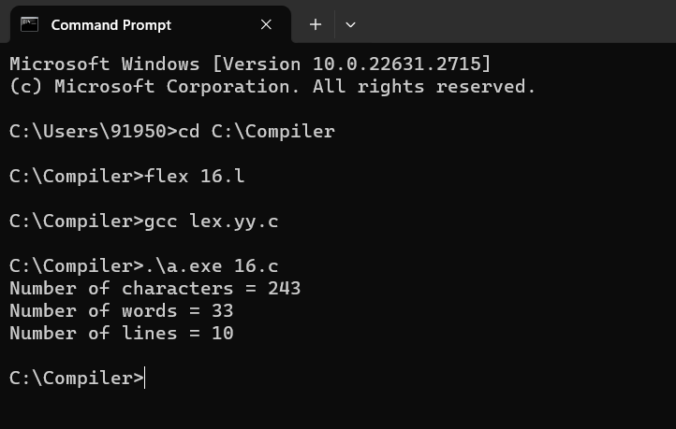

17.

Program:

digit [0-9]

%{

int cons=0;

%}

%%

{digit}+ { cons++; printf("%s is a constant\n", yytext); }

.|\n { }

%%

int yywrap(void) {

return 1; }

int main(void)

{

FILE *f;

char file[10];

printf("Enter File Name : ");

scanf("%s",file);

f = fopen(file,"r");

yyin = f;

yylex();

printf("Number of Constants : %d\n", cons);

fclose(yyin);

}

Input file:

#define P 314

#include<stdio.h> #include<conio.h>

 void main()

{

            int a,b,c = 30;

printf("hello");

}

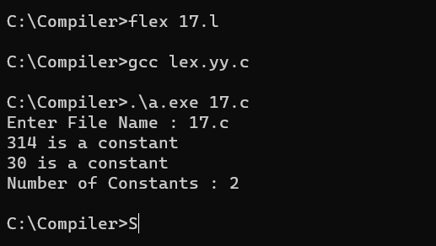

18.

Program:

%{

int nmacro, nheader;

%}

%%

^#define { nmacro++; }

^#include { nheader++; }

.|\n { }

%%

int yywrap(void) {

return 1;

}

int main(int argc, char *argv[]) {

yyin = fopen(argv[1], "r");

yylex();

printf("Number of macros defined = %d\n", nmacro);

printf("Number of header files included = %d\n", nheader);

fclose(yyin);

}

Input file:

#define PI 3.14

#include<stdio.h>

#include<conio.h>

 void main()

{

int a,b,c = 30;

printf("hello");

}

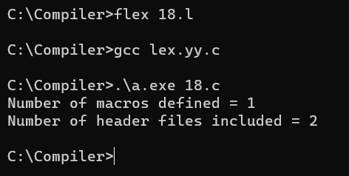

19.

Program:

%{

int tags;

%}

%%

"<"[^>]*> { tags++; printf("%s \n", yytext); }

.|\n { }

%%

int yywrap(void) {

return 1; }

int main(void)

{

FILE *f;

char file[10];

printf("Enter File Name : ");

scanf("%s",file);

f = fopen(file,"r");

yyin = f;

yylex();

printf("\n Number of html tags: %d",tags);

fclose(yyin);

}

Input file:

<html>

<body>

<h1>My First Heading</h1>

<p>My first paragraph.</p>

</body>

</html>

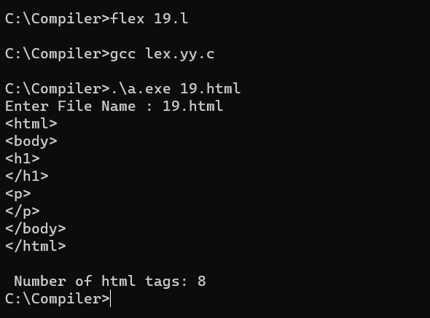

20.

Program:

%{

int yylineno;

%}

%%

^(.*)\n printf("%4d\t%s", ++yylineno, yytext);

%%

int yywrap(void) {

return 1;

}

int main(int argc, char *argv[]) {

yyin = fopen(argv[1], "r");

yylex();

fclose(yyin);

}

Input file:

#define PI 3.14

#include<stdio.h>

#include<conio.h>

   void main()

{

int a,b,c = 30;

printf("hello");

}

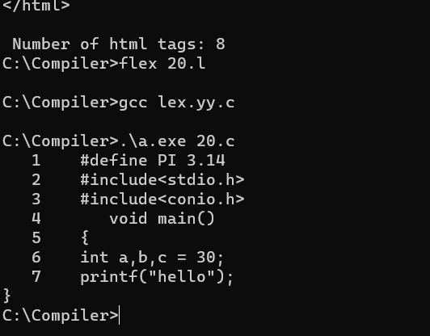

21.

Program:

%{

int nchar, nword, nline;

%}

%%

\n { nline++; nchar++; }

[^ \t\n]+ { nword++, nchar += yyleng; }

. { nchar++; }

%%

int yywrap(void) {

return 1;

}

int main(int argc, char *argv[]) {

yyin = fopen(argv[1], "r");

yylex();

printf("Number of characters = %d\n", nchar);

printf("Number of words = %d\n", nword);

printf("Number of lines = %d\n", nline);

fclose(yyin);

}

Input file:

 #include <stdio.h>

 int main()

 {

      int number1, number2, sum;

 printf("Enter two integers: ");

 scanf("%d %d", &number1, &number2);

 sum = number1 + number2;

      printf("%d + %d = %d", number1, number2, sum);

  return 0;

 }

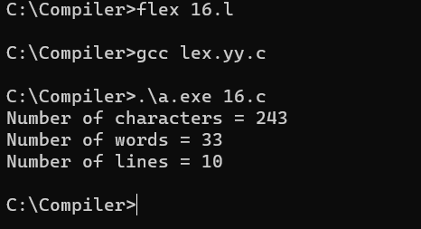

22.

Program:

%{

int com=0;

%}

%s COMMENT

%%

"/*" {BEGIN COMMENT;}

<COMMENT>"*/" {BEGIN 0; com++;}

<COMMENT>\n {com++;}

<COMMENT>. {;}

\/\/.* {; com++;}

.|\n {fprintf(yyout,"%s",yytext);}

%%

void main(int argc, char *argv[])

{

if(argc!=3)

{

printf("usage : a.exe input.c output.c\n");

exit(0);

}

yyin=fopen(argv[1],"r");

yyout=fopen(argv[2],"w");

yylex();

printf("\n number of comments are = %d\n",com);

}

int yywrap()

{

return 1;

}

Input file:

#include<stdio.h>

int main()

{

int a,b,c;

printf(“enter two numbers”); scanf(“%d %d”,&a,&b); c=a+b;//adding two numbers printf(“sum is %d”,c);

return 0;

}

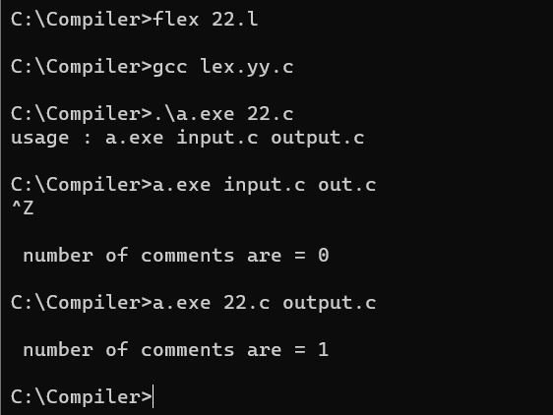

23.

Program:

%%

[A-Z]+[\t\n ] { printf("%s is a capital word\n",yytext); }

. ;

%%

int main( )

{

printf("Enter String :\n");

yylex();

}

int yywrap( )

{

return 1;

}

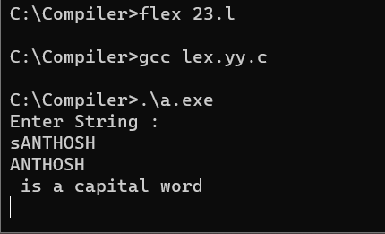

24.

Program:

%{

int flag=0;

%}

%%

[a-z . 0-9]+@[a-z]+".com"|".in" { flag=1; }

%%

int main()

{

yylex();

if(flag==1)

printf("Accepted");

else

printf("Not Accepted");

}

int yywrap()

{

return 1;

}

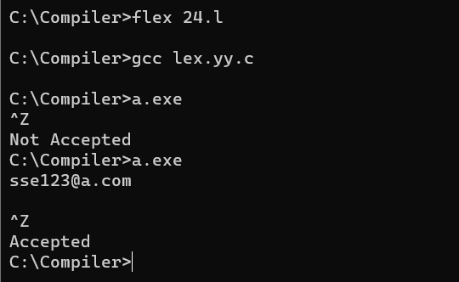

25.

Program

%{

int i;

%}

%%

[a-z A-Z]* { for(i=0;i<=yyleng;i++)

{ if((yytext[i]=='a')&&(yytext[i+1]=='b')&&(yytext[i+2]=='c'))

{ yytext[i]='A';

yytext[i+1]='B';

yytext[i+2]='C';

}

}

printf("%s",yytext);

}

[\t]* return 1;

.* {ECHO;}

\n {printf("%s",yytext);}

%%

int main()

{

yylex();

}

int yywrap()

{

return 1;

}

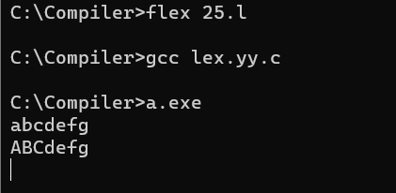

26.

Program:

%%

[1-9][0-9]{9} {printf("\nMobile Number Valid\n");}

.+ {printf("\nMobile Number Invalid\n");}

%%

int main()

{

printf("\nEnter Mobile Number : ");

yylex();

printf("\n");

return 0;

}

int yywrap()

{ }

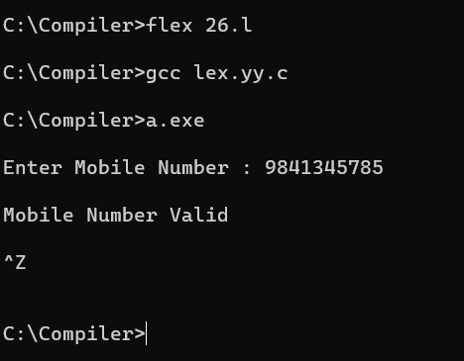

27.

Program:

digit [0-9]

letter [A-Za-z]

%{

int count_id,count_key;

%}

%%

(stdio.h|conio.h) { printf("%s is a standard library\n",yytext); }

(include|void|main|printf|int) { printf("%s is a keyword\n",yytext); count_key++; }

{letter}({letter}|{digit})* { printf("%s is a identifier\n", yytext); count_id++; }

{digit}+ { printf("%s is a number\n", yytext); }

\"(\\.|[^"\\])*\" { printf("%s is a string literal\n", yytext); }

.|\n { }

%%

int yywrap(void) {

return 1;

}

int main(int argc, char *argv[]) {

yyin = fopen(argv[1], "r");

yylex();

printf("number of identifiers = %d\n", count_id);

printf("number of keywords = %d\n", count_key);

fclose(yyin);

}

Input file:

#include<stdio.h>

void main()

{

int a,b,c = 30;

printf("hello");

}

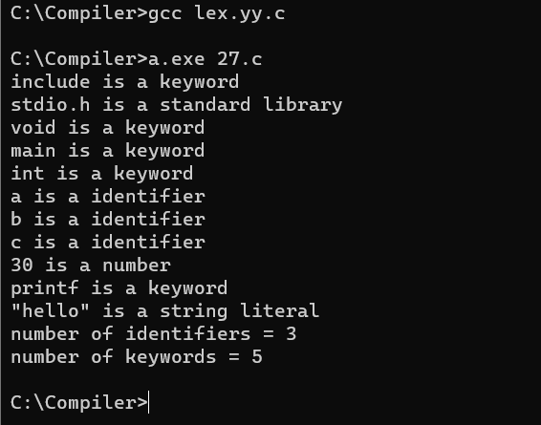

28.

Program:

%{

int vow_count=0;

int const_count =0;

%}

%%

[aeiouAEIOU] {vow_count++;}

[a-zA-Z] {const_count++;}

%%

int yywrap(){}

int main()

{

printf("Enter the string of vowels and consonants:");

yylex();

printf("Number of vowels are: %d\n", vow_count);

printf("Number of consonants are: %d\n", const_count);

return 0;

}

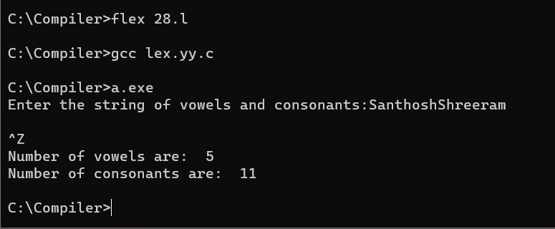

29.

Program:

digit [0-9]

letter [A-Za-z]

%{

int count_id,count_key;

%}

%%

(stdio.h|conio.h) { printf("%s is a standard library\n",yytext); }

(include|void|main|printf|int) { printf("%s is a keyword\n",yytext); count_key++; }

{letter}({letter}|{digit})* { printf("%s is a identifier\n", yytext); count_id++; }

{digit}+ { printf("%s is a number\n", yytext); }

\"(\\.|[^"\\])*\" { printf("%s is a string literal\n", yytext); }

.|\n { }

%%

int yywrap(void) {

return 1;

}

int main(int argc, char *argv[]) {

yyin = fopen(argv[1], "r");

yylex();

printf("number of identifiers = %d\n", count_id);

printf("number of keywords = %d\n", count_key);

fclose(yyin);

}

Input file:

#include<stdio.h>

void main()

{

int a,b,c = 30;

printf("hello");

}



30.

Program:

%{

#include<stdio.h>

#include<stdlib.h>

#include<string.h>

%}

%option noyywrap

%%

[0-9]+ {

printf("Number: %s\n", yytext);

}

[a-zA-Z]+ {

printf("Word: %s\n", yytext);

}

%%

int main() {

yylex();

return 0;

}

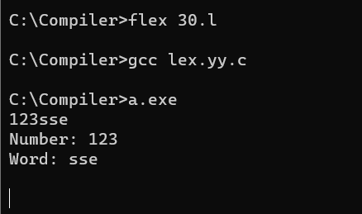

31.

Program:

%{

int positive_no = 0, negative_no = 0;

%}

%%

^[-][0-9]+ {negative_no++;

printf("negative number = %s\n",

yytext);} // negative number

[0-9]+ {positive_no++;

printf("positive number = %s\n",

yytext);} // positive number

%%

int yywrap(){}

int main()

{

yylex();

printf ("number of positive numbers = %d,"

"number of negative numbers = %d\n",

positive_no, negative_no);

return 0;

}

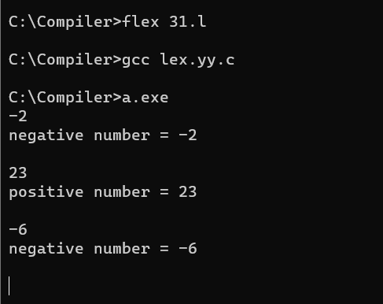

32.

Program:

%%

((http)|(ftp))s?:\/\/[a-zA-Z0-9](.[a-z])+(.[a-zA-Z0-9+=?]*)* {printf("\nURL Valid\n");}

.+ {printf("\nURL Invalid\n");}

%%

void main()

{

printf("\nEnter URL : ");

yylex();

printf("\n");

}

int yywrap()

{

}

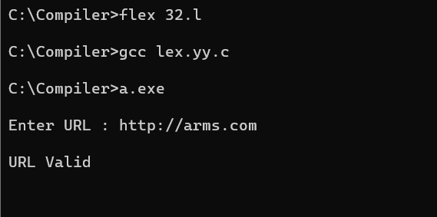

33.

Program:

%%

((0[1-9])|([1-2][0-9])|(3[0-1]))\/((0[1-9])|(1[0-2]))\/(19[0-9]{2}|2[0-9]{3}) printf("Valid DoB");

.* printf("Invalid DoB");

%%

int main()

{

yylex();

return 0;

}

int yywrap()

{}

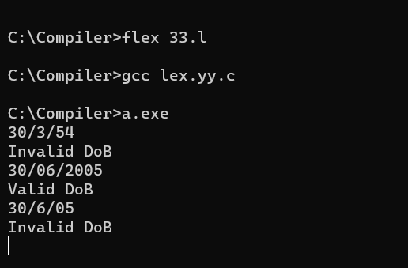

34.

Program:

%%

[0-9]+ {printf("\nValid digit \n");}

.* printf("\nInvalid digit\n");

%%

int yywrap(){}

int main()

{

yylex();

return 0;

}

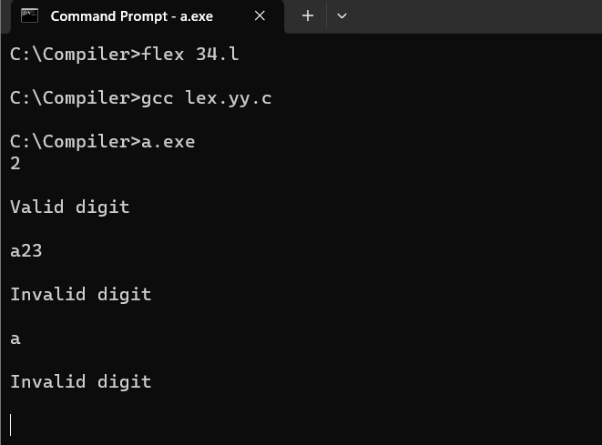

35.

Program:

%{

#undef yywrap

#define yywrap() 1

int f1=0,f2=0;

char oper;

float op1=0,op2=0,ans=0;

void eval();

%}

DIGIT [0-9]

NUM {DIGIT}+(\.{DIGIT}+)?

OP [*/+-]

%%

{NUM} {

if(f1==0)

{

op1=atof(yytext);

f1=1;

}

else if(f2==-1)

{

op2=atof(yytext);

f2=1;

}

if((f1==1) && (f2==1))

{

eval();

f1=0;

f2=0;

}

}

{OP} {

oper=(char) *yytext;

f2=-1;

}

[\n] {

if(f1==1 && f2==1)

{

eval;

f1=0;

f2=0;

}

}

%%

int main()

{

yylex();

}

void eval()

{

switch(oper)

{

case '+':

ans=op1+op2;

break;

case '-':

ans=op1-op2;

break;

case '*':

ans=op1*op2;

break;

case '/':

if(op2==0)

{

printf("ERROR");

return;

}

else

{

ans=op1/op2;

}

break;

default:

printf("operation not available");

break;

}

printf("The answer is = %lf",ans);

}

