Automated University Examination and Class Timetable Scheduling Using Constraint-Based Search and Optimization
Mrs B.DEEPA
COMPUTER SCIENCE AND ENGINEERING
RAJALAKSHMI ENGINEERING COLLEGE
CHENNAI, INDIA
deepa.b@rajalakshmi.edu.in

SANTHOSH G  COMPUTER SCIENCE AND ENGINEERING  RAJALAKSHMI ENGINEERING COLLEGE  CHENNAI, INDIA  santhosh.g.2024.cse@rajalakshmi.edu.in | ROHITH D  COMPUTER SCIENCE AND ENGINEERING  RAJALAKSHMI ENGINEERING COLLEGE  CHENNAI, INDIA  rohith.d.2024.cse@rajalakshmi.edu.in

Abstract—University timetable construction is a constrained assignment problem involving academic activities, rooms, faculty, student groups, and time slots. Manual planning becomes difficult when overlapping requirements must be satisfied and separately prepared examination and class schedules must later be reconciled. This paper describes an Automated University Examination and Class Timetable Scheduler using backtracking search guided by the Minimum Remaining Values (MRV) heuristic and forward checking. Simulated annealing is considered as an improvement stage for reducing soft-constraint penalties. A web application built with Python and Flask, with an HTML, CSS, and JavaScript interface, supports examination scheduling, class scheduling, student-specific timetable views, merged conflict detection, and algorithm statistics. The paper formalizes the problem, describes the system architecture and workflow, and proposes a validation plan. Since verified benchmark outputs were not supplied, no measured performance claims are made; results must be collected from the final implementation.
Keywords—university timetabling, constraint satisfaction, backtracking, minimum remaining values, forward checking, simulated annealing, conflict detection.

- Introduction
Academic timetabling assigns courses and examinations to time slots and rooms while respecting shared resources and cohort requirements. A room cannot host two activities simultaneously, and a faculty member or student group should not be assigned overlapping activities. Practical systems may also account for availability, room suitability, and institutional preferences. The problem is combinatorial: a locally acceptable assignment may block later activities, and separately generated schedules may conflict when merged. Constraint satisfaction provides a useful representation. Activities become variables, candidate room-time assignments become domains, and rules constrain combinations of values. Backtracking explores assignments; MRV prioritizes the most constrained unassigned activity; forward checking removes values made impossible by each new assignment. Local-search optimization can then reduce preference penalties when a feasible candidate exists [1]–[4]. This project combines schedule generation with a web interface and a final conflict-validation stage. Its contribution is an application-oriented formulation and validation plan rather than a claim of a new search algorithm. The paper distinguishes intended capabilities, algorithmic expectations, and evidence that must be collected from running software.
- LITERATURE SURVEY
Constraint-based approaches have been applied to university and examination timetabling for decades. Dechter describes general constraint-satisfaction problem (CSP) models and algorithms, including variable ordering and constraint propagation [1]. Russell and Norvig present backtracking and heuristic search as core artificial-intelligence problem-solving methods [2]. MRV, also called the fail-first principle, attempts difficult decisions early, while forward checking prunes neighboring domains after assignments [1], [2]. Burke and Petrovic survey research directions in automated timetabling, and Schaerf reviews automated school and university timetabling, noting that constraints vary across institutions [3], [4]. Carter et al. and Qu et al. review examination timetabling methods and practical concerns [5], [6].
Local-search methods are useful when the solution space is large and competing preferences must be balanced. Kirkpatrick et al. introduced simulated annealing as an optimization method inspired by physical annealing [7]. It evaluates neighboring schedules and may temporarily accept worse moves to escape local minima. Related work studies local search and simulated-annealing hyper-heuristics for course timetabling [8], [9]. These studies motivate annealing as an optional improvement stage, but do not prove that a particular parameter setting is effective for this project. Constraint-based reasoning and hybrid methods have also been applied to university and examination scheduling [10]– [13]. Standardized benchmark instances support reproducible comparisons, although public datasets may not represent every institution’s rules. The scheduler described here emphasizes integration: generating examination and class schedules, providing student-specific views, and validating the merged result.
- Constraint Satisfaction Problems
Constraint Satisfaction Problems provide a general representation for tasks involving variables, domains, and constraints. A solution assigns a value to every required variable while satisfying all constraints. Timetabling is a natural CSP application because each activity must be assigned a time and often a room, while student, room, and staff conflicts restrict combinations. Russell and Norvig provide a foundational treatment of CSPs and search strategies [1].
- Examination Timetabling
Examination timetabling has been studied as a practical optimization problem for decades. Schaerf surveys automated timetabling methods and discusses the range of approaches used for educational scheduling [2]. Carter's survey of practical examination timetabling emphasizes the constraints and operational considerations that shape real university problems [3]. Carter and Laporte review developments in practical examination scheduling [4]. These works motivate evaluating not only whether a timetable exists, but also whether it satisfies institutional constraints and provides acceptable quality.
- Heuristics and Local Search
MRV is a variable-ordering heuristic designed to select the most constrained variable first. Forward checking reduces future domains after each assignment. Simulated annealing, introduced as an optimization method by Kirkpatrick, Gelatt, and Vecchi [8], explores candidate solutions using a temperature-dependent acceptance rule. These techniques serve different purposes: CSP search aims to maintain feasibility, while local search can improve a numerical objective. The project combines these roles but must independently validate hard constraints.
D. Research Gap and Project Positioning
This project does not propose a new CSP algorithm or claim that simulated annealing is new. Its contribution is an applied web implementation integrating examination scheduling, class scheduling, student timetable views, post-merge conflict detection, and algorithm statistics.
- METHODS APPLIED
Let A be the set of academic activities, R the set of rooms, T the available time slots, F the faculty members, and G the student groups. Each activity a ∈ A is assigned a room and slot, S(a) = (r, t). Each activity is also associated with a faculty member and one or more student groups. Its domain D(a) contains room-slot pairs that pass initial availability and suitability checks. A candidate schedule S is feasible when all hard constraints are satisfied. Let H(S) be the number or weighted sum of hard-constraint violations and P(S) the soft-preference penalty. A conceptual objective is
J(S) = MH(S) + P(S),
where M is sufficiently large to discourage hard violations. A schedule should not be published if H(S) > 0.
A. Hard and Soft Constraints
Hard constraints include room exclusivity, faculty nonoverlap, student-group non-overlap, and assignment only to available slots. Room capacity and equipment suitability may also be enforced when the input data support them. Every required activity should receive a valid assignment or be explicitly reported as unscheduled. Possible soft constraints include reducing student idle gaps, balancing faculty workloads, respecting preferred periods, and distributing activities across the week. A preference must only be described as active when its penalty is implemented.
Hard constraints define the boundary between a valid and invalid timetable. If two examinations share a student, assigning them to overlapping times violates the model when student non-overlap is a required rule. If a room cannot host two simultaneous activities, double booking violates room feasibility. These constraints should be evaluated independently of the quality score. Soft preferences distinguish among schedules that are already feasible. A preference might encourage spreading examinations across days or avoiding an excessive concentration of assessments. A penalty function can assign weights to such preferences and calculate a total score. The meaning of that score depends on the chosen terms and weights, so it must be documented transparently. A common design risk is combining hard violations and soft penalties into one score without a strong guarantee that invalid schedules are rejected. If a hard violation can be outweighed by improvements in several soft terms, the optimizer might prefer an invalid schedule. A safer design validates hard constraints separately or assigns a robust infeasibility penalty that cannot be confused with ordinary preferences. The report should identify which constraints are hard, which are soft, how each is checked, and where each appears in the implementation. If the current program does not distinguish these categories explicitly, describe the actual design and list a clearer separation as a possible improvement. 14 During evaluation, report feasibility and preference quality as separate dimensions. A schedule with zero hard violations but a moderate soft score is feasible; a schedule with a low soft score but one hard conflict is not a valid solution under the model. This distinction is central to interpreting simulated annealing results.
B. Merged Schedule
Let SE be the examination schedule and SC the class schedule. The merged schedule is SM = SE ∪ SC . A post-merge validator rechecks shared rooms, faculty, student groups, and slot identity across SM. This is necessary even when each sub-schedule was independently validated, because independent checks cannot identify cross-phase collisions..
- SYSTEM ARCHITECTURE
The system separates the browser interface, Flask requesthandling layer, constraint model, scheduling engine, and validation/reporting layer. This modular design allows input validation and conflict checks to be tested independently of the user interface. The architecture is conceptual and should be reconciled with the final source code.
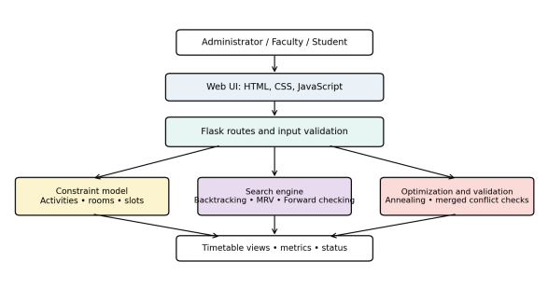
Fig. 1. Layered architecture of the proposed timetable scheduler

- PROPOSED METHOD
The workflow begins by loading course and examination activities, room data, faculty availability, student groups, and time slots. The application validates identifiers and required fields, constructs variable domains, and starts constraint search. After an initial candidate is found, an optional optimization phase may reduce soft penalties. Examination and class schedules are then merged and validated before being presented to users.
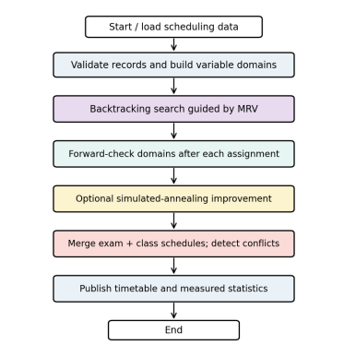
Fig. 2. Schedule generation, optimization, and merged validation workflow.
A. Backtracking Search
Backtracking performs depth-first exploration of partial assignments. At each stage, an unassigned activity is selected and a candidate room-slot value is tested. If it is consistent with the partial schedule, the assignment is accepted temporarily and search continues. If a conflict or empty domain appears, the assignment is undone and another candidate is attempted. For finite domains and exhaustive search, backtracking can find a solution when one exists, but its worst-case time complexity is exponential
B. Minimum Remaining Values
MRV chooses the unassigned activity with the smallest remaining domain. This fail-first strategy schedules activities with few legal options early, reducing the risk that they become impossible to place after flexible activities consume their available slots. Ties can be broken using a documented secondary rule, such as the number of constraints on an activity
C. Forward Checking
After assigning an activity, forward checking removes incompatible values from the domains of related unassigned activities. If any domain becomes empty, the current branch cannot lead to a feasible schedule and search backtracks. Domain changes must be restored when a branch is undone; otherwise, values removed in one branch can incorrectly disappear in later branches.
D. Simulated Annealing
Simulated annealing may be used after a feasible schedule has been produced to reduce soft-constraint penalties. A neighboring schedule is generated by a local change, such as moving an activity to another legal slot. Improvements are accepted, while some worse moves may be accepted according to a temperature-dependent probability. The implementation must define the neighborhood, cooling schedule, stopping condition, and objective function. Annealing does not guarantee a global optimum and must not be used to excuse hard-constraint violations
- IMPLEMENTATION
The prototype uses Python and Flask for request handling and scheduling logic, with HTML, CSS, and JavaScript for the user interface. The application scope includes examination scheduling, class scheduling, student-specific timetable views, merged conflict detection, and algorithm statistics. Python and Flask provide the implementation platform [14], [15]. The scheduling engine should report unscheduled activities and infeasible outcomes clearly. Conflict reports should identify the resource and activities involved rather than returning only a generic failure. Student-specific views should be generated from validated assignments and should not replace backend constraint checks.
Layer | Technology
Frontend | Angular
Backend | Python Flask
Engine | CSP
Storage | SupaBase
Table 1: Technology Stack
Simulated annealing evaluates neighboring candidate schedules using the implemented soft penalty. Its parameters and move operator must be recorded. The independent validation stage checks hard constraints and the combined examination/class schedule. Optimization statistics and feasibility status should be reported separately.
The scheduling engine represents activities, domains, and constraints. Backtracking attempts candidate assignments, MRV determines which unassigned variable to select, and forward checking prunes incompatible values from neighboring domains. Domain changes must be restored when backtracking returns to an earlier branch.
The CSP solver then chooses an unassigned variable, tries candidate values, checks consistency, and propagates the consequences of each assignment. MRV can influence the order of variable selection, while forward checking removes values that conflict with a newly assigned variable. If a branch cannot be extended, the solver restores the relevant state and tries another value. Correct state restoration is a central correctness requirement.
Constrain | Type | Validation
Room-Time collision | Hard | At most one activity per room and slot
Faculty Overlap | Hard | No simultaneous assignments
Group Overlaping | Hard | No concurrent cohort activities
Availability | Conditinal Hard | Assignment respects supplied limits
Gaps | Softs | Explicit penalty is calculated
Table 2: Constrains and validation
- EVALUATION METHOD
For each run, record instance size, activity count, available rooms and slots, constraint configuration, algorithm parameters, outcome status, elapsed time, and search counters if instrumented. Use the same instance and environment when comparing variants. For stochastic optimization, run multiple trials and report the chosen summary statistic, such as median objective value and range. Runtime should be measured consistently and should exclude unrelated browser rendering when comparing search engines. The evaluation should answer four questions: whether the scheduler generates feasible schedules for satisfiable instances; whether it reports infeasible or unfinished cases clearly; whether merged validation detects injected conflicts; and how MRV, forward checking, and optional annealing affect runtime and quality on identical inputs. Synthetic instances should be saved with identifiers so tests can be repeated.
ID | Input Condition | Expected Output
T1 | Conflict-free small instance | Valid schedule; zero hard conflicts
T2 | Two activities share room and slot | Room conflict reported
T3 | Faculty assignments overlap | Faculty conflict reported
T4 | Cohort activity overlap | Student conflict reported
T5 | Conflict appears after merge | Merged check reports conflic
T6 | Infeasible or limited search | No false success; clear status
Table 3: Proposed validation test cases
- RESULTS AND DISCUSSION
Verified benchmark measurements were not provided when this paper was prepared. Consequently, no runtime, completion-rate, or solution-quality values are claimed. The table below is a recording format and must be replaced with measurements collected from the working implementation. A schedule counts as successful only when it passes applicable hard-constraint checks.
MRV may expose constrained activities early; forward checking may detect dead ends before deeper exploration; and simulated annealing may reduce soft penalties while varying across runs. These are expectations from the algorithm design, not measured results for this application. If observed data do not show these trends, the paper should report that honestly and investigate the instance structure and implementation details
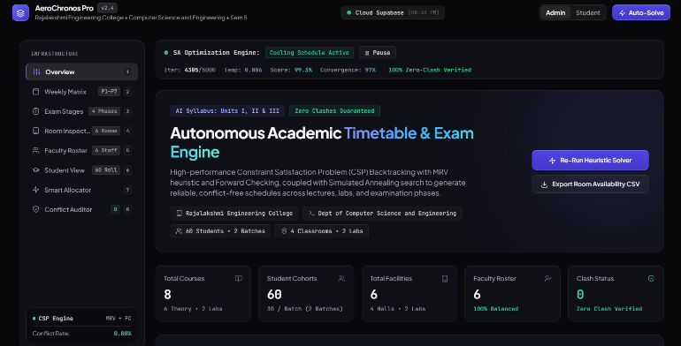
Fig 3: Dashboard
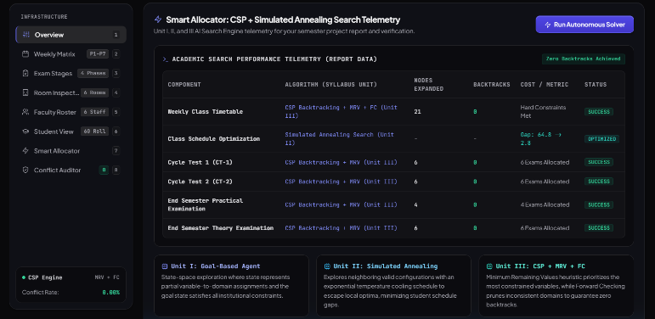
Fig 4: CSP Engine
- LIMITATIONS AND RESPONSIBLE USE
Results depend on whether test instances represent real institutional constraints. Small synthetic cases may not reflect the scale or irregularity of a full semester. Timing comparisons are sensitive to hardware, Python version, process load, and implementation choices. If simulated annealing is stochastic, one run is insufficient to characterize typical performance. The scheduler cannot enforce constraints absent from its model or supplied incorrectly. Incomplete availability records, incorrect cohort mappings, or inconsistent slot identifiers may produce an apparently valid but operationally unsuitable timetable. Before deployment, institutional stakeholders should verify policy coverage and exception handling. Student and faculty information should be minimized and protected with suitable access controls, and unvalidated schedules should not be presented as final.
- CONCLUSION
This paper described an Automated University Examination and Class Timetable Scheduler based on constraint-guided search. Backtracking provides systematic assignment exploration; MRV prioritizes activities with fewer legal choices; forward checking prunes conflicting domain values; and simulated annealing is a potential method for improving softconstraint quality. The web interface connects scheduling operations to student-specific views, statistics, and merged conflict validation. The key correctness principle is that examination and class schedules must be checked together before publication. Future work includes testing larger realistic instances, comparing algorithm configurations under identical conditions, measuring the effect of each heuristic, documenting optimization parameters, and improving explanations for infeasible schedules. Authentic screenshots and measured results should be added after the final application has been executed and validated.

REFERENCES
[1] R. Dechter, Constraint Processing. San Francisco, CA, USA: Morgan Kaufmann, 2003.
[2] S. Russell and P. Norvig, Artificial Intelligence: A Modern Approach, 4th ed. Hoboken, NJ, USA: Pearson, 2021.
[3] E. K. Burke and S. Petrovic, “Recent research directions in automated timetabling,” European Journal of Operational Research, vol. 140, no. 2, pp. 266–280, 2002, doi: 10.1016/S0377-2217(02)00069-3.
[4] A. Schaerf, “A survey of automated timetabling,” Artificial Intelligence Review, vol. 13, pp. 87–127, 1999, doi: 10.1023/A:1006576209967.
[5] M. W. Carter, G. Laporte, and S. Y. Lee, “Examination timetabling: Algorithmic strategies and applications,” Journal of the Operational Research Society, vol. 47, pp. 373–383, 1996.
[6] R. Qu, E. K. Burke, B. McCollum, L. T. G. Merlot, and S. Y. Lee, “A survey of search methodologies and automated system development for examination timetabling,” Journal of Scheduling, vol. 12, pp. 55–89, 2009, doi: 10.1007/s10951-008-0077-5.
[7] S. Kirkpatrick, C. D. Gelatt, Jr., and M. P. Vecchi, “Optimization by simulated annealing,” Science, vol. 220, no. 4598, pp. 671–680, 1983, doi: 10.1126/science.220.4598.671.
[8] E. K. Burke, Y. Bykov, J. P. Newall, and S. Petrovic, “A time-predefined ´ approach to course timetabling,” Yugoslav Journal of Operations Research, vol. 13, no. 2, pp. 139–151, 2003, doi: 10.2298/YJOR0302139B.
[9] R. Bai, E. K. Burke, G. Kendall, and B. McCollum, “A simulated annealing hyper-heuristic for university course timetabling,” in Proc. PATAT, 2006.
[10] S. B. Deris, S. Omatu, H. Ohta, and P. A. B. D. Samat, “University timetabling by constraint-based reasoning: A case study,” Journal of the Operational Research Society, vol. 48, no. 12, pp. 1178–1190, 1997, doi: 10.1057/palgrave.jors.2600469.
[11] L. T. G. Merlot, N. Boland, B. D. Hughes, and P. J. Stuckey, “A hybrid algorithm for the examination timetabling problem,” in Practice and Theory of Automated Timetabling IV, LNCS 2740. Berlin, Germany: Springer, 2003, pp. 207–231.
[12] S. Ceschia, L. Di Gaspero, and A. Schaerf, “Design, engineering, and experimental analysis of a simulated annealing approach to the post-enrolment course timetabling problem,” Computers & Operations Research, vol. 39, no. 7, pp. 1615–1624, 2012.
[13] E. K. Burke, B. McCollum, A. Meisels, S. Petrovic, and R. Qu, “A graph-based hyper-heuristic for educational timetabling problems,” European Journal of Operational Research, vol. 176, no. 1, pp. 177–192, 2007.
[14] Python Software Foundation, “Python 3 documentation.” [Online]. Available: https://docs.python.org/3/. Accessed: Oct. 23, 2026.
[15] Pallets Projects, “Flask documentation.” [Online]. Available: https:// flask.palletsprojects.com/. Accessed: Oct. 23, 2026.

