Experiment No. 2
Setting Up a Zoho Creator Account and Exploring the Platform Architecture and Interface
Name: Santhosh G | Roll No: 240701473

1. Aim
To create an account on Zoho Creator, build a sample application on the platform, and explore its architecture and interface — including the process of creating forms, reports, and dashboards — along with its Develop, Deploy, and Manage environments.
2. Setting Up Zoho Creator
I) Create the Sample Application
1. Go to creator.zoho.com and sign up using an email ID, or log in directly using an existing Zoho account.
2. Verify the account through the confirmation link/OTP sent to the registered email, and complete the initial account setup.
3. On the Zoho Creator home dashboard, click the “Create New Application” (+) button.
4. Choose to build the application “from scratch” (blank canvas) or select a ready-made template from the template gallery.
5. Enter a suitable application name and short description, then click “Create”.
6. The application opens in the Zoho Creator Builder, where forms, reports, pages, and workflows can be added to build the sample app.

II) Creating a Form, Report, and Dashboard
a) Form
A form is the basic data-entry component of a Zoho Creator application. It is created from the Builder by clicking “Add Form” and then dragging and dropping the required fields (Single Line, Number, Date, Dropdown, File Upload, etc.) onto the form canvas. Field properties such as name, validation rules, and default values can be configured from the properties panel. Once saved, the form becomes the primary interface through which users enter and submit records into the application.

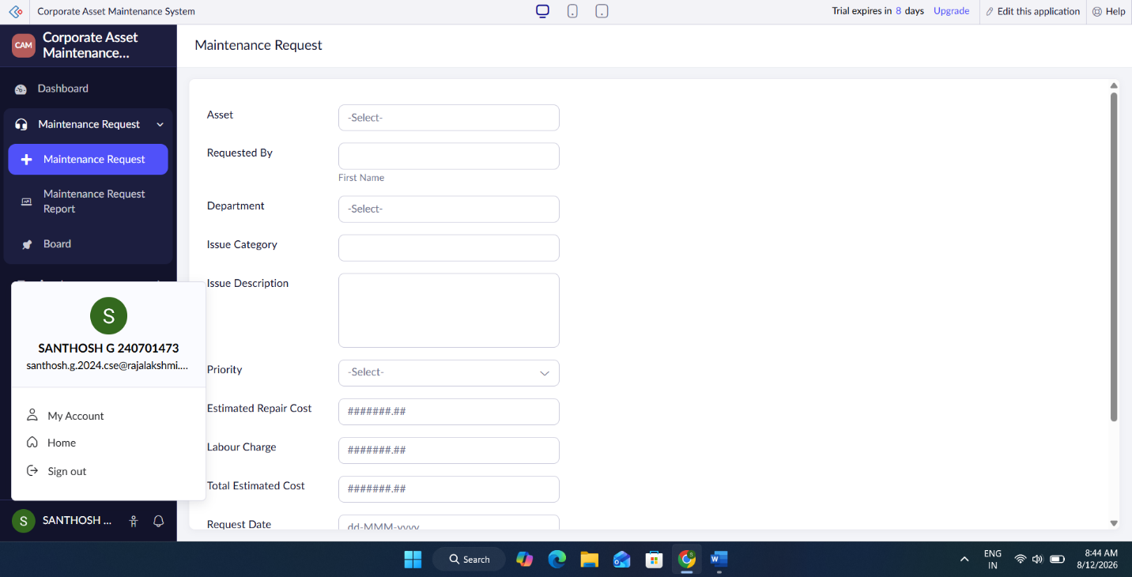
Fig. A — Form creation in Zoho Creator
b) Report
A report is automatically generated for every form and displays the records submitted through that form in a structured, tabular (or list/calendar/kanban) view. Reports can be customised by adding filters, sort orders, grouping, and criteria to view specific subsets of data. They allow users to search, edit, export, and analyse the records collected via the associated form, and act as the bridge between raw data entry and meaningful information.
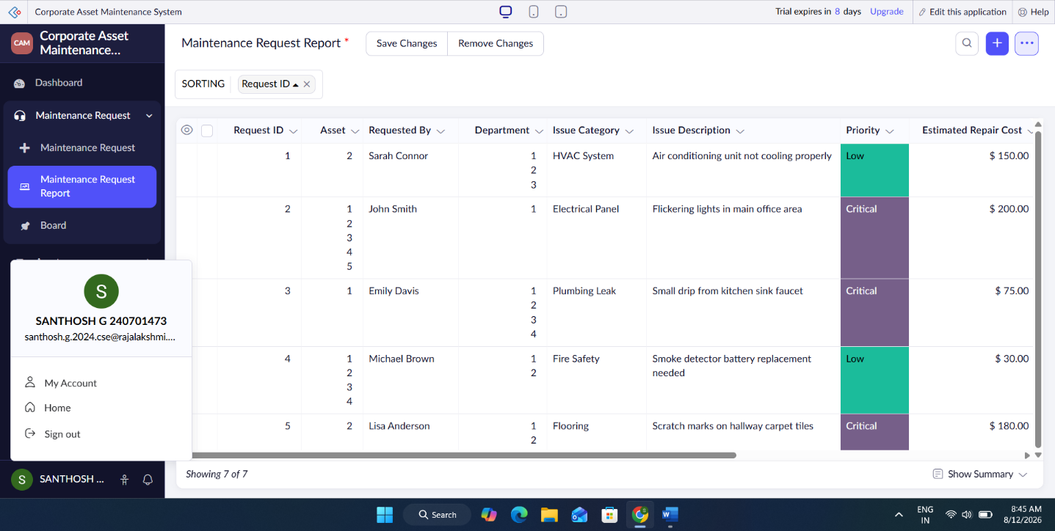
Fig. B — Report creation in Zoho Creator

c) Dashboard
A dashboard is a visual analytics page built using widgets such as charts, graphs, KPI counters, and pivot tables, all sourced from the application’s reports. It is created by adding a “Dashboard” component and configuring individual widgets to summarise key data trends. Dashboards give stakeholders a quick, at-a-glance understanding of application data without needing to browse through individual records.
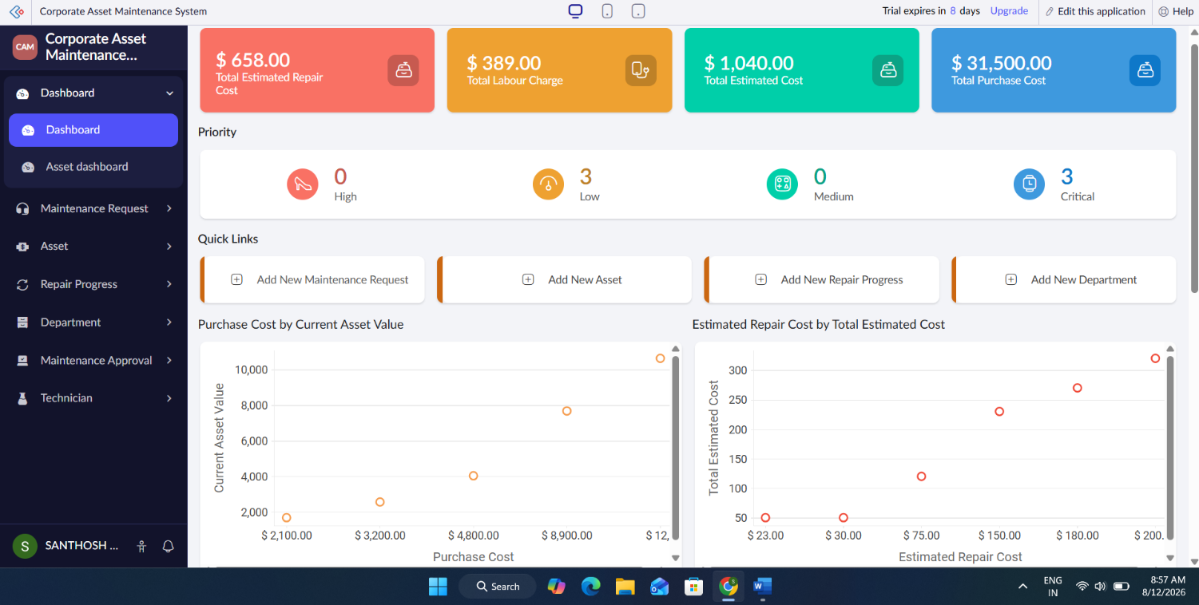
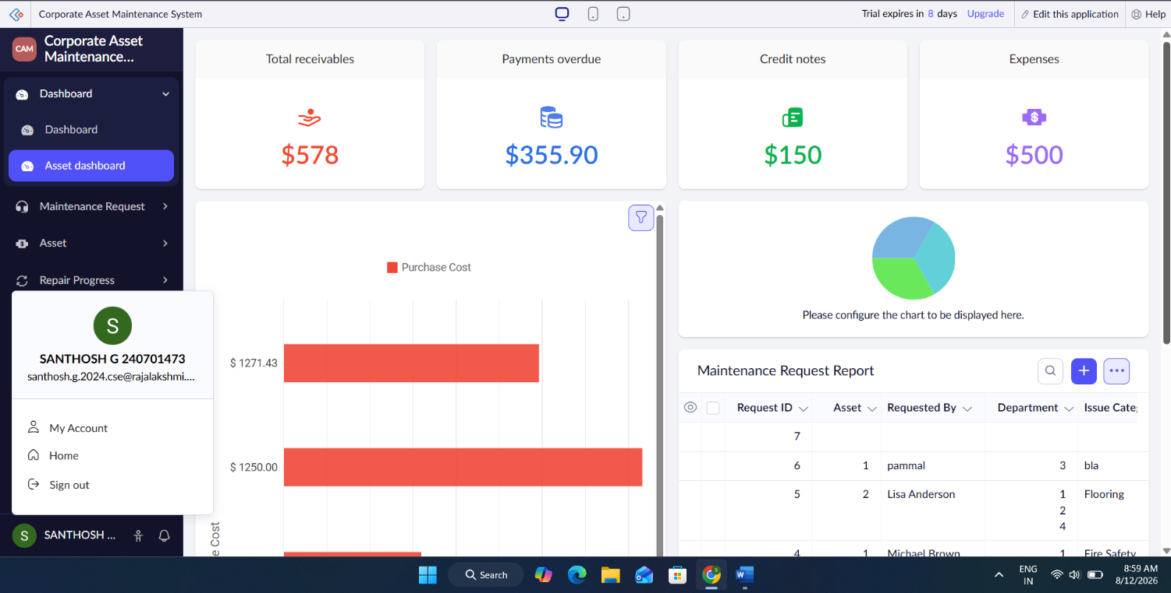
Fig. C — Dashboard creation in Zoho Creator

3. Exploring the Platform Architecture and Interface
The Zoho Creator interface is organised around three core environments that represent the complete application lifecycle — Develop, Deploy, and Manage. Each environment serves a distinct purpose in taking an application from design to production use.
Develop
• This is the design-time environment where the application is actually built, using the drag-and-drop Builder to create forms, pages, reports, and workflows.
• Business logic and automation are added here using Deluge scripting, custom functions, and visual workflow rules.
• It provides a live preview so the developer can test the look, feel, and functionality of the app while it is being constructed.

Deploy
• This environment is used to publish the completed application, making it accessible to end users on web and mobile platforms.
• Zoho Creator supports one-click deployment, and can push updates to production without disrupting ongoing usage.
• Deployment settings also allow the application to be shared publicly, restricted to specific users, or hosted through an on-premise setup.

Manage
• This environment lets administrators control user roles, permissions, and access levels for the deployed application.
• It provides tools to monitor application usage, view logs, track workflow execution, and troubleshoot errors.
• It also handles ongoing maintenance tasks such as data backup, security settings, and version updates without needing to modify the underlying code.

